
COMSATS University Islamabad, Lahore Campus
LAB - Security Testing
Course Title: | Software Testing |  |  |  | Course Code: | CSE 363 | Credit Hours: | 3(2,1)
Course Instructor | Yella Mehroze |  |  |  | Theory/Lab Name: | Lab
Semester: | 8th | Batch: |  | Section: |  | Depart | CS

Learning Outcomes
- Security Testing
- Installation and Configuration
  - Download and install virtual box
  - Download and install kali linux
  - Install Damn Vulnerable Web Application
  - Configure MY SQL
  - Configure Apache
  - Run DVWA
  - Learn its basics and interface
  - Learn how to change the security settings

Task 1

Follow the mentioned steps and run DVWA
Methodology

STEP 1 : DOWNLOAD AND INSTALL VIRTUAL BOX
Downloading Virtual Box [Go for Windows Host]
https://www.virtualbox.org/wiki/Downloads
Virtual Box Installation
https://www.youtube.com/watch?v=8mns5yqMfZk
STEP 2 : DOWNLOAD AND INSTALL KALI LINUX
Downloading Kali Linux
https://www.kali.org/get-kali/#kali-virtual-machines [64 bit]
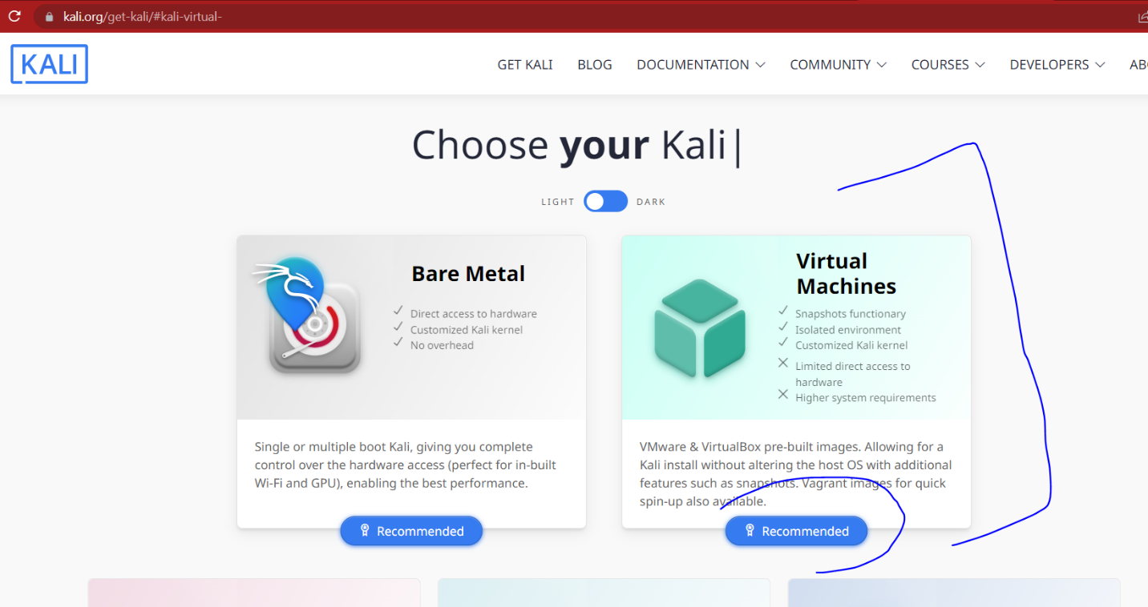

After clicking on recommended,

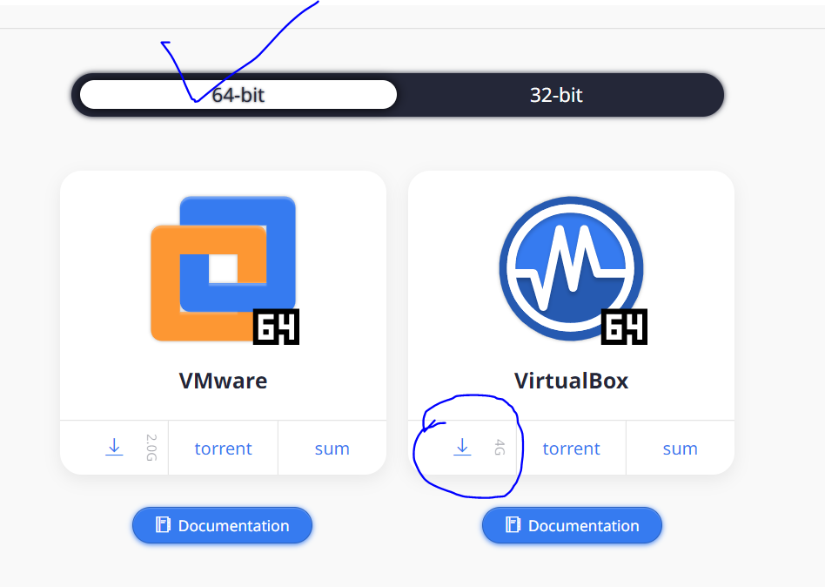

After downloading, you will get hthis

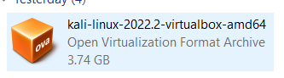

After this, open virtual box, click on FILE -> IMPORT APPLIANCE -> and then load the kali file displayed above …….[DO This before going to BIOS]………
This will not get installed as 64 bit not available in virtual box (for my case)

STEP 3 : BIOS SETTINGS (ENABLING VIRTUAL TECHNOLOGY)
- For this, search BIOS Key of your laptop on internet
- (Check laptop model number, paste it on google, and search BIOS key , FOR EXAMPLE : F10 in my case , HP model num XYZ)
- Watch this link LINK or any other you can search on you tube w.r.t you laptop but majorly we just need to enable virtual technology option as displayed in my shared tutorial (FOR BIOS ): https://youtu.be/-O66nIA6SlQ

Restart your laptop, press BIOS key and Then enable the virtual technology option and save the settings
Start your laptop, now Kali Linux would work.
Write your id and password and start.
STEP 4 : I : INSTALLING DVWA – II: CONFIGURING MYSQL - III:CONFIGURING APACHE
Open the root terminal in Kali
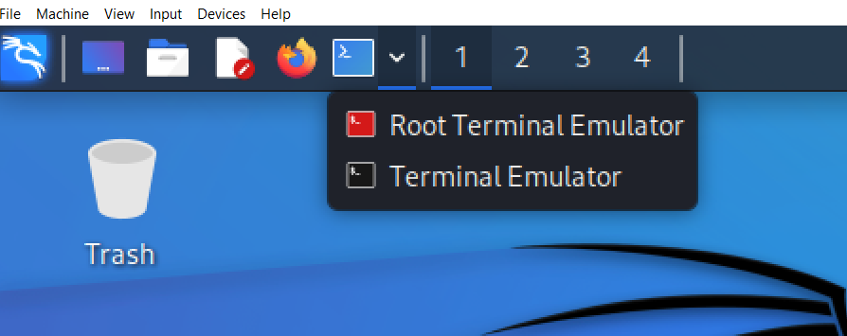
Execute the commands as given in the following tutorial sequence wise
https://www.youtube.com/watch?v=t7UUt-gT4m8&ab_channel=TechBeatz

When the tutorial is followed and you are at 20:57 sec, i.e. after this command (firefox http://127.0.0.1/dvwa), then a blank page will be opened on firefox (opposite to that of as displayed in video)
Manually edit your firefox link to http://127.0.0.1/dvwa/setup.php [in my case it was : http://127.0.0.1/dvwa/login.php that I changed manually to "setup.php"]
http://127.0.0.1/dvwa/security.php : USer = Admin, Password = password

STEP 5 : START THE APP AGAIN FOR PRACTISE

For practise shut down your kali and restart it, Every time you want to work on DVWA, We just need three commands (or precisely 2)
Starting Apache and MYSQL via Root
sudo service mysql start
sudo service apache2 start
-----------------------------------------------------------------------------------------------------------------------------------
After this , either use power shell to start Apache OR access it directly via browser
http://127.0.0.1/dvwa/login.php
Save these commands in a note pad file and paste on your desktop so you can easily open DWVA every time.
HINTS
- I have pasted the procedure and links I followed along with the problems i faced, After the above steps my DVWA is working Fine.
- Hint : No need to downgrade your php version (in the tutorial it uses 7. sth, by default,my version was 8. sth and I am using it)
- MYSQL and APACHE are already installed in kali [i went for kali virtual machine instead of bare], so we just need to configure it by commands as given in tutorial.
- My Selection & Suggestion : USE kali Virtual Machine
- In case you use a kali virtual machine (instead of a kali bare machine), it would save time and effort as there would be no need to manually install KALI and follow the long steps (if any one want to do that, he can send an email and I will share the link), rather we will just import the appliance and we are done with Kali installation.
- For configuring MYSQL and APACHE, use separate files i.. e separate root shells

For any queries

yellamehroze@cuilahore.edu.pk

Office: H-Block – Room 23 (H – 23)

