**Dynamic Frontend Components Report**

# Project Overview

This project focuses on building a dynamic frontend for a car rental website using Next.js and Sanity CMS. The main goal is to implement functional, reusable components to enable users to filter cars based on attributes such as type, seating capacity, and fuel capacity.

***Step 1: Planning the Filters***

**1. Identified Attributes:**

1. Car type (SUV, Sedan, Sport)
2. Seating capacity (2 People, 4 People, 5 People)
3. Fuel capacity (50L, 70L, 90L) **2. Defined Objectives:**
4. Enable users to filter cars dynamically.
5. Ensure the filters are reusable and modular.

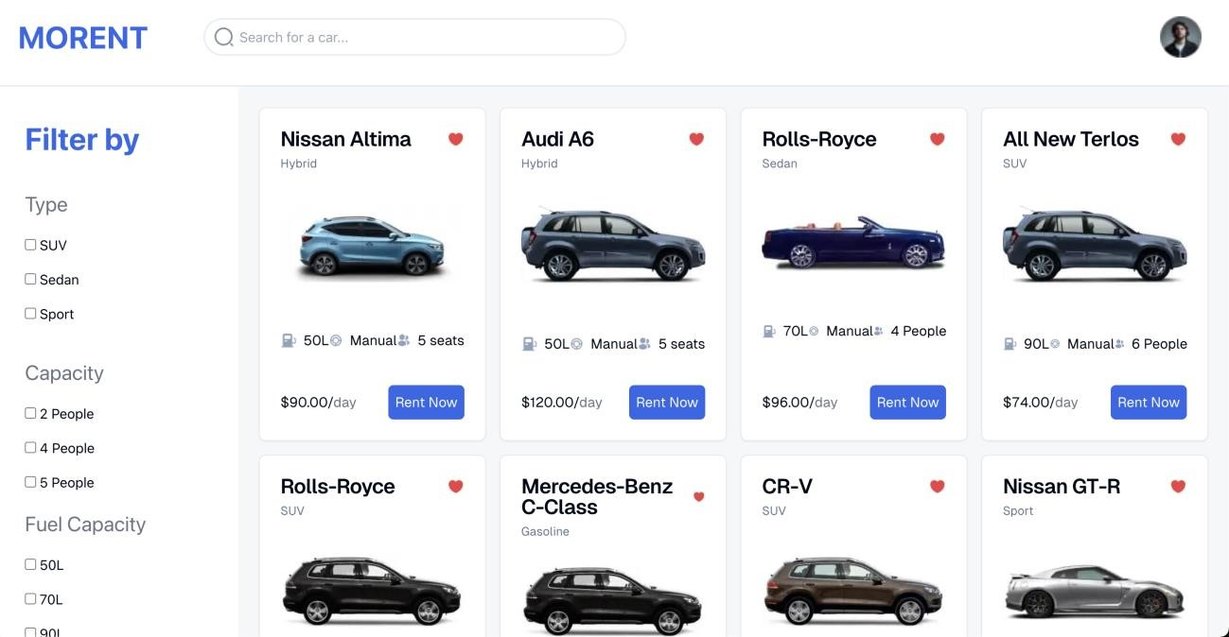

***Step 2: Setting Up the Filter Component***

1. **Created a Reusable Component:** 
   1. Developed a FilterComponent using React functional components with TypeScript.
   2. Integrated a useState hook to manage filter state locally.
2. **Implemented Input Elements:** 
   1. Added checkbox inputs for each attribute.
   2. Handled filter updates using an onChange event listener.
3. **Code Implementation:**

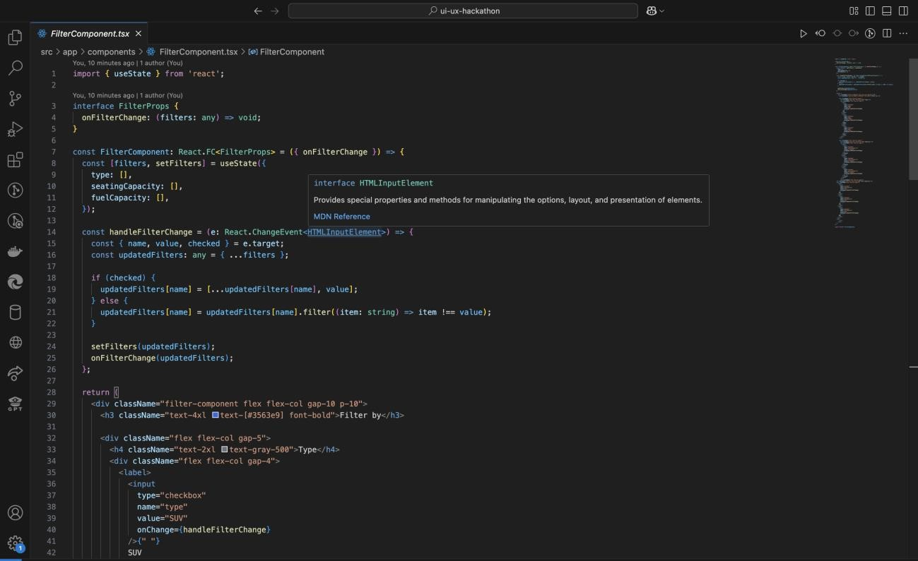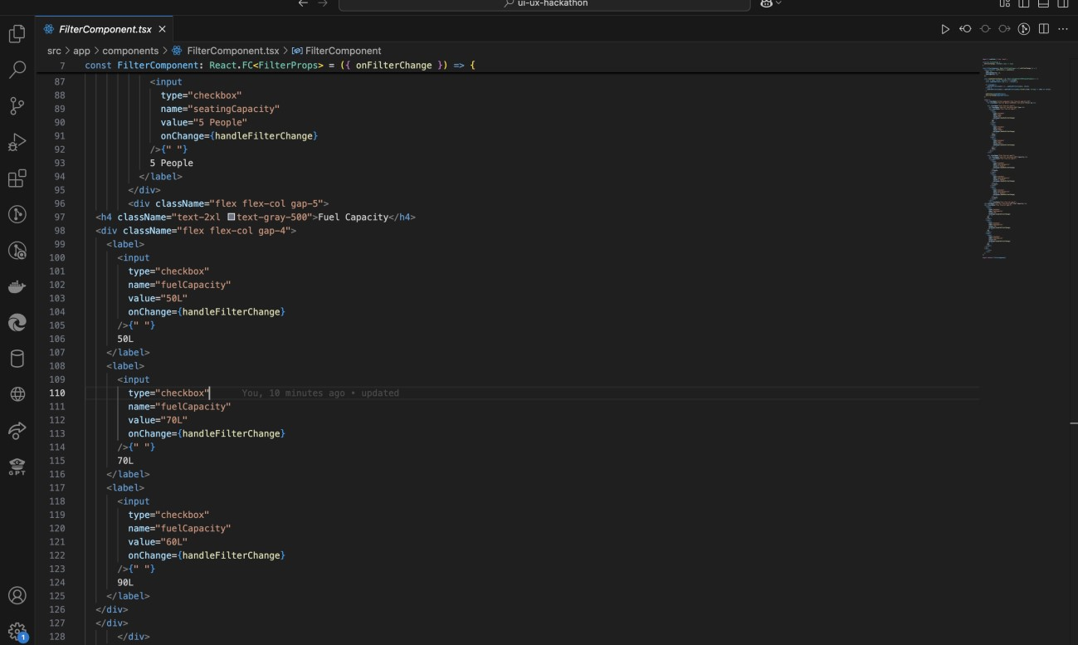

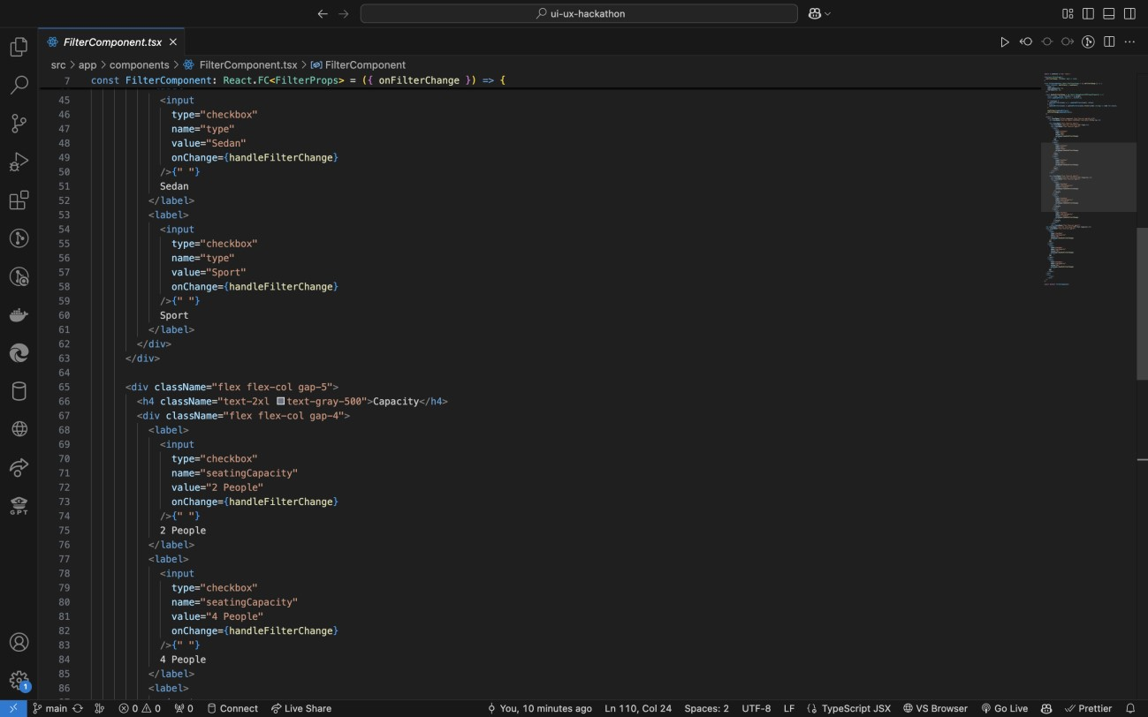

# Challenges Faced

1. **Data Structure Complexity:** 
   1. Initially faced difficulty managing nested filter states.
   2. Resolved by creating a unified state object for all filters.
2. **Performance Optimization:** 
   1. Filtering large datasets caused noticeable lag.
   2. Improved efficiency by applying filters sequentially in the applyFilters function.

# Outcomes and Learnings

1. **Functional Filters:** 
   1. Successfully implemented dynamic filtering for car type, seating capacity, and fuel capacity.
2. **Improved React Skills:** 
   1. Gained deeper understanding of state management and reusable component design.
3. **Sanity Integration:** 
   1. Enhanced familiarity with GROQ queries and Sanity’s CMS capabilities.

Code Deliverables

• Search bar

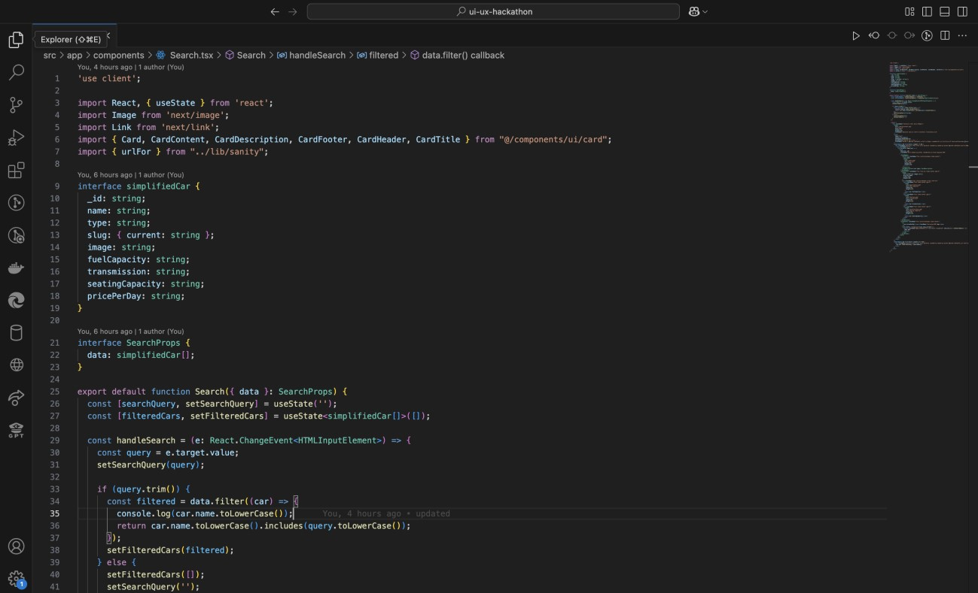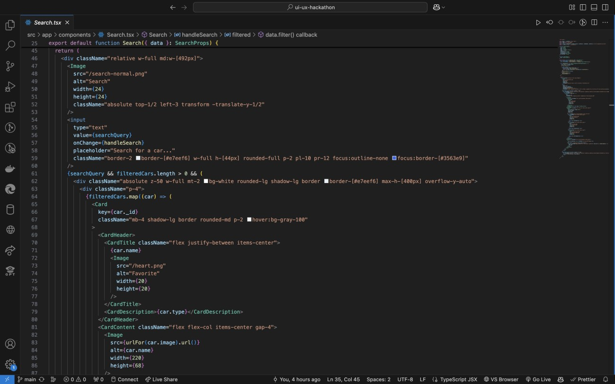

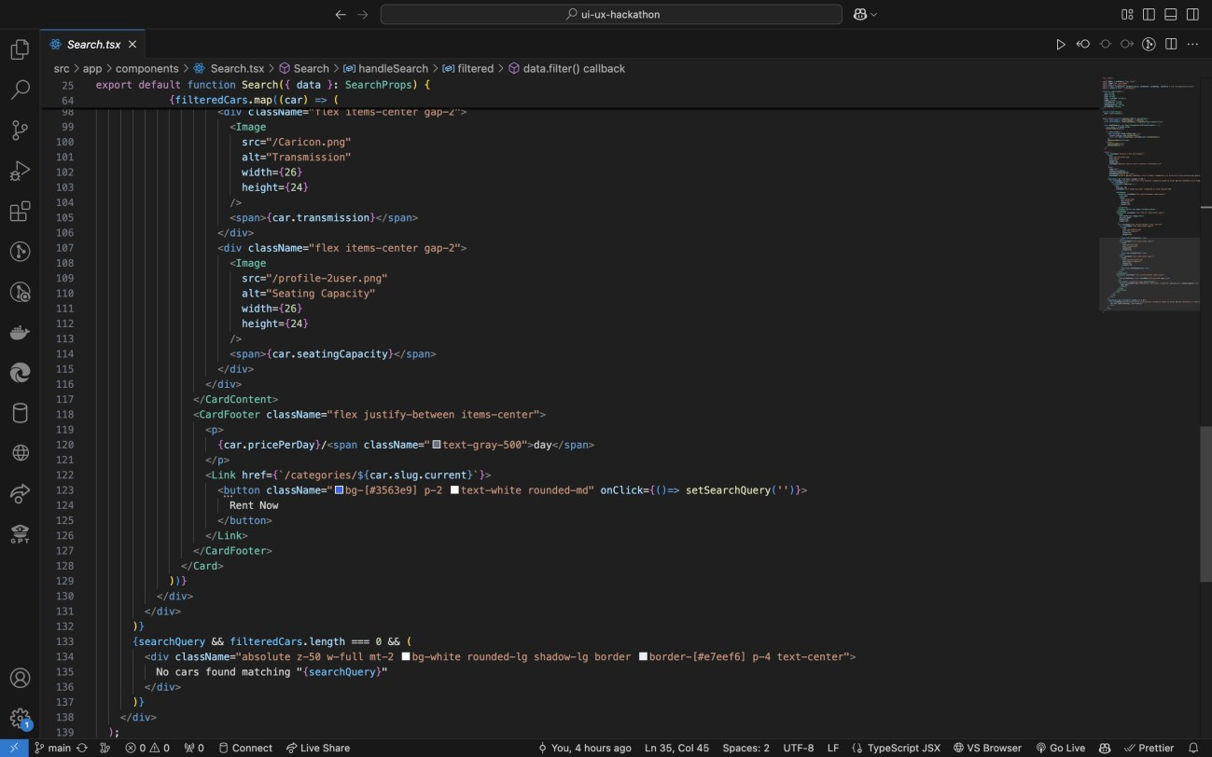

# Conclusion

The "Dynamic Frontend Components" project successfully demonstrates the creation of a user-friendly, filterable and searchable car rental interface. The modular approach ensures scalability and ease of future development.