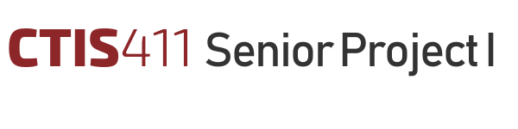

Software Requirements Specification
CULTURATI
Team 22

Ayesha Nizam, 22001260
Göktuğ Şenkoyun, 22103191
Talal Salman Zafeer, 22001483
Tarık Ebubekir Koca, 22103032
Enes Memigüven, 22002674

Bilkent University
Department of Information Systems and Technologies

04.12.2024
Change History
File Name | Document Type | Deliverable | Version | Submission Date
Deliverable_2.docx | MS Word 2013 | 2 | 0.1 | -
Team22_SRS_FR1 | MS Word 2013 | 2 | 1 | 09.11.2024
Team22_SRS_FR2 | MS Word 2013 | 2 | 2 | 04.12.2024

Project Team
Name, Surname | Student Id Number | e-mail
Ayesha  Nizam | 22001260 | ayesha.nizam@ug.bilkent.edu.tr
Göktuğ  Şenkoyun | 22103191 | goktug.senkoyun@ug.bilkent.edu.tr
Talal Salman  Zafeer | 22001483 | talalsalmanzafeer@gmail.com
Tarık Ebubekir  Koca | 22103032 | tebubekirkoca03@gmail.com
Enes  Memigüven | 22002674 | enes54657@gmail.com

Project Details
Project Name | CULTURATI
Software Name | CULTURATI
Company Name | Horizon Europe RIA
Academic Advisor | Neşe Şahin Özçelik
Github URL | https://github.com/AyeshaNizam-5/CULTURATI
WEB page

Individual Contributions Overview
Name, Surname | Summary of Contributions to the SRS Document
Ayesha  Nizam | Contributed to Product Perspective, Functional Requirements and Use Case Diagram. Modified Scope, User Characteristics, Non-Functional Requirements and formatting.
Göktuğ  Şenkoyun | Contributed to Verification, Discussions, Other Non-Functional Requirements and Requirements Prototype.
Talal Salman  Zafeer | Contributed to Product Scope, Logical Database Requirements  And EER Diagram.
Tarık Ebubekir  Koca | Contributed to User Characteristics, Assumptions and Dependencies and system model diagrams.
Enes  Memigüven | Contributed to Non-functional requirements and system model.

Change List
- The Executive summary is added
- System model and requirements prototype is added
- Functional and Non-functional requirements are changed in order to specify the project better.
- Scope is changed now it is more in line with our objectives
- Abbreviations are filled
- System model diagrams are added
- Use case and EER diagrams are redrawn
- Product perspective is extended and refined
- User characteristics are changed and refined
- Verification is completely rewritten

Executive Summary
The Software Requirements Specification (SRS) for CULTURATI provides a detailed framework for developing a content management system (CMS) that enables the creation, management, and preview of cultural content tailored for four primary user roles: administrators, editors, content creators, and data entry operators. The document focuses on two key use cases: UC-07 Create Content and UC-09 Manage Content, ensuring efficient workflows for cultural content creation and management. The CMS supports three main products: a web application for content management, Android and iOS applications for visitor-side interactions, and a robust API facilitating data exchange between the CMS and visitor applications. The system is built using PostgreSQL, React.js, Node.js with Express.js, and Axios for RESTful API interactions, ensuring scalability and maintainability. Critical non-functional requirements include retrieving and displaying content within 3 seconds under average load conditions and completing bulk content imports (1,000+ records) within 10 minutes for standard datasets. Additional features include a modular architecture, robust role-based access control, encrypted communication, and compliance with usability and performance standards. The CMS database for CULTURATI encompasses key entities such as Users (Administrators, Content Creators, Editors, Data Entry Operators), Institutions, Locations, and Content (Games and Routes), with well-defined relationships ensuring data integrity and role-based access. It enforces constraints like referential integrity, unique content validation, and real-time updates for critical attributes such as Current Occupancy, enabling efficient and reliable system operations. This SRS serves as a blueprint for the project, providing clarity on deliverables, constraints, and dependencies, while addressing challenges in developing a reliable, secure, and user-friendly system.

Table of Contents
Page Number
Executive Summary i
Table of Contents ii
1. Scope 1
Core Products Developed 1
Primary Users 2
Key Objectives 3
Exclusions 3
2. Product Perspective 5
3. User characteristics 12
4. Assumptions and dependencies 14
5. Functional requirements 16
FR-01: User Authentication 16
FR-02: Account Management 16
FR-03: Institution Management 18
FR-04: First-Time User Password Setup 19
FR-05: Content Creation by Content Creators 20
FR-06: Managing Categories, Difficulty Levels, and Types by Content Creators 22
FR-07: Managing Content by Content Creators 23
FR-08: Content Review and Approval by Editors 24
FR-09: Managing Institution Information by Data Entry Operators 26
FR-10: API Development for Data Sharing 27
Use Case Diagram 31
6. System Model 32
7. Requirements Prototypes 36
Header Bar 38
Button for Creating Custom Fields 38
Search Bar 39
Custom Fields Table 39
Filters 39
Header 41
Sections 42
Header 43
Fields for Input 44
Game Content Preview 46
Route Content Preview 47
Submission Failed Screen 50
Submission Successful Screen 51
Header 52
Fields for Input 52
Field Type Selection 53
Action Buttons 53
Header 54
Fields for Input 54
Field Type Selection 55
Action Buttons 55
First Screen: Field Deletion without Associations 57
Second Screen: Field Deletion with Integrity Constraints 57
8. Non-functional Requirements 59
1. Usability requirements 59
2. Performance requirements 59
3. Software system attributes 59
4. Constraints 60
5. Error Handling Requirements 60
6. Other Non-Functional Requirements 60
9. Logical Database Requirements 62
10. Verification 72
11. Discussions 74
1. Limitations and Constraints 74
2. Health and Safety Issues 74
3. Legal Issues 74
4. Economic Issues and Constraints 74
5. Sustainability 74
6. Ethical Issues 74
7. Multidisciplinary Collaboration 74
12. References 75

List of Tables
Page Number
Table 1. Cross Referencing Functional Requirements to Use Cases 32

List of Figures
Page Number
Figure 1. Use Case Diagram for CULTURATI 31
Figure 2. Sequnce Diagram for Manage Content 33
Figure 3. Activity Diagram for Manage Content 33
Figure 4. Class Diagram for Manage Content 34
Figure 5. Sequnce Diagram for Create Content 34
Figure 6. Activity Diagram for Create Content 34
Figure 7. Class diagram for Create Content 35
Figure 8. My content dashboard in Culturati 36
Figure 9. Manage Custom Fields dashboard in Culturati 38
Figure 10. Prompt that asks for which type of content will be created 40
Figure 11. Game content creation page 41
Figure 12. Route content creation page 43
Figure 13. Preview page for Game content 45
Figure 14. Preview page for Route content 46
Figure 15. Delete confirmation prompt for contents 48
Figure 16. Submission successful screen 49
Figure 17. Submission failed screen 50
Figure 18. Custom field creation screen 52
Figure 19. Custom field editing screen 54
Figure 20. Field Deletion Without Associations 56
Figure 21. Field Deletion with Associations 56
Figure 22. Enhanced Entity Relationship (EER) diagram for CULTURATI 71

Abbreviations

AI | Artificial intelligence
API | Application Programming Interface
CCI | Cultural and Creative Industries
GPS | Global Positioning System
IoT | Internet of Things
iOS | iPhone Operating System
RESTful API | Representational State Transfer Application Programming Interface
SQL | Structured Query Language
SRS | Software Requirements Specification
UI | User Interface

Scope
The CULTURATI project is an innovative digital platform designed to fulfill the dynamic needs of Cultural and Creative Industries (CCIs), particularly those in the business of cultural heritage sites, such as galleries, museums, and historic sites. The platform incorporates cutting-edge digital technology, including cloud computing, artificial intelligence (AI), and Internet of Things (IoT) sensors, to provide a thorough, interactive experience for both visitors and content producers, including museum managers and artists. The CULTURATI platform uses elements like real-time visitor management, personalized educational material, interactive games, and navigation routes to promote both participation and cultural preservation by bridging the gap between the public and cultural institutions.
Team 22 project is part of this bigger project, CULTURATI. Team 22 is responsible for developing the Content Management System (CMS) and a simplified visitor application prototype to test CMS functionality.

Core Products Developed
- Content Management System (CMS):
  - A web-based application for admins, content creators, data entry operators and editors to manage cultural content.
  - Features include:
    - Tools for creating, organizing, and editing educational content in various formats (text, images, videos).
    - Categorization of content by theme, difficulty level, and type.
    - User management functionalities for admins to create, assign roles, and manage accounts for content creators and editors.
    - Workflow for content approval by editors before it becomes available for visitor applications.
    - Institution information added by data entry operators.
    - APIs for seamless data transfer to visitor applications.
- Simplified Visitor Application Prototype:
  - A basic version of the visitor-facing Android and iOS applications to test the functionality and performance of the CMS.
  - Features include:
    - Displaying content retrieved from the CMS via APIs.
    - Simulating visitor interactions with educational games and navigation routes.
  - Note: The final fully functional visitor-facing applications are beyond the scope of Team 22’s responsibilities.
- API Development:
  - Development of RESTful APIs to enable smooth data exchange between the CMS and visitor applications.
  - API functionalities include:
    - Retrieval of approved content, such as games, routes, and metadata.
    - Real-time updates on categories, difficulty levels, and content statuses.

Primary Users
- Administrators:
  - Oversee platform operations and manage user accounts for data entry operators, content creators, and editors.
  - Create and manage institutions (e.g., museums, palaces, art galleries, historic town centers, castles).
  - Perform high-level administrative tasks, such as assigning roles and monitoring overall system activity.
- Data Entry Operators:
  - Add and manage institution-related content, such as location details, descriptions, images, and general information about cultural sites.
  - Ensure that all institutional data is accurate and updated for system-wide usage.
- Content Creators:
  - Produce educational content related to institutions, such as questions, routes, and multimedia (text, images, videos).
  - Assign categories, difficulty levels, and questions, asnwers, hints etc to content.
  - Collaborate with editors to refine and finalize content.
- Editors:
  - Review and approve content submitted by content creators before it is made available for integration with visitor-facing platforms.
  - Provide feedback or request modifications to ensure content meets quality standards.

Key Objectives
- Streamlined Content Management:
  - Provide a comprehensive and user-friendly interface for managing cultural content.
  - Ensure content flows seamlessly through the creation, approval, and publishing stages.
- Validation of CMS Functionality:
  - Develop a simplified visitor application prototype to verify the accuracy and usability of data provided by the CMS.
  - Simulate visitor interactions to test and refine CMS data output and API functionality.
- Integration with Larger Platform:
  - Enable data transfer to fully functional visitor-facing applications via APIs.
  - Ensure compatibility and scalability with the broader CULTURATI project infrastructure.

Exclusions
- Development of the fully functional visitor-facing Android and iOS applications is outside the scope of Team 22’s work.
- Advanced visitor application features like real-time IoT and AI integrations or dynamic route generation are not included.
This focus ensures that Team 22’s deliverables provide a strong foundation for content management while supporting seamless integration with the larger CULTURATI platform.

Product Perspective
The CULTURATI CMS provides a web-based platform, as well as Android and iOS applications, for administrators, content creators, and editors to manage cultural content. The CMS interfaces with the Visitor Application, a separate product where end-users (visitors) access the curated content. Through RESTful APIs, the CMS and Visitor Application exchange approved content, ensuring real-time access and updates.
- System interfaces;
The CULTURATI Content Management System (CMS) developed by Team 22 is part of a larger platform, interfacing primarily with visitor-side applications and the underlying database.
CMS and Visitor Application Interface:
  - Functionality: The CMS API provides approved content, including metadata, difficulty levels, and types, to the simplified visitor-side application developed by Team 22 for testing purposes.
  - Interface Description: RESTful APIs using JSON format will be developed for the following functionalities:
    - Retrieve content items based on categories, difficulty levels, and formats.
    - Send updates to visitor applications, such as newly approved or edited content.
    - Verify successful data transmission between the CMS and visitor application prototypes.
CMS and Database Interface:
  - Functionality: The CMS backend communicates with the PostgreSQL database for content storage and retrieval.
  - Interface Description:
    - The backend uses SQL queries and Object-Relational Mapping (ORM) libraries to interact with the database for CRUD (Create, Read, Update, and Delete) operations.
    - All interactions are secured via encrypted database connections.
- User interfaces;
The CULTURATI CMS interface supports web-based access for administrators, content creators, editors, and data entry operators, as well as simplified Android and iOS applications for testing CMS functionality.

i) Logical Characteristics of Each Interface
- Web Application UI
  - Dashboard Layout: Role-specific dashboards provide access to relevant tools:
    - Admin Dashboard: Includes user management (data entry operators, content creators, and editors) and institution creation/management (e.g., museums, galleries, castles).
    - Data Entry Operator Dashboard: Provides forms to input and update institution-related content, such as location details, descriptions, and images.
    - Content Creator Dashboard: Displays tools for creating, categorizing, and previewing educational content.
    - Editor Dashboard: Shows content review queues with actions to approve, reject, or request changes.
  - Page Layouts:
    - Institution Management Page: Enables admins to add, edit, and manage institution details, which data entry operators then populate with specific information.
    - Content Creation Page: A form-based layout for content creators to input details, assign categories, and preview content.
    - Content Review Page: List view for editors, showing content pending approval, with options for feedback and approval.
- Simplified Android and iOS Applications UI
  - Purpose: The mobile applications are prototypes for testing CMS functionality, allowing simulated visitor interactions with CMS data.
  - Mobile Layouts:
    - Simple displays for content categories, games, and routes, populated using CMS-provided APIs.
    - Basic navigation for exploring and interacting with test content.
    - Push notifications for simulating content updates from the CMS.

ii) Optimization for User Experience
Do's:
- Clear Navigation: Ensure simple, straightforward navigation with a minimal number of steps to complete primary tasks (e.g., content creation and approval).
- Role-Based Accessibility: Display only the functions relevant to each user role, reducing cognitive load and simplifying the user interface.
- Error Message Options: Provide users with an option to view either concise or detailed error messages, enhancing usability based on user preference.
- Consistent Design: Maintain uniform design language across web and mobile platforms to provide a seamless user experience.
Don’ts:
- Avoid Complex Workflows: Limit the number of fields and steps required to create or edit content.
- Reduce Redundancy: Avoid repetitive actions; for instance, ensure category selection occurs only once per content item.
- Prevent Screen Overload: Avoid displaying too many options at once. Use collapsible sections and tabs to organize content logically.
- Hardware interfaces;
Storage Servers:
- The CMS stores all data, including institution details, user accounts, and content items, on cloud-based servers managed by PostgreSQL.
- The servers are configured for scalable storage, ensuring the system can accommodate growing content and user data.
Access Devices:
- Web application: Accessed via desktop or laptop computers using standard browsers.
- Simplified Android and iOS applications: Accessed via mobile devices running the respective operating systems.
- Software interfaces;
The CULTURATI CMS relies on several software products, including a data management system, web browsers, and mobile operating systems, to ensure a seamless content management experience across different platforms.

1. Database Management System
- Name: PostgreSQL
- Version Number: Latest stable release
- Source: Open-source (PostgreSQL Global Development Group)
Interface Details:
- a) Purpose: PostgreSQL is used for storing, retrieving, and managing all content data within the CMS, including text, images, metadata (e.g., categories, difficulty levels), and user roles.
- b) Interface Definition: The CMS interacts with PostgreSQL via SQL queries. These interactions involve CRUD (Create, Read, Update, Delete) operations using standard SQL statements and returning data in structured tabular format. Queries are embedded within backend services, which connect to the database via an Object-Relational Mapping (ORM) library.

2. Web Browsers
- Name: Google Chrome, Mozilla Firefox, Safari
- Version Number: Latest two stable versions supported for each browser
- Source: Open web browsers (Google, Mozilla, Apple)
Interface Details:
- Purpose: Browsers are used to provide the CMS web application interface, enabling administrators, content creators, and editors to access and manage the CMS functionalities.
- Interface Definition: The CMS web application is accessed over the internet via HTTPS. The user interface uses HTML, CSS, and JavaScript to render content and ensure functionality across supported browsers. No additional interface definition is required, as these browsers are widely documented and follow standard web protocols.

3. Mobile Operating Systems
- Name: Android, iOS
- Version Number: Latest two versions supported for each OS (e.g., Android 13, iOS 17)
- Source: Android by Google, iOS by Apple
Interface Details:
- a) Purpose: Mobile operating systems provide the runtime environment for the CULTURATI CMS applications on Android and iOS devices, enabling content creators and editors to access the CMS remotely and perform essential content management tasks.
- b) Interface Definition: The CMS applications on Android and iOS communicate with the server over RESTful APIs using JSON for data exchange. These applications are developed with platform-specific SDKs (Android SDK and iOS SDK) to ensure compatibility with device standards. Communication with the CMS backend adheres to HTTPS protocols, and the applications render content based on the mobile device’s display capabilities.
Web frameworks:
- React.js (Frontend)
Purpose: For building the user interface of the web application.
- Node.js with Express.js
Purpose: To implement the CMS server-side logic and API development.
- Axios/ RESTful APIs:
Purpose: For API calls between CMS frontend and backend.
- Bcrypt:
Purpose: A library to help you hash passwords.
- Nodemailer:
Purpose: A library to enable two-factor authentication upon user registration by sending a 6-digits code to the user’s email.

- Communications interfaces;
The CULTURATI CMS involves multiple communication interfaces:
Database Communication:
- SQL queries are used to retrieve, update, and manage content stored in the PostgreSQL database.
Visitor Application Communication:
- RESTful APIs over HTTPS are used to transfer approved content from the CMS to visitor application prototypes.
- JSON format is used for all data exchange.
User Interaction Communication:
- Web application communicates with the backend using secure API calls.
- Mobile applications interact with CMS APIs for data retrieval and content display.
Data Entry Operator Communication:
- Data entry operators interact with the CMS through web-based forms, which communicate with the backend to store and update institution-related data.
- Memory constraints;
  - Content Storage:
  - Storage requirements will scale with the volume of content, including text, images, and multimedia files.
  - Cloud-based servers are configured for elastic storage, ensuring capacity meets demand.
  - Web Application:
  - Requires sufficient server memory to handle concurrent admin, data entry operator, content creator, and editor sessions.
  - Simplified Android and iOS Applications:
  - Mobile storage: Each application stores temporary data retrieved from the CMS (e.g., cached content).
  - Approximate memory usage: 100–200 MB per device, depending on the content volume retrieved during testing.

User characteristics
The CULTURATI CMS is designed for different groups of users, each with unique traits that affect how they use the product. Knowing these differences is key to creating a design that works well for everyone.
- Content Creator
One important group is content creators. These users are usually well-educated, with backgrounds in arts, history, or museum studies. Some may even have advanced degrees. Their experience ranges from seasoned professionals, like museum curators and historians, to enthusiastic volunteers who are new to content creation. Their technical skills vary from basic computer use to moderate experience with content management systems. This means the tools should be simple and easy to use, especially for those less familiar with technology. The platform needs to make content creation, editing, and management straightforward without overwhelming users.
- Administrator
Another key group is administrators (admins). They typically have higher education in areas like IT, management, or cultural studies and are experienced in running digital platforms, managing user accounts, and ensuring system security. Admins have advanced technical skills and can handle tasks like user management, visitor monitoring, and content review. For them, the platform should offer an easy-to-use interface that makes managing the system efficient and gives them quick access to data and controls.
- Editor
Editors are also important users of the CULTURATI platform. They often have strong educational backgrounds in fields like journalism or content editing. Editors are skilled at reviewing and polishing content to meet accuracy and institutional standards. Their technical skills are moderate, and they are comfortable using online content management tools. For editors, the platform should make it easy to review, update, and publish content without any complicated steps.
- Data Entry Operator
Data entry operators are responsible for adding and maintaining institution-related data, such as descriptions, images, and locations. They typically have a high school diploma or associate degree, with experience in administrative or data entry roles. Their technical skills are basic to moderate, with proficiency in typing, office tools, and online forms, but they may struggle with complex systems. Accuracy and attention to detail are critical for their role. To support them, the CMS must offer simple, clear interfaces, real-time error feedback, streamlined workflows, and accessibility features like screen readers and adjustable text sizes.
Understanding the characteristics of these groups—content creators, admins, editors, and end-users—is essential for designing the CULTURATI platform. Their different education levels, experiences, and technical skills help shape user-friendly tools and interfaces so everyone can use the platform effectively.

Assumptions and dependencies
The CULTURATI platform development is based on several assumptions and dependencies that could impact the stated requirements. These are outlined below:
- Technology and Infrastructure:
  - It is assumed that the hosting environment will support the required cloud-based infrastructure for scalability and real-time data management.
- External Systems and APIs:
  - The system assumes compatibility with various IoT sensor types (e.g., Wi-Fi, Bluetooth, GPS) for visitor tracking and flow management.
  - Dependencies on third-party APIs for integration with existing cultural institution management systems are anticipated. Any changes or limitations in these external APIs may require adjustments to the SRS.
- User Environment:
  - It is assumed that end-users (visitors) have access to devices capable of running the mobile or web applications smoothly, such as smartphones, tablets, or desktops with updated browsers.
  - For administrators and content creators, standard desktop or laptop systems with internet access are assumed for CMS operations.
- Regulatory Compliance:
  - The platform development assumes that it will comply with data privacy laws such as GDPR. Any changes in these regulations could necessitate modifications to the platform's requirements.
- User Availability and Training:
  - It is assumed that all user groups (admins, content creators, editors) will receive sufficient training to use the platform effectively. The success of the platform depends on users' ability to understand and utilize its features as intended.
  - Users are expected to have basic technical skills to navigate the web-based and mobile interfaces.
- Support and Maintenance:
  - Continuous access to maintenance and technical support for the platform is assumed to ensure smooth operation and timely resolution of issues.
  - Regular software updates will be supported to maintain compatibility with new versions of operating systems and browsers.

Functional requirements

FR-01: User Authentication
- The system shall require the following inputs for a user to log in:
a. Username and password entered into their respective fields.
b. Captcha security code to verify the user is human.
- The user shall click the "Login" button to submit their credentials.
- The system shall validate the entered credentials and captcha:
a. If the username, password, and captcha are correct, access shall be granted to the user’s account.
b. If any input is incorrect:
i. An error message shall display, explaining the issue.
ii. The user shall have up to three attempts to log in. After the third failed attempt, the account shall be locked.
iii. If the account is locked, the user shall receive a notification via email with instructions to unlock the account.

FR-02: Account Management
- Create User Account
  - Admins shall access the admin dashboard of the CMS website to manage user accounts.
  - On the dashboard, the admin shall click the "Create User Account" button to open the account creation page.
  - The account creation page shall require the following inputs:
a. Mandatory fields:
i. First Name
ii. Last Name
iii. Username
iv. Password
v. Confirm Password
vi. Email Address
b. The admin shall select the user’s role using a radio button for one of the following:
i. Content Creator
ii. Editor
iii. Data Entry Operator
c. The admin shall select the institution the user will belong to using a drop-down list of existing institutions.
  - After entering the required information, the admin shall click the "Create Account" button to complete the process.
  - Upon successful account creation:
a. The new user shall receive an email notification with:
i. Their temporary credentials.
ii. A link to log in to their account.
b. The system shall record the creation of the user account in an audit log.
- Manage User Accounts
  - The system shall allow admins to view a list of all users from the admin dashboard.
  - Admins shall only be able to manage the accounts they created.
a. Actions allowed for admins include:
i. Deleting a user account.
ii. Changing a user’s role.
iii. Assigning multiple roles to a single user.
iv. Editing user information, such as name, email, or username.
  - To perform an action, the admin shall:
a. Select a user from the list.
b. Click the corresponding action button (e.g., "Edit," "Delete").
c. Confirm the action in a pop-up dialog, where applicable.
- Assigning Multiple Roles
    - When editing a user account, the admin shall select additional roles for the user by:
a. Clicking on the "Edit User Roles" button.
b. Selecting one or more roles (Content Creator, Editor, or Data Entry Operator) using checkboxes.
c. Clicking the "Save Changes" button to finalize the role assignments.
  - The system shall update the user’s permissions based on their new role(s).

FR-03: Institution Management
- Admins shall have the ability to create new institutions from the admin dashboard by clicking the "Create Institution" button.
a. The system shall display an institution creation page where the admin inputs:
i. Institution name.
ii. Institution code.
iii. Uploads the institution logo and image by clicking the "Browse" button and selecting files from the local device.
iv. Selects the type of institution from a drop-down menu. Available types include:
- Museum.
- Gallery.
- Castle.
- University.
- Garden.
- Historic Town Center.
b. The admin shall click the "Save Institution" button to create the institution.
  - After creating an institution, the system shall allow the admin to assign existing users (editors, content creators, and data entry operators) to the institution.
a. The admin shall click the "Assign Users" button, which opens a new screen.
b. On this screen, the admin shall input the username and email of the user being assigned to the institution.
c. Once the user is assigned, the system shall notify them via email that they have been added to a new institution.
  - The system shall allow admins to display all institutions within the CMS.
a. Admins shall only manage institutions they have created.
b. Management capabilities include:
i. Editing institution details such as name, code, logo, image, and type.
ii. Assigning or removing users (editors, content creators, data entry operators) from the institution.
iii. Deleting the institution if it is no longer needed.
- When deleting an institution, the system shall prompt the admin for confirmation before permanently removing the institution and its associated data.

FR-04: First-Time User Password Setup
- When a user (editor, content creator, or data entry operator) accesses their account for the first time through the link received via email, the system shall redirect them to the "Password Setup" page.
a. The system shall display input fields for the following:
i. New Password.
ii. Confirm Password.
- The system shall enforce the following password requirements:
a. The password must be at least 8 characters long.
b. The password must contain at least one uppercase letter.
c. The password must include at least one symbol (e.g., @, #, $).
d. The password must not match the username.
- The user shall click the "Set Password" button to finalize the password setup.
- If the entered passwords do not meet the requirements or do not match:
a. The system shall display an error message specifying the issue (e.g., "Password does not meet complexity requirements" or "Passwords do not match").
b. The user shall be prompted to re-enter the password.
- Once the password is successfully set, the system shall redirect the user to the login page.
- The user shall log in using their new credentials following the process outlined in FR-01: User Authentication.

FR-05: Content Creation by Content Creators
- On a new page, the content creator shall select the type of content they want to create using a radio button:
a. Game Content
b. Route Content
- After selecting the content type, the content creator shall choose the following attributes from existing lists:
a. Category: The system shall display a drop-down menu containing existing categories such as art, painting, sculptures, nature, clay, and science.
b. Difficulty Level: The system shall display a drop-down menu with existing difficulty levels such as beginner, professional, or specific age ranges (e.g., 10-15 years).
c. Type of Content: The system shall display a drop-down menu with existing types such as individual, group, or family.
- Based on the selected content type, the following fields shall be provided for input:
a. For Game Content:
i. Question: A mandatory text field for the content creator to enter the question.
ii. Answer Options:
- The system shall require at least two answer options (mandatory).
- The question type shall be multiple-choice (MCQ).
iii. Correct Answer: A mandatory field for specifying the correct answer.
iv. Location: A mandatory field to specify the location the question belongs to (e.g., "an object in the museum at the third floor").
v. Penalty Score:
- A mandatory drop-down menu for selecting penalty scores (25%, 50%, or 70%), used in the visitor-side application to calculate total scores and deduct for incorrect attempts.
vi. Optional Fields for Additional Information:
- Sound File: A field to insert an audio file, with a placeholder value (e.g., "Insert sound file").
- Image File: A field to insert an image file, with a placeholder value (e.g., "Insert image file").
- Video File: A field to insert a video file, with a placeholder value (e.g., "Insert video file").
- External Link: A text field for inserting a hyperlink, leading to an external browser tab (e.g., an article).
vii. Clues: Optional fields to provide additional hints:
- Text, sound, or video file.
b. For Route Content:
i. Description: A mandatory text area for entering a detailed paragraph about the route.
ii. Location: A mandatory field with the link to location for the object/place the route content is being provided.
iii. Optional Fields for Additional Information:
- Sound File: A field to insert an audio file, with a placeholder value (e.g., "Insert sound file").
- Image File: A field to insert an image file, with a placeholder value (e.g., "Insert image file").
- Video File: A field to insert a video file, with a placeholder value (e.g., "Insert video file").
- External Link: A text field for inserting a hyperlink, leading to an external browser tab (e.g., an article).
- At the end of the form, the system shall provide two buttons:
a. Preview:
  - Clicking this button shall display a pop-up screen showing how the content will appear to visitors.
b. Save:
  - Clicking this button shall validate all mandatory fields.
  - If mandatory fields are missing, the system shall display appropriate error messages and highlight the missing fields.
  - If validation passes, the new content shall be stored in the system and sent to the editor’s review queue as per FR-08: Content Approval by Editors.

FR-06: Managing Categories, Difficulty Levels, and Types by Content Creators
- From the dashboard, the content creator shall have the option to create a new category, difficulty level, or type by clicking on Create Field button.
a. The system shall redirect the content creator to a page where they input the following details:
i. Name: The name of the new category, difficulty level, or type.
ii. Description: A brief description of the purpose or details of the field.
iii. Image: An option to upload an image by clicking the "Browse" button and selecting a file from their local device. Field Type: Options to choose which type the field will be. (Category, difficulty, type)
b. After filling in the details, the content creator shall click the "Save" button to add the new field to the respective list.
- The newly created field (category, difficulty level, or type) shall be added to the list of existing fields, which will be available for selection when creating content.
- The system shall allow content creators to manage only the categories, difficulty levels, or types they have created.
a. The system shall provide a "Manage Custom Fields" page displaying a list of all fields created by the content creator.
b. For each field, the system shall provide options to:
i. Edit:
- The content creator shall click the "Edit" button, which opens a form pre-filled with the existing name, description, and image.
- The content creator shall update the desired fields and click "Save Changes" to update the field.
ii. Delete:
- The content creator shall click the "Delete" button to remove the field from the list.
- The system shall display a confirmation dialog before permanently deleting the field.
- If a content creator attempts to delete a field currently associated with existing content:
a. The system shall display a warning message indicating that the field cannot be deleted until its associations are removed.

FR-07: Managing Content by Content Creators
- Content creators shall have the ability to manage the content they create, including editing, deleting, or printing/exporting it.
- The system shall allow content creators to view all content within their institution, regardless of who created it, while restricting management actions to only the content they created.
- To edit content:
a. The content creator shall click the "Edit" button next to the desired content item.
b. The system shall display the content editing page pre-filled with the existing data.
c. The content creator shall update the following fields as applicable:
i. Text fields (e.g., question, description).
ii. Attributes such as category, difficulty level, or type by selecting from existing options.
iii. Replace or remove additional attachments, such as sound files, images, or videos.
d. The content creator shall click the "Save Changes" button to update the content.
e. The system shall validate the changes and save them in the database.
- To delete content:
a. The content creator shall click the "Delete" button next to the desired content item.
b. The system shall display a confirmation dialog before permanently deleting the content.
c. If confirmed, the system shall remove the content from the database and update the content list.
- To print or export content:
a. The content creator shall select one or more content items from the institution's content list by checking the corresponding boxes.
b. The system shall provide options to:
i. Export the selected content as a PDF file.
ii. Export the selected content as a CSV file.
c. The content creator shall click the "Download" or "Print" button.
d. The system shall generate the selected export format with the following information:
i. Content title.
ii. Attributes (e.g., category, difficulty level, type).
iii. Detailed content (e.g., questions, answers, descriptions, attachments).
e. The system shall provide a link to download the file or send the file to the connected printer.
- The system shall ensure content visibility and management restrictions as follows:
a. Content creators can view all content within their institution.
b. Content creators can only edit, delete, or export content they have created.

FR-08: Content Review and Approval by Editors
- When a new content item is created by a content creator, the system shall notify all editors assigned to the institution for which the content is created.
a. Notifications shall be sent via:
i. Email, detailing the content title and attributes (e.g., category, difficulty level, type).
ii. The editor’s dashboard, where the new content will appear in their review queue.
- Editors shall have the ability to view all content within their assigned institution, regardless of its creator or status.
- Editors shall review content by selecting it from the review queue:
a. The editor shall click the "Review" button next to the desired content item, opening the content review page.
b. The review page shall display all content details, including:
i. Attributes such as category, difficulty level, and type.
ii. Content-specific data (e.g., questions, answers, descriptions).
iii. Attachments such as sound files, images, and videos.
- Editors shall have the following actions for each content item:
a. Approve Content:
i. Clicking the "Approve" button shall update the content status to “Approved.”
ii. Approved content shall be made available to the visitor-side application through the CMS APIs as per FR-10: API Development for Data Sharing.
b. Reject Content:
i. Clicking the "Reject" button shall update the content status to “Rejected.”
ii. The editor shall provide a reason for rejection in a mandatory text field.
iii. Rejected content shall be sent back to the content creator for revision.
- Editors shall not have permissions to create, edit, or delete content.
- The system shall update the status of all reviewed content and display it to the relevant users:
a. Content creators shall see the updated status (e.g., “Approved,” “Rejected,” or “Pending Review”) for their created content on their dashboard.
b. Editors shall see the updated status of all content within their institution.
- The system shall maintain an audit log of all editor actions, including approvals, rejections, and provided feedback.

FR-09: Managing Institution Information by Data Entry Operators
- Data entry operators shall add detailed information about the institutions assigned to them by the admins.
- For each assigned institution, the system shall provide a form for data entry operators to input the following mandatory fields:
a. Location Code:
i. Data entry operators can manually enter the location code into a text field.
ii. Alternatively, they can click the "Generate Location Code" button, which automatically generates a unique code.
b. Address: The system shall provide input fields to capture detailed address information, including:
i. Street.
ii. Block.
iii. Floor.
iv. Area.
v. City.
vi. State.
vii. Country.
c. Description: A mandatory text field to describe the institution.
d. Area (m²): A mandatory numeric field to specify the total area of the institution in square meters.
e. Capacity: A mandatory numeric field to specify the maximum number of people the institution can accommodate.
f. Location in Map:
i. A field to input the geographic coordinates or use a map interface to pinpoint the institution’s location.
ii. A field to provide a link to the location (e.g., Google Maps URL).
- The data entry operator shall click the "Save Information" button to submit the details.
- The system shall validate the input data to ensure all mandatory fields are completed and display appropriate error messages if any field is invalid or missing.
- Data entry operators shall have the ability to manage the detailed information for all institutions assigned to them:
a. Edit Information:
i. Data entry operators shall select an institution from their assigned list and click the "Edit" button.
ii. The system shall display the current information in a form for updating.
iii. After editing, the operator shall click the "Save Changes" button to update the information in the database.
b. Delete Information:
i. Data entry operators shall click the "Delete" button to remove specific entries they have added.
ii. The system shall display a confirmation dialog before permanently deleting the entry.
- The system shall restrict data entry operators to manage only the institutions they are assigned to by the admin.
- The system shall log all actions taken by data entry operators, including additions, edits, and deletions, for auditing purposes.

FR-10: API Development for Data Sharing
- The system shall include APIs to enable seamless data sharing between the Content Management System (CMS) and the visitor application.
- The APIs shall facilitate the sharing of the following data:
a. Categories: The list of available categories for games and routes.
b. Difficulty Levels: All predefined or user-defined difficulty levels.
c. Content Types: Types such as individual, group, or family.
d. Questions: Game-related questions, including options, correct answers, and penalties.
e. Routes: Route-related descriptions and additional information.
f. Institution Details: General and detailed information about institutions, such as location, capacity, and associated media (e.g., images, videos, and links).
- For each API endpoint, the system shall support:
a. Filters for Returning Specific Data:
i. The visitor application shall request data based on selected filters, including:
- Category.
- Difficulty level.
- Content type.
ii. The API shall return content (games or routes) that matches the selected filters.
b. Detailed Responses:
i. The API shall return all associated details for the requested content, including:
- Attributes such as category, difficulty level, and type.
- Multimedia attachments (e.g., images, videos, sound files, and external links).
- Metadata such as location information for questions or routes.
- The API shall adhere to the following specifications:
a. RESTful Design: All APIs shall follow RESTful principles, enabling easy integration with the visitor application.
b. Data Format:
i. Requests and responses shall use JSON format for structured data exchange.
ii. Multimedia data (e.g., images, videos) shall be shared via URLs for efficient retrieval.
c. Secure Communication: All API interactions shall occur over HTTPS to ensure data security.
- Specific API functionalities shall include:
a. Fetch Categories: Return all available categories for the visitor application.
b. Fetch Difficulty Levels: Return all available difficulty levels.
c. Fetch Content Types: Return all available content types.
d. Fetch Content by Filters:
i. Accept filter parameters (category, difficulty level, type).
ii. Return matching content items (game or route) with associated media and metadata.
e. Fetch Institution Details:
i. Return detailed information about institutions, including address, location map link, and associated media.
- The system shall log all API requests and responses for debugging, monitoring, and auditing purposes.
- The system shall provide API documentation to ensure developers integrating with the visitor application can easily understand and implement API functionality.
FR-11: User Account and Settings Management
- The system shall allow all users (Administrators, Content Creators, Editors, Data Entry Operators, and Visitors) to access their account settings through the settings page.
- Users shall have the ability to:
a. Update personal information, including first name, last name, email, phone, and address.
b. Change the dashboard theme, selecting from the following options:
i. Dark theme
ii. Light theme
iii. Custom color theme
c. Change the system language:
i. English
ii. Turkish
- Upon selection of a new language, all text and system content shall dynamically update to the chosen language.

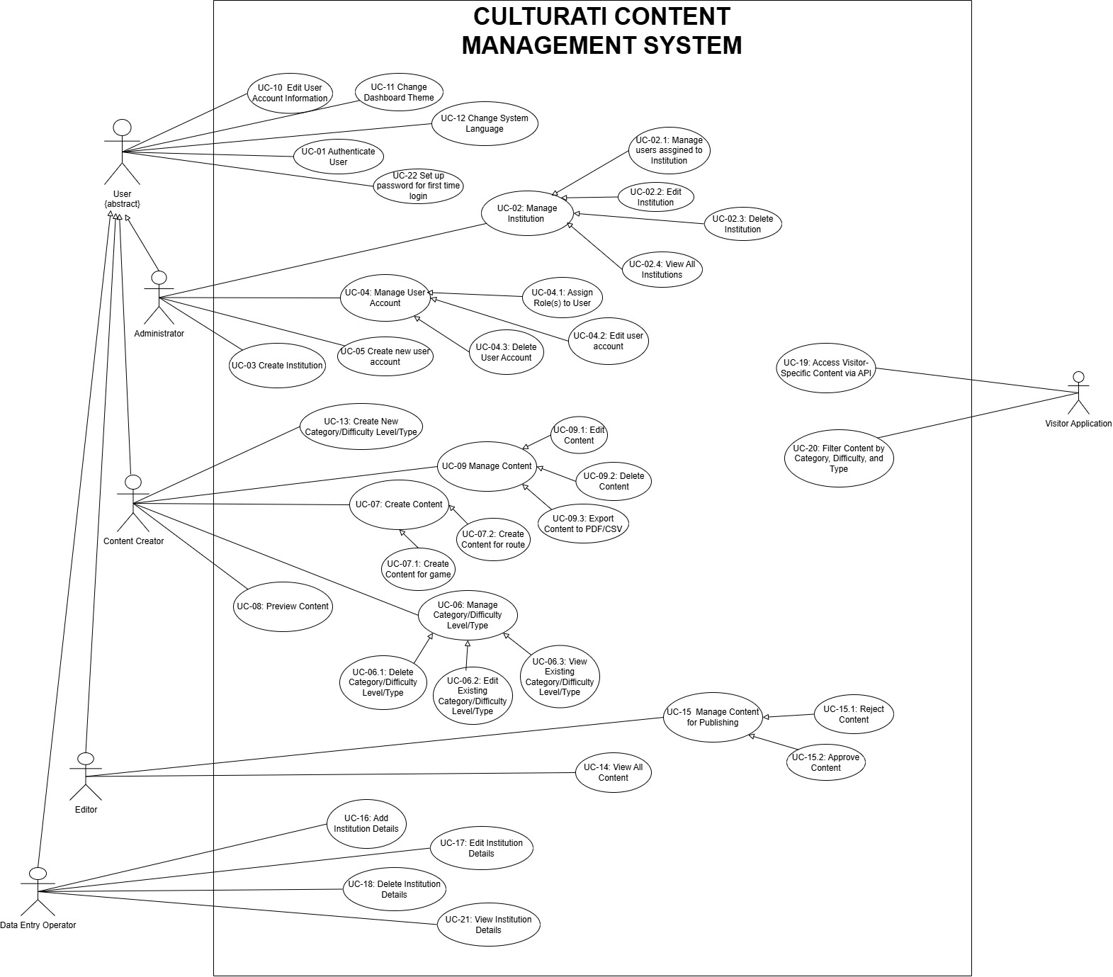
Use Case Diagram

Figure 1. Use Case Diagram for CULTURATI

Table 1. Cross Referencing Functional Requirements to Use Cases
Functional Requirement ID | Use Case ID | Initial Plan Functional Requirement ID [1]
FR-01 | UC-01 | FR-01
FR-03 | UC-02
FR-03.2 | UC-02.1
FR-03.3 | UC-02.2
FR-03.4,FR-03.4 | UC-02.3
FR-03.3 | UC-02.4
FR-03.1 | UC-03
FR-02.2 | UC-04 | FR-05.1
FR-02.3 | UC-04.1
FR-02.2 | UC-04.2
FR-02.2 | UC-04.3
FR-02.1 | UC-05
FR-06 | UC-06
FR-06.3 | UC-06.1
FR-06.3 | UC-06.2
FR-06.3 | UC-06.3
FR-05 | UC-07
FR-05.3.a | UC-07.1
FR-05.3.b | UC-07.2
FR-05.4.a | UC-08
FR-07 | UC-09 | FR-02
FR-07.3 | UC-09.1
FR-07.4 | UC-09.2
FR-7.5 | UC-09.3
FR-11.1 | UC-10
FR-11.2 | UC-11
FR-11.3 | UC-12
FR-06.1 | UC-13
FR-08.2 | UC-14
FR-08.3 | UC-15 | FR-05.2
FR-08.3.b | UC-15.1 | FR-05.2
FR-08.3.a | UC-15.2 | FR-05.2
FR-09.1,FR-09.2 | UC-16
FR-09.5.a | UC-17
FR-09.5.b | UC-18
FR-10 | UC-19
FR-10.3 | UC-20 | FR-03
FR-09.5 | UC-21
FR-04 | UC-22

System Model
The use cases that have been selected for system model diagrams are:
- Manage Content

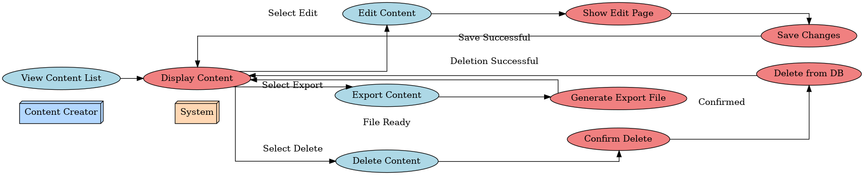
Figure 2. Sequnce Diagram for Manage Content


Figure 3. Activity Diagram for Manage Content
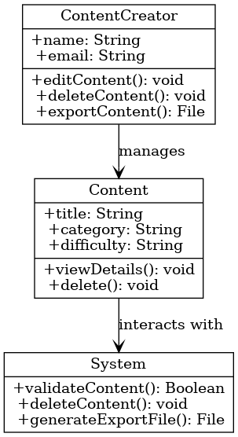
Figure 4. Class Diagram for Manage Content
- Create Content

Figure 5. Sequnce Diagram for Create Content

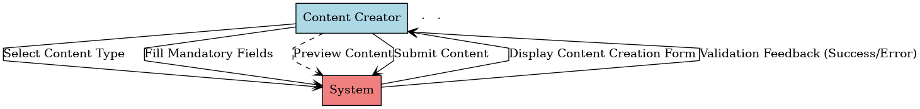
Figure 6. Activity Diagram for Create Content
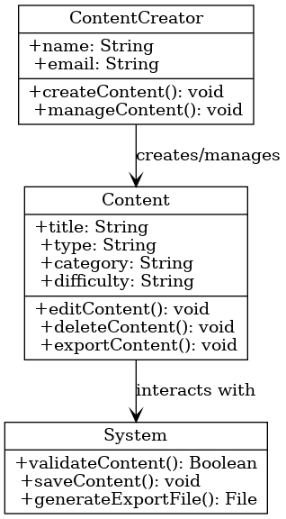
Figure 7. Class diagram for Create Content

Requirements Prototypes
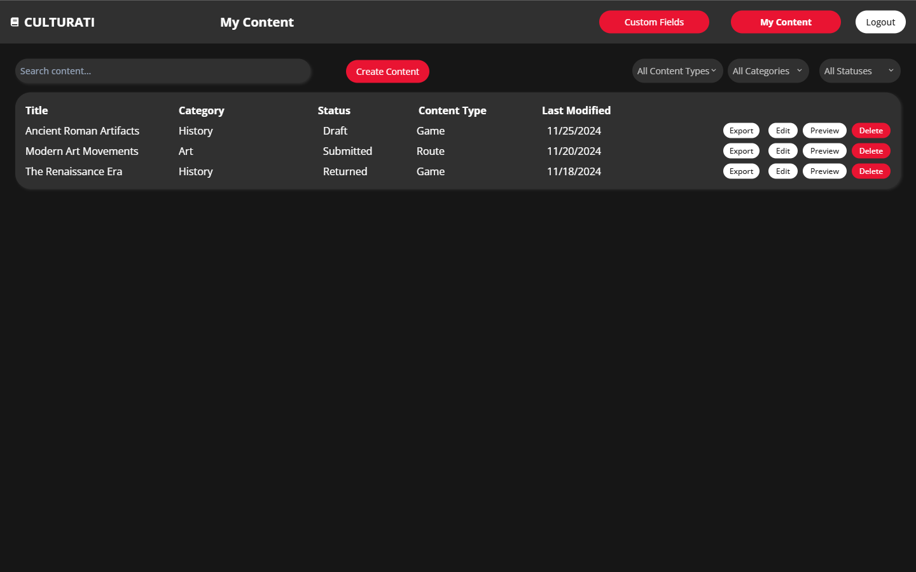
Figure 8. My content dashboard in Culturati

The Manage Content Dashboard is designed for content creators to view, manage, and organize their created content. Below is a breakdown of its features:
- Header Bar:
Navigation Options:
    - Custom Fields: A button to manage categories, difficulty levels, or types of content.
    - My Content: The current active page, highlighted to show the user’s focus on managing existing content.
    - Logout: Allows the user to securely exit the application.
- Search Bar:
  - A search input field at the top of the dashboard for quickly locating specific content by title or keyword.
- Filters:
  - Category Filter: Dropdown menu to filter content by categories (e.g., History, Art, Science).
  - Status Filter: Dropdown menu to filter content by status (e.g., Draft, Submitted, Returned).
  - Content Type filter: Dropdown menu to filter content by their types (e.g. Game, Route)
- Content List Table:
  - Displays a summary of all content created by the user in a tabular format with the following columns:
    - Title: Name of the content (e.g., "Ancient Roman Artifacts").
    - Category: Content's assigned category (e.g., History, Art).
    - Status: Indicates the current status of the content:
      - Draft: Content is incomplete and yet to be submitted.
      - Submitted: Content has been finalized and sent for approval.
      - Returned: Content was reviewed and returned with comments for revisions.
    - Content Type: Specifies whether the content is a "Game" or "Route."
    - Last Modified: The most recent date the content was edited.
- Action Buttons:
  - For each content item, there are three action buttons:
    - Edit: Opens the content creation form to modify the selected content.
    - Preview: Displays the content as it would appear to visitors.
    - Delete: Permanently removes the content after a confirmation prompt.
    - Export: Enables user to export the content as CSV or PDF file.
  - Create Content: Redirects to the content creation form.

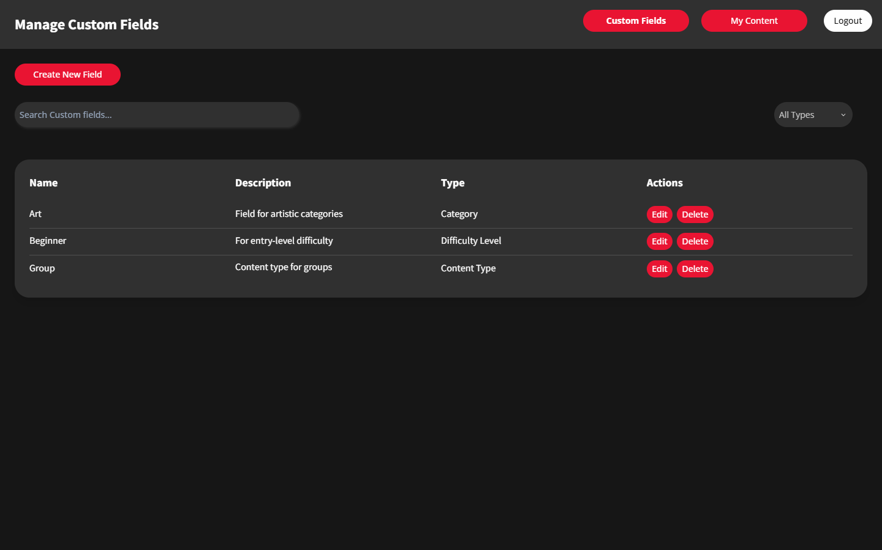
Figure 9. Manage Custom Fields dashboard in Culturati
The Manage Custom Fields Dashboard allows content creators to create, view, and manage custom fields such as categories, difficulty levels, and content types for their content creation process. Below is a breakdown of the features:

Header Bar
- Title: "Manage Custom Fields" is prominently displayed to indicate the purpose of the interface.
- Navigation Options:
  - Custom Fields: Highlights that the user is currently on the Custom Fields management screen.
  - My Content: Redirects the user to their existing content list.
  - Logout: Allows the user to securely exit the application.

Button for Creating Custom Fields
- Create New Field: Redirects to a form where users can define a new field.

Search Bar
- Search Custom Fields: Allows users to search for specific custom fields by name or description.

Custom Fields Table
The table displays a list of all custom fields created by the content creator, with the following columns:
- Name: The name of the custom field (e.g., Art, Beginner, Tutorial).
- Description: A short description of the custom field's purpose (e.g., "Field for artistic categories").
- Type: Specifies the type of field:
  - Category: Organizes content by themes or topics.
  - Difficulty Level: Defines the complexity level of content.
  - Content Type: Specifies the content type. (Individual, Family etc. ).
- Actions:
  - Edit: Opens a form to modify the custom field's details.
  - Delete: Removes the custom field after a confirmation prompt.

Filters
- Type Filter: A dropdown menu labeled "All Types" allows users to filter custom fields by type (e.g., Category, Difficulty Level, and Content Type).

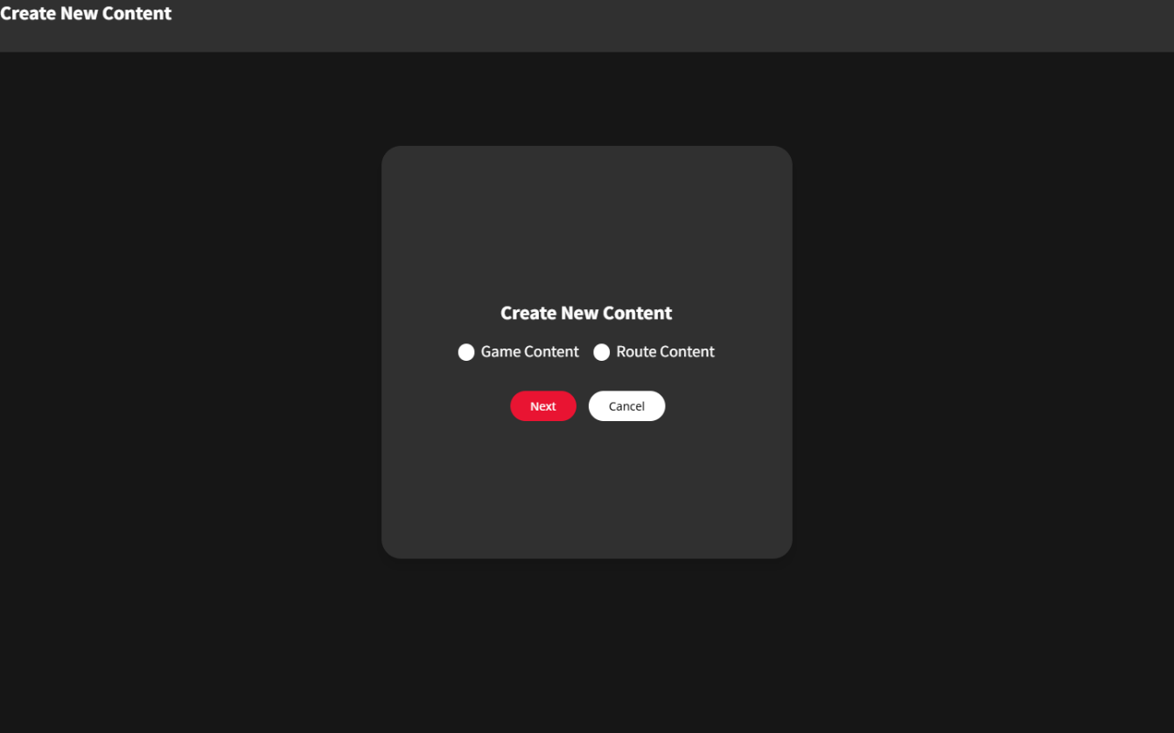
Figure 10. Prompt that asks for which type of content will be created

This prompt appears after clicking the Create New Content button in the My content dashboard. It will ask for 2 types of content which are Game and Route. After selecting either one of them then pressing the next button the page will redirect to the selected content creation page.
If cancel is clicked the user will be redirected to my content dashboard.

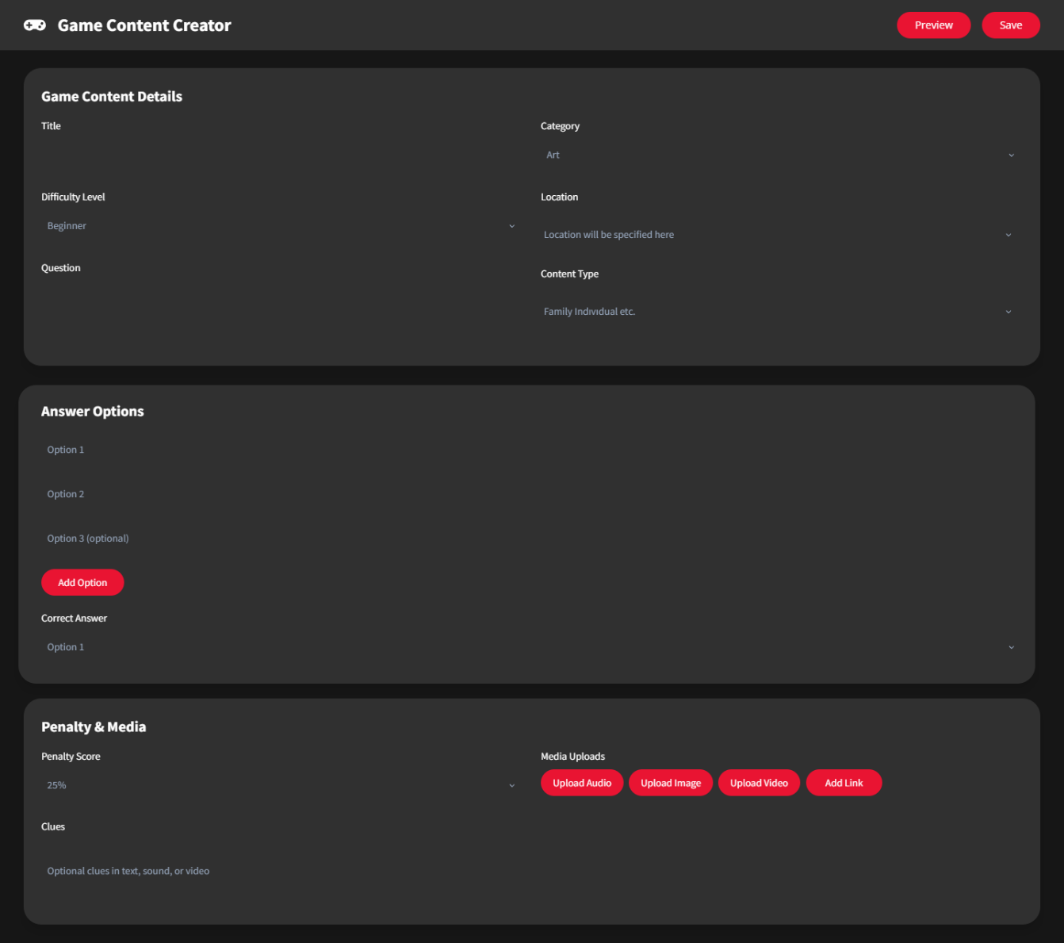
Figure 11. Game content creation page

The Game Content Creator Page is designed for content creators to input details and define all elements necessary to create an interactive game for the CULTURATI platform. Below is a breakdown of the features:

Header
- Title: "Game Content Creator" clearly indicates the purpose of the page.
- Action Buttons:
  - Preview: Allows the content creator to see how the game will appear to users before saving.
  - Save: Saves the content and validates all required fields.

Sections

1. Game Content Details
- Title: Input field for the game’s title.
- Category: Dropdown menu to select a category (e.g., Art, History).
- Difficulty Level: Dropdown menu to select the game’s difficulty level (e.g., Beginner, Intermediate, Advanced).
- Location: Input field to specify the location related to the game content (e.g., a museum room or area).
- Question: Text input field for the game’s question (mandatory).
- Content Type: Displays the type of content (e.g., Family, Individual).

2. Answer Options
- Option Fields: Fields for the creator to enter multiple-choice answers:
  - At least two options are required, with additional fields for optional answers.
- Add Option: A button to add more answer fields as needed.
- Correct Answer: Dropdown menu to select the correct answer from the provided options.

3. Penalty & Media
- Penalty Score: Dropdown menu to assign penalty values for incorrect answers (e.g., 25%, 50%, 70%).
- Clues: Optional fields to provide additional hints for the game in text, sound, or video format.
- Media Uploads:
  - Upload Audio: Button to upload an audio file for the game.
  - Upload Image: Button to upload an image relevant to the question or content.
  - Upload Video: Button to upload a video clip.
  - Add Link: Button to add an external link to additional resources

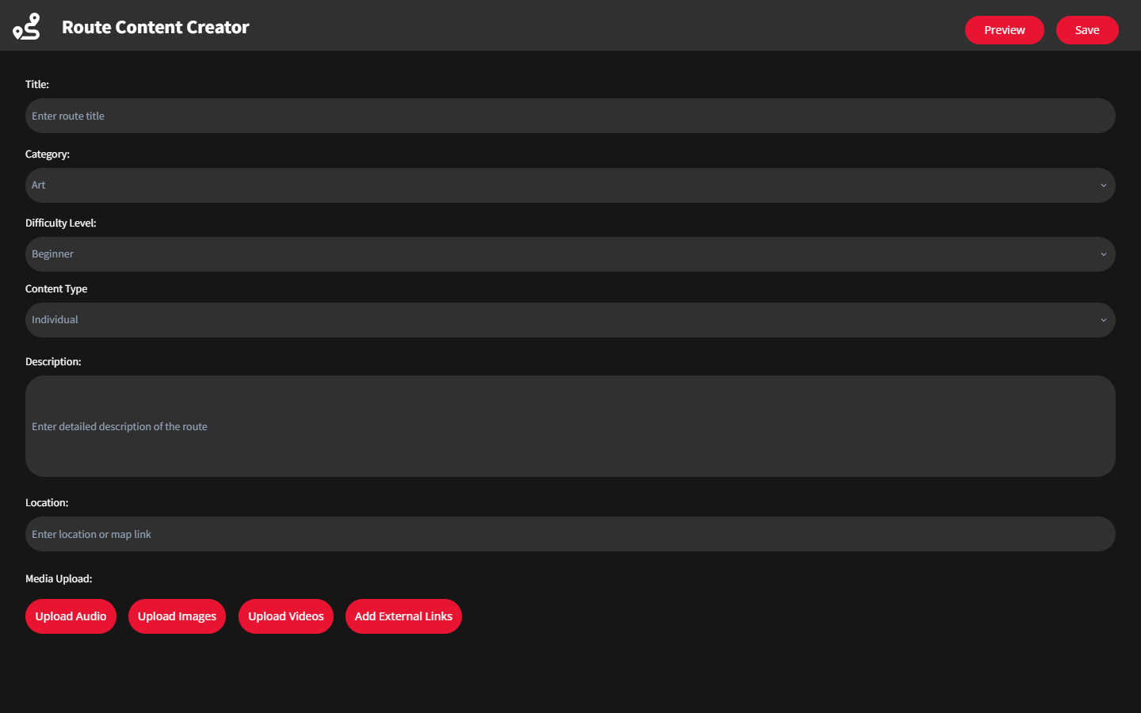
Figure 12. Route content creation page
The Route Content Creator Page is designed for content creators to input details and define all elements necessary to create educational or cultural route content for the CULTURATI platform. Below is a breakdown of its features:

Header
- Title: "Route Content Creator" displayed prominently at the top, indicating the purpose of the interface.
- Action Buttons:
  - Preview: Allows the content creator to see how the route will appear to users before saving.
  - Save: Saves the route content and validates all required fields.

Fields for Input

1. Title
- Text input field for the route title (e.g., "Renaissance Walk").
- Placeholder text: "Enter route title."

2. Category
- Dropdown menu to select a category for the route (e.g., Art, History, Nature).

3. Difficulty Level
- Dropdown menu to select the difficulty level of the route (e.g., Beginner, Intermediate, Advanced).

4. Content Type
- Dropdown menu to specify the content type (e.g., Individual, Group, Family).

5. Description
- A large text area for entering a detailed description of the route.
- Placeholder text: "Enter detailed description of the route."

6. Location
- Text input field for specifying the route location or adding a map link.
- Placeholder text: "Enter location or map link."

7. Media Upload
- Upload Buttons:
  - Upload Audio: Allows users to upload audio files related to the route.
  - Upload Images: Allows users to upload relevant images.
  - Upload Videos: Allows users to upload video content for the route.
  - Add External Links: Allows users to provide external resources or related information via hyperlinks.
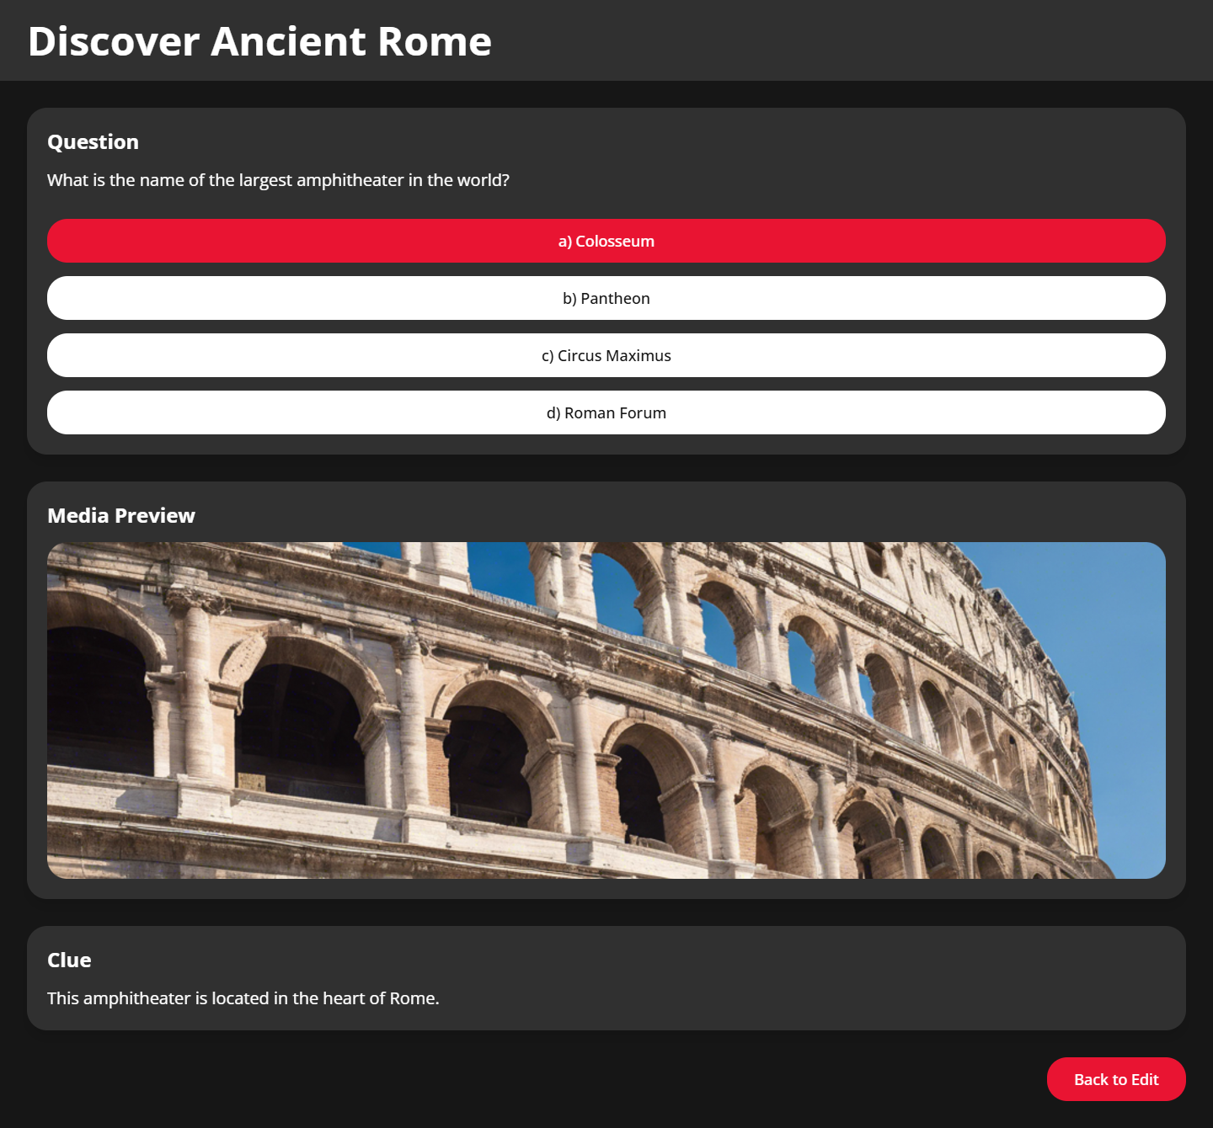
Figure 13. Preview page for Game content

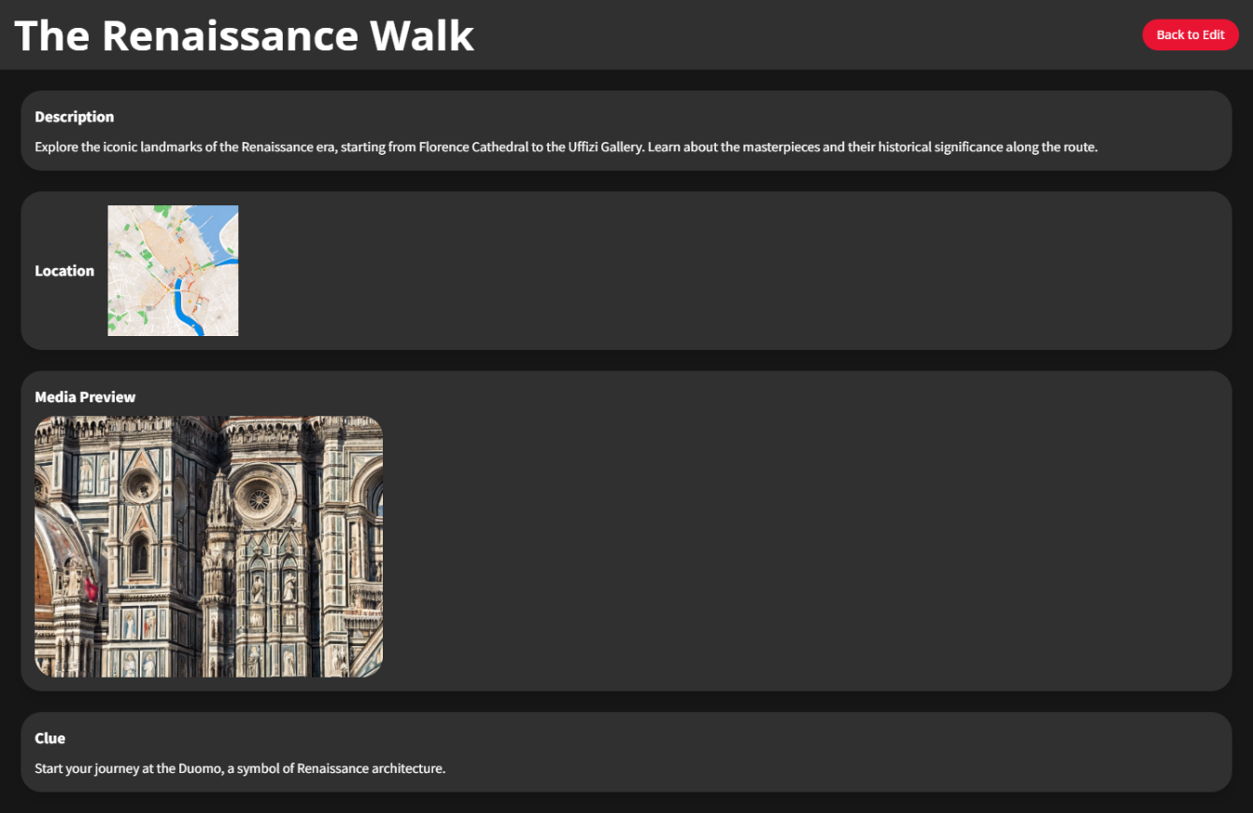
Figure 14. Preview page for Route content
The Preview Screens allow content creators to visualize how their content will appear to visitors before finalizing and submitting it. Both previews are tailored to ensure user-facing clarity and engagement, displaying content in an intuitive and user-friendly format.

Game Content Preview
- Title:
  - Displays the game title prominently at the top (e.g., "Discover Ancient Rome").
- Question Section:
  - Presents the question as it will appear to users (e.g., "What is the name of the largest amphitheater in the world?").
  - Displays multiple-choice answer options:
    - The correct answer is highlighted in red (e.g., "a) Colosseum").
    - Other options are shown in white, indicating available choices.
- Media Preview:
  - Displays a visual media element (e.g., an image of the Colosseum) to enhance the context of the question.
- Clue:
  - Includes a textual hint or clue to aid users in answering the question (e.g., "This amphitheater is located in the heart of Rome.").
- Back to Edit Button:
  - Redirects the creator back to the game creation form for adjustments.

Route Content Preview
- Title:
  - Displays the route title prominently at the top (e.g., "The Renaissance Walk").
- Description:
  - A detailed textual description of the route is provided (e.g., "Explore the iconic landmarks of the Renaissance era, starting from Florence Cathedral to the Uffizi Gallery.").
- Location:
  - Displays the route's location, either as a text field or a visual map (e.g., a map of Florence).
- Media Preview:
  - Includes a visual media element, such as an image of a key landmark (e.g., Florence Cathedral), to provide a preview of what users will encounter on the route.
- Clue:
  - A textual hint to guide users along the route or provide additional context (e.g., "Start your journey at the Duomo, a symbol of Renaissance architecture.").
- Back to Edit Button:
  - Redirects the creator back to the route creation form for modifications.

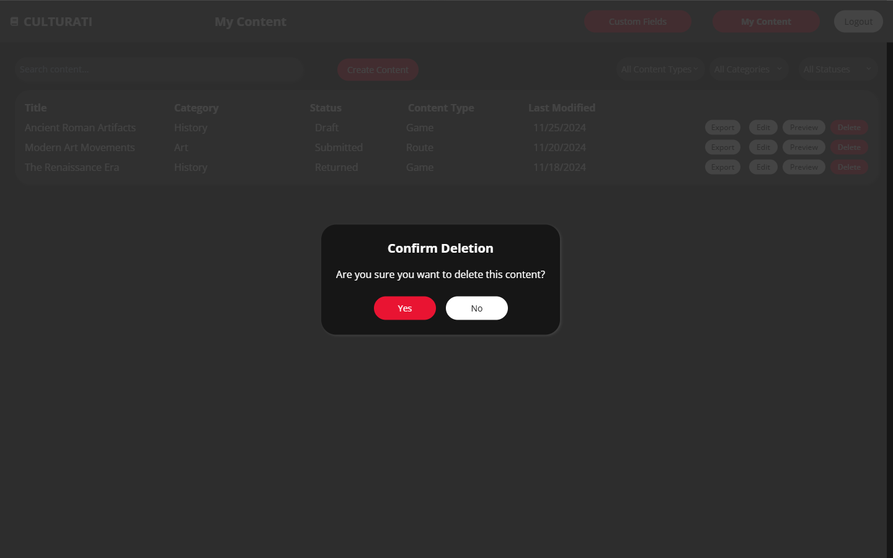
Figure 15. Delete confirmation prompt for contents
The Delete Confirmation Dialog is a pop-up interface designed to ensure that users intentionally delete content by confirming their action. This prevents accidental deletion of important content. Below is a detailed breakdown:
- Dialog Header:
  - Text: "Confirm Deletion" prominently displayed to indicate the purpose of the dialog.
  - The header clearly communicates the importance of the action being taken.
- Confirmation Message:
  - Text: "Are you sure you want to delete this content?"
  - Provides clarity to the user about what the action entails.
- Action Buttons:
  - Yes (Red Button): Confirms the deletion of the selected content.
    - If clicked, the system will remove the content permanently (based on prior implementation).
  - No (White Button): Cancels the deletion process and closes the dialog.
    - This ensures the user can safely back out without making unwanted changes.
- Darkened Background:
  - The background of the main interface is dimmed to focus the user’s attention on the confirmation dialog, enhancing usability and avoiding distraction.

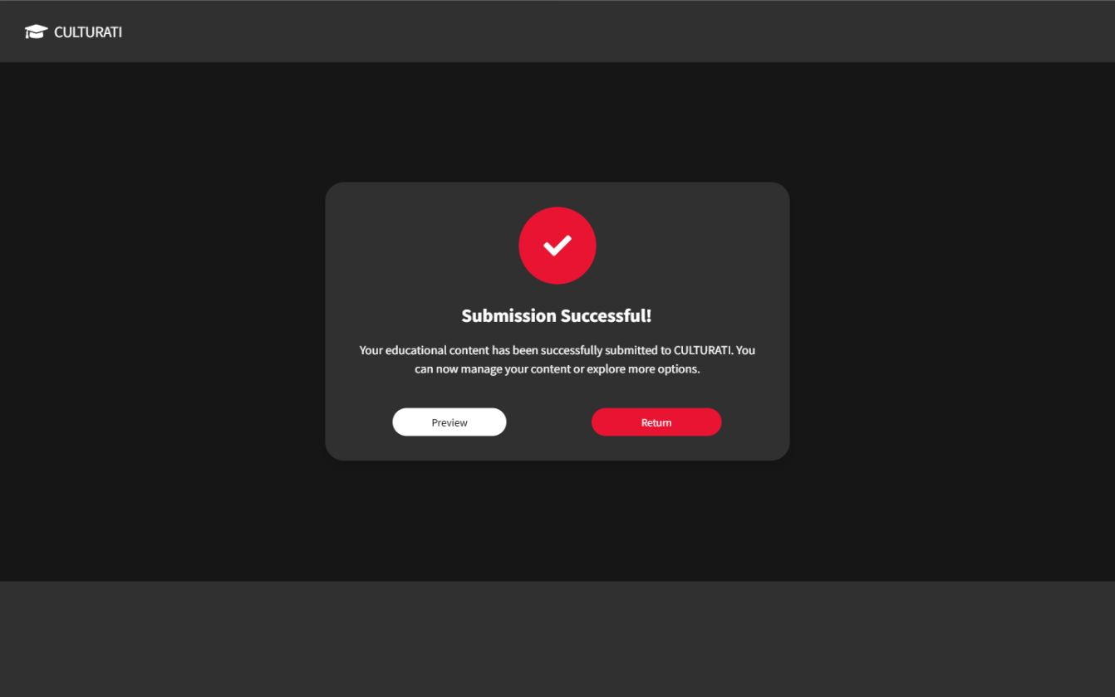
Figure 16. Submission successful screen

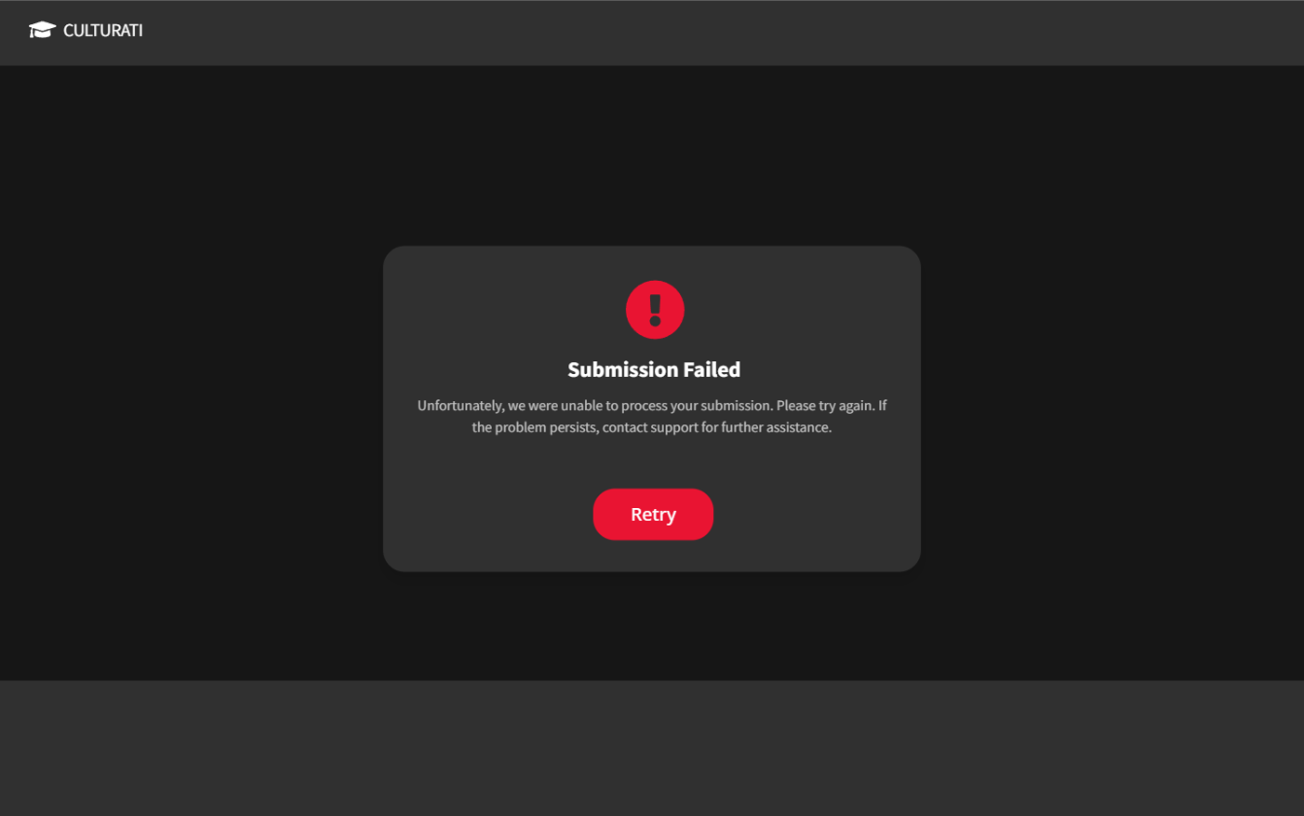
Figure 17. Submission failed screen

Submission Failed Screen
This screen is displayed when the content submission process encounters an issue and cannot be completed successfully. It provides clear feedback to the user and guides them on the next steps.
- Header:
  - "Submission Failed" is prominently displayed to immediately inform the user of the outcome.
  - An icon with an exclamation mark emphasizes the error visually.
- Message:
  - Detailed error message: "Unfortunately, we were unable to process your submission. Please try again. If the problem persists, contact support for further assistance."
  - Provides clarity and suggests an actionable next step in case of repeated failures.
- Action Button:
  - Retry (Red Button): Allows the user to attempt the submission process again.

Purpose
- To notify the user about the failed submission process.
- To provide a retry option, preventing the user from starting over entirely.

Submission Successful Screen
This screen confirms that the content has been successfully submitted to the CULTURATI platform. It provides the user with options for next steps.
- Header:
  - "Submission Successful!" is prominently displayed to celebrate the success of the action.
  - A checkmark icon visually reinforces the positive outcome.
- Message:
  - Confirmation message: "Your educational content has been successfully submitted to CULTURATI. You can now manage your content or explore more options."
  - Offers users reassurance that their action was completed as expected.
- Action Buttons:
  - Preview (White Button): Allows the user to view the submitted content as it will appear to visitors.
  - Return (Red Button): Redirects user to my content dashboard.

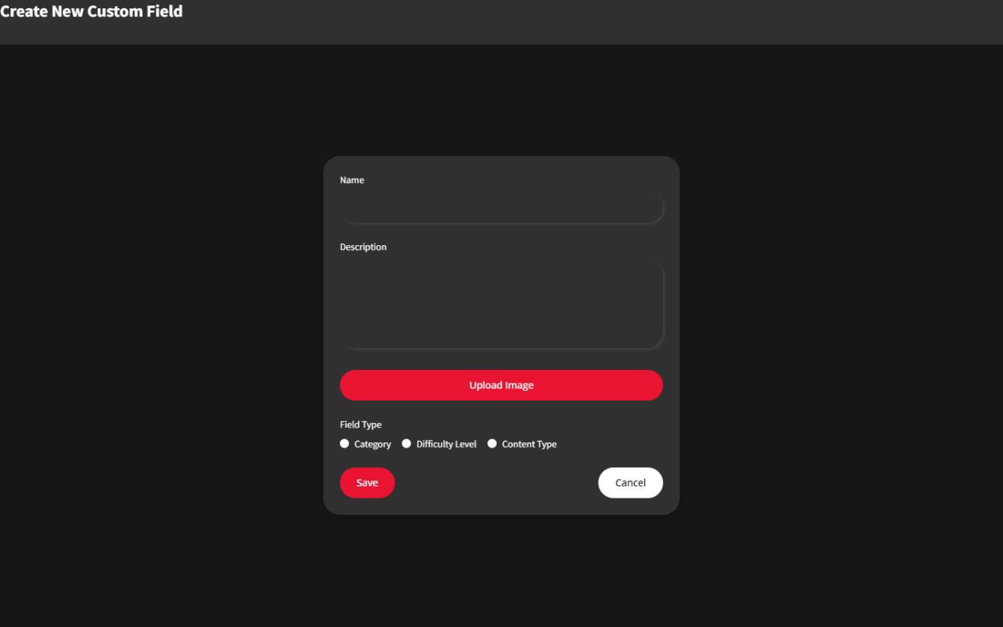
Figure 18. Custom field creation screen
This interface allows content creators to define new custom fields for use in content creation. These fields can include categories, difficulty levels, or content types. Below is a detailed breakdown of the features:

Header
- Title: "Create New Custom Field" is displayed prominently at the top to indicate the purpose of the page.

Fields for Input
- Name:
  - Text input field for the name of the custom field (e.g., "Art" for Category, "Beginner" for Difficulty Level).
  - Placeholder text ensures clarity about what to enter.
- Description:
  - A text area for entering a brief description of the custom field’s purpose or details (e.g., "Field for artistic categories").
- Upload Image:
  - A red button to upload an image representing the custom field. This image can help provide a visual cue when selecting the field in other parts of the platform.

Field Type Selection
- Radio Buttons:
  - Category: Allows the user to define a new category (e.g., Art, History).
  - Difficulty Level: Enables the creation of a new difficulty level (e.g., Beginner, Advanced).
  - Content Type: Facilitates the definition of a new content type (e.g., Group, Individual).

Action Buttons
- Save (Red Button):
  - Validates all inputs and saves the new custom field to the system.
- Cancel (White Button):
  - Cancels the action and returns to the previous screen without saving changes.

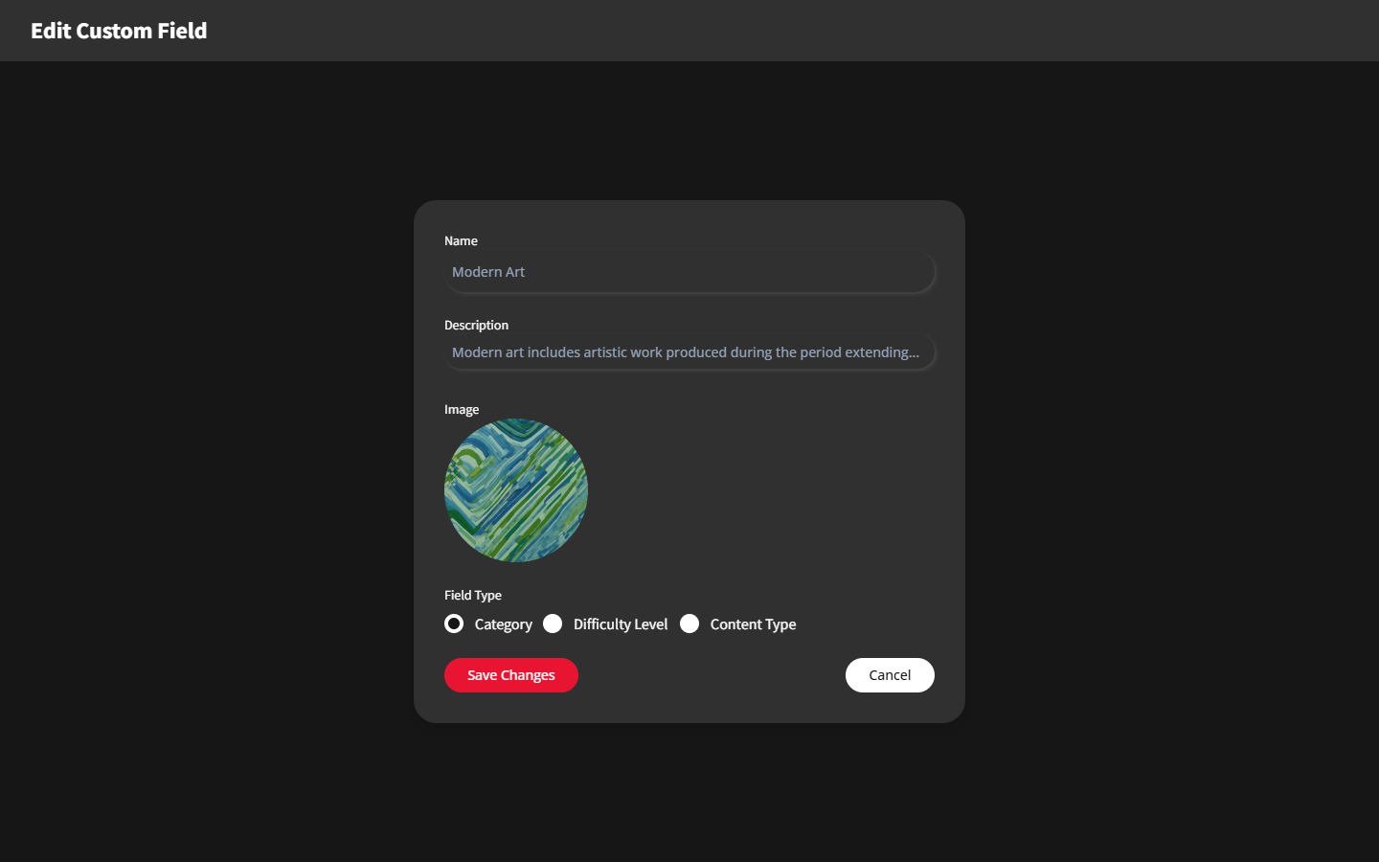
Figure 19. Custom field editing screen
The Edit Custom Field Interface is designed for content creators to modify existing custom fields, such as categories, difficulty levels, or content types. It provides a user-friendly form with pre-filled values to make updates easily and efficiently.

Header
- Title: "Edit Custom Field" prominently displayed at the top, indicating the purpose of the page.

Fields for Input
- Name:
  - A text input field pre-filled with the current name of the custom field (e.g., "Modern Art").
  - The user can edit the name to update it.
- Description:
  - A text area pre-filled with the current description of the custom field (e.g., "Modern art includes artistic work produced during the period extending...").
  - Allows the user to modify or refine the description for better clarity or accuracy.
- Image:
  - Displays the currently uploaded image representing the custom field (e.g., an abstract image for "Modern Art").
  - The user can replace the image if necessary (though the specific replace functionality is not shown here).

Field Type Selection
- Radio Buttons:
  - Shows the current type of the field (e.g., "Category" is selected for this example).
  - Allows the user to switch the field type to another option, such as "Difficulty Level" or "Content Type," if required.

Action Buttons
- Save Changes (Red Button):
  - Validates the updated inputs and saves the changes made to the custom field.
- Cancel (White Button):
  - Discards any changes and returns to the previous screen without updating the field.

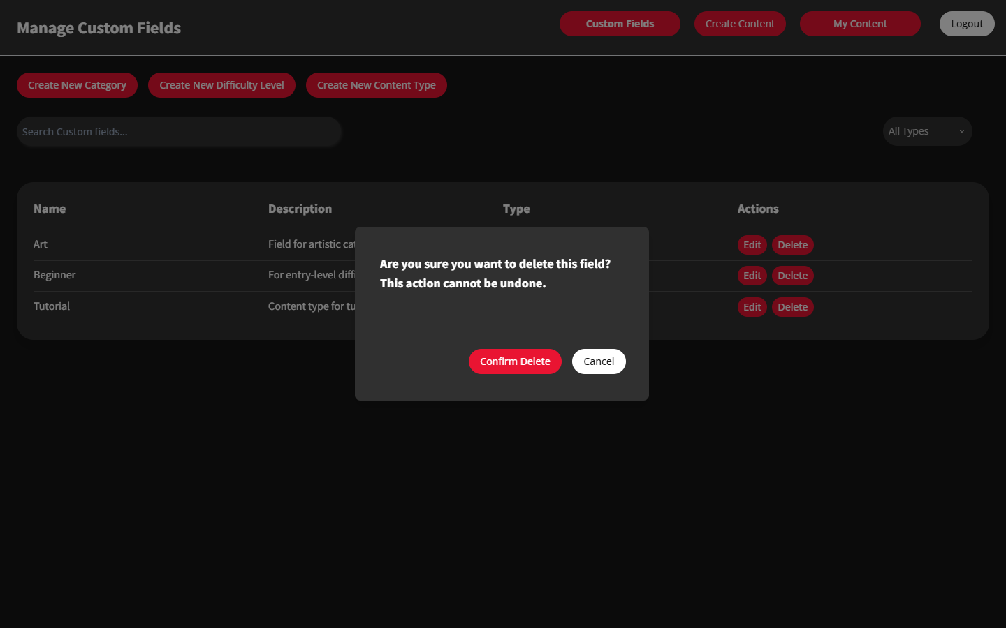
Figure 20. Field Deletion Without Associations

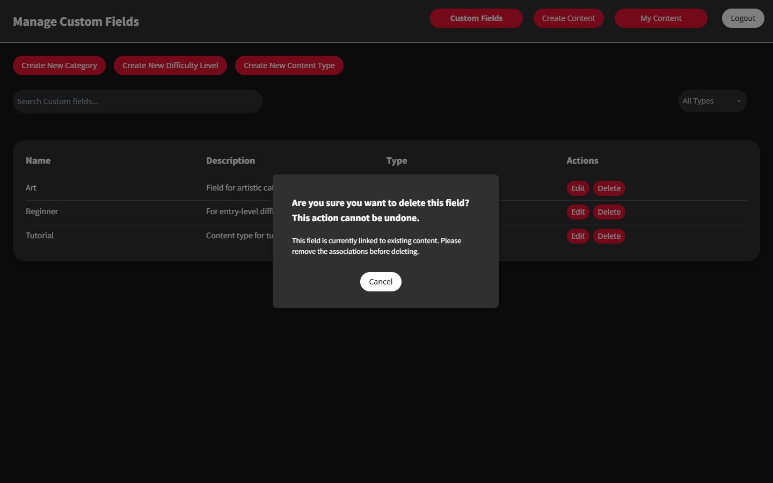
Figure 21. Field Deletion with Associations

First Screen: Field Deletion without Associations

Description
This screen is displayed when a user attempts to delete a custom field (e.g., category, difficulty level, or content type) that is not associated with any existing content. The system allows the deletion without any restrictions.

Features
- Message:
  - The dialog asks for confirmation: "Are you sure you want to delete this field? This action cannot be undone."
  - The message is clear and emphasizes the irreversibility of the action.
- Action Buttons:
  - Confirm Delete (Red Button): Deletes the field permanently.
  - Cancel (White Button): Cancels the action and closes the dialog without deleting the field.

Purpose
- To ensure the user explicitly confirms the deletion of the field.
- To prevent accidental deletions while allowing fields with no associations to be deleted safely.

Second Screen: Field Deletion with Integrity Constraints

Description
This screen is displayed when a user attempts to delete a custom field that is associated with existing content. The system blocks the deletion and provides a warning message.

Features
- Message:
  - The dialog informs the user: "This field is currently linked to existing content. Please remove the associations before deleting."
  - This message ensures that the user understands the reason why the deletion cannot proceed.
- Action Buttons:
  - Cancel (White Button): Closes the dialog, allowing the user to take corrective actions (e.g., editing or reassigning the field).

Purpose
- To maintain data integrity by preventing the deletion of fields that are actively being used by content.
- To guide the user to first dissociate or update the field in question before attempting to delete it.

Non-functional Requirements

Usability requirements
- The system's interface must be user-friendly, allowing an average user to complete key tasks within 2 minutes without prior training.
- The admin panel must provide tooltips and concise error messages to guide users effectively.

Performance requirements
- The system must retrieve and display content from the content management system (CMS) within 3 seconds under average load conditions.
- The import process for bulk content transfer (1000+ records per side) must complete within 10 minutes for a standard dataset.
- The system should support up to 50 simultaneous users without a noticeable performance degradation.

Software system attributes
  - Reliability: The system must provide a 95% uptime, excluding scheduled maintenance.
  - Availability: The system must recover from failures (e.g., server crashes) within 1 hour to ensure consistent availability.
  - Security:
- All sensitive data (e.g., user credentials) must be encrypted using AES-256.
- User roles (admin/visitor) must have strictly defined access control to prevent unauthorized actions.
  - Maintainability:
- The system should use modular code and follow standard coding conventions to facilitate updates and bug fixes.
- Documentation must be provided for all key modules, ensuring easy onboarding for new developers.
  - Portability: The system must support deployment on any operating system with Node.js and PostgreSQL installed.

Constraints
- The system must comply with GDPR regulations to ensure data privacy and protection for users in Europe.
- The project must be developed using React for the frontend and TypeScript for maintainable code, as required by project guidelines.
- The database must be compatible with PostgreSQL, as mandated by the infrastructure requirements.

Error Handling Requirements
User Errors:
- If a user inputs incorrect data (e.g., invalid dates), the system must display a clear error message and allow re-entry.
- Invalid data imported into the system must be logged with details of the error and skipped during processing.
System Errors:
- If a system process fails (e.g., server timeout), the application must log the error and notify the admin via email or system alert.
- For minor bugs (e.g., non-critical function failures), the system should log and continue operation without crashing.

Other Non-Functional Requirements
- Data Import/Export:
- The system must support batch import/export functionality for content (e.g., transferring 1000+ records) in formats such as CSV or JSON.
- Import processes must validate data integrity and notify users of any invalid records.
Scalability: The system must be able to scale to support 200 simultaneous users with minimal infrastructure upgrades.

Logical Database Requirements
- Types of Information Used by Various Functions
- User Information: The database stores information for user accounts, which include roles such as Administrator, Content Creator, Editor, and Data Entry Operator. Each user role has unique attributes:
- Administrators: Have an AdminLevel attribute that defines permissions and access to system functions, such as managing users and institutions.
- Content Creators: Feature attributes such as ExpertiseArea and ReviewExperience, which help categorize their proficiency in specific topics.
- Editors: Focus on reviewing and approving cultural content for quality and compliance.
- Data Entry Operators: Responsible for inputting and updating institution related metadata with efficiency and accuracy.
- Cultural Content Data:
- Games: Each game is characterized by its Title, Description, Category, DifficultyLevel, Clue, and PenaltyScore. Games are linked to cultural content and institutions to ensure each game is built upon a type of content followed by its relevant location in the facility which furthers into provided routes.
- Routes: Routes consist of Stops (linked to specific locations which also is linked with routes for the games then), Difficulty, and EstimatedTime. These attributes allow customization and organization for institutional needs.
- Multimedia Content: Includes videos, images, and documents linked to specific content items, enhancing the richness and relevance of cultural data. Attributes like Category, Tags, and RelatedMedia are crucial for organizing content.
- Location Data: Captures the attributes of physical locations such as Name, Capacity, Facilities, and CurrentOccupancy. Locations are associated with institutions and routes. IoT integration will allow monitoring real-time occupancy and managing capacity effectively.
- Content Management Data: Metadata supports the organization and categorization of cultural content. Fields like ContentType, Level, and Tags enable systematic curation and effective review processes by Editors and Content Creators.

- Frequency of Use
  - Real-Time Location Data: Frequently updated, especially during peak hours, to dynamically manage visitor flow and prevent overcrowding.
  - Content Access and Updates: Accessed by Content Creators, Editors, and Data Entry Operators during content creation, institution information entry and updates. Editors perform quality checks and revisions. Data Entry Operators input institution credentials metadata and updated routes/location map for the institution.
  - User Account Access: Accessed upon user login for role-based tasks. Updates are infrequent, typically occurring during account modifications or role changes. Administrator provides credentials to user based on their assigned role (i.e., content creator, editor, data entry operator).
- Accessing Capabilities
  - Administrator:
- Role and Privileges:
- As a standalone entity, the Administrator assigns roles to the User entity (Editor, Content Creator, Data Entry Operator).
- Manages relationships between users, institutions, and content.
- Has full control over system entities like Content, Game, Route, Location, and Institution.
- Institution Management:
- Can assign ManagedInstitutions to users, ensuring that only specific users manage designated institutions.
- Oversees institutional attributes such as InstitutionType, Location, and Capacity.
- Content Assignment:
- Supervises content creation and editing by assigning tasks to Editors and Content Creators based on their expertise areas (ExpertiseArea).
  - User Accounts:
- Editor:
- Reviews, edits, and approves content created by Content Creators.
- Access to attributes like DifficultyLevel, Tags, and Category to validate content relevance.
- Does not manage real-time data like CurrentOccupancy or institutional details.
- Content Creator:
- Creates Games and Routes under the supervision of Editors and Administrators.
- Can define attributes like Tags, Level, EstimatedCompletionTime, and Stops for routes.
- Data Entry Operator:
- Focused on inputting real-time data for Locations, such as Capacity, Facilities, and CurrentOccupancy.
- Maintains operational accuracy without access to higher-level content or user data.
  - Location and Institution Management:
- Administrators assign specific Locations or Institutions to Data Entry Operators and Editors to ensure clear operational responsibilities.
- Data Entry Operators update real-time Location data (CurrentOccupancy, GeoLocationCoordinates), enabling dynamic resource allocation.
  - Content Management:
- Content Creators are restricted to creating content, while Editors and Administrators oversee quality assurance and compliance.
- Content updates are systematically logged to maintain accountability.

- Data Entities and Relationships
  - Administrator (Entity):
- Attributes:
- AdminID: A unique identifier for each Administrator.
- AdminLevel: Specifies the hierarchy level, which dictates their scope of authority (e.g., global or institutional-level access).

- Relationships:
Assigns:
- Connects the Administrator to the User entity by assigning roles (Editor, Content Creator, Data Entry Operator).
- Ensures proper role distribution and accountability within the system.
- Cardinality: One Administrator can assign roles to multiple Users, but each User role is assigned by one Administrator.

  - User (Entity):
- Attributes:
- UserID: A unique identifier for each user.
- UserName: The user's account name for login purposes.
- Password: Encrypted credentials for secure access.
- RoleType: Specifies the user's role (Editor, Content Creator, or Data Entry Operator).
- PhoneNumber, RegistrationDate, AccountAge, LastLogin: Additional metadata for user management.
- Sub-Entities/Role Relationships:
Editor:
- Focuses on reviewing, editing, and approving content.
- Linked to Content through the Creates and ReviewExperience attributes.
- Content Creator:
- Generates new Content, including Games and Routes, based on ExpertiseArea.
- Assigned tasks by the Administrator based on institutional needs.

- Data Entry Operator:
- Updates real-time data for Location, including CurrentOccupancy and Facilities.
- Relationships:
- ManagedInstitutions: Upon registration by the Administration links Users (Editors and Data Entry Operators) to specific Institutions, Content Creator to Content, ensuring task allocation remains institution-specific.

  - Institution (Entity):
- Attributes:
- InstitutionID: A unique identifier for each institution.
- Name: Institution name (e.g., museum, cultural center).
- InstitutionType: Specifies the type (e.g., gallery, historical site).
- Relationships:
- Includes: Connects the Institution to one or more Locations, indicating multiple locations present within the institution.
- ManagedInstitutions: Links institutions to Data Entry Operator for operational management.
  - Location (Entity):
- Attributes:
- LocationID: A unique identifier for each location.
- Name: The name of the physical or virtual site.
- GeoLocationCoordinates: The geographical latitude and longitude of the location.
- Capacity: Maximum allowable visitors.
- CurrentOccupancy: Real-time visitor count, updated by Data Entry Operators.
- Facilities and Description: Details about amenities and location-specific features.
- Relationships:
- Located At: Connects Location to one or more games, allowing variety of games to be played at a single location. Furthermore, connects Location to Routes for tailored routes as per player’s need.
  - Content (Entity)
- Attributes:
- ContentID: A unique identifier for each content entry.
- Title: The name of the content piece (e.g., game, route).
- ContentType: Specifies whether it’s a Game or Route.
- Tags, Category, Level: Metadata for classification and curation.
- PopularityScore: Measures engagement with the content.
- Relationships:
- Creates: Links Content Creator (from the User entity) to new content entries.
Cardinality: A Content Creator can generate multiple Content items, but each content piece is attributed to a single creator.
- Belongs To Content: Sub-entities like Game and Route are connected to the main Content entity.
  - Game (Sub-Entity of Content)
- Attributes:
- GameID: Inherits ContentID but is uniquely identifiable within games.
- Title, Category, Description: Detailed descriptors of the game.
- DifficultyLevel: Indicates complexity, allowing tailored experiences.
- PenaltyScore: For game scoring systems.
- Clue: Hints or guidance associated with the game.
- Relationships: Part of the Content entity through the Belongs To Content relationship.
  - 7. Route (Sub-Entity of Content)
- Attributes:
- RouteID: Inherits ContentID but uniquely identifiable for routes.
- Stops: List of Locations included in the route.
- Difficulty: Indicates the ease of completing the route.
- EstimatedTime: Average time to complete the route.
- Relationships: Linked to the Location entity to define specific stops along the route and provide players with multiple filtered routes.

- Integrity Constraints
To ensure consistency and accuracy, the system enforces integrity constraints at multiple levels:
- Administrator Role Assignment:
- The Administrator entity assigns roles (Editor, Content Creator, Data Entry Operator) to the User entity through the Assigns relationship.
- Prevents duplicate or conflicting role assignments (e.g., a user cannot simultaneously act as both an Editor and Data Entry Operator).
- Role-Specific Permissions:
- The system enforces role-based access controls (RBAC). For example:
- Editors can modify metadata for content but cannot assign institutional responsibilities or update location details.
- Content Creators cannot access institutional or location data.
- Referential Integrity:
- Institutional Relationships:
- Every Institution must be linked to valid Locations through the Located At relationship.
- Prevents orphaned records where an institution lacks a location or vice versa.
- Content Relationships:
- Game and Route entities are tied to valid Content entries via ContentID.
- Deletion of a Content entry enforces cascading updates (e.g., deletion or reassignment of related games and routes).
- Data Validation Constraints:
- Content Validation:
- Titles for Games and Routes must be unique within their respective categories.
- EstimatedCompletionTime and DifficultyLevel values must adhere to predefined ranges.
- Location Validation:
- Capacity for a Location must always be greater than zero.
- CurrentOccupancy cannot exceed the Capacity.
- Relationship Cardinality Constraints:
Enforces the following:
- A Location can belong to only one Institution, but an Institution can have multiple Locations.
- A User can be assigned multiple roles, but only by an Administrator.
- Data Consistency:
- Real-time updates (e.g., CurrentOccupancy in Location) are restricted to Data Entry Operators to ensure accurate inputs.

- Data Retention Requirements
- Administrator and User Data:
- Administrator Information:
- Retained indefinitely to maintain a record of role assignments and system modifications.
- Attributes like AdminLevel are critical for maintaining system security and auditing.
- User Accounts:
- User account data, including roles and permissions, is retained for the duration of the account’s activity.
- Archived or anonymized after prolonged inactivity to comply with data protection regulations.
- Content Data:
- Content (Games, Routes) and associated metadata (Tags, Categories, Levels) are retained if they are relevant to active institutions or users.
- Content not accessed or updated for an extended period is archived for future reference or reactivation.
- Location Data:
- Real-time attributes like CurrentOccupancy are logged for operational analysis and retained for a limited duration (e.g., 6 months) to optimize storage.
- Static attributes like Capacity, Facilities, and GeoLocationCoordinates are retained indefinitely as they form the foundation for route and content curation.
- Institutional Data:
- Institutional records are stored for as long as the institution remains part of the system.
- Deactivated institutions are archived but maintain their relationships with locations and content for historical accuracy.
- Audit Trails:
- All modifications to critical entities (Content, Location, Institution, and User roles) are logged.
- These logs are retained for a fixed duration (e.g., 5 years) for compliance, troubleshooting, and performance analysis.
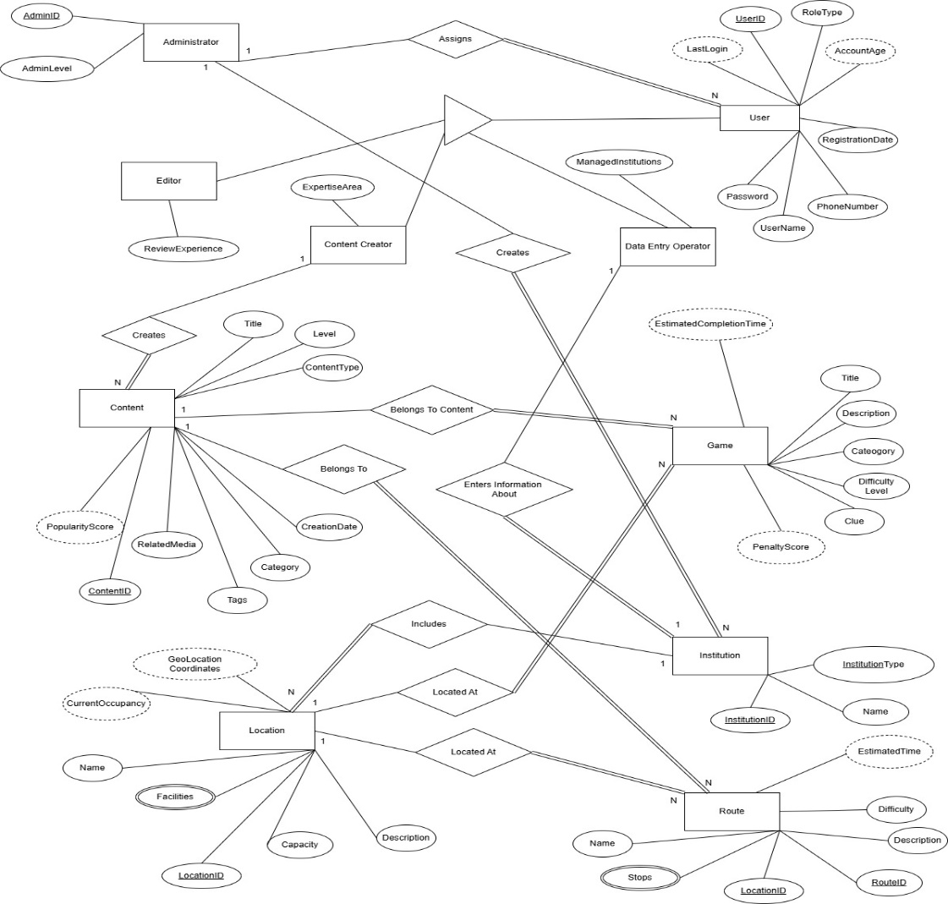
Figure 22. Enhanced Entity Relationship (EER) diagram for CULTURATI

Verification
Software verification for the CULTURATI project focuses on ensuring that all core functional and non-functional requirements are satisfied using two practical and manageable methods. These methods are designed for a part-time team and aim to validate the system's functionality and performance efficiently within the project's timeframe.
Verification Approaches and Methods
- Functional Testing via Use Case Validation
  - Purpose: To verify that all primary functionalities, as outlined in the functional requirements, perform as intended and meet user expectations.
  - Method:
    - Key use cases derived from the functional requirements (e.g., user registration, content creation, content approval) will form the basis of the testing process.
    - For each use case, simple test cases will be created with:
      - Input: User actions or system triggers.
      - Expected Output: Desired system response.
      - Success/Failure Criteria: Clear conditions for passing or failing the test.
    - Team members will execute these test cases manually and document results in a shared report.
    - Example:
      - Use Case: FR-01 (User Authentication)
        - Input: Valid username and password.
        - Expected Output: Successful login and access to user account.
        - Failure Scenario: Invalid credentials prompt an error message.
- System Testing with Basic Performance Benchmarks
  - Purpose: To ensure that the system satisfies essential non-functional requirements, including performance and usability.
  - Method:
    - Performance Metrics:
      - Response Time: Measure page load times using browser developer tools or simple testing tools (e.g., GTmetrix). Target: 90% of pages should load within 2 seconds.
      - Concurrent Users: Simulate up to 50 concurrent users with tools like Apache JMeter. Target: The system should remain functional without significant degradation.

11. Discussions

Limitations and Constraints
While preparing the SRS, one key limitation was limited access to stakeholder feedback. Gathering detailed information from all stakeholders took longer than expected due to scheduling constraints, which affected the depth of requirement analysis. Additionally, some technical details about the integration with existing infrastructure were not readily available, limiting our ability to define certain requirements clearly.

Health and Safety Issues
Some of our members became sick during the preparation of the document. This slowed down the progress.

Legal Issues
During the SRS preparation, there were no immediate legal issues encountered.

Economic Issues and Constraints
No economic issues during the SRS preparation, everything done using free software.

Sustainability
No specific sustainability activities were directly undertaken while preparing the SRS.

Ethical Issues
There were no ethical issues encountered specifically during the preparation of the SRS.

Multidisciplinary Collaboration
No specific Multidisciplinary collaboration aside from the documents and feedback we took from Neşe Şahin Özçelik, from CTIS and Dr. Eda Gürel from THM.

References

[1] | Nizam, Şenkoyun, Zafeer, Koca and Memigüven , "Initial Plan of Team 22," 2024.

GenAI tool: Gpt 4.0 Prompt: (document is uploaded and directives are given for executive summary in the template) given the file can you generate us an executive summary that specifies these directives this is the DB part of cms. give two sentences from this to add to executive summary, mentioning main entities etc change some things in this executive summary, tell the two use cases we have for system model and protyping is UC-07 Create content and UC-09 Manage content.
GenAI tool: Gpt 4.0 Prompt: change the above paragraph for me, mention our project as team 22 is part of a bigger project and we will developing one component, the content management part, which includes a web application for admins, content creators and editors. also mention we as a team will only develpe simplied version of android and ios application for visitor where the data from content management system that we will develope will be used and displayed to visitor and visitor will interact with it. but we will not develope the actual visitor android and ios application, just simplified version to test if our CMS works fine or not. we will develope API for smooth data transfer from our cms to visitor side applications
GenAI tool: Gpt 4.0 Prompt: the first is what the document require and the second is what we wrote, but we need to change the a) system interface part. only what team 22 will do that part and also give more details. b) update user interface part as well, it is good, especially the dos and dont part is good but remove anything team 22 is not doing c) hardware interface is applicable, i dont how but it is. maybe where we store our data, the remote servers. d) in software interface, what is already written is good but also mention any external library or framework we might use. e) in commication, mention all sorts of communocation, like with database, with visitor side application . every type of communication. f) memory constraint is applicable like the maybe for the content storage, the memory needed for web application, simplied version of ios and android. storage space there.
GenAI tool: Gpt 4.0 Prompt :Data Entry Operator for this can you give me the user characteristics for data entry operators as well? Describe those general characteristics of the intended groups of users of the product including characteristics that may influence usability, such as educational level, experience, disabilities, and technical expertise. Remember that your users and their characteristics will be a major factor for shaping your requirements. Considering the given pdf files and screenshots generate user characteristics for culuturati project.
ChatGPT prompt: From given files and scrernshots generate assumptions part for the culturati project according to guide lines on the screenshot
GenAI tool: Gpt 4.0 Prompt: we need to give alot of more details, very low level details for every FR, like exaclty what input user will do, and click button to perform actions. create FRs for the above information, i will give more information for the rest.
ChatGpt Prompt: From the given files and screen shots generate 6 diagrams for the system model which are content management and content creation. 3 diagram for each one
GenAI tool: Gpt 4.0 Prompt: given this screenshot please describe what happens in context with the other documents and directives given.
GenAI tool: Gpt 4.0 Prompt: given this screenshot please describe what happens in context with the other documents and directives given.
GenAI tool: Gpt 4.0 Prompt: given this screenshot please describe what happens in context with the other documents and directives given.
GenAI tool: Gpt 4.0 Prompt: given this screenshot please describe what happens in context with the other documents and directives given.
GenAI tool: Gpt 4.0 Prompt: given these 2 screenshots please describe what happens in context with the other documents and directives given.
GenAI tool: Gpt 4.0 Prompt: given this screenshot please describe what happens in context with the other documents and directives given.
GenAI tool: Gpt 4.0 Prompt: given these 2 screenshots please describe what happens in context with the other documents and directives given.
GenAI tool: Gpt 4.0 Prompt: given this screenshot please describe what happens in context with the other documents and directives given.
GenAI tool: Gpt 4.0 Prompt: given this screenshot please describe what happens in context with the other documents and directives given.
GenAI tool: Gpt 4.0 Prompt: given these 2 screenshots please describe what happens in context with the other documents and directives given. For these 2 especially talk about the integrity constraint and highlight the difference between 2 screens
GenAI tool: ChatGPT4o Prompt: Non-functional Requirements -Povided GPT with the heading information from template. To create the non-functional requirements
GenAI tool: GPT4.0 prompt: i need to write non functional requirements for the above given set instructions. give me non functional that are easy to actually implement and test. nothing unrealistic, only what we can implement and test at students. [12/1/2024 3:17 PM] Ayesha Nizam: we have only like 3 Non FRs [12/1/2024 3:19 PM] Ayesha Nizam: Fast receiving the content from the content management system by the visitor admin app and visitor app is important [12/1/2024 3:19 PM] Ayesha Nizam: Current system gets the query results in 3 seconds in average [12/1/2024 3:19 PM] Ayesha Nizam: So your system should give the response at least 3 seconds [12/1/2024 3:19 PM] Ayesha Nizam: This also could be the non functional requirement for your system [12/1/2024 3:19 PM] Ayesha Nizam: This import and export is important becasuse now there are 1000 content for each side. These contens must be transfered to your system by the import process these are what we from our professor, include these
GenAI tool: ChatGPT 4o Prompt: “Provided with the functionalities, entities, relationships in general between multiple entitiies, give me a detailed explanation on Logical Database Requirement for the SRS including, Types of Information Used by Various Functions, Frequency of Usage, Accessing Capabilities, Data Entities & Relationships, Integrity Constraints, and Data Retention Requirements.” Rationale: To get a detailed, clear & consice explanation on the development of the database logic and ease making an EER Diagram.
GenAI tool: ChatGPT 4o Prompt: (providing the previous version of the software verification part) can you only give us 1 or 2 things that we can do in this part that is most critical for our project? Since we are 5 people it would bring us a lot of workloads.

