Task 2:
Code:
#include <iostream>
using namespace std;

void heapify(int heap[], int n, int i)
{
int largest = i;
int left = 2 * i + 1;
int right = 2 * i + 2;

if (left < n && heap[left] > heap[largest])
{
largest = left;
}

if (right < n && heap[right] > heap[largest])
{
largest = right;
}

if (largest != i)
{
swap(heap[i], heap[largest]);
heapify(heap, n, largest);
}
}

void heapSort(int heap[], int n)
{
for (int i = n / 2 - 1; i >= 0; i--)
{
heapify(heap, n, i);
}

}
int main()
{
int n;
cout << "Enter number of items" << endl;
cin >> n;

int prices[100];

for (int i = 0; i < n; i++)
{
cout << "Enter price for item " << i + 1 << endl;
cin >> prices[i];
}

heapSort(prices, n);

for (int i = 0; i < n; i++)
{
cout << prices[i] << " ";
}
system("pause");
return 0;
}

Output:
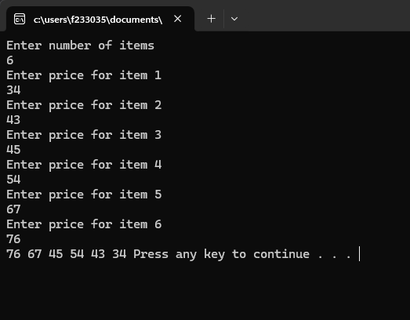
Task 4:
Code:
#include <iostream>
using namespace std;

void swap(int &a, int &b)
{
int temp = a;
a = b;
b = temp;
}

void sort(int arr[], int n)
{
int rollNumbers[5], marks[5];

for (int i = 0; i < 5; i++)
{
rollNumbers[i] = arr[i];
marks[i] = arr[i + 5];
}

for (int i = 0; i < n - 1; i++)
{
for (int j = 0; j < n - i - 1; j++)
{
if (rollNumbers[j] > rollNumbers[j + 1])
{
swap(rollNumbers[j], rollNumbers[j + 1]);

swap(marks[j], marks[j + 1]);
}
}
}

for (int i = 0; i < 5; i++)
{
arr[i] = rollNumbers[i];
arr[i + 5] = marks[i];
}
}

int main()
{
int arr[10];

cout << "Enter roll numbers (5 values):\n";
for (int i = 0; i < 5; i++)
{
cin >> arr[i];
}

cout << "Enter marks corresponding to the roll numbers (5 values):\n";
for (int i = 5; i < 10; i++)
{
cin >> arr[i];
}

sort(arr, 5);

cout << "\nSorted Roll Numbers and Marks:\n";
for (int i = 0; i < 5; i++)
{
cout << "Roll Number: " << arr[i] << ", Marks: " << arr[i + 5] << endl;
}
system("pause");
}

Output:

