

REPORT OF ASSIGNMENT 3:

Name | Ayesha Shabbir
Registration no: | 25I-8037
Instructor name: | Sir Mateen Yaqoob
Subject: | Data science tools and techniques
Assignment | 3

Q#1: Large-scale Web Crawl NLP + EDA Assignment (100 Marks)
Perform the following tasks. A Common Crawl-like dataset has been provided for experiments.
Records: 50,000. File: dataset.csv
Task 1: Preprocessing & Tokenization (20 Marks)
✓ Load the provided CSV file and inspect top 100 records for structure and anomalies.
✓ Create a stopword dictionary tailored to the dataset (you will be provided with
stopwords.txt). Explain choices for any added tokens.
✓ Tokenize the content field, normalize case, remove punctuation, and remove stopwords.
Show example output for 10 pages.
Task 2: Stemming and Lemmatization (15 Marks)
✓ Using the tokenized output, perform stemming (Porter or Snowball) and lemmatization
(WordNet or spaCy).
✓ Compare and contrast the outputs for 10 sample documents and explain which is more
appropriate for web-crawl text and why.
Task 3: Bag-of-Words (15 Marks)
✓ Build a document-term matrix (Bag-of-Words) using the preprocessed tokens. Use
vocabulary pruning to remove very rare and very frequent tokens (e.g., min_df=5,
max_df=0.85).
✓ Report top 50 terms by document frequency and show their counts.
✓ Deliverable: DTM matrix, table of top 50 terms.
Task 4: TF-IDF for Top K words (20 Marks)
✓ Compute TF-IDF across the corpus. Select TOP K words by aggregate TF-IDF score
where K is a variable (set K=50, 100, 200 in experiments).
✓ Save the TF-IDF vectors for the chosen K and provide a brief analysis of what kinds of
words are ranked highest.
✓ Deliverable: TF-IDF results, saved vectors (as .npy or .csv)
Task 5: Visualization (30 Marks)
✓ Using the TF-IDF vectors for your chosen K (suggest K=100 for visual clarity):
✓ Reduce dimensionality using PCA and plot the top components, coloring points by
language or http_status.
✓ Create a cluster map (hierarchical clustering heatmap) of the top 50 TF-IDF terms vs a
sample of 500 documents.
✓ Bar chart of the top 30 terms by aggregate TF-IDF score.
✓ Heatmap of term co-occurrence (or term correlation) for top 50 terms.
✓ Deliverable: Plots included in the notebook, and a short interpretation for each plot (≈400
words total).
Report Writing (10 Marks)
✓ Submit a brief report (~800–1000 words) covering:
✓ Overview of preprocessing steps.
✓ Comparison of stemming vs lemmatization.
✓ Insights from BoW and TF-IDF analyses.

Large-scale Web Crawl NLP + EDA Assignment
Large-Scale Web Crawl dataset:
- In this assignment, I was provided with large scale web crawl dataset consisting of 5000 records with 20 features.
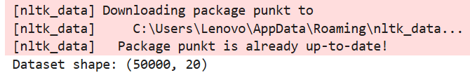
- Its features include:
- Id: it uniquely identify each web page present in crawl dataset.
- url: URL of that web page.
- Domain: domain used in that wed page link.
- Top domain: top domain present in that web page.
- Crawl date: on which date user, visited this page.
- http status: response code .
- mime-type: it tell about type of content present on that web page such as html, application or pdf.
- Charset: character encoding used for that web page.
- Language: tell about the language present in that web page.
- Is https: it tell whether the web page is using secured protocol or not.
- Had js: it means whether web page has incorporated java script or not.
- Num images: it tell about number of images present on that page.
- Inlinks counts: it count the number of hyper links pointing to that page.
- Outlinks counts: it counts the number of hyper links pointing outwards to other domains.
- Anchors count: number of hyperlinks in that page.
- Content length: it tell about the content length of that page.
- PageRank: it tell about importance of page.
- Title: it contains the title of page.
- Meta description: it contain meta description of web page.
- Content: it contains the content on web page which is used for NLP task.

Preprocessing step:
Tokenization:
- In this, I have taken the content column from dataset and convert its content into lower case then made the tokens of it using treebankwordtokenizer(). It gives words such as keyword, map reduce, cloud, search, view etc.
Stop word dictionary:
- In this I had loaded the stop word file provided to me and then stored that file in set and in that add some keyword which are so frequent in crawl dataset but are not meaningful such as http, https, www, com, net, nbsp, amp, gt, br, div, span.
- After adding these words in provided stop list, the total words become 152.
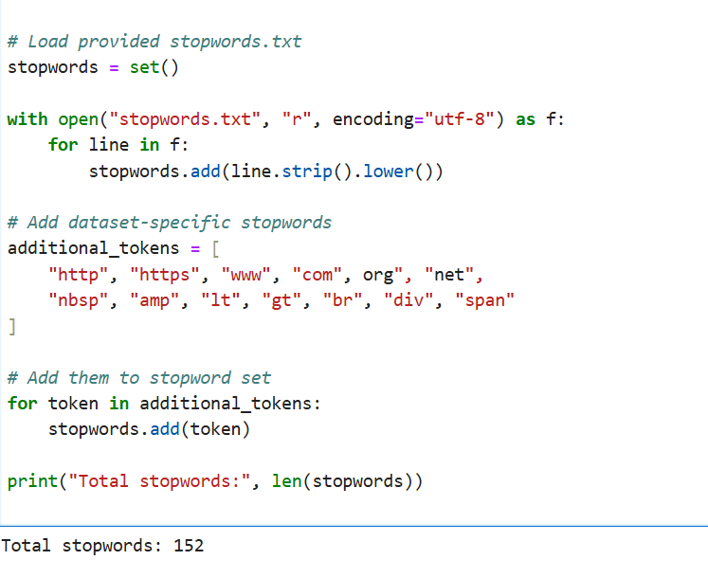
Comparison of Porter stemmer, snowball stemmer and lemmatization:
- Porter stemmer: Stemmer is used to remove the suffixes from the tokens but this porter stemmer is aggressive, yielding non dictionary words. For example: in my dataset, mapreduce, analysis are stemmed into mapreduc and analysi.
- Snowball stemmer: Snowball stemmer are also to stem tokens but it words on pre- defined rules for stemming so it is more flexible as compared to porter stemmer.
- Lemmatization: Lammetization is a process used to convert words used after stemming into dictionary words which are more meaningful. For example service to service, summary to summary.
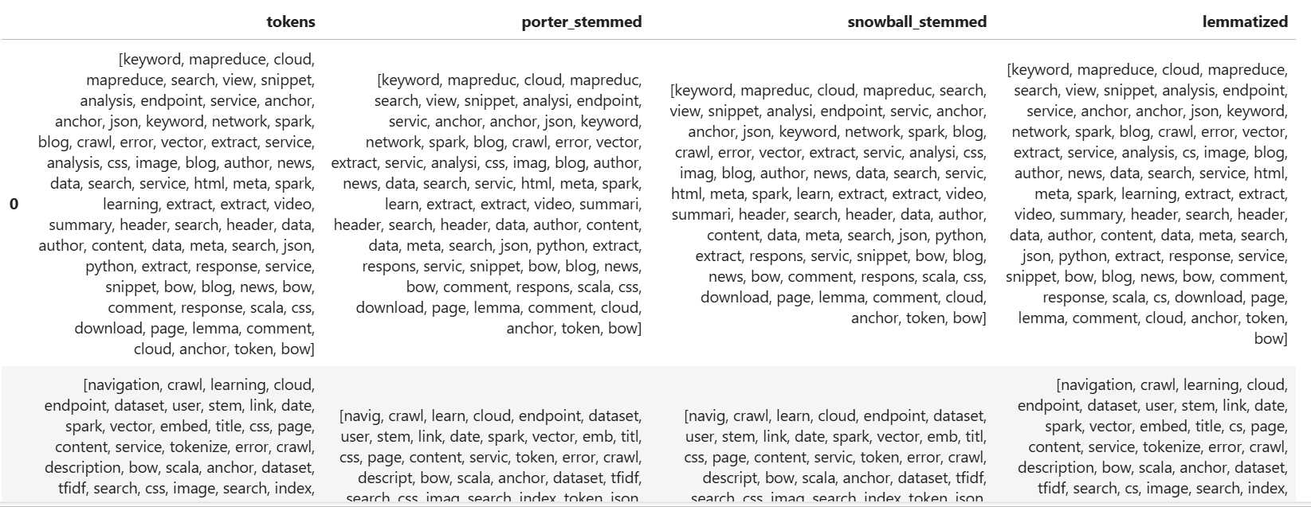

Document Term Matrix (DTM):
- Document term matrix is made by using bag of words.
- In this DTM, each row represent the document and how many times that term appear in that document.
- Vocabulary pruning is applied to remove words that appears in less than 5 document and term that appear most than 85% because it behaves as stop words.
- After making document term matrix, top 50 words are presented .
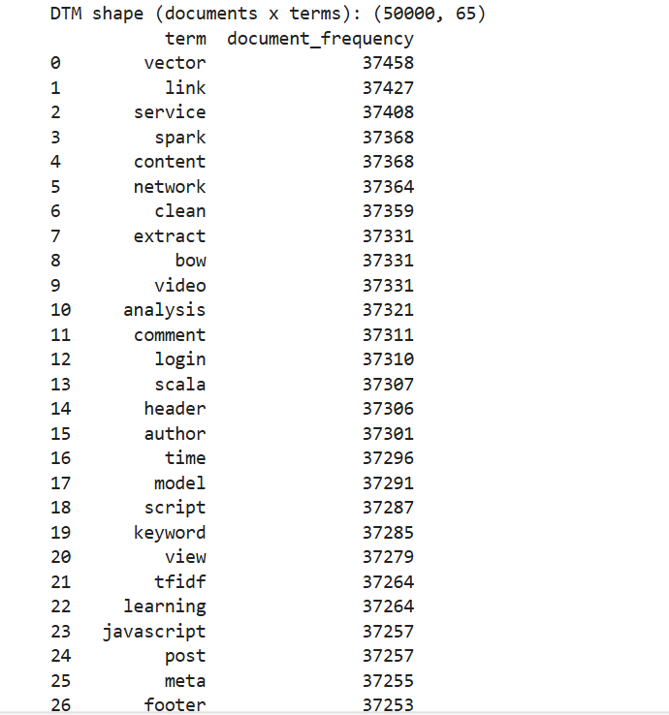
Term Frequency- Inverse Document Frequency:
- After calculating, Term frequency, TF-IDF are created which represents terms, and how many times they appears in each document.
- This is matrix shape where each row contain documents and in columns, frequency how many times they appears in that document using TF-IDF.
- Then three files are exported, TF-IDF containing top 50 words, TF-IDF containing top 100 words and TF-IDF containing top 200 words.
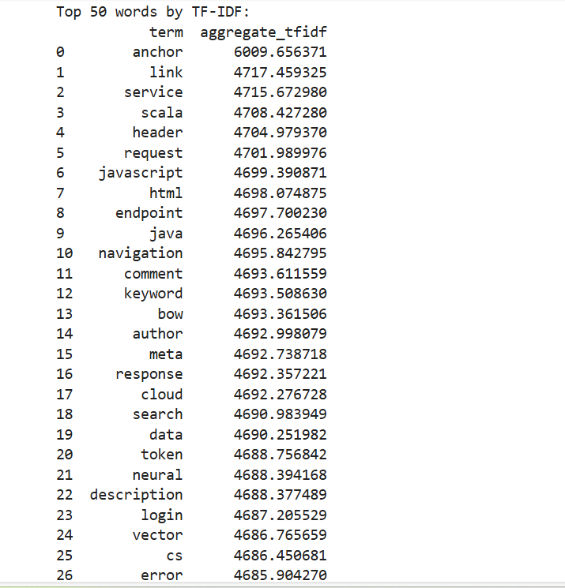

TF-IDF Visualization:
These TF-IDF are represented using :
- PCA.
- Cluster Map.
- Bar chart.
- Correlation heat map.
PCA plot:
- The scatter plot generate after applying PCA technique represents top 100 words based on their TF-IDF.
- In that image, each word is represented by bullet and their color indicate the language from which that word belongs to:
- Here in this figure most of the dots appear as blue means they belongs to English language.
- The number of dots represents the number of documents present in our dataset.
- This figure is illustrated as:
- 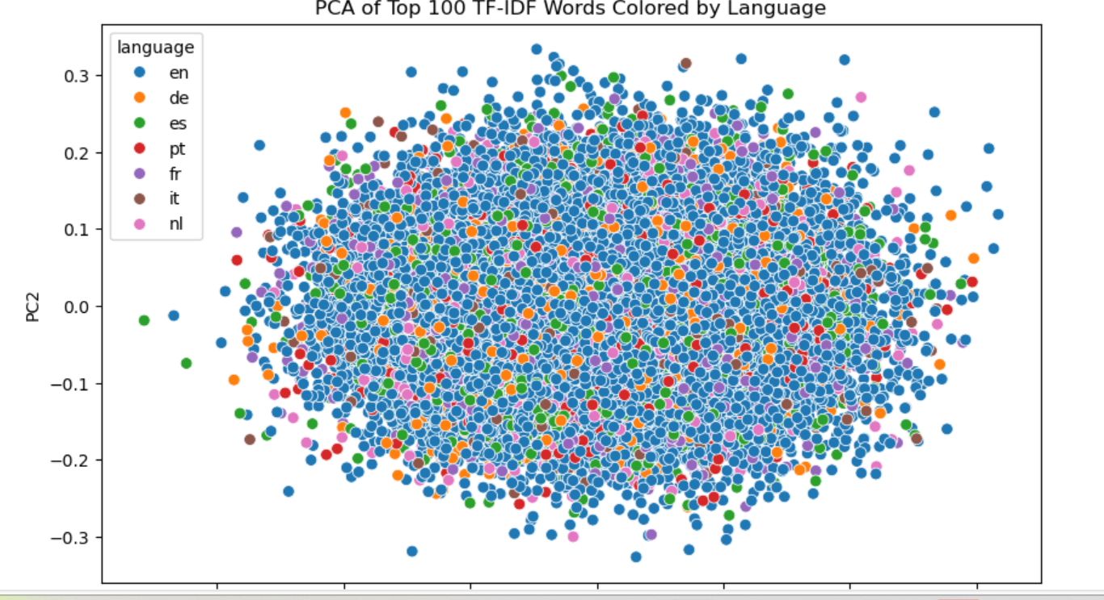

Cluster map:
- This figure below represents the cluster map of this dataset.
- In that map, rows represents documents and column represents top TF-IDF words .
- In that rows, similar documents containing same words are clustered together where short branches indicates more similar documents whereas long branches indicate less similar document.
- In columns, similar words present in different documents are grouped together.
- In that figure, yellow color represent important words while blue color indicates less important words.
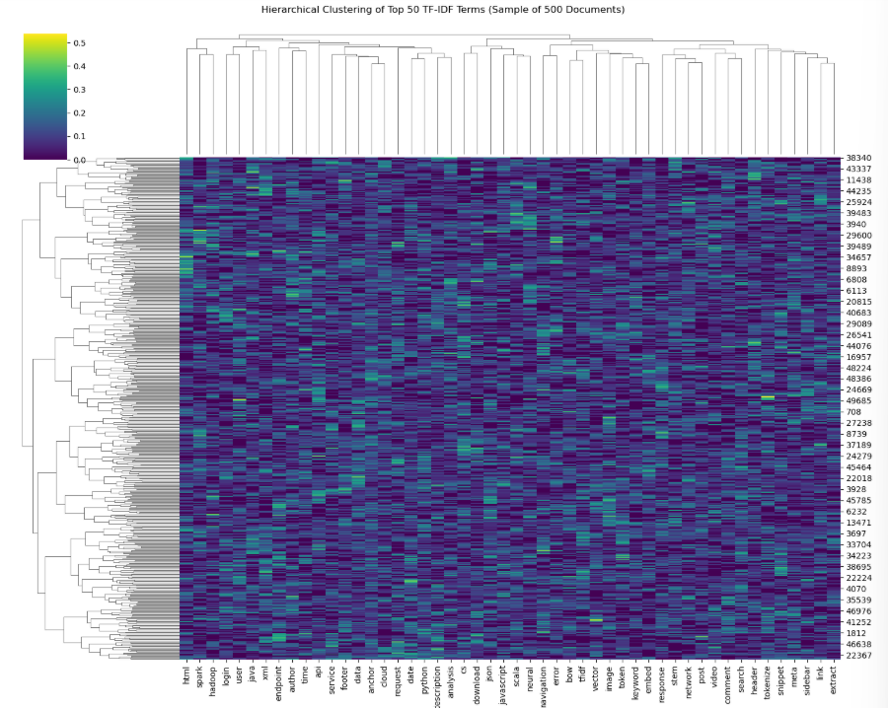

Correlation Heatmap:
- The figure below represents the correlation map for this web crawl dataset.
- In this map, in rows and columns top 50 TF-IDF words are represented and column indicate their correlation.
- In diagonal red line is observed which indicate perfect correlation. The correlation of word with itself is also red.
- But in other columns light grey color is observed which indicate no correlation.
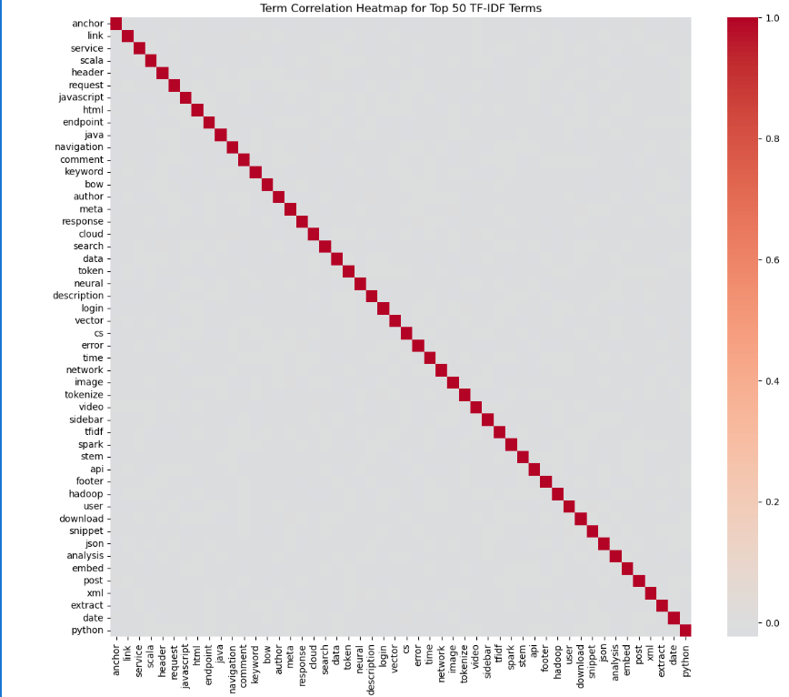
Bar chart:
- In the bar chart, on x axis TF-IDF is represented and on y axis top 30 words are represented.
- Top 30 words with their TF-IDF are represented using bars.
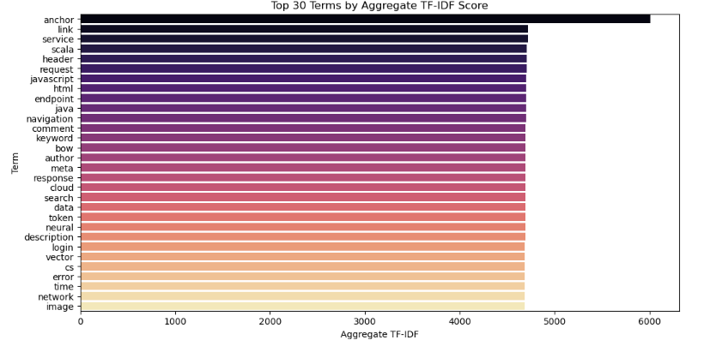

Conclusion:
In this assignment, I have learnt about NLP task and its pre-processing. First tokens are made then stemming and Lammetization is applied. After that bag of word matrix is calculated and TF-IDF is calculated. Different visualization maps are used to represent top 50 TF-IDF words such as PCA, Cluster Map, Correlation map and bar chart.

