A Data Analytics Internship Project Report
Six-Week Data Analytics Internship Program
Submitted To
GLOBAL NEXT CONSULTING INDIA PVT. LTD.
Submitted By
Ayesha Siddikha Shaik
B.Tech – Artificial Intelligence & Data Science
KLM College of Engineering for Women
Under the Guidance of
Dr. Anuradha Gupta
Project Director
Global Next Consulting India Pvt. Ltd.
Internship Duration: 01 June 2026 – 20 July 2026

July 2026

INDEX
Chapter | Title | Page No.
 | DECLARATION OF AUTHENTICITY | 3
 | CERTIFICATE | 4
 | ACKNOWLEDGEMENT | 5
 | ABSTRACT | 6
CHAPTER 1 | INTRODUCTION
1.1 | Company Profile | 7
1.2 | Objectives of the Internship | 7-8
1.3 | Internship Overview | 8
CHAPTER 2 | WEEKLY PROJECTS
2.1 | Week 1: Customer Churn Analysis & Prediction(Microsoft Excel)
2.2 | Week 2: E-Commerce Sales Trends Analysis (Advanced Excel & PostgreSQL)
2.3 | Week 3: Renewable Energy Forecasting (Python, Excel, SQL)
2.4 | Week 4: COVID Data Visualization (Tableau)
2.5 | Week 5: Supply Chain Analysis| Power BI
2.6 | Week 6: Financial Fraud Detection (Python, Machine Learning ,Power BI & Streamlit)
CHAPTER 3 | CONCLUSION
3.1 | Overall Learning Outcomes
3.2 | Internship Experience & Industry Exposure
3.3 | Future Scope
 | REFERENCES
DECLARATION OF AUTHENTICITY
I hereby declare that the work presented in this report entitled "Data Analytics Internship Report" is an original record of the work carried out by me during the Six-Week Data Analytics Internship Program conducted by Global Next Consulting India Pvt. Ltd., under the guidance of Dr. Anuradha Gupta (Project Director) from 01 June 2026 to 20 July 2026.
I certify that the analyses, findings, visualizations, and project outcomes presented in this report are based on my own efforts and learning throughout the internship period. Wherever the ideas, data, or information of others have been utilized, appropriate acknowledgment has been provided.
I further declare that this report has not been submitted, either wholly or partially, to any other institution, university, or organization for the award of any degree, diploma, certification, or any other academic qualification.
I affirm that this report reflects my genuine work and has been prepared in accordance with the principles of academic integrity, honesty, and professional ethics.
Ayesha Siddikha Shaik
Date: 20 July 2026

CERTIFICATE
This is to certify that Ms. Ayesha Siddikha Shaik, a Final-Year B.Tech student in Artificial Intelligence & Data Science from KLM College of Engineering for Women, has successfully completed the Six-Week Data Analytics Internship Program conducted by Global Next Consulting India Pvt. Ltd. during the period 01 June 2026 to 20 July 2026.
During the internship, she actively participated in the assigned learning modules, practical exercises, and project-based activities. She demonstrated dedication, analytical thinking, and a strong commitment to learning while successfully completing the internship requirements.
It is further certified that this internship report is an original record of the work carried out by the candidate under the guidance of Dr. Anuradha Gupta, Project Director, and has not been submitted, either wholly or partially, to any other institution or organization for the award of any degree, diploma, or certification.
Dr. Anuradha Gupta
Project Director
Global Next Consulting India Pvt. Ltd.

ACKNOWLEDGEMENT
I would like to express my sincere gratitude to Global Next Consulting India Pvt. Ltd. for providing me with the opportunity to undertake the Six-Week Data Analytics Internship Program. This internship has been an enriching learning experience that enabled me to strengthen my technical knowledge and gain practical exposure to real-world data analytics concepts and tools.
I extend my heartfelt appreciation to Dr. Anuradha Gupta, Project Director, for her invaluable guidance, continuous encouragement, and constructive feedback throughout the internship. Her mentorship and expert insights significantly contributed to the successful completion of this internship and the preparation of this report.
I would also like to thank the entire team at Global Next Consulting India Pvt. Ltd. for creating a supportive learning environment and for providing the necessary resources, technical assistance, and valuable learning opportunities during the internship.
I express my sincere gratitude to the faculty members of KLM College of Engineering for Women for their constant motivation, encouragement, and academic support throughout my learning journey.
Finally, I would like to thank my family and friends for their unwavering support, encouragement, and motivation, which inspired me to successfully complete this internship and prepare this report.
I am grateful to everyone who directly or indirectly contributed to making this internship a valuable learning experience.
Ayesha Siddikha Shaik

ABSTRACT
This report presents a comprehensive overview of my Six-Week Data Analytics Internship completed at Global Next Consulting India Pvt. Ltd. The internship was designed to provide practical exposure to data analytics through a series of structured weekly projects, enabling the application of theoretical concepts to real-world business scenarios.
Throughout the internship, I worked on diverse projects involving data collection, data cleaning, exploratory data analysis (EDA), statistical analysis, interactive dashboard development, sales forecasting, inventory optimization, and business intelligence reporting. These projects were completed using industry-standard tools and technologies, including Python, SQL, Microsoft Excel, Power BI, and Machine Learning techniques.
The internship significantly enhanced my technical proficiency in data preprocessing, feature engineering, data visualization, predictive analytics, and dashboard development. It also strengthened my analytical thinking, problem-solving abilities, presentation skills, and understanding of data-driven decision-making in business environments.
Overall, this internship provided valuable hands-on industry exposure and practical experience in solving business problems using data analytics. The knowledge and skills acquired during this program have established a strong foundation for pursuing a professional career in the fields of Data Analytics, Business Intelligence, and Data Science.

CHAPTER 1
INTRODUCTION
1.1 Company Profile
Global Next Consulting India Private Limited (GNCIPL), headquartered in Greater Noida, Uttar Pradesh, is a technology-driven consulting organization specializing in Cybersecurity, Data Analytics, Artificial Intelligence, Cloud Computing, and Digital Transformation Services. The company is committed to helping organizations leverage modern technologies to solve complex business challenges while ensuring the security and integrity of their digital assets.
GNCIPL provides industry-focused solutions across multiple domains, including Finance, Healthcare, Manufacturing, Retail, and Information Technology. Its service portfolio includes cybersecurity consulting, data analytics, business intelligence, risk assessment, incident response, compliance consulting, machine learning solutions, and digital transformation strategies. By combining technical expertise with a client-centric approach, the organization delivers customized solutions that support informed decision-making and sustainable business growth.
The company strongly emphasizes innovation, integrity, excellence, collaboration, and continuous learning, providing interns and professionals with opportunities to gain practical exposure to industry-standard tools, technologies, and real-world business projects.
Contact Details
Organization: Global Next Consulting India Pvt. Ltd.
Head Office:
B5, 402, P4 PHI-2, CGEWHO Tower, Greater Noida – 201310, Uttar Pradesh, India
Contact Numbers:
0120-4001768
+91-9315504902
+91-7666141260
Email:
hr@gncipl.com

1.2 Objectives of the Internship
The primary objective of the Six-Week Data Analytics Internship at Global Next Consulting India Pvt. Ltd. was to gain practical exposure to real-world data analytics workflows while strengthening technical, analytical, and problem-solving skills through project-based learning.
The key objectives of the internship were:
- To develop practical proficiency in Python, Microsoft Excel, SQL (PostgreSQL), Power BI, Tableau, and Machine Learning for solving real-world business problems.
- To gain hands-on experience in data collection, preprocessing, cleaning, transformation, exploratory data analysis (EDA), and feature engineering using structured and unstructured datasets.
- To design and develop interactive dashboards, business reports, and visualizations that effectively communicate data-driven insights to support decision-making.
- To understand and implement predictive analytics techniques, including forecasting and machine learning models, for business intelligence applications.
- To strengthen analytical thinking, critical reasoning, presentation skills, and professional communication through weekly project presentations and technical documentation.
- To apply industry best practices in data analytics by completing multiple real-world projects covering customer analytics, sales analytics, financial analytics, agricultural analytics, and retail sales forecasting.
- To gain practical exposure to the complete data analytics lifecycle, from data acquisition and preprocessing to visualization, forecasting, and business recommendation generation.

1.3 Internship Overview
The internship was conducted over a period of six weeks, with each week dedicated to a specific project designed to develop practical skills in different areas of data analytics. The projects progressively introduced concepts ranging from data analysis using spreadsheets to programming with Python, SQL-based data management, interactive dashboard development, machine learning, and business intelligence reporting.
Throughout the internship, I successfully completed six hands-on projects covering customer analytics, sales analysis, agricultural analytics, financial performance analysis, and retail sales forecasting. Each project emphasized the complete data analytics workflow, including data preprocessing, exploratory data analysis, visualization, predictive modeling, and business recommendation generation. The internship concluded with an industry-oriented project on Retail Sales Forecasting & Inventory Optimization, integrating Python, Machine Learning, and Power BI to address real-world retail business challenges.

Chapter 2 - Projects
2.1 Week 1: Customer Churn Analysis & Prediction
2.1.1 Introduction
Customer retention has become one of the most critical challenges for subscription-based businesses, particularly in the Software-as-a-Service (SaaS) industry. Acquiring new customers requires significantly higher investment than retaining existing ones, making churn reduction a key business priority.
This project focuses on analyzing customer churn behavior using behavioral and transactional data collected from a subscription-based SaaS platform. The analysis examines customer engagement, payment behavior, support interactions, inactivity levels, and subscription information to identify the major factors contributing to customer attrition.
The dataset consists of 2,800 customer records with 10 key features, including plan type, weekly usage hours, payment failures, tenure, support tickets, inactivity, and churn status. Through exploratory data analysis and business intelligence techniques, the project develops a churn risk scoring framework that enables organizations to proactively identify high-risk customers and improve retention strategies.

2.1.2 Objectives
Primary Objectives
- To analyze customer churn behavior using subscription and behavioral data.
- To identify the major factors contributing to customer attrition.
- To segment customers based on their churn risk levels.
- To develop a customer churn risk scoring framework.
- To generate business recommendations for improving customer retention.
Specific Analytical Goals
- Evaluate overall customer churn distribution.
- Analyze the impact of customer engagement and inactivity on churn.
- Study payment failures and their relationship with customer attrition.
- Assess the influence of customer support interactions.
- Identify high-risk customers using predefined behavioral indicators.
- Recommend proactive retention strategies based on analytical findings.

2.1.3 Methodology
a) Dataset Preparation
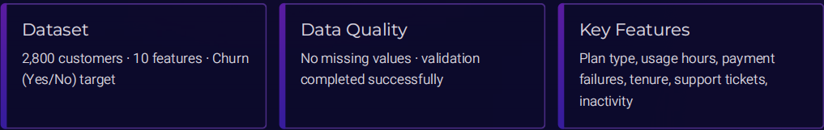
- Imported the customer churn dataset containing 2,800 customer records and 10 behavioral features.
- Verified data quality and confirmed that no missing values were present.
- Validated data consistency and ensured all variables were suitable for analysis.
- Reviewed customer subscription plans, engagement metrics, payment history, and support information before conducting analysis.
b) Exploratory Data Analysis
The customer dataset was analyzed using various behavioral indicators to identify patterns associated with churn.
The following factors were examined:
- Subscription Plan
- Weekly Usage Hours
- Customer Inactivity
- Payment Failures
- Support Ticket Volume
- Customer Tenure
Behavioral comparisons were performed between churned and retained customers to identify significant differences influencing customer retention.
c) Churn Risk Scoring Framework
A rule-based churn risk framework was developed by assigning one risk point for each of the following conditions:
- Weekly product usage below 10 hours.
- More than three payment failures.
- More than five customer support tickets.
- Last customer login exceeding 30 days.
Customers satisfying multiple conditions were classified as high-risk customers requiring immediate retention efforts.

2.1.4 Results and Insights
a) Customer Churn Overview
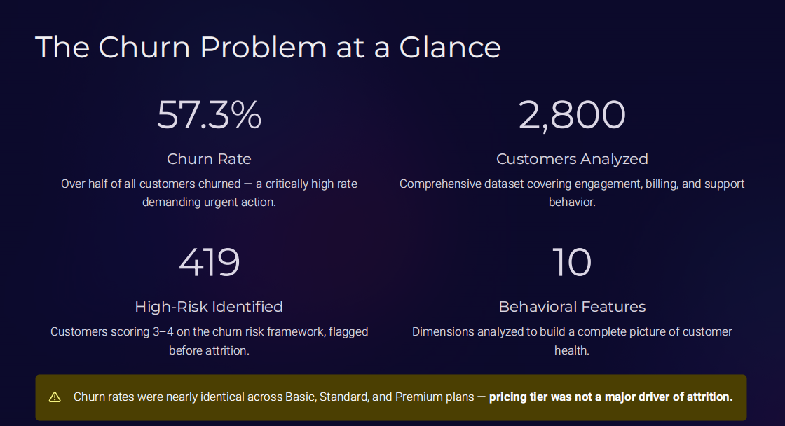
The analysis identified a customer churn rate of 57.3%, indicating a significant retention challenge for the organization.
A total of 2,800 customers were analyzed using 10 behavioral variables, and the churn risk framework successfully identified 419 high-risk customers before actual customer attrition occurred.
b) Subscription Plan Analysis
Customer churn rates remained nearly identical across Basic, Standard, and Premium subscription plans.
This indicates that pricing plans were not the primary reason for customer churn.
Instead, customer behavior played a much greater role in determining retention outcomes.
c) Customer Engagement Analysis
Customers who eventually churned consistently demonstrated lower weekly product usage compared to retained customers.
Reduced engagement suggests declining customer interest and satisfaction, making usage behavior one of the strongest predictors of churn.
d) Customer Inactivity Analysis
Inactivity emerged as the most influential behavioral indicator.
Customers remaining inactive for more than 30 days were significantly more likely to leave the platform.
This provides businesses with an actionable early-warning signal that can trigger automated customer engagement campaigns before churn occurs.
e) Payment Failure Analysis
Customers experiencing multiple payment failures showed substantially higher churn rates.
Payment-related issues represent both billing friction and declining customer commitment, making them an important intervention point for improving retention.
f) Customer Support Analysis
Customers generating a high number of support tickets were more likely to churn.
Frequent unresolved issues may increase customer dissatisfaction and accelerate the decision to discontinue the service.
Improving support quality can therefore contribute directly to customer retention.
g) Churn Risk Segmentation
The risk scoring framework successfully classified 419 customers as high-risk based on behavioral indicators.
These customers can be prioritized for targeted retention campaigns before they decide to leave the platform.

2.1.5 Recommendations
Based on the analysis, the following business recommendations are proposed:
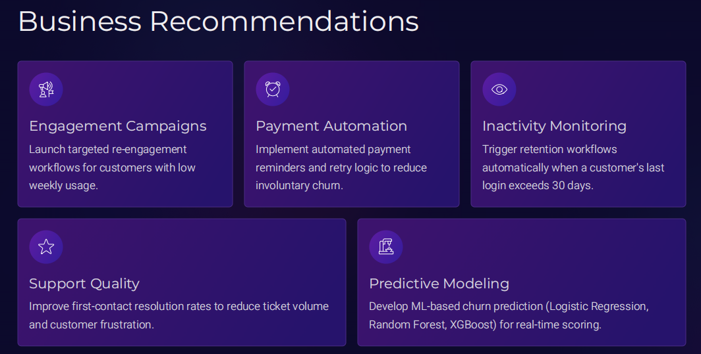
Improve Customer Engagement
- Launch personalized engagement campaigns targeting customers with declining weekly usage.
- Provide product tutorials, feature recommendations, and promotional offers to encourage regular platform usage.
Strengthen Payment Management
- Implement automated payment reminders and intelligent payment retry mechanisms.
- Notify customers immediately when payment failures occur.
Monitor Customer Inactivity
- Automatically identify customers who remain inactive for more than 30 days.
- Trigger personalized retention campaigns before customers become inactive for extended periods.
Enhance Customer Support
- Improve first-contact resolution rates.
- Reduce customer waiting time.
- Analyze recurring support issues and address root causes.
Implement Predictive Analytics
- Develop machine learning models such as Logistic Regression, Random Forest, and XGBoost to predict churn probability in real time.
- Integrate predictive models into customer relationship management systems for continuous churn monitoring.

2.1.6 Conclusion
This project successfully analyzed customer churn behavior within a subscription-based SaaS environment using behavioral analytics and business intelligence techniques.
The analysis demonstrated that customer churn is primarily driven by behavioral factors rather than subscription plans. Low customer engagement, prolonged inactivity, payment failures, and frequent support interactions emerged as the strongest indicators of churn.
The churn risk scoring framework effectively identified 419 high-risk customers, enabling organizations to implement proactive retention strategies before customer attrition occurs.
Overall, the project highlights how data-driven customer analytics can support informed decision-making, improve customer retention, enhance operational efficiency, and contribute to long-term business growth.

2.2 Week 2: Customer Experience Analysis Using E-Commerce Customer Support Data
2.2.1 Introduction
Customer experience is one of the most important factors influencing customer satisfaction, loyalty, and business growth in the e-commerce industry. Every interaction between a customer and a support team contributes to the overall perception of a company's service quality.
This project focuses on analyzing customer support data to evaluate service performance, identify response patterns, measure customer satisfaction, and uncover operational challenges. By examining customer interactions, response times, issue categories, support channels, and resolution outcomes, the analysis provides valuable insights that help organizations improve customer service efficiency and enhance customer retention.
The project was carried out using Microsoft Excel, where data cleaning, exploratory analysis, KPI development, Pivot Tables, Pivot Charts, and an interactive dashboard were used to transform raw customer support records into meaningful business insights.
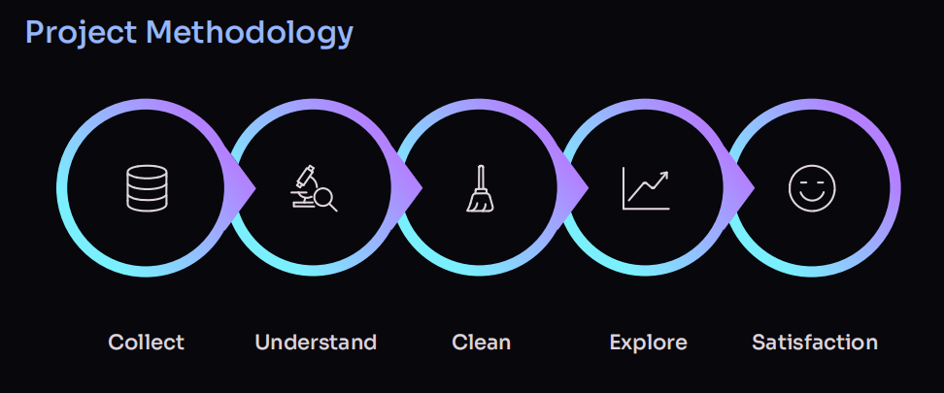
2.2.2 Objectives
Primary Objectives
- To analyze customer support interactions and evaluate service performance.
- To identify factors affecting customer satisfaction and issue resolution.
- To measure key customer support KPIs using Excel.
- To develop an interactive dashboard for monitoring customer experience.
- To generate business insights that support service improvement and customer retention.
Specific Analytical Goals
- Analyze customer satisfaction across different support channels.
- Evaluate response time and issue resolution performance.
- Compare ticket volumes by issue category.
- Study customer interactions across various communication channels.
- Identify trends that impact customer satisfaction.
- Design an interactive dashboard for business decision-making.

2.2.3 Methodology
a) Dataset Preparation
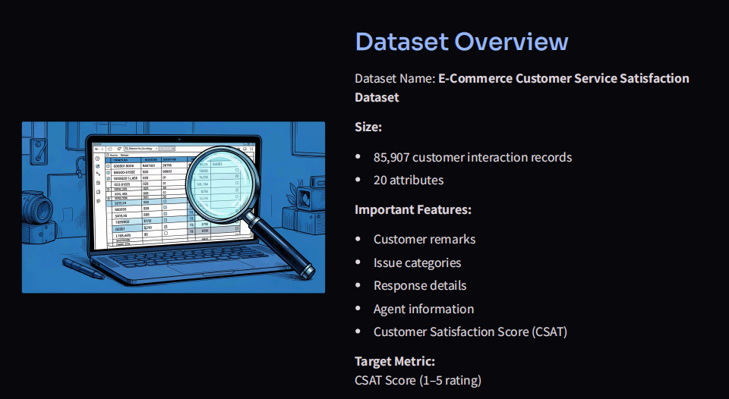
- Imported the E-Commerce Customer Support dataset into Microsoft Excel.
- Reviewed the dataset for missing values, duplicate records, and inconsistent entries.
- Standardized categorical variables such as support channel, issue category, and ticket status.
- Verified numerical and date-related fields for analytical consistency.
- Prepared the dataset for dashboard development and reporting.
b) Data Analysis
The dataset was analyzed using Microsoft Excel features including:
- Pivot Tables
- Pivot Charts
- Sorting and Filtering
- Conditional Formatting
- KPI Calculations
The following business metrics were evaluated:
- Total Customer Support Tickets
- Average Customer Satisfaction Score
- Average Response Time
- Average Resolution Time
- Issue Category Distribution
- Support Channel Performance
- Resolution Status Analysis
c) Dashboard Development
An interactive Excel dashboard was designed containing:
- KPI Cards
  - Total Tickets
  - Average Satisfaction Score
  - Average Response Time
  - Average Resolution Time
- Customer Satisfaction Analysis
- Issue Category Distribution
- Support Channel Performance
- Resolution Status Analysis
- Ticket Volume Trends
- Interactive Slicers for dynamic filtering and business exploration

2.2.4 Results and Insights
a) Customer Support Performance
The dashboard provided a comprehensive overview of customer support operations by summarizing ticket volume, customer satisfaction, response efficiency, and resolution effectiveness.
b) Customer Satisfaction Analysis
- Customer satisfaction varied across different support interactions.
- Faster issue resolution generally resulted in higher satisfaction ratings.
- Delayed responses were associated with lower customer satisfaction.
c) Issue Category Analysis
- Certain issue categories generated significantly more customer support requests than others.
- Frequently reported issues indicate opportunities for operational improvements and preventive measures.
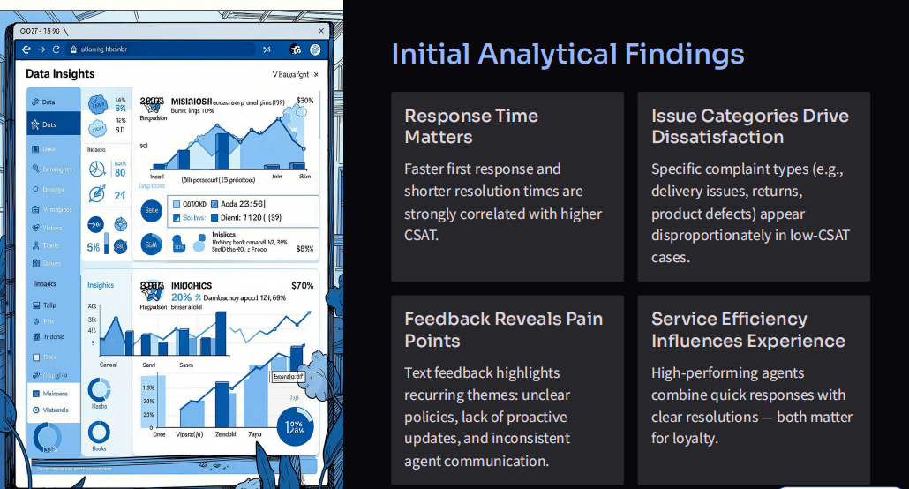
d) Response Time Analysis
- Response time emerged as one of the strongest factors affecting customer experience.
- Reducing response delays can significantly improve customer satisfaction and service quality.
e) Support Channel Performance
- Customer interactions differed across support channels such as Email, Chat, and Phone.
- Some communication channels handled larger ticket volumes while maintaining better response efficiency.
f) Resolution Analysis
- Successfully resolved tickets contributed positively to customer experience.
- Monitoring unresolved or delayed tickets helps organizations improve service efficiency.

2.2.5 Recommendations
- Reduce customer response time by improving support team efficiency.
- Prioritize frequently reported issue categories for faster resolution.
- Strengthen support channels with high customer demand.
- Monitor customer satisfaction regularly through dashboard KPIs.
- Use customer feedback to improve products and support services.
- Implement proactive customer support strategies to reduce recurring issues.

2.2.6 Conclusion
This project successfully analyzed customer support data to evaluate overall customer experience using Microsoft Excel.
Through data cleaning, exploratory analysis, KPI development, Pivot Tables, Pivot Charts, and dashboard visualization, meaningful insights were generated regarding customer satisfaction, response efficiency, issue trends, and support performance.
The interactive dashboard provides decision-makers with valuable information to monitor service quality, improve operational efficiency, enhance customer satisfaction, and strengthen long-term customer relationships.

2.3 Week 3: Renewable Energy Forecasting Using Advanced Excel & PostgreSQL
2.3.1 Introduction
Renewable energy has become an essential component of sustainable development, helping reduce dependence on fossil fuels while minimizing environmental impact. Efficient management of renewable energy resources requires continuous monitoring of energy generation and the environmental conditions that influence production.
This project focuses on analyzing renewable energy generation data alongside weather parameters such as temperature, humidity, wind speed, and Global Horizontal Irradiance (GHI). Using Advanced Excel and PostgreSQL, historical data was transformed into meaningful business insights through data cleaning, exploratory analysis, KPI reporting, dashboard development, and SQL-based analytics.
The dataset contains 196,777 records collected between 2017 and 2022, providing valuable information for understanding energy generation trends and the influence of weather conditions on renewable energy performance. The project demonstrates how data analytics can support operational planning, resource optimization, and future energy forecasting.

2.3.2 Objectives
Primary Objectives
- To analyze renewable energy generation using historical operational and weather data.
- To evaluate the impact of environmental conditions on energy production.
- To develop an interactive Excel dashboard for monitoring key performance indicators.
- To perform SQL-based analysis using PostgreSQL for data validation and business reporting.
- To generate actionable insights that support renewable energy planning and decision-making.
Specific Analytical Goals
- Measure total and average renewable energy generation.
- Analyze seasonal and yearly energy generation trends.
- Study monthly variations in temperature, humidity, wind speed, and GHI.
- Evaluate the relationship between weather conditions and energy output.
- Validate analytical results using SQL queries.
- Recommend strategies to improve renewable energy forecasting and operational efficiency.

2.3.3 Methodology
a) Dataset Preparation
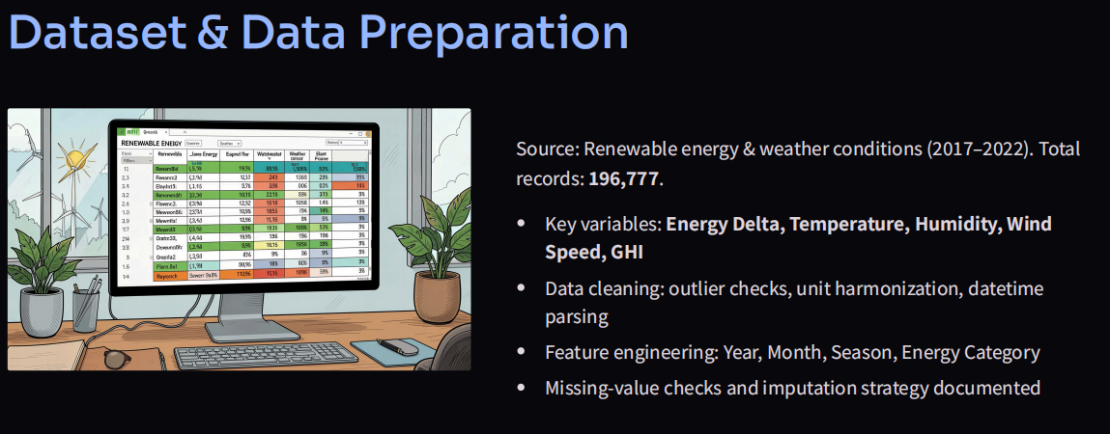
The renewable energy dataset containing 196,777 records and 17 attributes was imported into Microsoft Excel for analysis.
Data preparation included:
- Verification of missing values and duplicate records.
- Validation of numerical and categorical variables.
- Standardization of date and time formats.
- Data quality assessment and consistency checks.
- Feature engineering to create analytical fields such as:
  - Year
  - Month
  - Season
  - Energy Category
The cleaned dataset was then imported into PostgreSQL for SQL-based business analysis and KPI validation.
b) Exploratory Data Analysis
Exploratory Data Analysis (EDA) was conducted using Advanced Excel to identify trends and relationships within the dataset.
The analysis included:
- Monthly Temperature Trends
- Monthly Humidity Analysis
- Wind Speed Distribution
- Year-wise Energy Generation
- Seasonal Energy Comparison
- Energy Category Analysis
- KPI Development
The results were summarized using Pivot Tables, Pivot Charts, Conditional Formatting, and interactive dashboard components.
c) SQL-Based Analysis
The cleaned dataset was imported into PostgreSQL to perform analytical queries that validated dashboard results and generated additional business insights.
The SQL analysis included:
- Total Number of Records
- Total Energy Generated
- Average Energy Generated
- Maximum Energy Generated
- Average Temperature
- Average Humidity
- Average Wind Speed
- Monthly Energy Analysis
- Weather-Based Energy Analysis
SQL aggregates were used to verify KPI calculations developed in Microsoft Excel, ensuring data accuracy and consistency across reporting platforms.
d) Dashboard Development
An interactive Excel dashboard was created to visualize renewable energy performance.
The dashboard included:
- KPI Cards
  - Total Energy Generated
  - Average Energy Generated
  - Maximum Energy Generated
  - Average Temperature
  - Average Humidity
  - Average Wind Speed
  - Average GHI
- Year-wise Energy Trend
- Monthly Weather Analysis
- Seasonal Energy Comparison
- Interactive Filters and Slicers
The dashboard enables users to monitor renewable energy generation efficiently and supports data-driven operational planning.

2.3.4 Results and Insights
a) KPI Summary
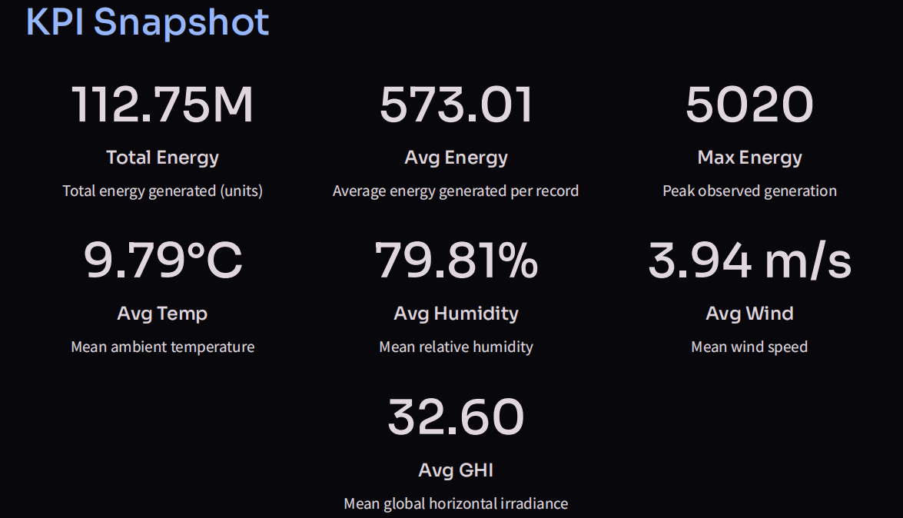
The renewable energy system generated approximately 112.75 million units of energy during the analysis period.
The average energy generated per observation was 573.01 units, while the maximum recorded energy output reached 5,020 units.
The average environmental conditions observed throughout the study were:
- Temperature: 9.79°C
- Humidity: 79.81%
- Wind Speed: 3.94 m/s
- GHI: 32.60
These KPIs provide an overall view of renewable energy performance and operational conditions.
b) Weather Analysis
Monthly analysis revealed clear seasonal variations in environmental conditions.
Temperature increased during summer months, resulting in higher Global Horizontal Irradiance (GHI) values.
Humidity reached its highest levels during the monsoon season, contributing to fluctuations in renewable energy generation.
Wind speed remained relatively stable throughout the year but showed occasional increases during storm events, influencing short-term energy production.
The findings demonstrate that weather conditions play a significant role in determining renewable energy output.
c) Energy Generation Analysis
Energy generation exhibited distinct seasonal patterns over the six-year study period.
Higher energy production was recorded during seasons with increased sunlight availability and favorable weather conditions.
Conversely, periods characterized by heavy rainfall and elevated humidity resulted in comparatively lower energy generation.
These seasonal variations highlight the importance of incorporating weather conditions into renewable energy planning and forecasting models.
d) SQL Validation
PostgreSQL analysis successfully validated all major KPI calculations produced in Microsoft Excel.
The SQL queries confirmed values related to total energy generation, average energy output, weather statistics, and monthly performance trends.
The integration of Excel and PostgreSQL improved reporting reliability and strengthened confidence in the analytical findings.

2.3.5 Recommendations
Based on the analytical findings, the following recommendations are proposed:
- Continuously monitor weather conditions to improve renewable energy planning.
- Utilize historical weather data for more accurate energy forecasting.
- Strengthen KPI-based monitoring systems to enhance operational visibility.
- Integrate Machine Learning models for renewable energy prediction.
- Expand dashboard reporting using Business Intelligence tools such as Power BI and Tableau.
- Develop real-time monitoring systems for proactive energy management.
- Incorporate weather variables such as GHI, humidity, and wind speed into predictive forecasting models for improved accuracy.

2.3.6 Conclusion
This project successfully analyzed renewable energy generation data using Advanced Excel and PostgreSQL, demonstrating how data analytics can support sustainable energy management and operational planning.
Through data cleaning, exploratory data analysis, dashboard development, KPI reporting, and SQL-based validation, the project identified significant relationships between weather conditions and renewable energy generation.
The analysis showed that seasonal variations in temperature, humidity, wind speed, and solar irradiance have a measurable impact on energy production, emphasizing the importance of weather-driven forecasting models.
Overall, the project highlights the value of combining spreadsheet analytics with database technologies to transform large-scale renewable energy data into actionable business intelligence, supporting informed decision-making and future predictive analytics initiatives.

2.4 Week 4: COVID-19 Data Visualization (Tableau)
2.4.1 Introduction
The COVID-19 pandemic created an urgent need for accurate data analysis and visualization to support healthcare planning and public decision-making. Governments and healthcare organizations relied on data analytics to monitor infection trends, vaccination progress, testing capacity, and regional impact.
This project focuses on analyzing COVID-19 data in India using Tableau. Interactive dashboards were developed to visualize state-wise cases, deaths, recoveries, vaccination statistics, testing infrastructure, demographic distribution, and geographical patterns.
The objective was to convert complex healthcare datasets into meaningful visual insights that help understand the spread of the pandemic and support informed decision-making.

2.4.2 Objectives
Primary Objectives
- To analyze COVID-19 statistics across different states of India.
- To visualize confirmed cases, recoveries, and death trends.
- To evaluate vaccination progress and testing performance.
- To develop an interactive Tableau dashboard for healthcare analytics.
- To generate actionable insights from pandemic-related data.
Specific Analytical Goals
- Compare confirmed, recovered, and death cases across states.
- Identify states with the highest COVID-19 impact.
- Analyze vaccination coverage by dose type and vaccine.
- Study age-wise and gender-wise case distribution.
- Evaluate testing laboratories and state-wise testing statistics.
- Develop an interactive dashboard with filters for dynamic exploration.

2.4.3 Methodology
a) Dataset Preparation
The COVID-19 dataset was collected from publicly available healthcare sources and imported into Microsoft Excel for preprocessing before visualization in Tableau.
The dataset includes:
- State and Union Territory
- Confirmed Cases
- Recovered Cases
- Death Cases
- Vaccination Data
- Testing Statistics
- Age Distribution
- Gender Distribution
- ICMR Testing Laboratories
- Geographic Information
Data preparation activities included:
- Validation of missing values
- Removal of duplicate records
- Standardization of state names
- Verification of numerical fields
- Preparation of spatial data for geographical mapping
b) Analysis Techniques
The project utilized Tableau to perform interactive visual analytics through multiple dashboard components.
The analysis included:
- State-wise geographical mapping
- Time-series trend analysis
- Vaccination comparison
- Demographic analysis
- Healthcare infrastructure analysis
- Testing statistics visualization
Interactive filters were incorporated to allow users to explore specific states and pandemic trends dynamically.
c) Dashboard Development
An interactive Tableau dashboard was developed containing:
- State-wise COVID-19 Death Map
- Confirmed, Recovered and Death Trend Analysis
- Age Group Distribution
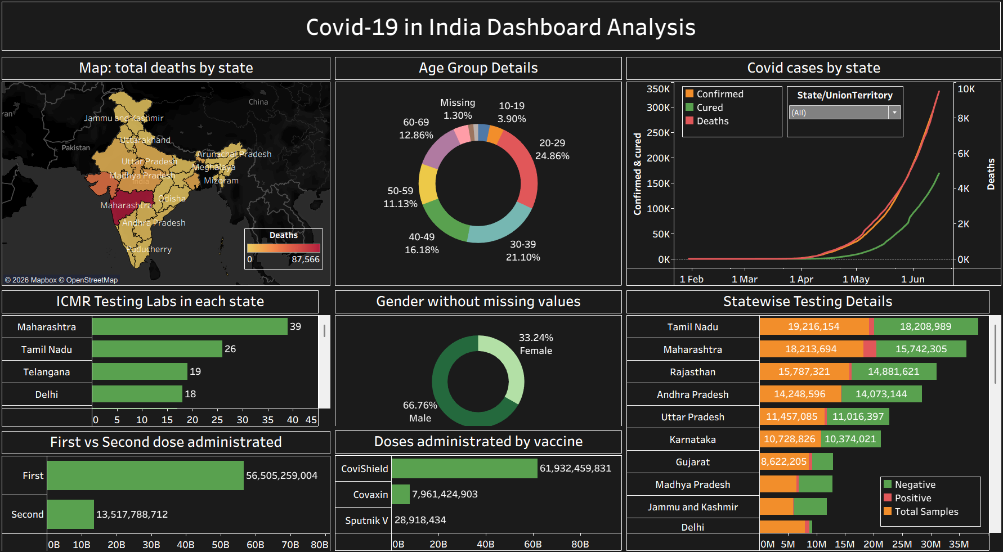
- Gender Distribution
- ICMR Testing Laboratories by State
- State-wise Testing Statistics
- First vs Second Dose Vaccination Analysis
- Vaccine-wise Dose Administration
- Interactive State Filter

2.4.4 Results and Insights
a) Pandemic Overview
The dashboard provides a comprehensive overview of India's COVID-19 situation by integrating multiple healthcare indicators into a single interactive platform.
b) State-wise COVID-19 Analysis
- Maharashtra recorded the highest number of COVID-19 deaths among all states.
- Several highly populated states experienced significantly higher confirmed case counts.
- The geographical map clearly highlights regional variations in pandemic severity.
c) Case Trend Analysis
- Confirmed, recovered, and death cases increased rapidly during the major waves of the pandemic.
- Recovery numbers showed continuous improvement with enhanced healthcare management.
- The dashboard enables users to compare pandemic trends across different time periods.
d) Vaccination Analysis
First vs Second Dose
- Administration of the first vaccine dose was significantly higher than the second dose during the study period.
- Vaccination coverage expanded rapidly after the nationwide vaccination campaign.
Vaccine-wise Distribution
- Covishield accounted for the majority of administered vaccine doses.
- Covaxin represented the second-largest share of vaccinations.
- Sputnik V contributed a comparatively smaller proportion.
e) Demographic Analysis
Age Group Distribution
- Individuals aged 20–39 years represented the largest proportion of confirmed COVID-19 cases.
- Younger populations experienced lower case representation compared to working-age adults.
Gender Distribution
- Male patients accounted for a larger share of reported cases than female patients.
- The gender analysis highlights differences in pandemic exposure across populations.
f) Testing Infrastructure Analysis
- Maharashtra, Tamil Nadu, Telangana, and Delhi reported the highest number of ICMR testing laboratories.
- State-wise testing statistics indicate that larger states conducted significantly more COVID-19 tests.
- Expanded testing capacity contributed to improved case detection and monitoring.

2.4.5 Recommendations
- Strengthen healthcare infrastructure in high-risk regions.
- Expand testing facilities in underserved states.
- Continue vaccination awareness programs to improve coverage.
- Utilize interactive dashboards for real-time public health monitoring.
- Integrate live healthcare datasets for continuous pandemic surveillance.
- Apply predictive analytics to support future outbreak preparedness.

2.4.6 Conclusion
The COVID-19 India Dashboard Analysis project successfully demonstrates the use of Tableau for healthcare data visualization and interactive analytics.
Through geographical mapping, trend analysis, vaccination monitoring, demographic analysis, and testing statistics, the dashboard transforms complex pandemic data into meaningful business intelligence. The project highlights the importance of data visualization in understanding public health trends, supporting policy decisions, and improving healthcare planning.
Overall, this project strengthened practical skills in Tableau, dashboard development, healthcare analytics, geospatial visualization, and interactive reporting, demonstrating how business intelligence tools can effectively communicate critical insights during large-scale public health events.

2.5 Week 5: Supply Chain Analysis Dashboard
2.5 Introduction
2.5.1 Project Overview
Efficient supply chain management is essential for ensuring smooth business operations, timely product delivery, optimized inventory levels, and improved customer satisfaction. Organizations generate large volumes of operational data related to sales, inventory, shipments, warehouses, and customer orders. Transforming this data into meaningful insights enables businesses to improve efficiency, reduce operational costs, and support strategic decision-making.
This project focuses on analyzing supply chain operations using Power BI by developing an interactive dashboard that provides comprehensive insights into business performance, inventory management, and shipment operations. The dashboard integrates key performance indicators (KPIs), trend analysis, product performance, inventory monitoring, and shipment tracking to evaluate overall supply chain efficiency.
The project demonstrates practical business intelligence skills including data preparation, KPI development, data modeling, dashboard design, and interactive reporting to support data-driven supply chain management.

2.5.2 Problem Statement
Supply chain organizations often struggle to monitor sales performance, warehouse inventory, product demand, and shipment efficiency using large volumes of operational data. Without centralized reporting, it becomes difficult to identify inventory issues, delayed shipments, high-performing product categories, and overall business performance.
The objective of this project is to transform raw supply chain data into an interactive business intelligence dashboard that enables organizations to monitor operational performance, optimize inventory, improve shipment efficiency, and support strategic business decisions.

2.5.3 Project Objectives
The primary objectives of this project are:
- To clean and prepare supply chain data for analysis.
- To perform exploratory analysis on sales, inventory, and shipment data.
- To develop interactive Power BI dashboards for business monitoring.
- To evaluate sales performance across product departments and categories.
- To analyze warehouse inventory levels and storage costs.
- To monitor shipment performance and delivery delays.
- To identify top-performing products and departments.
- To generate actionable business insights for improving supply chain operations.

2.5.3.1 Dataset Information
The supply chain dataset contains operational business records related to product sales, inventory management, warehousing, and shipment activities.
Dataset Overview
Attribute | Details
Domain | Supply Chain Management
Tools Used | Microsoft Excel, Power BI
Data Type | Business Operations
Analysis Areas | Sales, Inventory, Shipment, Warehousing
Major Dataset Attributes
- Order ID
- Order Date
- Shipment Date
- Product Name
- Product Category
- Product Department
- Customer Information
- Sales Amount
- Profit
- Discount
- Inventory Cost
- Warehouse Inventory
- Shipment Mode
- Shipment Status
- Storage Cost
- Warehouse Country

2.5.3.2 Data Cleaning and Preparation
Before analysis, the dataset was prepared to ensure consistency and accuracy.
The following preprocessing activities were performed:
- Removed duplicate records.
- Verified missing values.
- Standardized categorical values.
- Validated date formats.
- Checked numerical data consistency.
- Prepared the dataset for Power BI modeling.
- Created relationships and calculated measures for reporting.
The cleaned dataset provided a reliable foundation for dashboard development and business analysis.

2.5.4 Dashboard Development
The dashboard was designed using Microsoft Power BI with three interactive report pages.
Page 1 – Business Performance Dashboard
This page provides an executive overview of overall business performance.
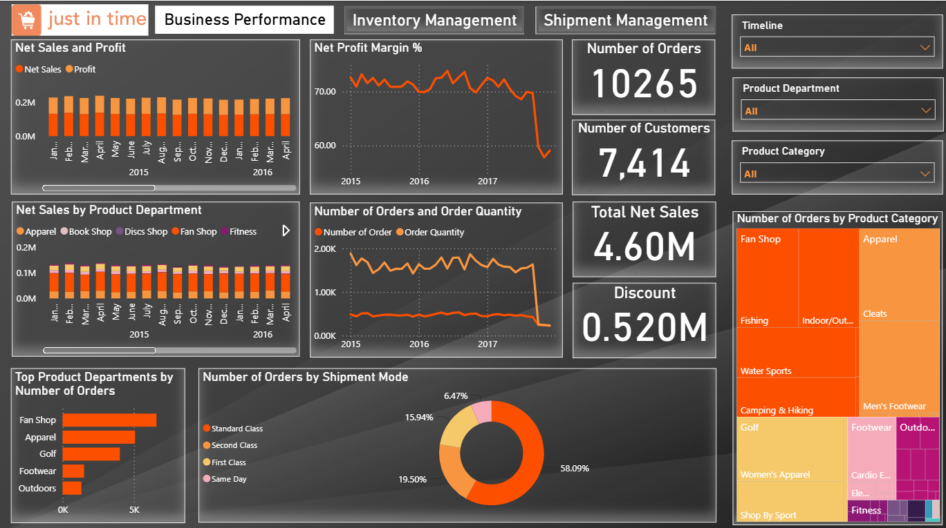
Key metrics include:
- Total Net Sales
- Total Profit
- Profit Margin
- Number of Orders
- Number of Customers
- Product Department Performance
- Product Category Analysis
- Shipment Mode Distribution
- Sales Trends
- Order Quantity Trends
Interactive filters allow users to analyze performance across different timelines, departments, and product categories.
Page 2 – Inventory Management Dashboard
This dashboard focuses on warehouse inventory optimization.
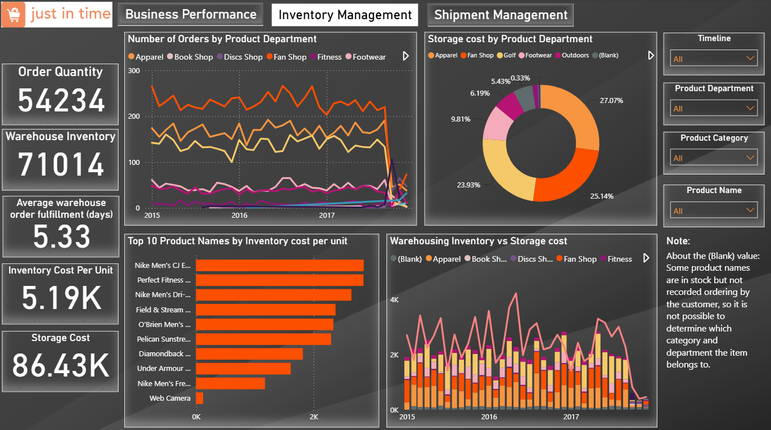
The analysis includes:
- Warehouse Inventory
- Order Quantity
- Inventory Cost Per Unit
- Storage Cost
- Product Department Inventory
- Warehouse Inventory Trends
- Inventory Cost by Product
- Storage Cost Distribution
The dashboard helps identify inventory utilization and warehouse cost patterns.
Page 3 – Shipment Management Dashboard
The shipment dashboard evaluates logistics performance.
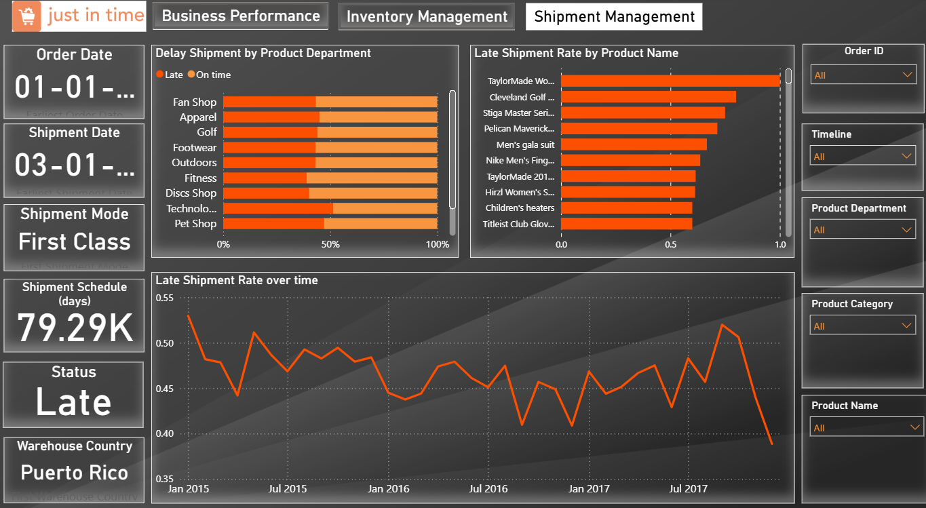
Major analyses include:
- Shipment Status
- Shipment Mode
- Delivery Schedule
- Late Shipment Rate
- Delay Analysis by Product Department
- Shipment Trend Analysis
- Product-wise Delay Rate
This page enables monitoring of delivery efficiency and shipment reliability.

2.5.5 Key Performance Indicators (KPIs)
The dashboard tracks important operational KPIs, including:
- Total Net Sales
- Total Profit
- Profit Margin (%)
- Number of Orders
- Number of Customers
- Warehouse Inventory
- Inventory Cost per Unit
- Storage Cost
- Shipment Delay Rate
- Order Quantity
These KPIs provide a comprehensive view of overall supply chain performance.

2.5.6 Analysis Performed
The following business analyses were conducted:
Business Performance Analysis
- Sales trend analysis
- Profit margin evaluation
- Customer analysis
- Product department performance
- Product category contribution
Inventory Analysis
- Warehouse inventory monitoring
- Inventory cost analysis
- Storage cost evaluation
- Product inventory distribution
Shipment Analysis
- Shipment delay analysis
- Delivery schedule monitoring
- Shipment mode comparison
- Product-wise shipment performance

2.5.7 Key Insights
- Business performance remained stable with consistent sales and customer orders.
- Certain product departments generated significantly higher sales compared to others.
- Inventory costs varied considerably across product categories.
- Warehouse storage costs were concentrated among a few major departments.
- Standard shipping accounted for the majority of shipments.
- Shipment delays were observed across multiple product departments, indicating opportunities for logistics improvement.
- Product-level shipment analysis highlighted items with consistently higher delay rates.
- Interactive dashboards enabled faster identification of operational bottlenecks.

2.5.8 Business Recommendations
Based on the analysis, the following recommendations are proposed:
- Improve inventory planning for high-demand product categories.
- Optimize warehouse storage allocation to reduce operational costs.
- Monitor shipment delays regularly using KPI dashboards.
- Strengthen logistics planning for departments with higher delay rates.
- Focus on high-performing product departments to maximize revenue.
- Improve forecasting for inventory replenishment.
- Enhance shipment tracking to improve customer satisfaction.
- Continue using business intelligence dashboards for operational monitoring.

2.5.9 Conclusion
The Supply Chain Analysis project successfully transformed operational business data into an interactive Power BI dashboard that provides meaningful insights into sales performance, inventory management, and shipment operations.
The dashboard enables organizations to monitor key business metrics, identify operational inefficiencies, evaluate warehouse performance, and improve shipment reliability through data-driven decision-making.
Overall, this project demonstrates the effective application of Power BI for supply chain analytics and highlights how business intelligence solutions can support efficient inventory management, logistics optimization, and organizational performance improvement.

2.6 WEEK 6: AI-Driven Financial Fraud Analytics System (Machine Learning, SQL, Power BI & Streamlit)
2.6.1 Project Overview
The AI-Driven Financial Fraud Analytics System is an end-to-end business intelligence and machine learning solution developed to detect fraudulent financial transactions and provide actionable business insights through interactive dashboards and a web application.
The project integrates data preprocessing, exploratory data analysis, feature engineering, machine learning, SQL analytics, Power BI dashboard development, and Streamlit deployment to create a complete fraud detection system. The solution enables financial institutions to monitor transaction behavior, identify suspicious activities, and support real-time fraud prediction.
2.6.2 Exploratory Data Analysis (EDA)
Exploratory Data Analysis (EDA) was performed to understand the structure, quality, and characteristics of the financial transaction dataset before building predictive models. Statistical summaries and visualizations were created to identify fraud patterns, transaction behavior, and relationships among variables.
The following analyses were performed:
- Dataset Structure and Missing Value Analysis
- Fraud vs Genuine Transaction Distribution
- Transaction Type Distribution
- Fraud Distribution by Transaction Type
- Transaction Amount Distribution
- Transaction Amount Boxplot
- Correlation Heatmap
- Feature Importance Analysis
- Daily Transaction Trend
- Fraud Trend Analysis
The EDA revealed that fraudulent transactions represented only a very small percentage of the dataset, indicating a highly imbalanced classification problem. It also showed that fraudulent activities were concentrated mainly in TRANSFER and CASH_OUT transactions, providing valuable insights for feature engineering and model development.
2.6.3 Feature Engineering
Feature engineering was carried out to improve the predictive capability of the fraud detection model by generating new variables that better represent transaction behavior.
The following engineered features were created:
- Balance Origin Difference
- Balance Destination Difference
- Amount-to-Balance Ratio
- High Value Transaction Indicator
- Zero Balance Sender Indicator
- Zero Balance Receiver Indicator
- Hour of Transaction
- Day of Transaction
These newly created features helped capture hidden transaction patterns and significantly enhanced the model's ability to distinguish between genuine and fraudulent transactions.
2.6.4 Machine Learning Model Development
The cleaned and feature-engineered dataset was divided into training and testing datasets using an 80:20 split. The target variable was isFraud, where fraudulent transactions were labeled as 1 and genuine transactions as 0.
The following machine learning algorithms were implemented:
- Random Forest Classifier
- Isolation Forest
The Random Forest Classifier was selected as the primary prediction model due to its high accuracy, robustness, ability to handle imbalanced datasets, and resistance to overfitting. The Isolation Forest algorithm was implemented as an anomaly detection model for comparison.
The trained Random Forest model was saved using Joblib and integrated into the Streamlit web application to enable real-time fraud prediction.
2.6.5 Model Evaluation
The developed machine learning models were evaluated using standard classification metrics to assess prediction performance.
The following evaluation metrics were used:
- Accuracy
- Precision
- Recall
- F1-Score
- ROC-AUC Score
- Confusion Matrix
- ROC Curve
The Random Forest model demonstrated excellent predictive performance by effectively identifying fraudulent transactions while minimizing false predictions. Based on the evaluation results, Random Forest was selected as the final deployment model.
2.6.6 SQL-Based Fraud Analytics
SQL was used to perform business-oriented analysis on financial transaction data and generate meaningful fraud-related insights.
The SQL analysis included:
- Total Number of Transactions
- Total Fraudulent Transactions
- Fraud Rate Calculation
- Fraud by Transaction Type
- Average Transaction Amount
- Highest Transaction Amount
- High Value Transaction Analysis
- Daily Transaction Summary
- Fraud Trend Analysis
- Fraud Percentage by Transaction Type
- Balance Analysis
- Top Fraudulent Transactions
- Summary Reports
These SQL queries demonstrate how structured databases can be efficiently analyzed to support financial decision-making and fraud monitoring.
2.6.7 Power BI Dashboard Development
An interactive Power BI dashboard was developed to provide executives and analysts with a comprehensive overview of fraud statistics, transaction behavior, and financial performance.
The dashboard includes executive KPI cards and multiple interactive visualizations that enable users to monitor fraud activities efficiently.
Dashboard KPIs
- Total Transactions
- Fraud Transactions
- Fraud Rate
- Average Transaction Amount
- Highest Transaction Amount
- High Value Transactions
Dashboard Visualizations
- Fraud by Transaction Type
- High Value Transaction Distribution
- Transaction Amount by Type
- Transaction Type Distribution
- Fraud Rate Gauge
- Fraud Trend Over Time
Interactive filters allow users to dynamically explore fraud patterns and transaction behavior, supporting faster and more informed business decisions.
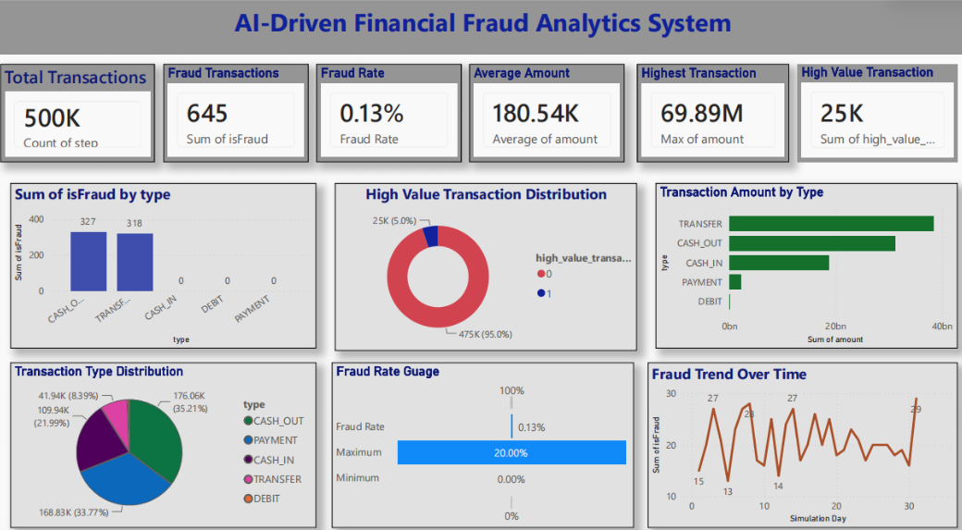
2.6.8 Streamlit Web Application
A user-friendly Streamlit web application was developed to provide an interactive interface for fraud analytics and real-time fraud prediction.
The application integrates the trained Random Forest model with analytical dashboards, allowing users to perform predictions and visualize fraud statistics without requiring technical expertise.
The application consists of the following modules:
Dashboard
Displays project overview, fraud KPIs, transaction statistics, and business highlights.
Analytics
Provides interactive charts for fraud distribution, transaction type analysis, and transaction amount visualization.
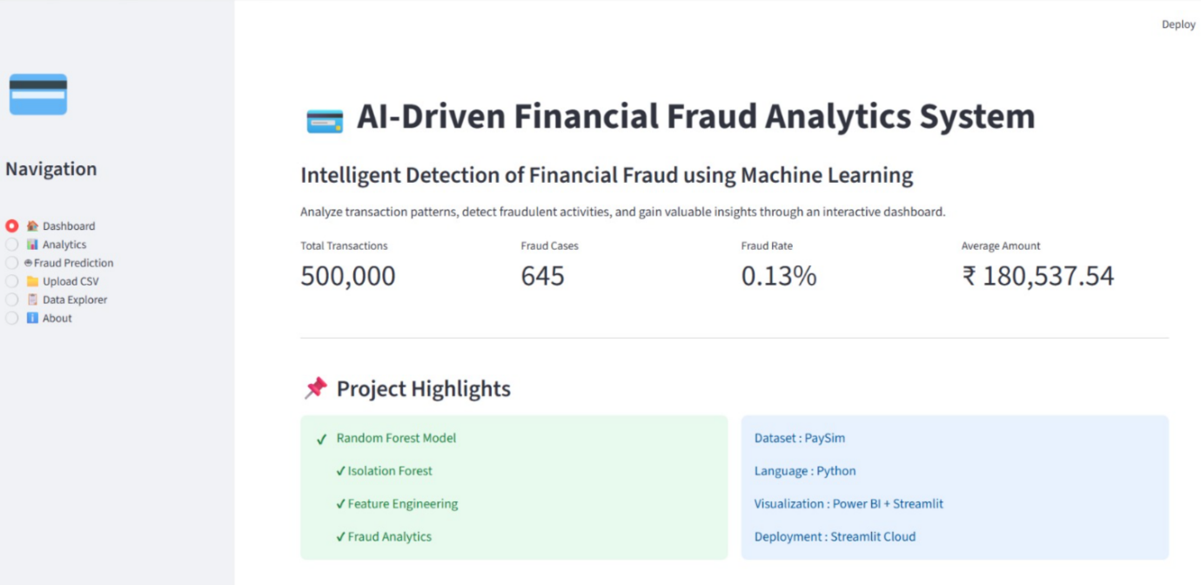
Fraud Prediction
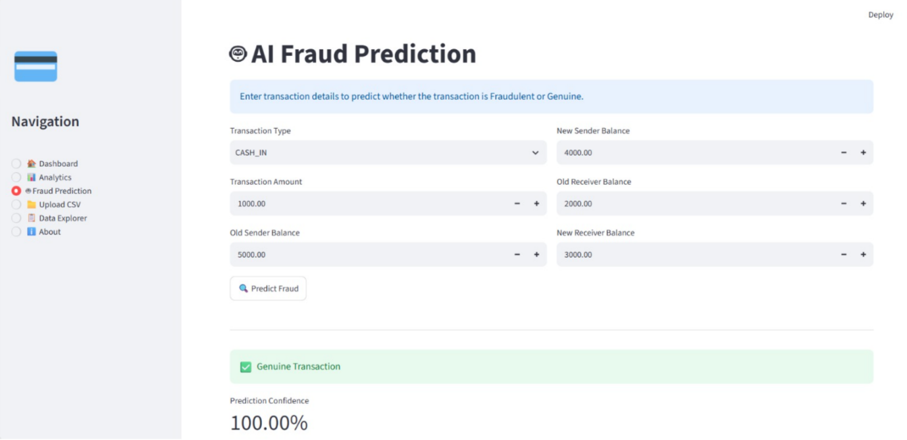
Allows users to enter transaction details and predicts whether the transaction is fraudulent or genuine. The application also displays prediction confidence and risk assessment.
Upload Dataset
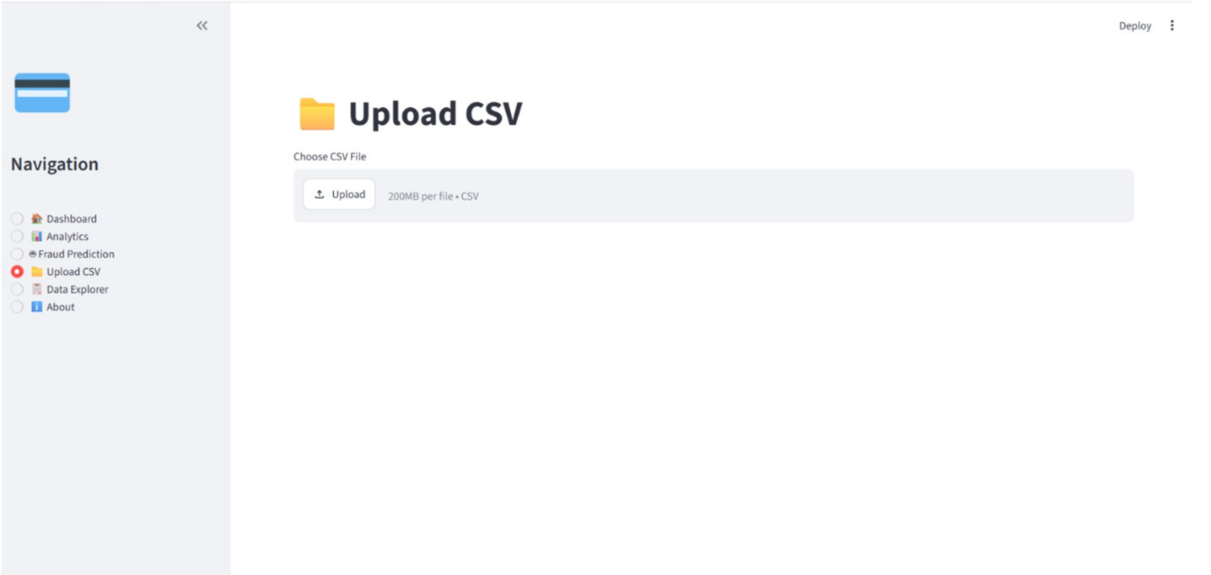
Allows users to upload transaction datasets for further analysis
Data Explorer
Displays dataset records, dimensions, missing value analysis, and statistical summaries.
About
Provides project description, technologies used, objectives, and developer information.
2.6.9 Key Performance Indicators (KPIs)
The system continuously monitors the following KPIs:
- Total Transactions
- Fraud Transactions
- Fraud Rate
- Average Transaction Amount
- Highest Transaction Amount
- High Value Transactions
- Fraud by Transaction Type
- Fraud Prediction Confidence
- Transaction Distribution
- Daily Fraud Trend
These KPIs provide decision-makers with a comprehensive overview of fraud activity and overall financial transaction behavior.
2.6.10 Analysis Performed
The following analyses were conducted during the project:
Transaction Analysis
- Transaction Volume Analysis
- Transaction Amount Distribution
- Transaction Type Analysis
- High Value Transaction Analysis
Fraud Analysis
- Fraud Distribution
- Fraud by Transaction Type
- Fraud Rate Analysis
- Fraud Trend Analysis
Machine Learning Analysis
- Random Forest Classification
- Isolation Forest Anomaly Detection
- Model Evaluation
- Feature Importance Analysis
Business Intelligence Analysis
- SQL-Based Fraud Analytics
- Power BI Interactive Dashboard
- Streamlit Web Application
- Real-Time Fraud Prediction
2.6.11 Key Insights
The project generated several valuable business insights:
- The dataset contained approximately 500,000 financial transactions, with only 645 fraudulent transactions, indicating a highly imbalanced dataset.
- Fraudulent transactions were primarily concentrated in TRANSFER and CASH_OUT transaction types.
- High-value transactions exhibited a greater probability of fraudulent activity.
- Feature engineering significantly improved fraud detection performance by capturing transaction behavior more effectively.
- The Random Forest model achieved reliable classification performance and was selected for deployment.
- SQL analytics enabled efficient extraction of fraud-related business insights.
- The Power BI dashboard provided an executive view of fraud statistics and transaction patterns.
- The Streamlit application successfully integrated machine learning with interactive analytics, enabling real-time fraud prediction through an intuitive interface.
2.6.12 Business Recommendations
Based on the project findings, the following recommendations are proposed:
- Implement AI-based fraud detection for real-time transaction monitoring.
- Continuously update machine learning models using recent transaction data.
- Closely monitor high-value transactions and suspicious transfer activities.
- Deploy interactive dashboards for continuous fraud surveillance.
- Integrate SQL analytics into operational reporting systems.
- Strengthen fraud prevention strategies for high-risk transaction categories.
- Periodically retrain machine learning models to adapt to emerging fraud patterns.
- Incorporate additional behavioral features to further improve prediction accuracy.
2.6.13 Conclusion
The AI-Driven Financial Fraud Analytics System successfully demonstrates the integration of Machine Learning, SQL, Power BI, and Streamlit to develop a comprehensive fraud detection solution.
The project transformed raw financial transaction data into meaningful business insights through data preprocessing, exploratory data analysis, feature engineering, machine learning model development, SQL analytics, interactive dashboards, and real-time web deployment. The Random Forest model effectively classified fraudulent transactions, while the Streamlit application enabled users to perform fraud prediction through an intuitive and interactive interface.
Overall, the project highlights the practical application of Artificial Intelligence and Business Intelligence techniques in financial fraud detection, demonstrating how data-driven solutions can help financial institutions reduce fraud risks, improve operational efficiency, and support informed decision-making.

CHAPTER 3: CONCLUSION
3.1 Overall Learning Outcomes
The six-week Data Analytics Internship at Global Next Consulting India Pvt. Ltd. provided comprehensive practical exposure to the complete data analytics lifecycle, including data collection, preprocessing, exploratory data analysis, visualization, statistical analysis, dashboard development, and machine learning.
Throughout the internship, I successfully completed six industry-oriented projects covering diverse business domains such as customer analytics, e-commerce, agriculture, financial analytics, retail analytics, and sales forecasting. Each project enhanced my ability to solve real-world business problems using data-driven approaches while strengthening my understanding of analytical methodologies and business intelligence practices.
The internship significantly improved my technical proficiency in Microsoft Excel, Advanced Excel, PostgreSQL, Python, Tableau, Power BI, Machine Learning, and Data Visualization. I also gained practical experience in developing interactive dashboards, performing business analysis, creating predictive models, and communicating analytical findings through professional reports and presentations.
Beyond technical knowledge, the internship strengthened essential professional competencies such as analytical thinking, problem-solving, critical reasoning, time management, documentation, presentation skills, and effective communication. Overall, this internship bridged the gap between academic learning and industry expectations, providing valuable hands-on experience in applying data analytics techniques to real business scenarios.

5.2 Internship Experience & Industry Exposure
The internship offered valuable exposure to an industry-oriented learning environment where theoretical concepts were translated into practical business applications. Weekly project assignments encouraged independent problem-solving, structured analytical thinking, and the application of modern data analytics tools to solve real-world challenges.
Working across multiple domains improved my ability to understand business requirements, analyze large datasets, identify meaningful patterns, and present actionable insights through interactive dashboards and visual reports. The internship also provided experience in documenting analytical workflows, delivering project presentations, and maintaining professional standards throughout the project lifecycle.
Furthermore, the final capstone project on Retail Sales Forecasting & Inventory Optimization enabled me to integrate data analytics, machine learning, forecasting techniques, inventory management concepts, and business intelligence into a comprehensive end-to-end solution. This experience strengthened my confidence in handling practical analytical projects similar to those encountered in professional organizations.
5.3 Future Scope
The knowledge and practical skills acquired during this internship provide a strong foundation for pursuing advanced roles in Data Analytics and Business Intelligence. Future enhancements to the projects completed during the internship may include:
- Developing real-time analytics dashboards using cloud-based platforms.
- Integrating big data technologies for large-scale data processing.
- Applying advanced machine learning and deep learning models for improved predictive analytics.
- Deploying analytical solutions as web-based applications using Streamlit or cloud services.
- Automating end-to-end data pipelines using ETL and workflow orchestration tools.
- Incorporating real-time business data for continuous monitoring and decision support.
- Exploring advanced analytics using Microsoft Fabric, Databricks, and cloud-based data platforms.
The experience gained during this internship has established a strong practical foundation for contributing effectively to data-driven organizations and pursuing a professional career in Data Analytics, Business Intelligence, and Artificial Intelligence.

REFERENCES
- Kaggle. Public Datasets for Data Analytics and Machine Learning Projects.
https://www.kaggle.com/datasets
- Microsoft. Microsoft Excel Documentation.
https://support.microsoft.com/excel
- Microsoft. Power BI Documentation.
https://learn.microsoft.com/power-bi
- Tableau. Tableau Desktop Documentation.
https://help.tableau.com
- PostgreSQL Global Development Group. PostgreSQL Documentation.
https://www.postgresql.org/docs/
- Python Software Foundation. Python Documentation.
https://docs.python.org/3/
- Pandas Development Team. Pandas Documentation.
https://pandas.pydata.org/docs/
- NumPy Developers. NumPy Documentation.
https://numpy.org/doc/
- Matplotlib Development Team. Matplotlib Documentation.
https://matplotlib.org/stable/
- Plotly Technologies Inc. Plotly Python Documentation.
https://plotly.com/python/
- Scikit-learn Developers. Machine Learning in Python – Scikit-learn Documentation.
https://scikit-learn.org/stable/
- Statsmodels Developers. Statsmodels Documentation.
https://www.statsmodels.org/
- Meta. Prophet Forecasting Documentation.
https://facebook.github.io/prophet/
- XGBoost Developers. XGBoost Documentation.
https://xgboost.readthedocs.io/
- W3Schools. SQL Tutorial and Reference.
https://www.w3schools.com/sql/
- HackerRank. SQL Practice Problems.
https://www.hackerrank.com/domains/sql
- GeeksforGeeks. Data Analytics, Python and SQL Learning Resources.
https://www.geeksforgeeks.org/
- Towards Data Science. Articles on Data Analytics, Machine Learning and Business Intelligence.
https://towardsdatascience.com/
- IBM SkillsBuild & IBM Documentation. Data Analytics Learning Resources.
https://skillsbuild.org/
- Global Next Consulting India Pvt. Ltd. Internship Guidelines, Weekly Project Materials and Learning Resources.

