**Project Report**

**RouteMind: An Intelligent Route Finder**

***By***

*Mishkat Fatima – 221336*

*Ayesha Khalid– 221408*

*Aamna Ibrahim Qureshi – 221438*

***Submitted To:***

*Ma’am Warda Aslam*



**Department of Computer Science**

**Air University Islamabad (AU)**

**Table Of Content**

1. Introduction: 3

2. Problem Statement: 3

3. Problem Solution / Objectives of the Proposed System: 3

4. Tools and Technologies: 4

5. System Design: 4

5.1 Architecture Overview: 4

5.2 System Architecture Diagram: 5

5.2 Methodology: 5

5.3 Justification of Selected AI Techniques: 6

6. Test Results and Evaluation: 6

6.1 Test Scenarios: 6

6.2 Sample Output: 6

6.3 Performance Discussion: 9

6.4 Limitations: 10

7. Output: 10

8. Conclusion: 11

# Introduction:

In today's smart cities, efficient route planning is essential for intelligent transportation systems. Traditional algorithms like A* provide the shortest path but fail to consider real-world dynamic conditions such as traffic, weather, road quality, and time of day. RouteMind bridges this gap by integrating fuzzy logic with the A search algorithm*, allowing the route cost to be intelligently adjusted based on uncertain and subjective inputs. This enhances real-world usability for logistics, ride-sharing apps, and navigation systems.

# Problem Statement:

Current navigation algorithms typically assume that all roads are equal apart from their distance, which oversimplifies real-world travel scenarios. In practice, route efficiency is influenced by several dynamic and environmental factors such as traffic congestion, adverse weather conditions, road surface quality, the time of day—particularly during rush hours versus off-peak periods—and the type of road, whether it’s a highway or a local street. These elements can significantly affect travel time and safety. Therefore, there is a clear need for a more intelligent cost evaluation system that incorporates these variables during pathfinding to provide more realistic and effective route suggestions.

# Problem Solution / Objectives of the Proposed System:

**RouteMind** is an intelligent route optimization system designed to adapt to real-world conditions using advanced AI techniques. Its key objectives include:

* **Fuzzy Logic Integration**: Incorporates fuzzy logic to handle subjective and uncertain factors such as traffic congestion, weather conditions, road quality, time of day, and road type—enabling more human-like decision-making.
* **Optimal Pathfinding with A\***: Utilizes the A* algorithm to compute the most efficient path between two nodes in a weighted graph, ensuring both speed and accuracy.
* **Dynamic Visualization**: Provides a clear graphical representation of the calculated optimal route, allowing users to easily interpret and evaluate results.
* **Custom Parameter Simulation**: Supports flexible input of real-world variables (e.g., traffic = 7, weather = 6) for interactive experimentation and testing across diverse scenarios.

This makes RouteMind a smart, adaptive route suggestion system useful in dynamic environments.

# Tools and Technologies:

|  |  |  |
| --- | --- | --- |
| **Category** | **Technology** | **Purpose** |
| **Frontend** | Tkinter  CustomTkinter | For creating the graphical user interface where users can input conditions like traffic, weather, etc. |
| **Backend** | Python | Serves as the core development platform for processing input, running fuzzy logic, and executing the A* algorithm. |
| **Logic Engine** | scikit-fuzzy | Implements the fuzzy logic controller that evaluates complex conditions (traffic, weather, etc.) to compute dynamic costs. |
| **Graph Engine** | NetworkX | Manages graph data structures and performs A* search for optimal routing. |
| **Visualization** | Matplotlib | Displays the graph and highlights the optimal path based on computed fuzzy-adjusted costs. |
| **Math Engine** | NumPy | Used for efficient numerical calculations and vector-based operations like computing distances. |

# System Design:

## Architecture Overview:

The RouteMind system is structured into modular components to ensure separation of concerns and scalability. The architecture includes the following key components:

* **User Interface Layer (Tkinter):** Accepts user inputs like traffic level, weather, time of day, etc.
* **Fuzzy Logic Engine (scikit-fuzzy):** Converts real-world inputs into a fuzzy-adjusted route cost.
* **Routing Engine (NetworkX with A*):** Calculates the optimal path using A* algorithm, integrating fuzzy cost.
* **Visualization Layer (Matplotlib):** Displays the graph and highlights the chosen path.

## 5.2 System Architecture Diagram:

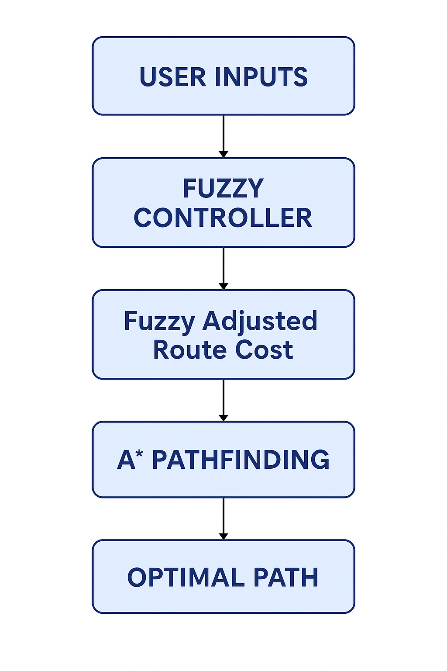

**Diagram Explanation:**

Data flows from the user input into the fuzzy logic controller, which calculates a dynamic cost based on environmental factors. This cost is used in the A* algorithm to determine the optimal path, which is then visualized.

## Methodology:

* The user inputs five parameters: traffic, weather, road condition, time of day, and road type.
* The fuzzy logic engine processes these inputs based on predefined fuzzy sets and rules to output a cost value.
* The cost is added as a modifier in the A* algorithm's weight function to influence route selection.
* The shortest path based on total adjusted cost is calculated and returned.
* The result is displayed graphically using matplotlib.

## Justification of Selected AI Techniques:

Fuzzy Logic was chosen because it can handle uncertain, subjective inputs like “traffic is high” or “road is poor,” which cannot be represented as binary or crisp values and A* Algorithm was selected for its optimality and speed in pathfinding on graphs, outperforming simpler algorithms.

# Test Results and Evaluation:

## Test Scenarios:

To evaluate RouteMind, several test cases were simulated by altering the fuzzy input variables. The objective was to observe changes in route cost and optimal path selection based on environmental factors.

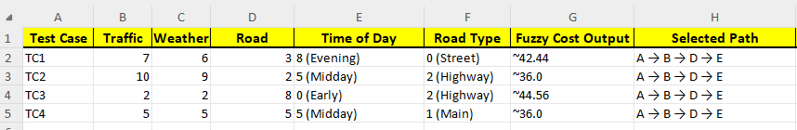

## Sample Output:

**For TC1:**

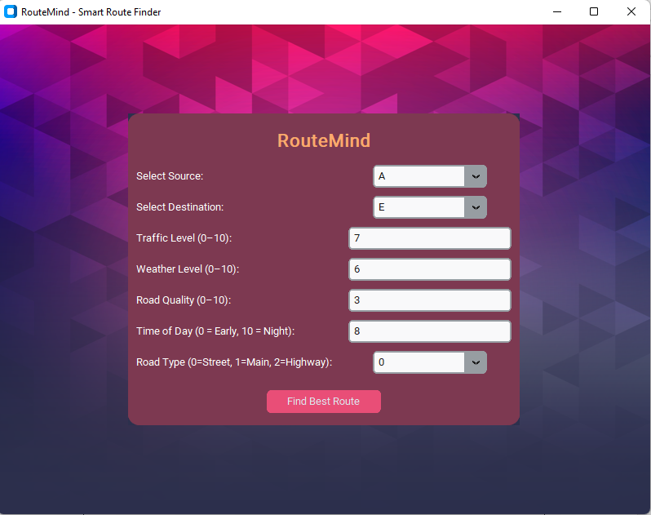

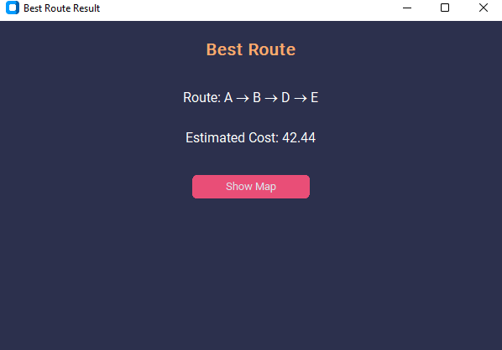

**For TC2:**

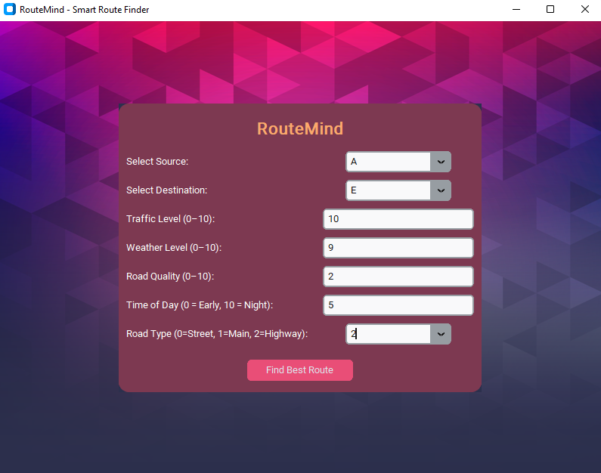

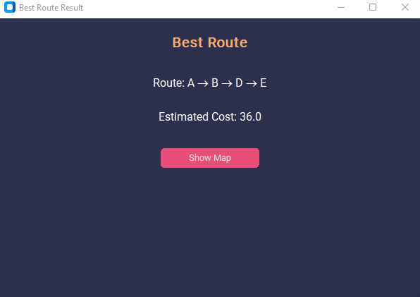

**For TC3:**

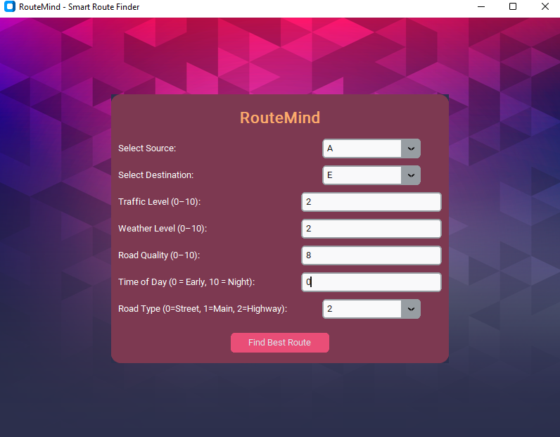

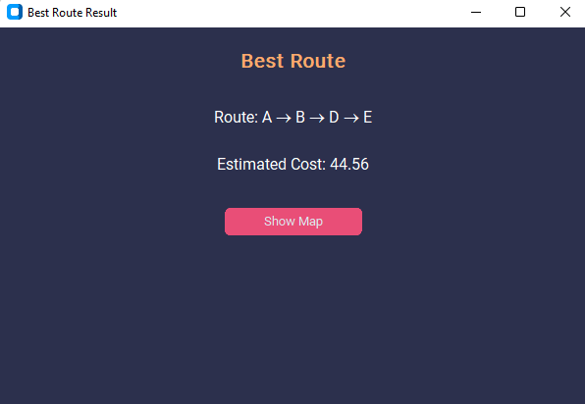

**For TC4:**

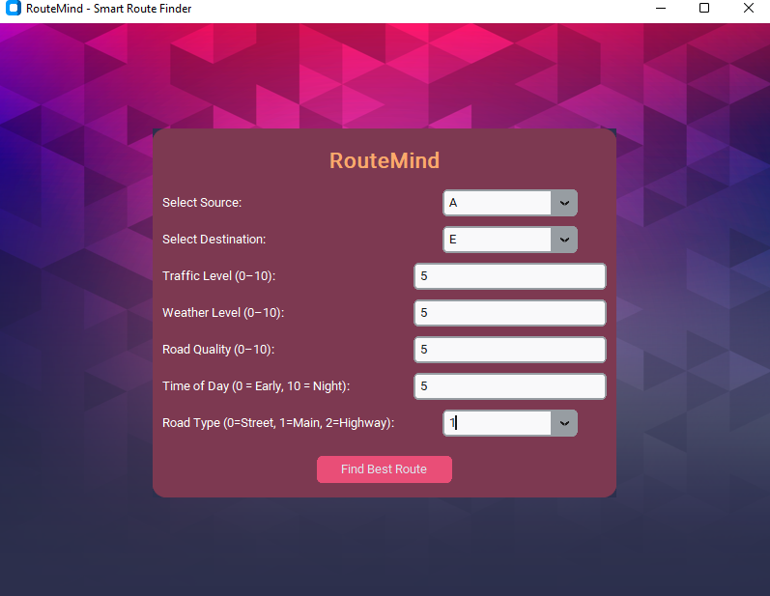

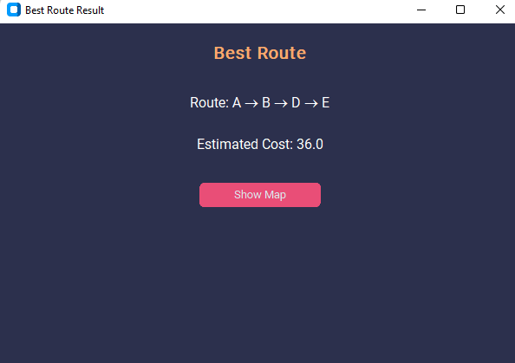

## Performance Discussion:

* The fuzzy cost dynamically adjusts based on inputs, proving the fuzzy logic layer is functioning correctly.
* The route stays optimal with changing conditions; for example, heavy traffic and poor weather result in higher costs, influencing A* to prefer alternate paths.
* The visualization component successfully reflects the selected path, ensuring clear understanding of the route.

## Limitations:

* The graph is currently small and hardcoded; it doesn’t reflect a real map.
* The system does not include real-time data input (e.g., live traffic from Google Maps).
* Scalability is limited — performance on large graphs is not tested.
* GUI is minimal and may be expanded for better user experience.

# Output:

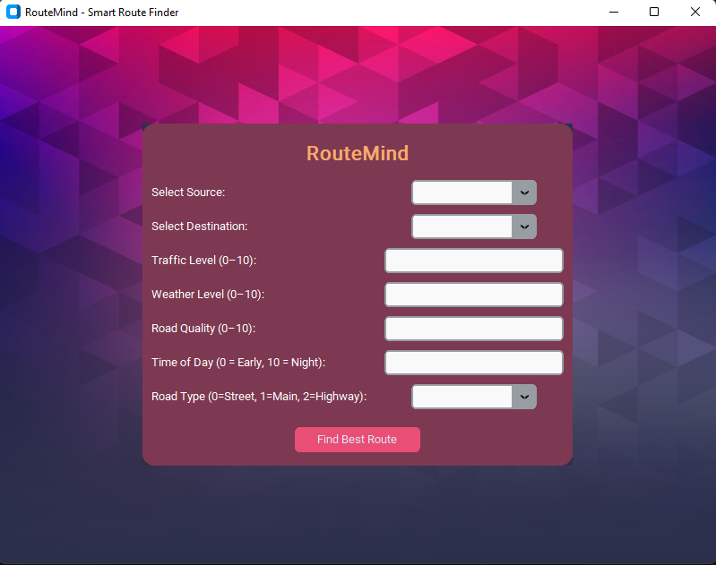

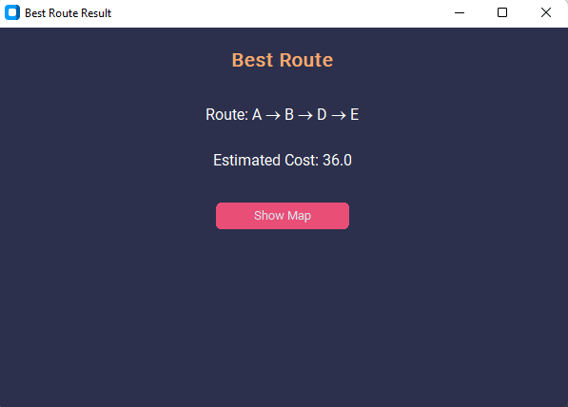

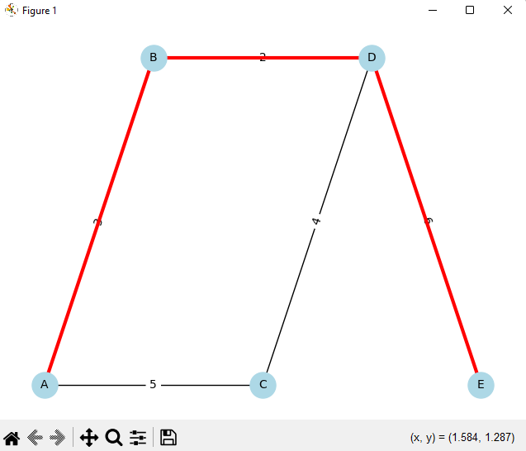

# Conclusion:

RouteMind combines the intelligence of fuzzy logic with the efficiency of the A algorithm* to build a smarter route planner that reflects real-life travel dynamics.