Baojian Integrated Camera-Control Unit
SDK Development Documentation
BKX16 / BKX18 Integrated Camera-Control Unit SDK
April 2024

Revision History
Version | Date | Revision Notes
V1.0 | 2024/04/22 | Created; distinct from the previous SDK version

Contents

I. SDK Documentation Overview
To make it easier for customers to perform secondary development based on the BKX16-series integrated camera-control unit, our company provides this SDK development package. This SDK package is updated and released from time to time according to actual needs, while keeping version compatibility as far as possible. Customers can decide whether to upgrade based on their own usage.

II. Interface Definitions
BketCameraControlAdapter is the external call class, and BketCameraControlIface is the external callback interface. Before calling, the aar package (bket_camera.aar) must be imported into the program before this class is used. For the software version, refer to the contents of the SDK archive released by the manufacturer.
The external interface functions of this class are as follows:
1.
public static synchronized BketCameraControlAdapter getInstance(BketCameraControlIface iface, Context context)
Description: Instantiate the BketCameraControlAdapter class.
Parameters: iface – callback interface; context – context.
2.
public int bkcam_openHostCamera()
Description: Open the main camera.
Parameters: none.
3.
public int bkcam_closeHostCamera()
Description: Close the main camera.
Parameters: none.
4.
public int bkcam_startHostRecord(String fileName)
Description: Start main-camera recording.
Parameters: fileName – recording file name, full path.
Return: 0 – main camera is already recording; 1 – recording can start.
5.
public int bkcam_stopHostRecord()
Description: Stop main-camera recording.
Parameters: none.
Return: none.
6.
public int bkcam_hostTakePic(String fileName)
Description: Take one picture with the main camera; saved file uses the .jpg suffix.
Parameters: fileName – image file name, full path.
7.
public int bkcam_openSubCamera()
Description: Open the sub camera.
Parameters: none.
8.
public int bkcam_closeSubCamera()
Description: Close the sub camera.
Parameters: none.
9.
public int bkcam_startSubRecord(String fileName)
Description: Start sub-camera recording.
Parameters: fileName – recording file name, full path.
Return: 0 – camera is already recording; 1 – recording can start.
10.
public int bkcam_stopSubRecord()
Description: Stop sub-camera recording.
Parameters: none.
Return: none.
11.
public int bkcam_subTakePic(String fileName)
Description: Take one picture with the sub camera; saved file uses the .jpg suffix.
Parameters: fileName – image file name, full path.
Return: none.
12.
public void bkcam_reset()
Description: Reset camera-related services; generally called when opening the camera or recording fails.
Parameters: none.
Return: none.
13.
public boolean bkcam_isHostRecording()
Description: Whether the main camera is recording.
Parameters: none.
Return: true – recording; false – not recording.
14.
public boolean bkcam_isSubRecording()
Description: Whether the sub camera is recording.
Parameters: none.
Return: true – recording; false – not recording.
15.
public void bkcam_setCameraParam(int sysVideoMode, int sysSectionMode,
int sysSectionVal, int hostVideoBitRate, int subVideoBitRate,
int hostCameraExposure, int subCameraExposure)
Description: Set parameters.
Parameter | Meaning / Values
sysVideoMode | 0: host 1080P / sub 720P  1: host 720P / sub 1080P  2: host 720P / sub 720P  3: valid only for models BKX16Plus and BKX18 — host 1080P / sub 1080P
sysSectionMode | 0: main segmented, sub not segmented  1: main not segmented, sub segmented  2: main segmented, sub segmented  3: main not segmented, sub not segmented
sysSectionVal | Segment file size, in MB, 2–10
hostVideoBitRate | Main-camera bitrate, in M, 2–8
subVideoBitRate | Sub-camera bitrate, in M, 2–8
hostCameraExposure | Main-camera exposure time, 0–24
subCameraExposure | Sub-camera exposure time, 0–24
16.
public void bkcam_setVideoMode(int sysVideoMode)
Description: Set the recording video format for the main and sub cameras.
Parameters: sysVideoMode:
0: host 1080P / sub 720P
1: host 720P / sub 1080P
2: host 720P / sub 720P
3: valid only for models BKX16Plus and BKX18 — host 1080P / sub 1080P
17.
public void bkcam_setSectionMode(int sysSectionMode)
Description: Set the segmentation mode for the main and sub recording video.
Parameters: sysSectionMode:
0: main segmented, sub not segmented
1: main not segmented, sub segmented
2: main segmented, sub segmented
3: main not segmented, sub not segmented
18.
public void bkcam_setHostVideoBitRate(int hostVideoBitRate)
Description: Set the main-camera bitrate.
Parameters: hostVideoBitRate – main-camera bitrate, in M, 2–8.
19.
public void bkcam_setSubVideoBitRate(int subVideoBitRate)
Description: Set the sub-camera bitrate.
Parameters: subVideoBitRate – sub-camera bitrate, in M, 2–8.
20.
public void bkcam_setSectionVal(int sysSectionVal)
Description: Set the recording segment size.
Parameters: sysSectionVal – segment file size, in MB, 2–10.
21.
public void bkcam_setHostCameraExposure(int hostCameraExposure)
Description: Set main-camera exposure.
Parameters: hostCameraExposure – main-camera exposure time, 0–24.
22.
public void bkcam_setSubCameraExposure(int subCameraExposure)
Description: Set sub-camera exposure.
Parameters: subCameraExposure – sub-camera exposure time, 0–24.
23.
public String bkcam_getCameraInfo()
Description: Get camera information.
Parameters: none.
Return: a JSON-format string.
24.
public String bkcam_getCameraLogPath()
Description: Get the SDK log path.
Parameters: none.
Return: path name.
25.
public boolean bkcam_hostCameraIsOnline()
Description: Query whether the main camera is online.
Parameters: none.
Return: true – online; false – not online.
26.
public boolean bkcam_subCameraIsOnline()
Description: Query whether the sub camera is online.
Parameters: none.
Return: true – online; false – not online.
27.
public String bkcam_bketGetSdkVersion()
Description: Read the SDK version number.
Parameters: none.
Return: SDK version number.
Note: the original document numbers two interfaces as 23; getCameraLogPath onward have been re-numbered sequentially here.

III. Callback Functions
- Main-camera recording complete; returns the current video file name.
void onInfoHostVideoFile(String fileName);
- Sub-camera recording complete; returns the current video file name.
void onInfoSubVideoFile(String fileName);
- Main-camera photo taken; returns the current image file name.
void onInfoHostTakePicFile(String fileName);
- Sub-camera photo taken; returns the current image file name.
void onInfoSubTakePicFile(String fileName);
- Returns main-camera status information.
void onInfoOpenHostCameraStatus(int status);
status | Meaning
-1 | Open failed
0 | Closed
1 | Opened successfully
2 | Recording
11 | Recording stopped successfully
10, 12 | Abnormal recording stop
- Returns sub-camera status information.
void onInfoOpenSubCameraStatus(int status);
status | Meaning
-1 | Open failed
0 | Closed
1 | Opened successfully
2 | Recording
11 | Recording stopped successfully
10, 12 | Abnormal recording stop

IV. Preparation
- Place the .aar file in the lib folder of the Android Studio project (project structure shown below).
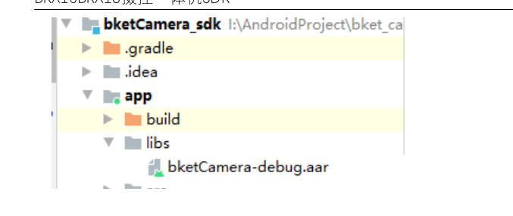
- Add the following to dependencies in build.gradle (Module):
implementation 'com.alibaba:fastjson:1.2.40'
implementation fileTree(dir: 'libs', include: ['*.aar'])
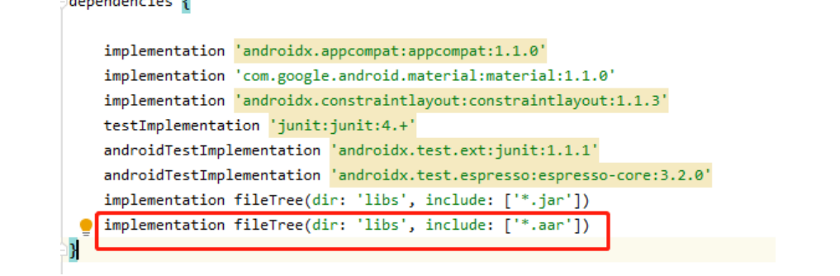
Actual build.gradle dependencies (original screenshot)
- Add the following to the project's AndroidManifest.xml file:
a. Service declarations:
<service android:name="com.bket.bketCamera.BketHostCameraService"></service>
<service android:name="com.bket.bketCamera.BketSubCameraService"></service>
<service android:name="com.bket.bketCamera.BketX18HostCameraService"></service>
<service android:name="com.bket.bketCamera.BketX18SubCameraService"></service>
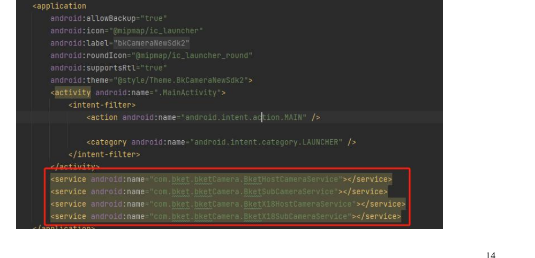
Service registration inside <application> (original screenshot)
b. Permissions and features:
<uses-permission android:name="android.permission.SYSTEM_ALERT_WINDOW" />
<uses-permission android:name="android.permission.INTERNET" />
<uses-permission android:name="android.permission.WRITE_EXTERNAL_STORAGE" />
<uses-permission android:name="android.permission.CAMERA" />
<uses-permission android:name="android.permission.RECORD_AUDIO" />
<uses-permission android:name="android.permission.MOUNT_UNMOUNT_FILESYSTEMS" />
<uses-permission android:name="android.permission.WRITE_EXTERNAL_STORAGE" />
<uses-permission android:name="android.permission.FLASHLIGHT" />
<uses-feature android:name="android.hardware.camera" />
<uses-feature android:name="android.hardware.camera.autofocus"/>
- Compile Android SDK version information:
compileSdkVersion 28
buildToolsVersion "28.0.2"

defaultConfig {
minSdkVersion 19
targetSdkVersion 28
versionCode 1
versionName "1.0"

testInstrumentationRunner "androidx.test.runner.AndroidJUnitRunner"
consumerProguardFiles "consumer-rules.pro"
}
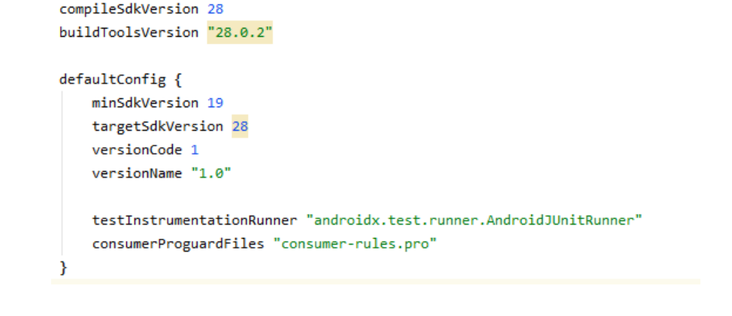
Actual compile configuration (original screenshot)

V. Usage Examples
- Declare variables:
private BketCameraControlAdapter bketCameraControlAdapter;
bketCameraControlAdapter = BketCameraControlAdapter.getInstance(this, getApplicationContext());
- Recording call flows:
a. Standard recording flow (main camera as example) — recommended.
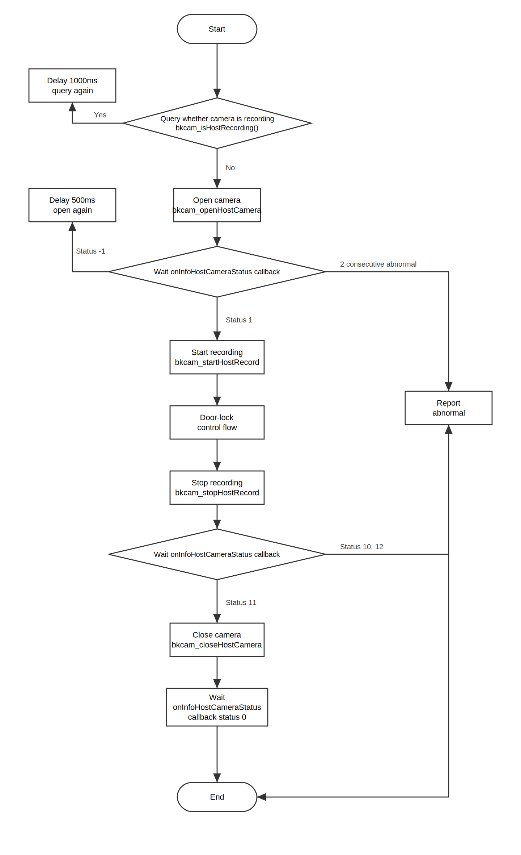
b. Simple flow (main camera as example) — recommended.
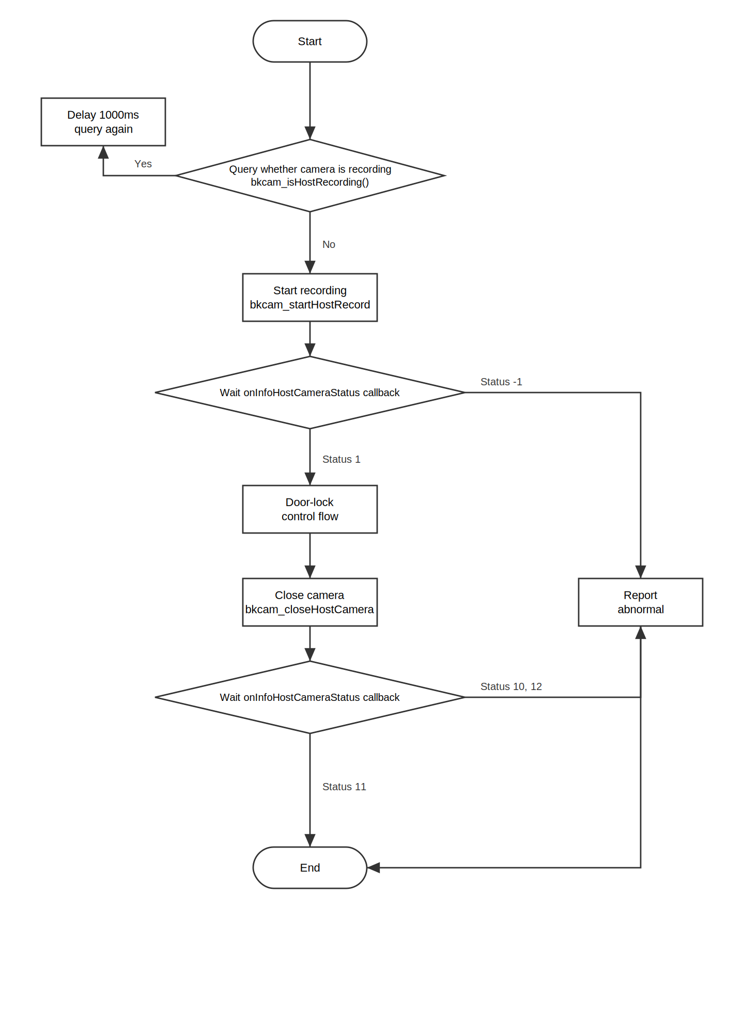
c. Fast flow (main camera as example).
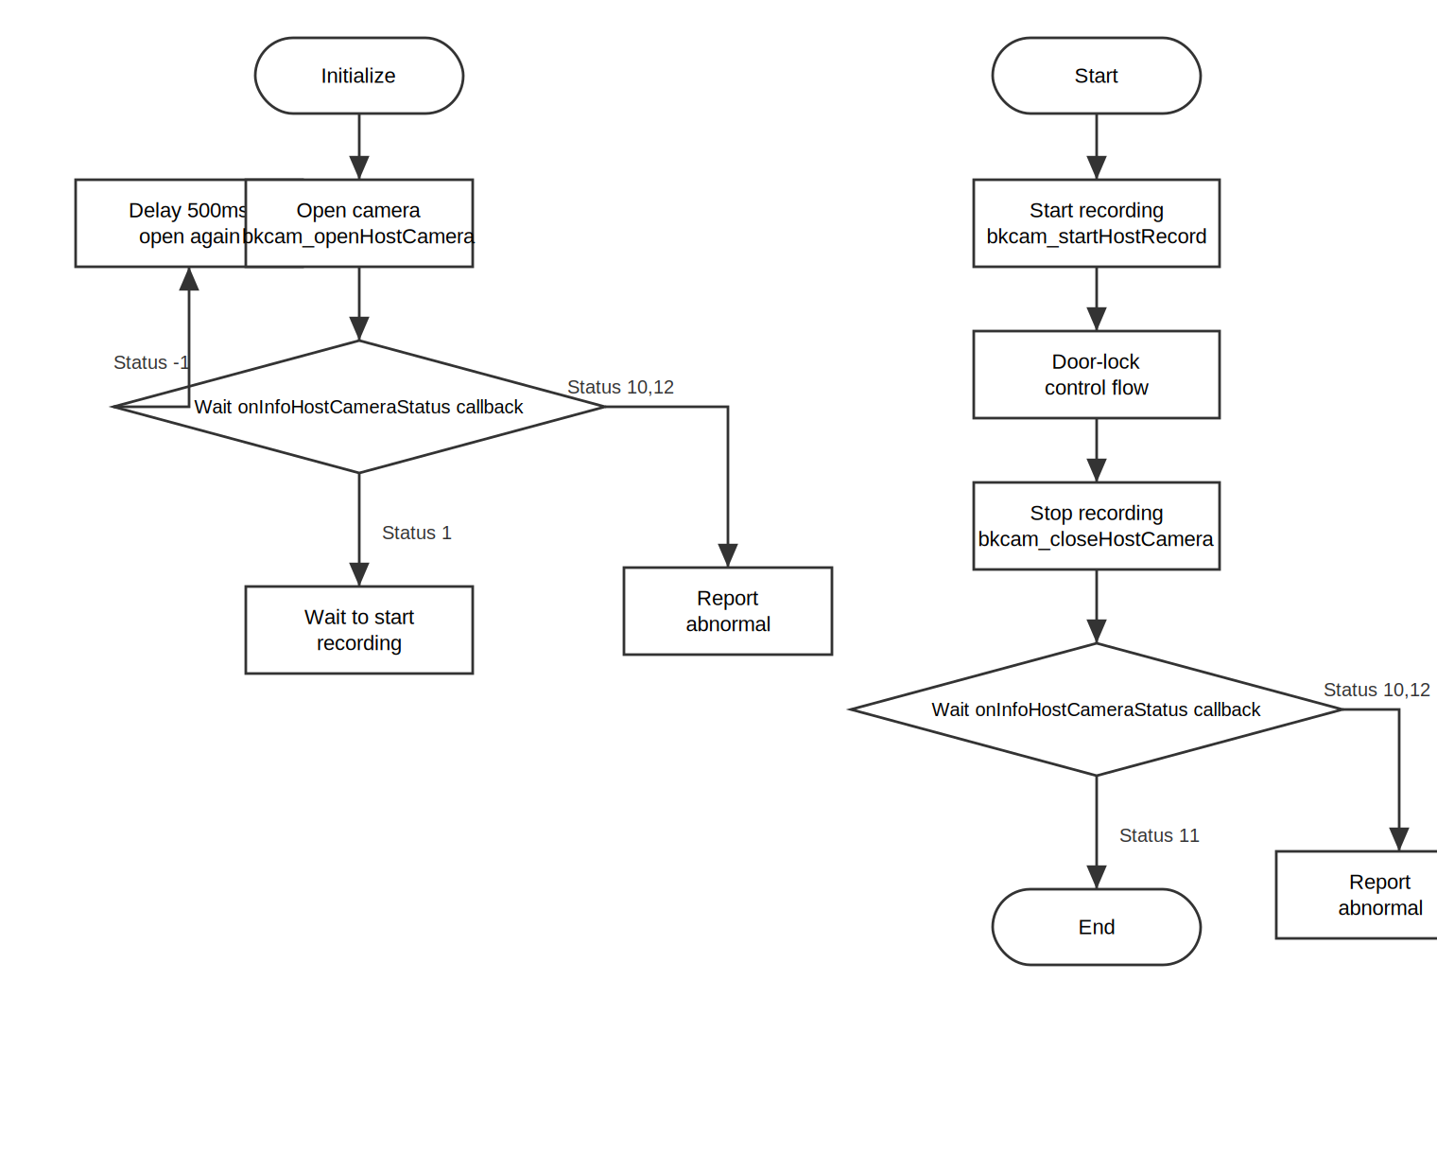
Note: With this flow, the camera stays in working state after being opened. Compared with the previous two flows, it will exhaust the camera's lifespan more quickly.

VI. Notes
Due to hardware resource limitations: if you are using our 8917 platform, recording two video streams and playing video at the same time will affect video recording. We recommend not playing video during the purchase process.

VII. Technical Support
Please contact Nanjing Baojian Electronic Technology Co., Ltd. for technical support.
Email: bkservice@bketek.com
Tel: 025-88017908
Fax: 025-88017908

