**NAME :** Ayesha Sajjad **Roll No:** 2022EE107 D

**Question # 1**

**(a)**

**Truth Table:**

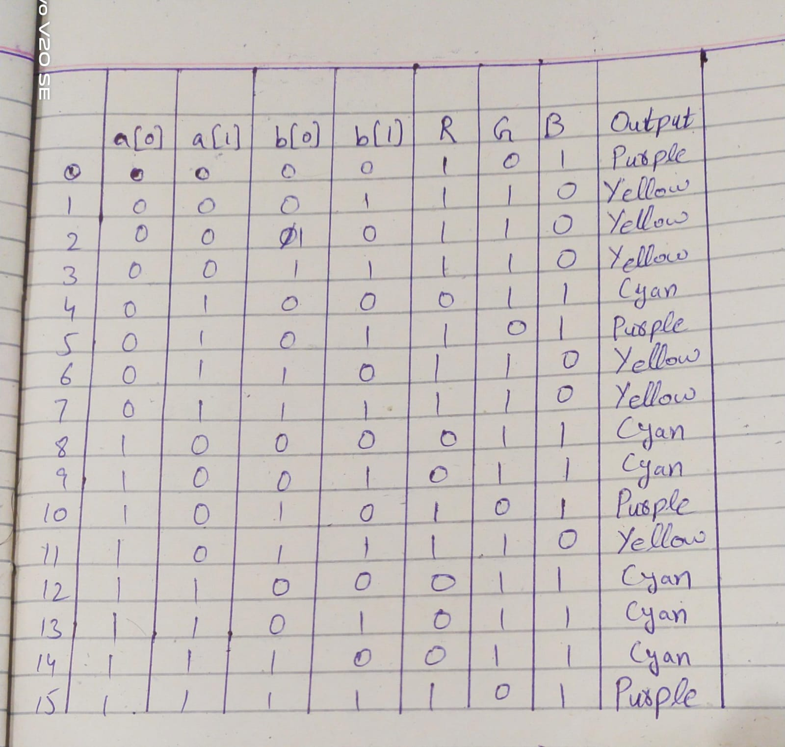

**(b)**

**K-Maps for RGB:**

**For RED LED:**

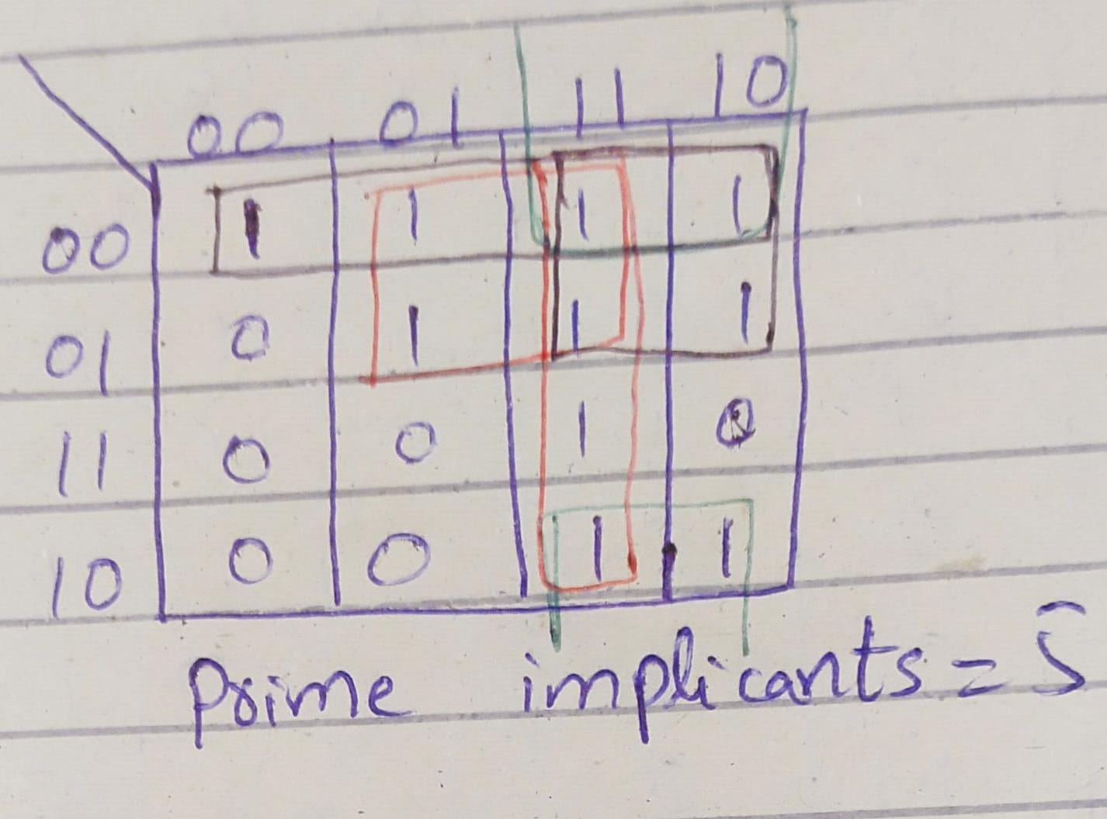

Equation:

a[0] a[1] + a[0] b[1] + b[0] b[1] + a[0] b[0] + a[1] b[0]

Essential Prime Implicants (5) = a[0]a[1]+a[0] b[1]+b[0] b[1]+a[0] b[0]+a[1]b[0]

**For GREEN LED:**

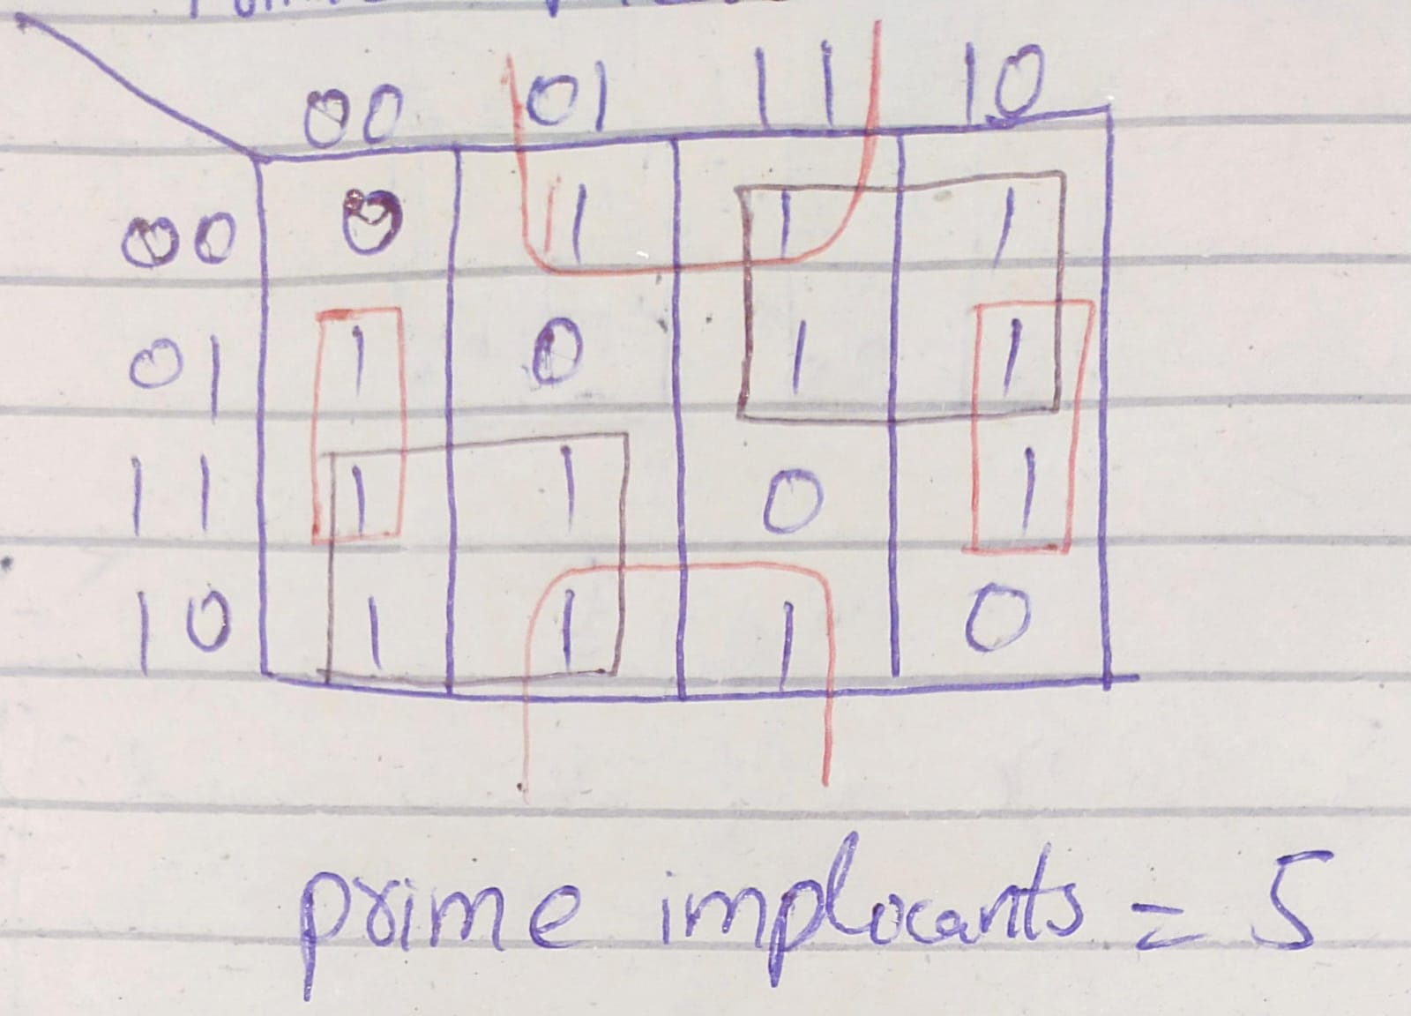

Equation:

a[0] b[0] + a[1] b[1] + a[1] b[1] + a[0] b[0]

Essential Prime Implicants = a[0]b[0]+a[0]a[1]b[1]+a[1]b[0]b[1]+a[1]b[0]b[1]+a[0]b[0]+a[0]a[1]b[1]

**For BLUE LED:**

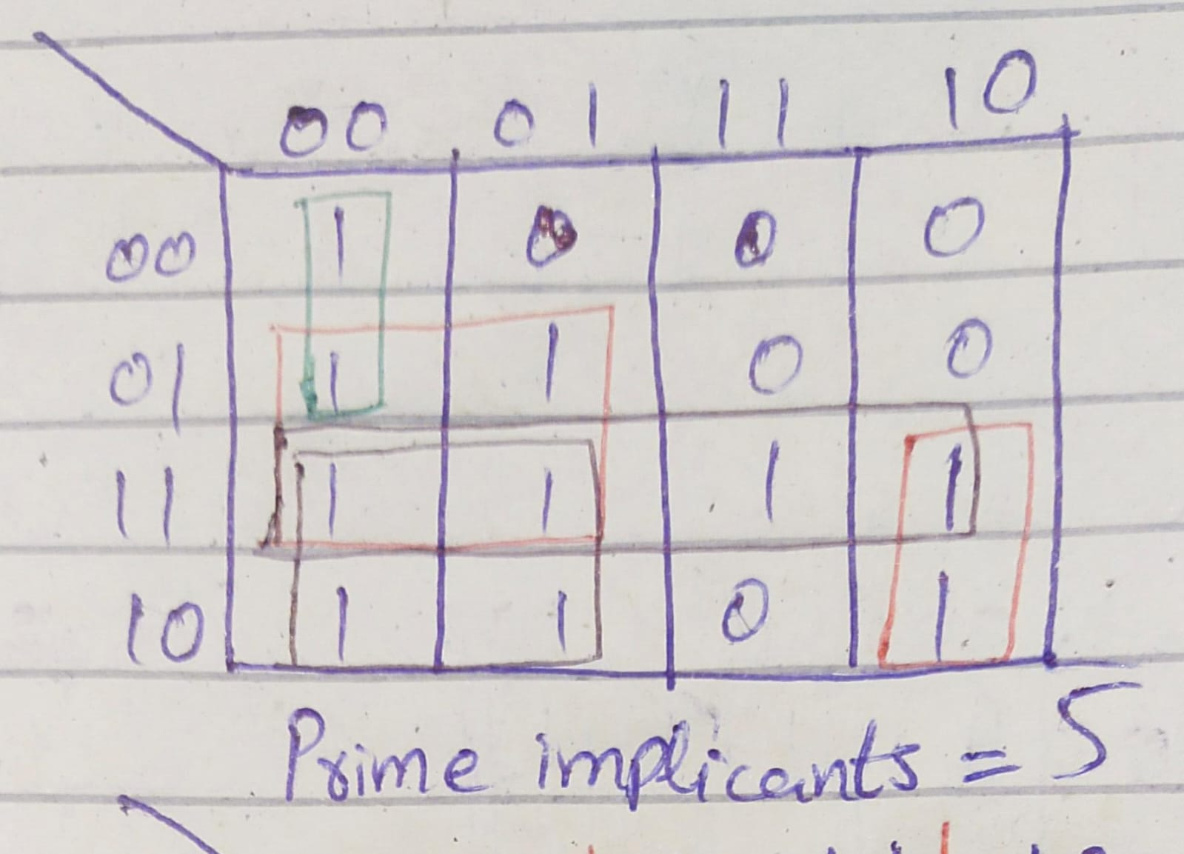

Equation:

b[0] b[1] + a[0] a[1] + a[1] b[0] + a[0] b[0] + a[0] b[1]

Essential Prime Implicants (5) =b[0] b[1] + a[0] a[1] + a[1] b[0] + a[0] b[0] + a[0] b[1]

**Combinational Delay:**

Maximum Combination delay is **8.824ns** from d1 to b.

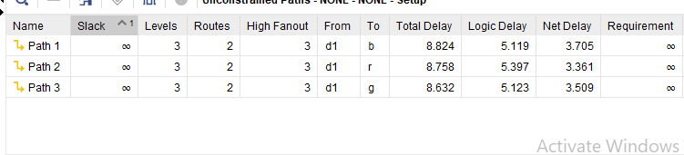**Schematics:**

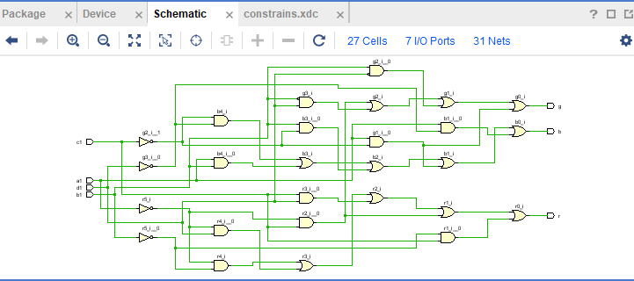

**Resource Utilization:**

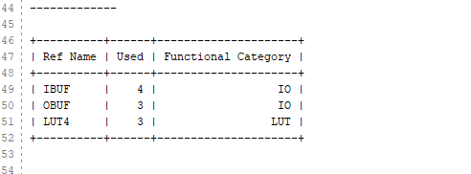

Total **10** resources are utilized in FPGA has been utilized.