**Complex Engineering Problem**

Understanding and designing networks is the main objective of this course. As a design &

planning engineer, you have to design a network that will cover the area of HITEC University

with a coverage space of 25,000 square feet. This network should be supportable to both wired

and wireless users; keeping in mind the demographics of the area, both in-door and out-door

coverage must be supported. The design must consider the environmental aspects and provide

good performance in every area of the university so that each student can be facilitated; there

should be no shadow area. The use of mobile devices presents a broad set of challenges, which

you've learned throughout this course. The students can use their imagination in designing

the network; you may opt for any networking protocol at any stage provided that the choice should

be justified through a valid reason. Before starting any work, a site survey is an important activity

and is done by all the service provider companies. Visit every corner of the university and

capture the details of users in the area at different times.

**Deliverables**

Write a detailed report that describes the design of the network. Following specifications

should be kept in mind while designing:

• Draw the complete architecture of the network along with details of all components.

For better clarity, first sketch the HITEC University along with a suspected number of

users on the plain page and present this work along with the CEP and Lab project.

• Identify each lab, considering 10 users in each lab.

• To better understand the workings of the internet, you can plan the network building-wise.

For example, treat the Israr block independently and route the traffic of complete Israr

block to MSC (Main Switching Center).

• You can change the location of MSC depending on the network bandwidth parameters.

• The Network design must consider all the subnets and calculations must be presented

legibly.

• Network design must also incorporate future expansions like under-construction

girls and boys hostels.

• The DNS, DHCP, and Mail servers can also be deployed and as a software engineer

make a domain for each department, so that, the students can search the information

about the concerned department.

• The design should be cost-effective and reliable. In case, you face a network connectivity

issue in any area, highlight it accordingly.

• Your report must explain the decisions you are making with your network along with

their justifications for why you're making those decisions.

• Draw and label a diagram of the design using either Microsoft Visio or Smart Art in

Microsoft Word, including both the incoming wired connections and the wireless

networking components.

**Diagram of Design:**

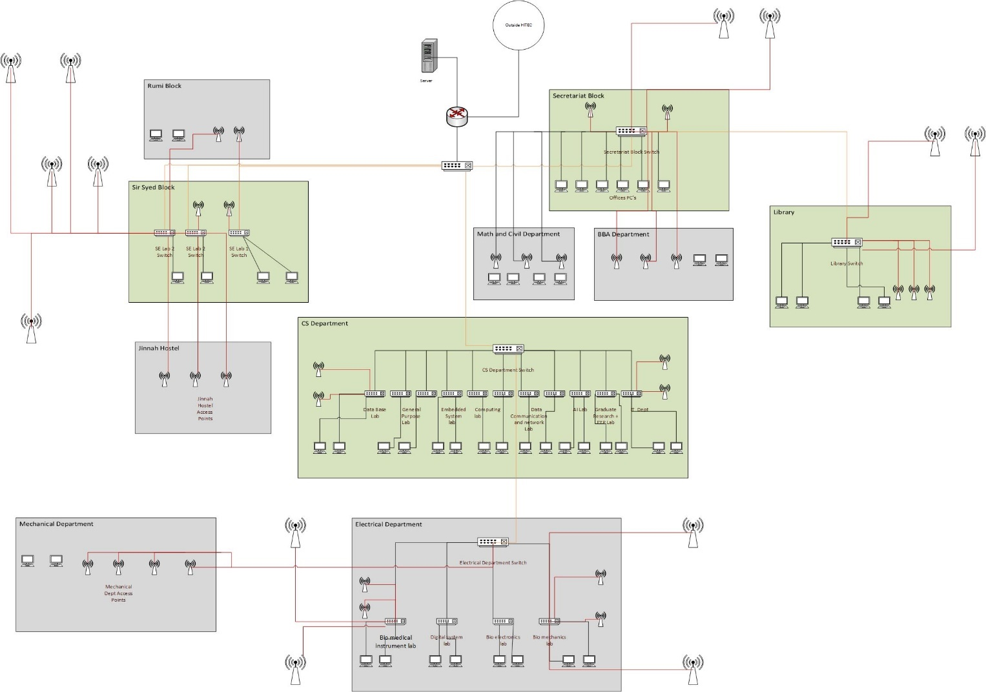

**Implementation of Design:**

1. **Link Aggregation:**

We use Link aggregation between switches of different labs i.e., between switches of the CS department, electrical department, and Sir Syed department because it provides various benefits that contribute to improved performance, reliability, and efficiency.

* One of the primary reasons for implementing link aggregation is to increase the overall bandwidth between devices. By combining multiple physical links into a single logical link, the aggregated bandwidth is greater than that of individual links. This is particularly important in high-traffic environments where a single link might become a bottleneck.
* Link aggregation enables load balancing across multiple links, distributing network traffic more evenly. This ensures that no single link is overwhelmed while others remain underutilized. Load balancing helps optimize network resources and prevents congestion on any single link.
* Link aggregation provides redundancy and improves network reliability. If one physical link fails or experiences issues, traffic can be automatically rerouted through the remaining active links. This fault tolerance minimizes downtime and ensures continuous network operation.
* As network requirements grow, link aggregation allows for easy scalability by adding more links to the aggregate. This flexibility makes it simpler to adapt to increasing demands on the network without requiring a complete redesign or overhaul.
* Implementing link aggregation is often more cost-effective than investing in high-speed individual links. It allows organizations to achieve higher bandwidth at a lower cost by combining existing, lower-speed links.
* Link aggregation contributes to better overall network performance by reducing latency and improving response times.
* Link aggregation helps in efficiently utilizing network resources by making sure that all available links contribute to the network's performance.

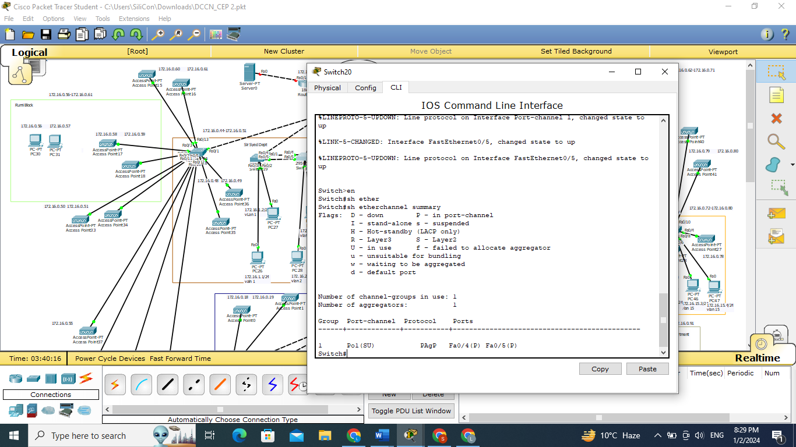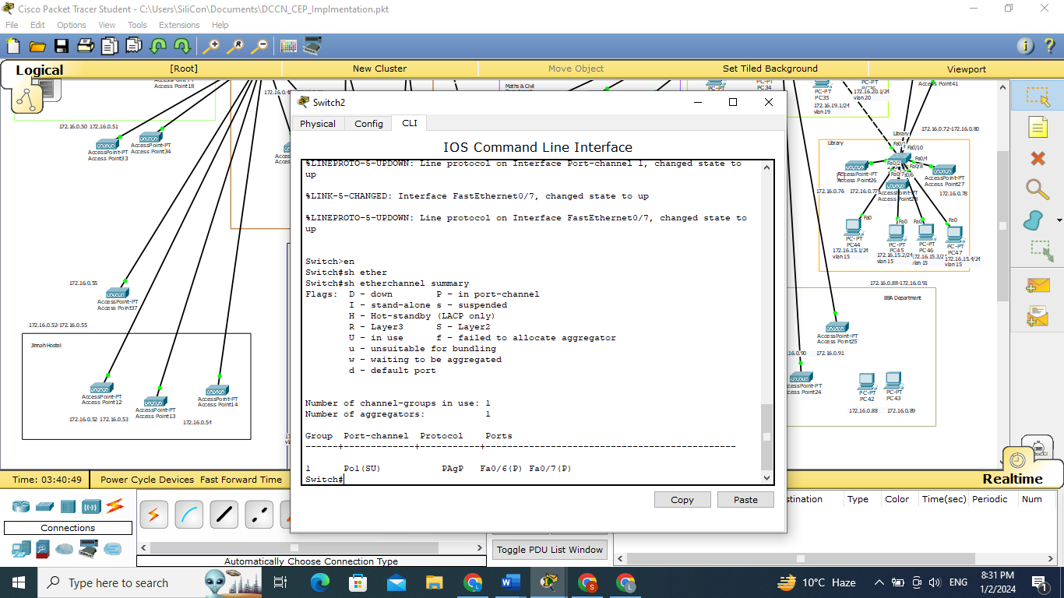

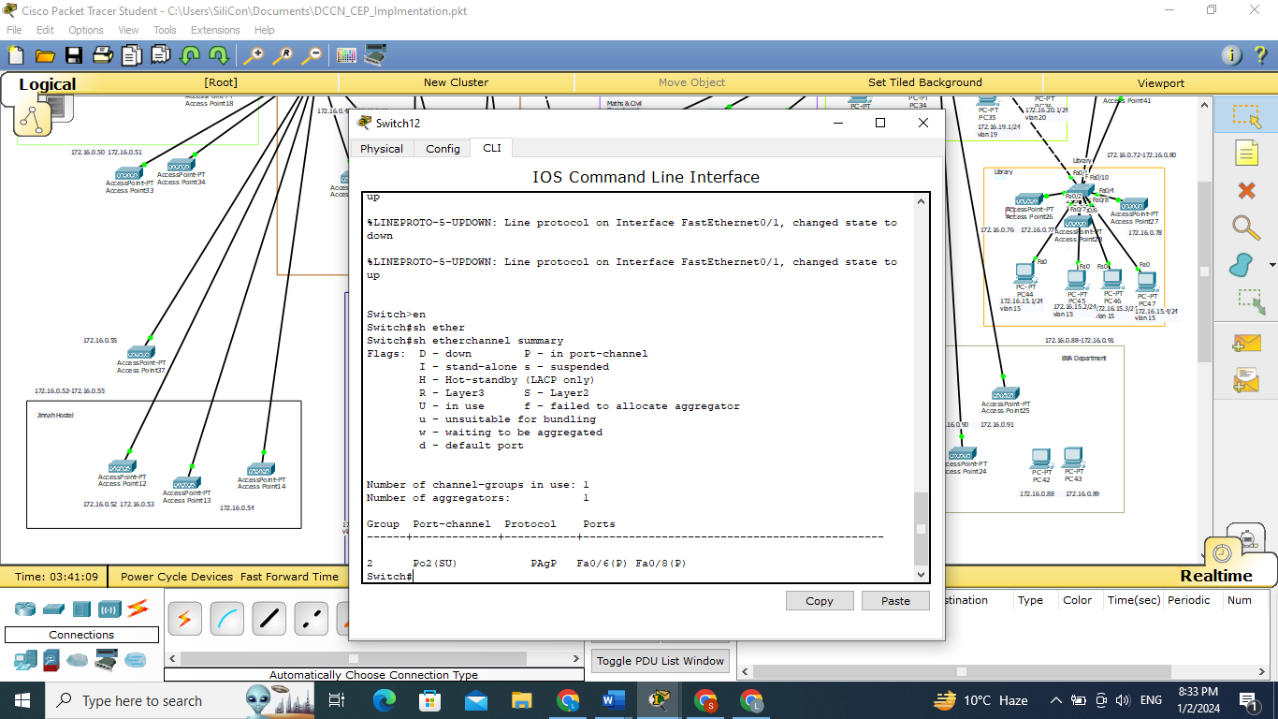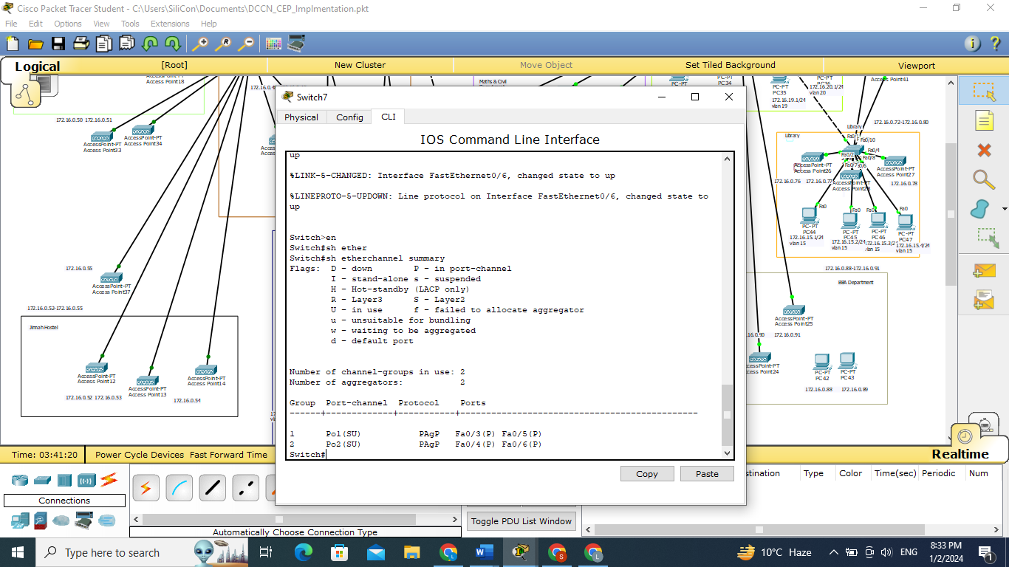

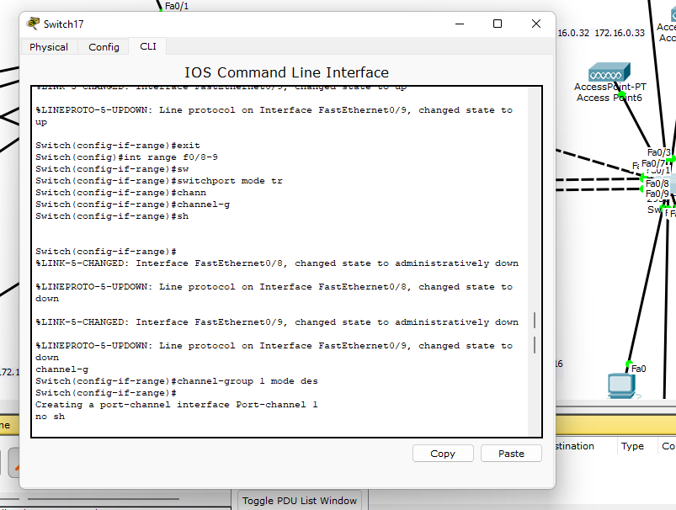

1. **VLANS CONCEPT:**

We use the VLANs concept and make separate VLANs for each lab in departments.

* VLANs isolate broadcast traffic within each lab, preventing unnecessary congestion on the overall network.
* Different labs can have separate VLANs, ensuring the isolation of sensitive data and restricting unauthorized access.
* Each lab gets dedicated network resources, preventing one lab from impacting the performance of others.
* VLANs allow independent configuration and troubleshooting for each lab, making network management more straightforward.
* Quality of Service(QoS) can be applied based on lab needs, prioritizing specific types of traffic for better performance.
* VLANs provide flexibility for adapting to new labs or changes in existing ones without major network alterations.
* Bandwidth can be allocated based on the unique requirements of each lab, preventing one lab from consuming excessive resources, we allocate maximum bandwidth from 8:30 to 3:30 to departments and other time to the hostel.
* VLANs help enforce policies and access controls to meet compliance and regulatory standards for specific labs.

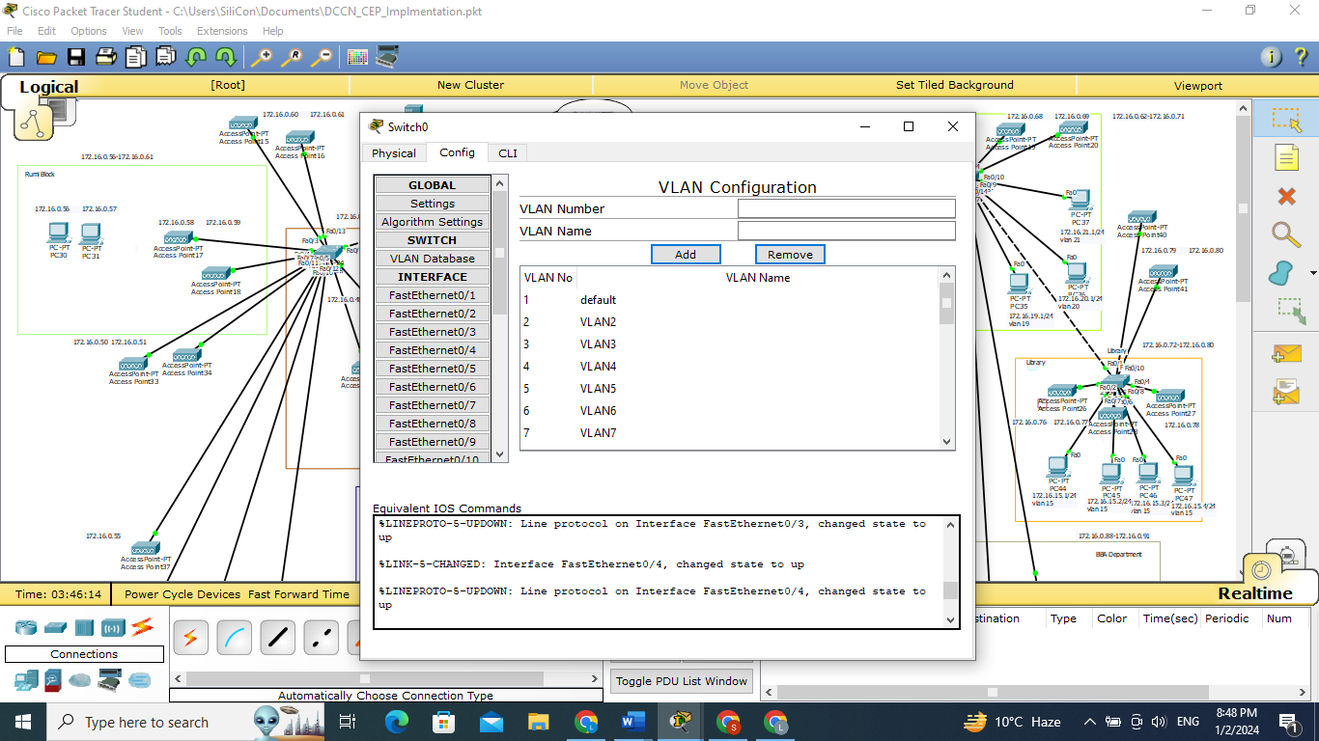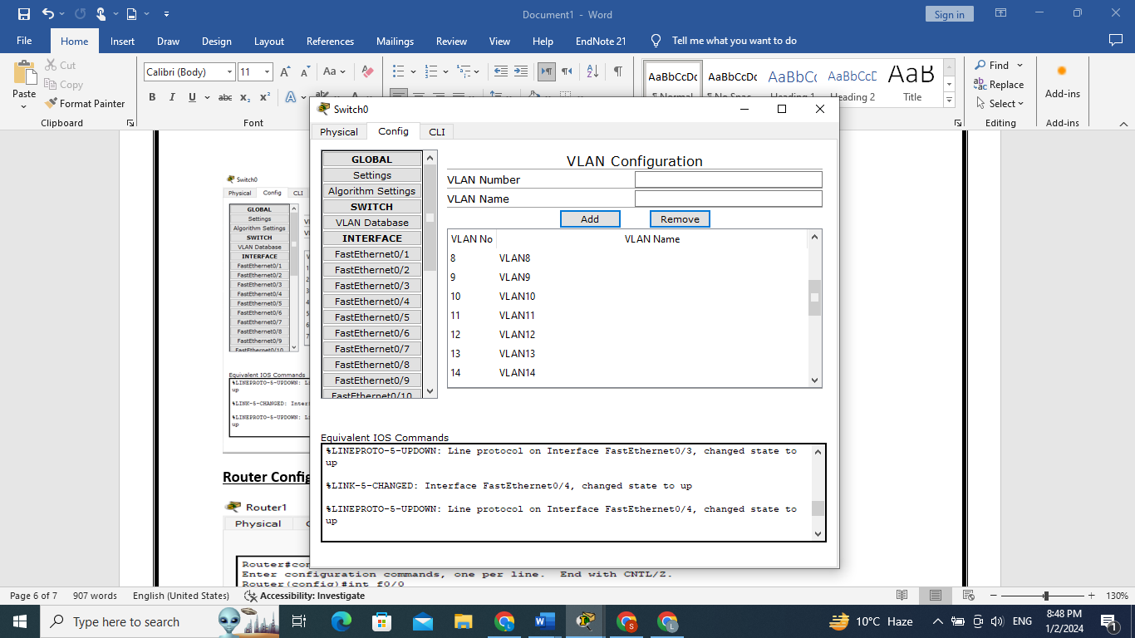

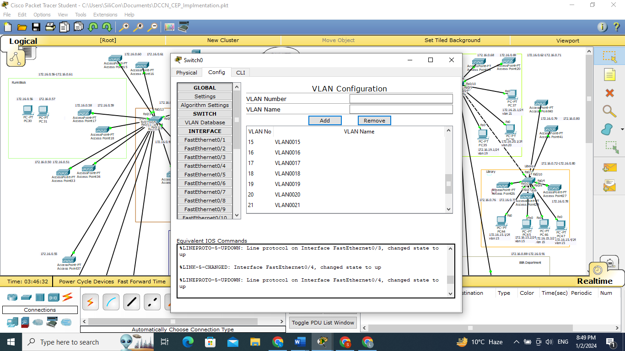

1. **Access Points:**

We add access points on inside and outside departments for high speed and good performance in every area of the university so that each student can be facilitated.

* Access Points in Israr Block i.e., 16
* Access Points in Sir Syed i.e., 4
* Access Points in Rumi Block i.e., 4
* Access Points in Jinnah Hostel i.e., 4
* Access Points in Secretariate i.e., 10
* Access Points in Library i.e., 5

**Router Configuration:**

We have done router on a stick configuration so achieve inter vlan routing.

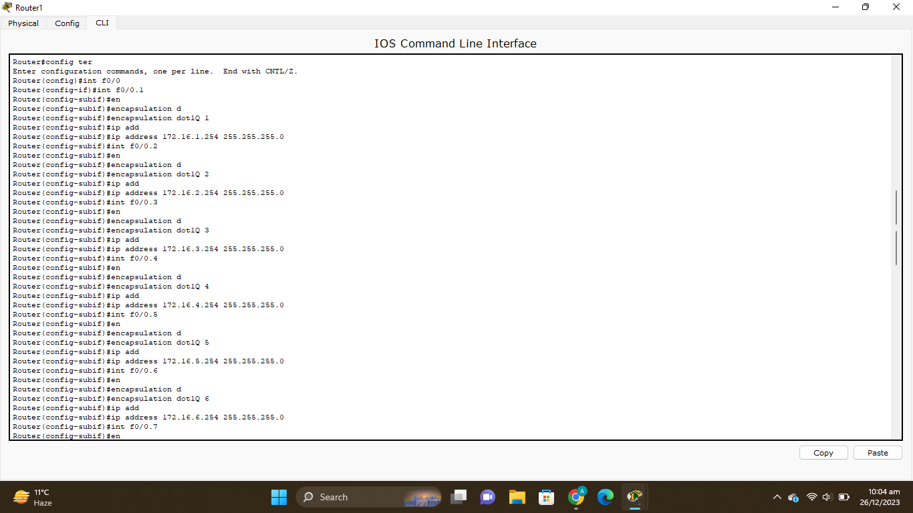

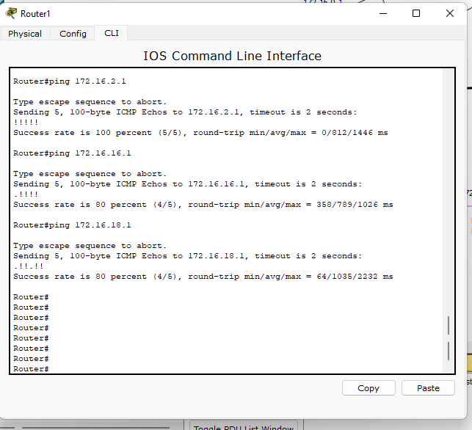

**Ping:**

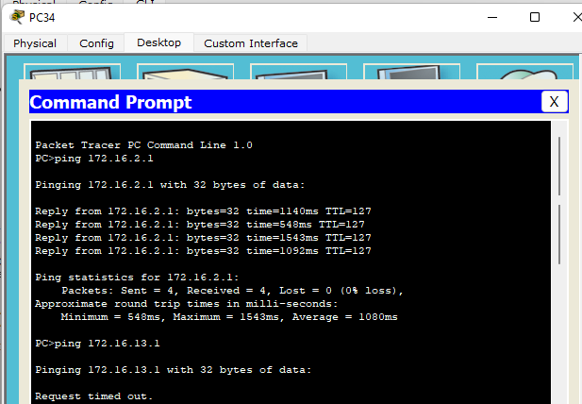

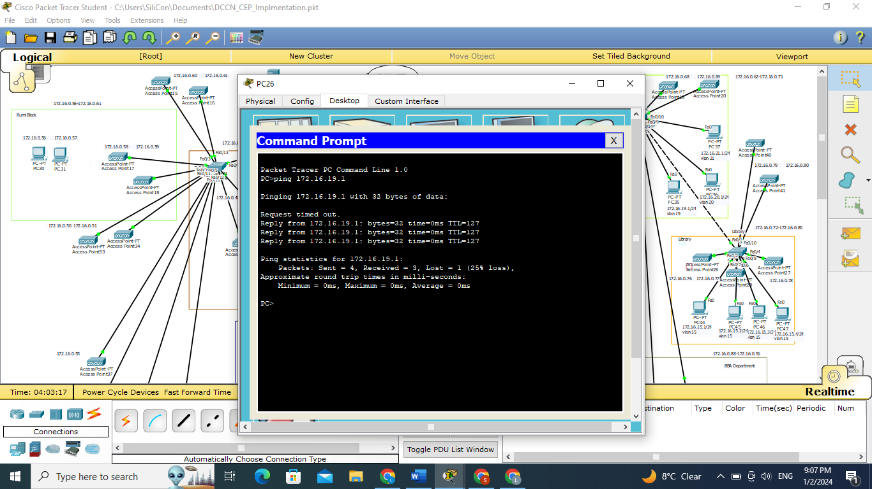

**Implementation on Cisco:**

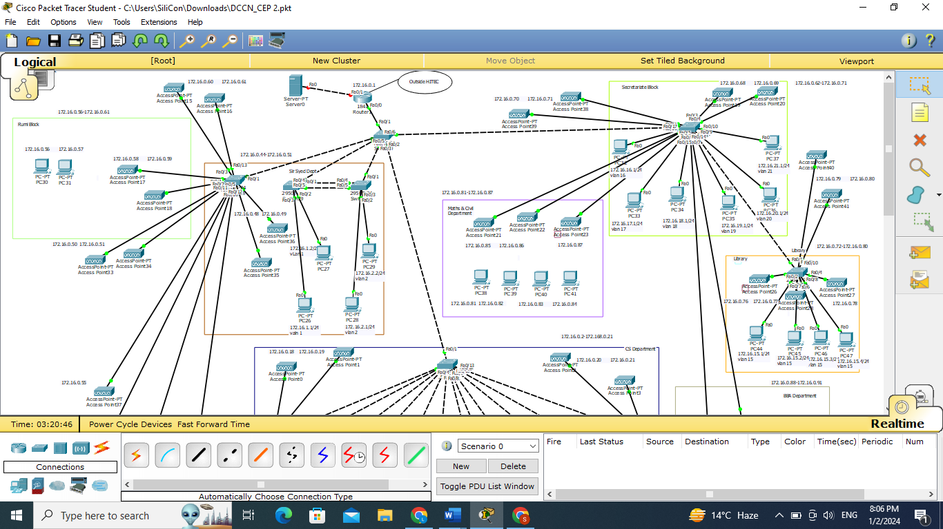

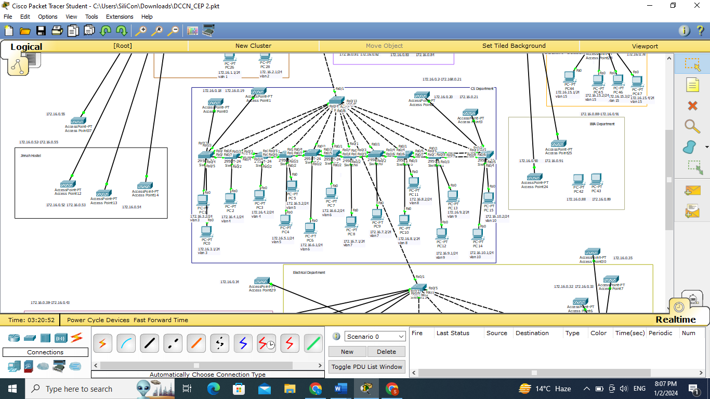

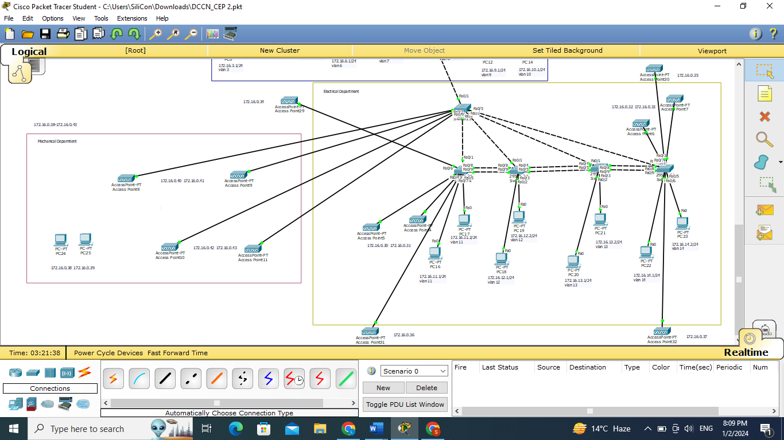

**Conclusion:**

In conclusion, the implementation of Cisco technologies, featuring link aggregation and VLANs, has significantly improved our university's network. This project successfully increased bandwidth, improved fault tolerance, and optimized resource allocation through link aggregation. The use of VLANs enhanced security, isolated broadcast domains, and provided flexibility for different labs. The seamless integration of these technologies positions our network for scalability and adaptability, ensuring a reliable, secure, and high-performance infrastructure for the university community.