Customer Segmentation Prediction using K-Means clustering:
1. Abstract
Customer segmentation is an essential analytical approach that helps businesses understand customer behavior and improve strategic decision-making. This project develops an intelligent customer segmentation system using the K-Means Clustering algorithm to group mall customers into distinct segments based on their annual income and spending score, while also considering demographic information such as age and gender. By identifying meaningful customer groups, the system enables mall management to design targeted marketing campaigns, enhance customer satisfaction, and optimize resource allocation. The model successfully identified five customer clusters, each representing unique purchasing patterns and customer profiles.
2. Introduction
In the modern retail environment, understanding customer purchasing behavior is critical for improving profitability and customer engagement. Traditional marketing strategies often treat all customers similarly, which can reduce effectiveness. Customer segmentation allows organizations to divide customers into smaller groups with similar characteristics so that personalized services can be offered.
Mall businesses generate large volumes of customer data, including demographic and spending information. Analyzing this data can reveal hidden patterns that support business intelligence. This project applies machine learning techniques to automatically classify customers into groups, helping the mall improve customer retention and revenue generation.
3. Problem Statement
To Develop an intelligent customer segmentation system that analyzes mall customer data and clusters customers into distinct groups based on their purchasing behavior and demographic characteristics. The system should identify meaningful customer segments to help the mall improve marketing strategies, enhance customer experience, and support better business decision-making.
4. Dataset Description
The dataset used for this project contains customer information collected from a shopping mall. It consists of the following attributes:
Column Name | Description
CustomerID | Unique identifier for each customer
Gender | Gender of customer
Age | Age of customer
Annual Income (k$) | Annual income of customer in thousand dollars
Spending Score (1-100) | Score assigned based on customer spending behavior
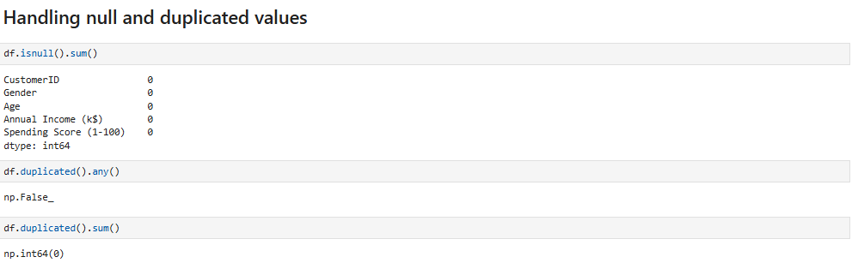
The dataset contains no missing or duplicate values, ensuring data quality and consistency for accurate analysis.
Dataset Characteristics
- Total records: 200 customers
- Missing values: None
- Duplicate values: None
- Data type:
  - Numerical: Age, Annual Income, Spending Score
  - Categorical: Gender
The dataset contains clean and structured data suitable for clustering analysis.
5. Data Preprocessing
Before applying the clustering algorithm, several preprocessing steps were performed:
1. Missing Value Check
The dataset was inspected for null values:
- No missing values were found.
2. Duplicate Value Check
The dataset was checked for repeated records:
- No duplicate records were found.
3. Feature Selection
The following features were selected for clustering:
- Annual Income (k$)
- Spending Score (1-100)
These two variables provide a clear representation of customer purchasing behavior.
6. Exploratory Data Analysis (EDA)
EDA was performed to understand data patterns:
Key Observations
- Customers with higher income do not always spend more.
- Some low-income customers showed high spending behavior.
- Spending patterns varied significantly across customer groups.
- Age had moderate influence on spending behavior.
- Gender distribution was relatively balanced.
Visual Analysis
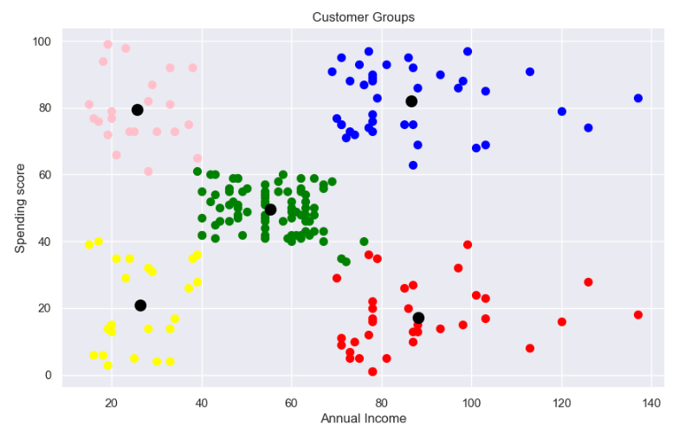
7. Methodology
Models Used:
Algorithm Used: K-Means Clustering
K-Means is an unsupervised machine learning algorithm used to partition data into K clusters.
Steps:
- Select number of clusters $K$
- Randomly initialize centroids
- Assign each data point to nearest centroid
- Recalculate centroid positions
- Repeat until convergence
Distance Formula
Euclidean distance was used:
$$d=\sqrt{\left(x_{2}-x_{1})^{2}+(y_{2}-y_{1})^{2}\right.}$$
Optimal Cluster Selection
The Elbow Method was used to determine the optimal number of clusters.
WCSS formula:
$$WCSS=\sum_{i=1}^{k}{\sum_{x∈C_{i}}{∣∣x-}}μ_{i}∣∣^{2}$$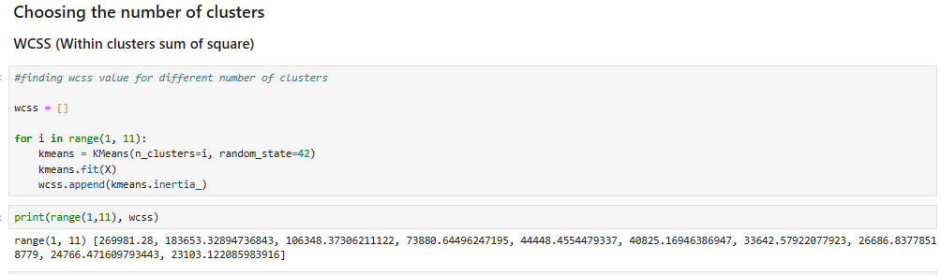

Where:
- $C_{i}$= cluster
- $μ_{i}$= centroid
- $x$= data point
The elbow point appeared at:
$$K=5$$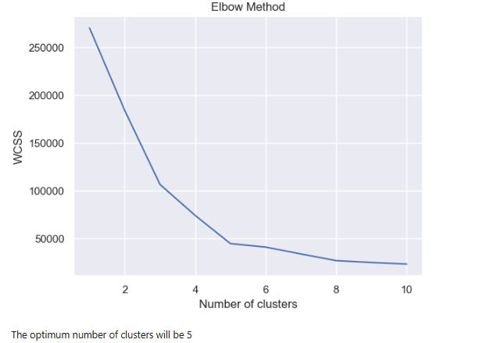
Therefore, the final model used 5 clusters.
8. Code Implementation
Data Preparation
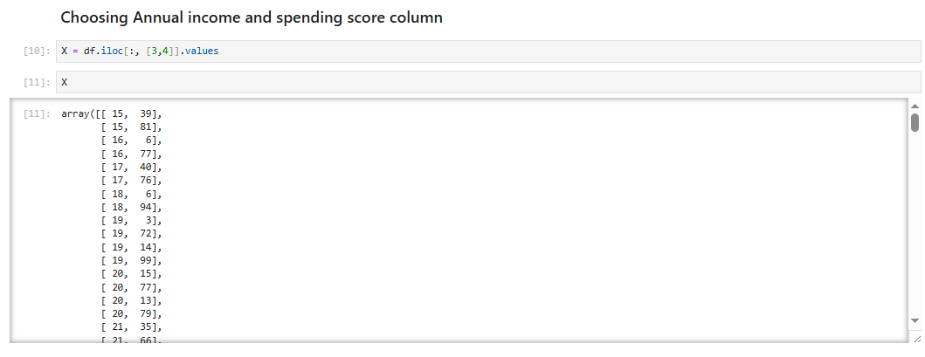
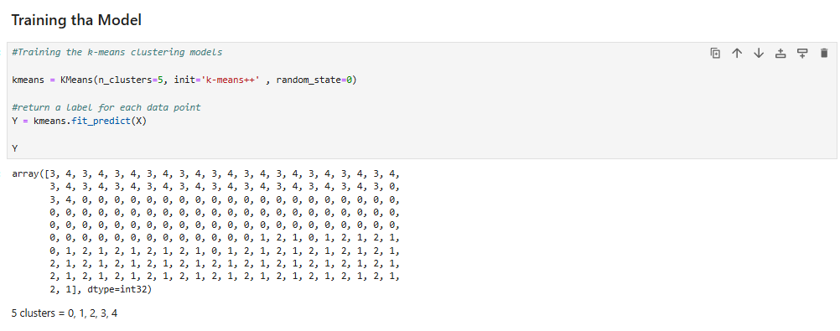
10. Results & Discussion
The K-Means model successfully divided customers into five distinct segments.
Cluster Interpretation
Cluster | Characteristics | Business Meaning
Cluster 1 | Low income, high spending | Impulsive customers
Cluster 2 | High income, high spending | Premium customers
Cluster 3 | Medium income, medium spending | Regular customers
Cluster 4 | High income, low spending | Careful customers
Cluster 5 | Low income, low spending | Budget customers

11. Limitations
Although the model performed well, some limitations remain:
- 1. Limited Features
- Only a few customer attributes were available.
- 2. Static Data
- The dataset captures a single snapshot of customer behavior.
- 3. Assumption of Circular Clusters
- K-Means assumes spherical cluster shapes.
- 4. Sensitive to Initialization
- Different centroid initialization can produce slightly different clusters.
- 5. No Real-Time Adaptation
- The model does not update automatically with new customer data.
12. Future Improvements
The system can be improved by:
1. Add More Features
Include:
- Purchase frequency
- Product category
- Visit timing
- Transaction history
2. Use Advanced Algorithms
Test:
- DBSCAN
- Hierarchical Clustering
- Gaussian Mixture Models
3. Real-Time Segmentation
Build a system that updates customer segments automatically.
4. Recommendation System
Combine segmentation with personalized product recommendations.
5. Predictive Analytics
Forecast future spending behavior using machine learning models.
13. Conclusion
This project successfully developed a machine learning model for predicting movie ratings. The Linear Regression model performed slightly better than Random Forest, achieving an R² score of approximately 0.53.
The study highlights the importance of data preprocessing and feature engineering in improving model performance. Further enhancements can significantly improve predictive accuracy.

