**Predictive analysis of social media’s impact on mental health using logistic regression:**

**Overview:**

Social media being an essential part of life nowadays, can have serious impact on mental well-being leading to hazardous diseases and disorders. The problem is that most people are unaware from the fact that their social media was negatively influencing their daily lives.

This project performs predictive analysis of social media’s impact on mental health using logistic regression model trained on survey datasets. This is a machine learning model in which user can simply enter their data by answering few questions and the model would predict if they are healthy or at risk.

The necessarily of this model is that it allows early detection of mental health risks, which help user to take preventive measures at initial stages. It also helps researchers and doctors to find the correlation between social media and mental health so that they can perform analysis for making social media human-friendly.

**Sequence diagram:**

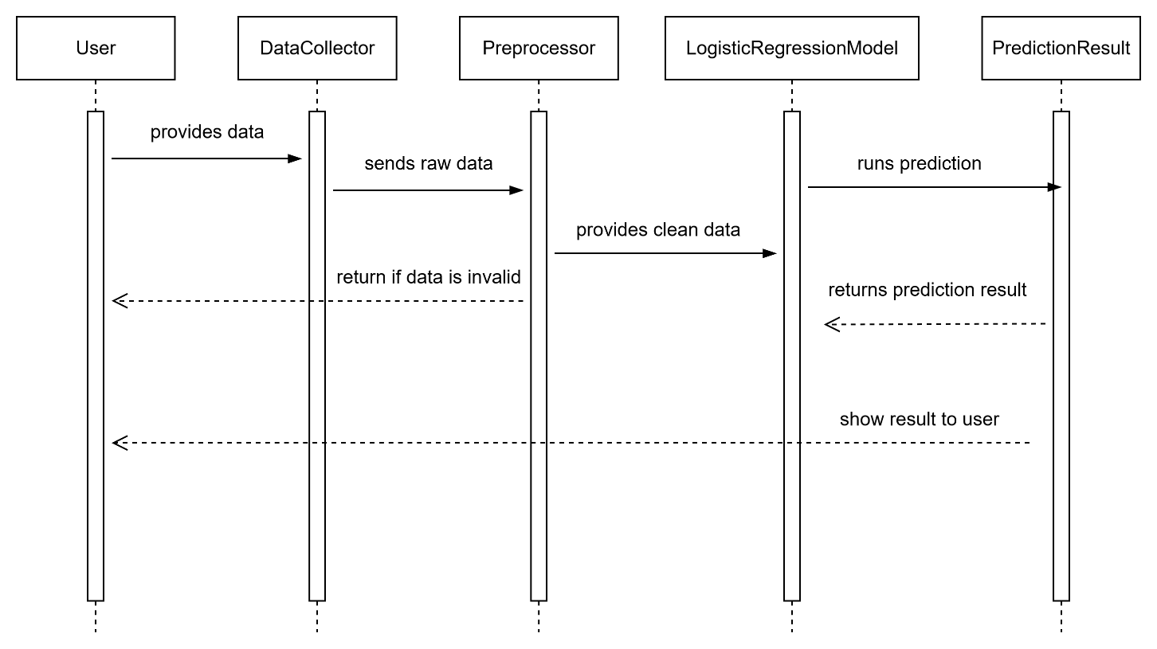

**Class diagram:**

**Activity diagram:**

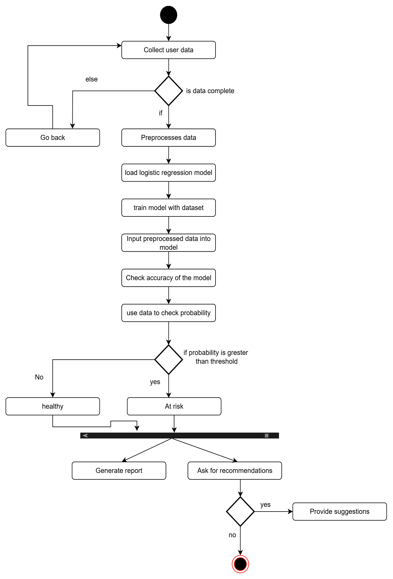

**Model Justification:**

The choice of logistic regression model was due to its simplicity, interpretability and suitability for a binary classification problem. As this model classifies the user in two categories healthy or at risk so this model is an ideal approach for the project. This interpretability is important to mental health domain where results must be explainable to researchers, doctors and non-technical users.

**Consequences:**

* Provides early detection of medical health risks based on use of social media.
* Help users track their usage and take preventive measures on initial stages.
* Help researchers and experts finding the social media usage patterns and its effects.
* Can be expanded to larger datasets and can be integrated to web or mobile application.