PROMPT1:
i want to create menu.html for my chai corner..how will i do that.
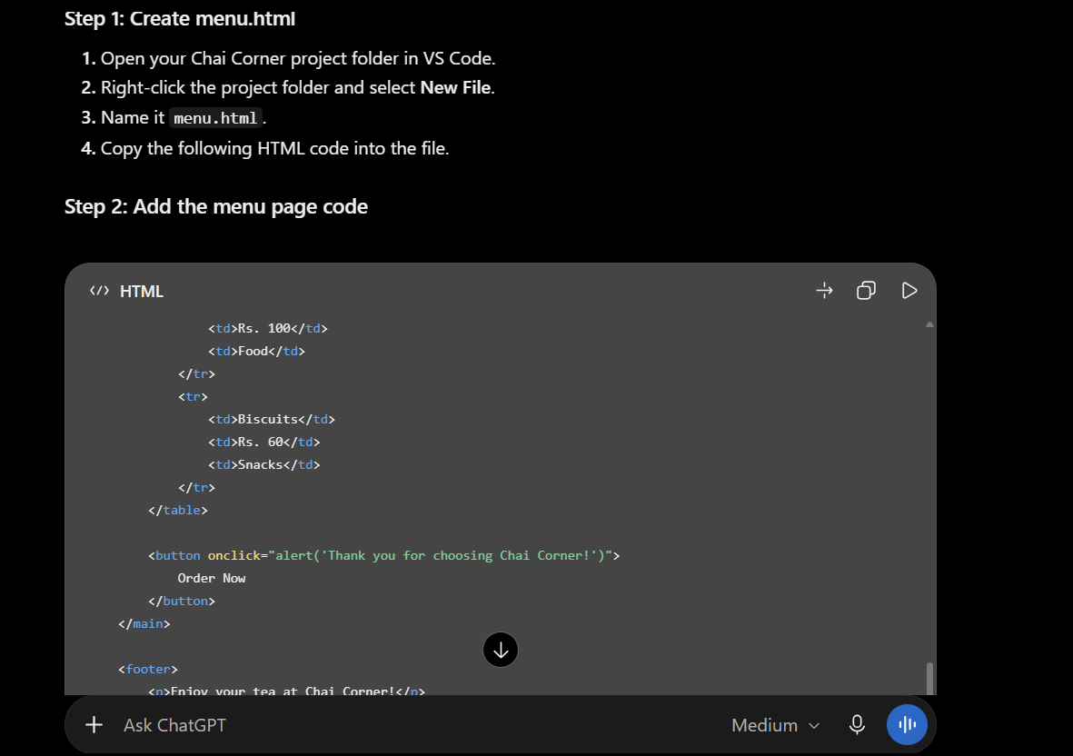
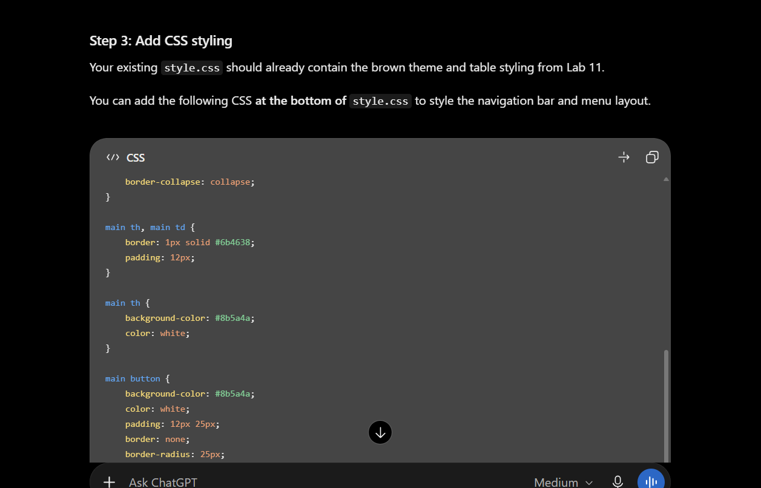
Prompt 2:
how will i make gallery.html


