

**Syeda ayesha Fatima**

**Classwork**

**Task1:**

<!DOCTYPE html>

<html lang="en">

<head>

    <meta charset="UTF-8">

    <meta name="viewport" content="width=device-width, initial-scale=1.0">

    <title>Bootstrap</title>

    <link rel="stylesheet" href="https://cdn.jsdelivr.net/npm/bootstrap@5.3.3/dist/css/bootstrap.min.css">

</head>

<body>

    <nav class="navbar navbar-expand-lg navbar-dark bg-dark">

        <div class="container-fluid">

          <a class="navbar-brand" href="#">Navbar</a>

          <button class="navbar-toggler" type="button" data-bs-toggle="collapse" data-bs-target="#navbarSupportedContent" aria-controls="navbarSupportedContent" aria-expanded="false" aria-label="Toggle navigation">

            <span class="navbar-toggler-icon"></span>

          </button>

          <div class="collapse navbar-collapse" id="navbarSupportedContent">

            <ul class="navbar-nav me-auto mb-2 mb-lg-0">

              <li class="nav-item">

                <a class="nav-link active" aria-current="page" href="#">Home</a>

              </li>

              <li class="nav-item">

                <a class="nav-link" href="#">Link</a>

              </li>

              <li class="nav-item dropdown">

                <a class="nav-link dropdown-toggle" href="#" role="button" data-bs-toggle="dropdown" aria-expanded="false">

                  Dropdown

                </a>

                <ul class="dropdown-menu">

                  <li><a class="dropdown-item" href="#">Action</a></li>

                  <li><a class="dropdown-item" href="#">Another action</a></li>

                  <li><hr class="dropdown-divider"></li>

                  <li><a class="dropdown-item" href="#">Something else here</a></li>

                </ul>

              </li>

              <li class="nav-item">

                <a class="nav-link disabled" aria-disabled="true">Disabled</a>

              </li>

            </ul>

            <form class="d-flex" role="search">

              <input class="form-control me-2" type="search" placeholder="Search" aria-label="Search">

              <button class="btn btn-outline-success" type="submit">Search</button>

            </form>

          </div>

        </div>

      </nav>

</body>

</html>

**Task2:**

<!DOCTYPE html>

<html lang="en">

<head>

    <meta charset="UTF-8">

    <meta name="viewport" content="width=device-width, initial-scale=1.0">

    <title>Document</title>

<link rel="stylesheet" href="https://cdn.jsdelivr.net/npm/bootstrap@5.3.3/dist/css/bootstrap.min.css">

</head>

<body>

    <div class="card" style="width: 18rem;">

        <img src="moon2.jpg" class="card-img-top" alt="...">

        <div class="card-body">

          <h5 class="card-title">Card title</h5>

          <p class="card-text">Some quick example text to build on the card title and make up the bulk of the card's content.</p>

        </div>

        <ul class="list-group list-group-flush">

          <li class="list-group-item">An item</li>

          <li class="list-group-item">A second item</li>

          <li class="list-group-item">A third item</li>

        </ul>

        <div class="card-body">

          <a href="#" class="card-link">Card link</a>

          <a href="#" class="card-link">Another link</a>

        </div>

      </div>

</body>

</html>

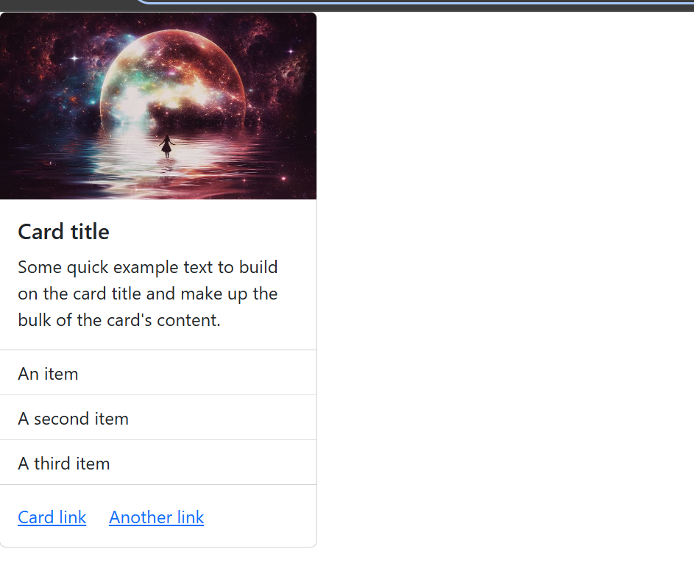

**Task 3:**

<!DOCTYPE html>

<html lang="en">

<head>

    <meta charset="UTF-8">

    <meta name="viewport" content="width=device-width, initial-scale=1.0">

    <title>Document</title>

    <link rel="stylesheet" href="transition.css">

</head>

<body>

        <button class="color-btn">Hover me</button>

        <button class="scale-btn">Hover me</button>

        <button class="rotate-btn">rotate me</button>

        <button class="slide-btn">Slide in</button>

        <button class="border-btn">hover me</button>

        <button class="color-btn">Hover me</button>

   <div class="transition">

    <p>hover on it</p>

   </div>

   <div class="t1">

   </div>

</body>

</html>

**TASK 4:**

<!DOCTYPE html>

<html lang="en">

<head>

    <meta charset="UTF-8">

    <meta name="viewport" content="width=device-width, initial-scale=1.0">

    <title>Document</title>

    <link rel="stylesheet" href="https://cdn.jsdelivr.net/npm/bootstrap@5.3.3/dist/css/bootstrap.min.css">

</head>

<body>

    <div class="alert alert-primary" role="alert">

        A simple primary alert—check it out!

      </div>

      <div class="alert alert-secondary" role="alert">

        A simple secondary alert—check it out!

      </div>

      <div class="alert alert-success" role="alert">

        A simple success alert—check it out!

      </div>

      <div class="alert alert-danger" role="alert">

        A simple danger alert—check it out!

      </div>

      <div class="alert alert-warning" role="alert">

        A simple warning alert—check it out!

      </div>

      <div class="alert alert-info" role="alert">

        A simple info alert—check it out!

      </div>

      <div class="alert alert-light" role="alert">

        A simple light alert—check it out!

      </div>

      <div class="alert alert-dark" role="alert">

        A simple dark alert—check it out!

      </div>

</body>

</html>