

Subject: Deep Learning (MGT-388)

Midterm Project
Model 1: DNN for Telecom Customer Churn Prediction
Model 2: CNN for American Sign Language Recognition
Section A
Submitted By:
Names | Registration Number
Ayeza Hussain | CIIT/SP24-BBD-033/ISB

Submission date:
31th October, 2026

Project Overview
For this midterm project I built two deep learning models on two different datasets. The first is a DNN that predicts whether a telecom customer will leave the company (churn). The second is a CNN that looks at a small picture of a hand and tells which American Sign Language letter it shows.
Each model has its own part in this report, and every part follows the headings given in the project brief: problem definition, dataset and source link, proposed solution, data preprocessing, model architecture, training results and evaluation, and conclusion. At the end there is a third part where I explain the main concepts and the code in simple words.
Table 1: Short summary of the two models
 | Model 1: DNN | Model 2: CNN
Task | Predict if a customer will churn (two classes) | Recognise an ASL letter from an image (24 classes)
Dataset | Telco Customer Churn, 7,043 customers | Sign Language MNIST, 27,455 train and 7,172 test images
Model | 19-128-64-32-1 dense network, 12,929 parameters | Two-block CNN, 1,686,264 parameters
Test result | Accuracy 74.4%, AUC 0.833, churn recall 0.76 | Accuracy 94.85%, macro F1 0.94 (separate test set)

Part 1: DNN Model – Telco Customer Churn

1.1 Problem Definition
Churn means that a customer stops using the service of a company. For a telecom company this is a real problem, because finding a new customer costs more than keeping an old one. If the company knows which customers are likely to leave, it can contact them early and offer something like a discount or a better plan.
So the problem I am solving is this: given the details of a customer (account information, services used, charges and so on), predict whether the customer will churn (Yes) or stay (No). This is a binary classification problem on tabular data. The model gives a probability of churn and I use 0.5 as the cut-off to decide between the two classes.

1.2 Dataset Description and Source
I used the Telco Customer Churn dataset, which is an IBM sample dataset published on Kaggle. The link is https://www.kaggle.com/datasets/blastchar/telco-customer-churn
It has 7,043 customers (rows) and 21 columns, which are 20 features and the target column Churn. The target is not balanced: 5,174 customers stayed (73.5%) and 1,869 churned (26.5%). I had to keep this in mind later, because a model can get a high accuracy just by always predicting that the customer stays.
Table 2: Feature groups in the dataset
Group | Columns
Demographics | gender, SeniorCitizen, Partner, Dependents
Account information | tenure, Contract, PaperlessBilling, PaymentMethod
Services | PhoneService, MultipleLines, InternetService, OnlineSecurity, OnlineBackup, DeviceProtection, TechSupport, StreamingTV, StreamingMovies
Charges | MonthlyCharges, TotalCharges
Identifier (dropped) | customerID

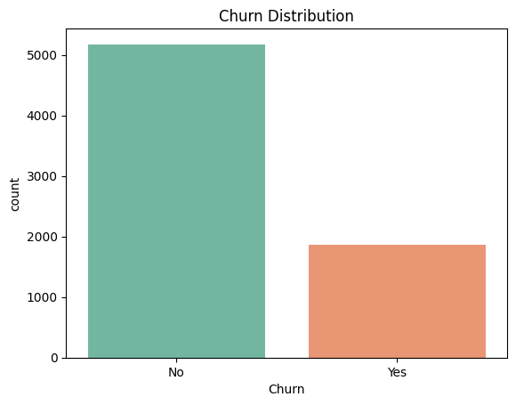
Figure 1: Number of customers who stayed (No) and who churned (Yes).

1.3 Proposed Solution
I decided to use a Deep Neural Network (DNN). A churn decision usually depends on several features together, for example a short tenure combined with a month-to-month contract, and a DNN can learn this kind of non-linear combination.
The plan is to clean the data, turn the text columns into numbers and scale the features. Then the data goes through three hidden layers with dropout, and the last layer is a single sigmoid neuron that gives the probability of churn. Because only about 27% of customers churn, I also used class weights so the model does not ignore the churners.

1.4 Data Preprocessing
These are the steps I applied to the data before training and the reason for each one.
Table 3: Preprocessing steps
# | Step | Why I did it
1 | Dropped customerID | It is only an ID, so it does not help to predict anything.
2 | Converted TotalCharges to numbers and filled the 11 missing values with the median | The column was stored as text because 11 rows had an empty value. The network cannot work with missing values.
3 | Changed the target to numbers (Yes = 1, No = 0) | The sigmoid output and the loss function need a 0 or 1 target.
4 | Used LabelEncoder on the 15 text columns | To change the categories into integers so the network can use them.
5 | Split the data 80/20 with stratify (5,634 train and 1,409 test, random_state = 42) | Stratify keeps the same churn percentage in both parts. The test set is only used at the end.
6 | Scaled the features with StandardScaler, fitted on the training data only | The features have very different ranges (tenure is 0 to 72, TotalCharges goes up to about 8,600). I fitted it only on the training data so no information from the test set leaks in.
7 | Computed class weights: 0.681 for stay and 1.884 for churn | A mistake on a churner counts about 2.8 times more, so the model pays attention to them.
8 | Used 20% of the training data as validation (about 1,127 customers) inside fit | To watch for overfitting and to use early stopping.

After these steps there are 19 input features, so the input layer of the network has 19 nodes.

1.5 Model Architecture
The network has three hidden layers that get smaller (128, 64 and 32 neurons) and one output neuron. The table shows every layer and how many parameters it has.
Table 4: DNN layers
Layer | Output shape | Activation | Parameters | Notes
Input | 19 | - | 0 | One node per feature
Dense 1 | 128 | ReLU | 2,560 | First hidden layer
Dropout (0.3) | 128 | - | 0 | Regularisation
Dense 2 | 64 | ReLU | 8,256 | Second hidden layer
Dropout (0.3) | 64 | - | 0 | Regularisation
Dense 3 | 32 | ReLU | 2,080 | Third hidden layer
Output | 1 | Sigmoid | 33 | Churn probability
Total |  |  | 12,929 | All trainable

I used ReLU in the hidden layers because it is simple and works well in practice. The output layer uses sigmoid because it squeezes any number into the range 0 to 1, which I can read as a probability. Dropout of 0.3 means that 30% of the neurons are switched off randomly in every training step, which helps the network not to memorise the training data.
Table 5: Training settings
Setting | Value
Loss function | Binary cross-entropy
Optimizer | Adam (default learning rate 0.001)
Metrics tracked | Accuracy and AUC
Batch size / max epochs | 32 / 100
Class weights | {0: 0.681, 1: 1.884}
Callback | EarlyStopping on validation loss, patience 10, restore best weights

1.6 Training Results and Evaluation

Training
Training stopped by itself after 17 epochs because of early stopping. The lowest validation loss was 0.5042 at epoch 7, and the weights from that epoch were restored after 10 epochs with no improvement. In the plot below you can see that the training accuracy keeps going up (0.768 at epoch 17) but the validation accuracy stays around 0.72 and the validation loss moves between 0.50 and 0.54. So the model starts to overfit a little after the first epochs, and early stopping was useful here.
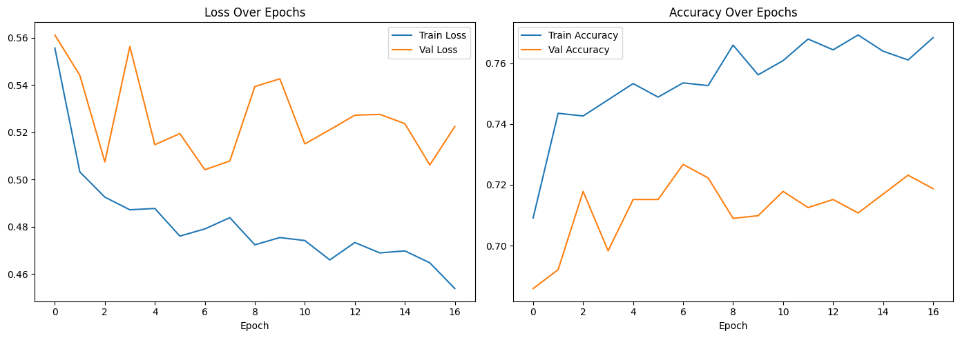
Figure 2: Loss and accuracy of the DNN for each epoch.

Test results
After training I tested the model on the 1,409 customers that it had never seen.
Table 6: DNN results on the test set
Metric | Value
Test accuracy | 0.7438
Test AUC | 0.8330
Test loss (binary cross-entropy) | 0.4873
Table 7: Classification report (cut-off 0.5)
Class | Precision | Recall | F1-score | Support
No churn | 0.89 | 0.74 | 0.81 | 1,035
Churn | 0.51 | 0.76 | 0.61 | 374
Accuracy |  |  | 0.74 | 1,409
Macro average | 0.70 | 0.75 | 0.71 | 1,409
Weighted average | 0.79 | 0.74 | 0.76 | 1,409

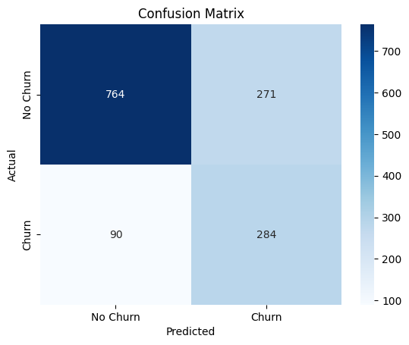
Figure 3: Confusion matrix of the DNN on the test set.
Table 8: Confusion matrix numbers
 | Predicted: No churn | Predicted: Churn
Actual: No churn | 764 (true negatives) | 271 (false positives)
Actual: Churn | 90 (false negatives) | 284 (true positives)

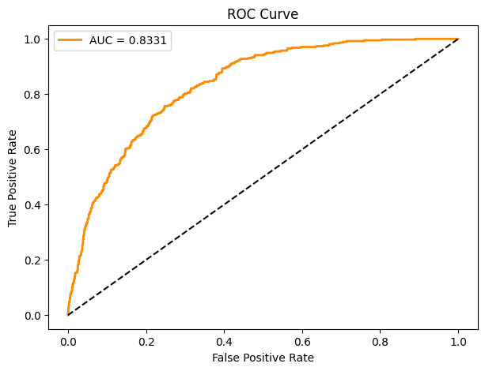
Figure 4: ROC curve of the DNN (AUC = 0.833).

Comparison with a simple baseline
To check if the DNN is really better than a simple model, I also trained a logistic regression on the same scaled data with the same class weights, and tested both models on the same 1,409 customers.
Table 9: Logistic regression compared with the DNN on the test set
Metric | Logistic Regression | DNN
Accuracy | 0.7395 | 0.7438
Precision (churn) | 0.5059 | 0.5117
Recall (churn) | 0.7968 | 0.7594
F1-score (churn) | 0.6189 | 0.6114
ROC-AUC | 0.8396 | 0.8331

The two models are almost the same. The DNN is a little better in accuracy and precision, and logistic regression is a little better in recall, F1-score and AUC. The differences are very small, and with only 1,409 test customers I cannot say that one of them is really better. So on this dataset the extra hidden layers did not give a clear improvement. This is probably because the dataset is small and the link between the features and churn is close to linear. (The AUC of the DNN is 0.8330 in Keras and 0.8331 in scikit-learn. The small difference is because Keras estimates the AUC with a fixed number of thresholds.)

What the results mean
The accuracy is 74.4%, which looks fine, but it does not say much here. A model that always predicts that the customer stays would already get 73.5% because of the class imbalance. So I looked more at the other numbers.
The model found 284 of the 374 customers who really churned, which is a recall of 76%. A model that always says "stay" would find none of them. This is mainly because of the class weights. The price for this is the precision of 0.51: the model flagged 555 customers as churners and only 284 of them really left, so 271 were false alarms. Whether this is acceptable depends on how much a retention offer costs compared with losing a customer. If the offer is cheap, a lot of false alarms is not a big problem.
The AUC of 0.833 means that if I pick one churner and one non-churner at random, the model gives the higher probability to the churner about 83% of the time.

Prediction on new customers
In the notebook I also tested the model like it would be used in real life. For one new customer (female, 24 months of tenure, month-to-month contract, fibre optic internet, no online security, monthly charges of 85.25) the model gave a churn probability of 0.7753 (77.5%), so the prediction was Churn. I also predicted five random test customers. All five really stayed, and the model got three of them right and gave two false alarms (probabilities 0.51 and 0.72). The customers are picked randomly, so this result changes every time the cell is run. Finally I saved the model, the scaler and the feature names together in a .joblib file and loaded it again, and it gave the same prediction (0.7753).

1.7 Conclusion
In this part I trained a DNN with three hidden layers to predict churn on the Telco dataset. After cleaning, encoding, scaling and using class weights, the model got 74.4% accuracy and an AUC of 0.833 on unseen customers, and it found 76% of the customers who churned. Dropout and early stopping kept the overfitting small, but there is still a small gap between training and validation accuracy. The class weights improved recall but made the precision lower (0.51). For a retention campaign I think this is a reasonable trade-off, because missing a customer who leaves is usually worse than sending an offer to someone who would have stayed. When I compared the DNN with a logistic regression baseline, both gave almost the same results (AUC 0.833 for the DNN and 0.840 for logistic regression), so on this dataset the extra hidden layers did not help much.
There are some limitations in my work:
- I used label encoding for columns like PaymentMethod, which gives the categories a number order that does not really exist. One-hot encoding would be better.
- The DNN did not beat the logistic regression baseline, so a simpler model would have been enough here. With more time I would also try a tree-based model like gradient boosting, which often works well on this kind of tabular data.
- The results come from a single random split with 1,409 test customers. Cross-validation would give a more stable estimate.
- I kept the cut-off at 0.5. In a real company it should be chosen using the real cost of an offer.

Part 2: CNN Model – American Sign Language Recognition

2.1 Problem Definition
American Sign Language (ASL) is used by many Deaf and hard-of-hearing people, but most hearing people do not know it, which makes communication difficult. A system that can recognise hand signs from an image could be used in translation apps, sign language learning tools and other accessibility applications.
The problem is: given a 28 x 28 grayscale image of a hand, decide which of the 24 ASL letters it shows. The letters J and Z are not included because they need movement of the hand, so they cannot be shown in one still image. This is a multi-class image classification problem.

2.2 Dataset Description and Source
I used the Sign Language MNIST dataset from Kaggle: https://www.kaggle.com/datasets/datamunge/sign-language-mnist
It comes as two CSV files in the same style as the original MNIST digits. Each row has a label and then 784 pixel values (a flattened 28 x 28 image with values from 0 to 255). There are 27,455 training images and 7,172 test images. The labels go from 0 to 24 and label 9 (J) is missing, and Z (25) does not appear either, so there are 24 classes. The classes are quite balanced, with about 957 to 1,294 training images per letter, so accuracy is a fair metric for this dataset.
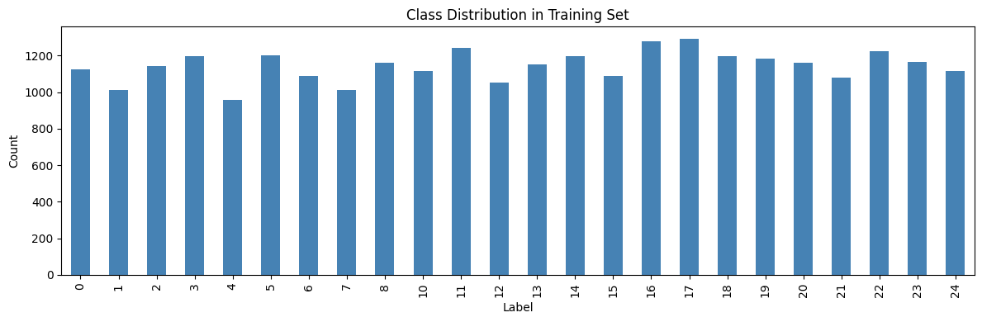
Figure 5: Number of training images for each label.
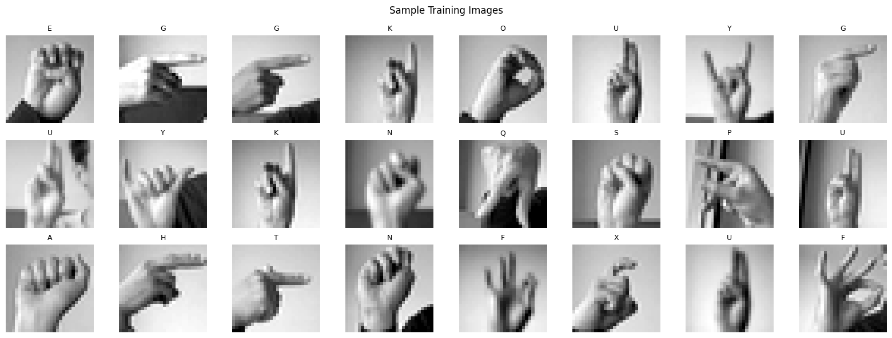
Figure 6: Random sample of training images with their letters.

2.3 Proposed Solution
For images I used a Convolutional Neural Network (CNN). A normal dense network would need to flatten the picture and would lose the information about which pixels are next to each other. A CNN uses small filters that slide over the image, so it keeps this structure and it uses the same weights in every position. The first layers learn simple things like edges and curves, and the later layers combine them into finger positions and hand shapes. At the end, dense layers decide which letter it is. I added batch normalization, max pooling and dropout to make the training more stable and to reduce overfitting.

2.4 Data Preprocessing
Table 10: Preprocessing steps
# | Step | Why I did it
1 | Separated the label column from the 784 pixel columns | The pixels are the input and the label is what we want to predict.
2 | Reshaped each row to (28, 28, 1) | A CNN needs the input as (samples, height, width, channels). There is 1 channel because the images are grayscale.
3 | Divided the pixel values by 255 | This puts the values between 0 and 1, which makes training faster and more stable.
4 | Made a label map from the 24 labels to the letters A to Y without J and Z | Label 9 is missing, so I needed a map to turn the predictions back into the right letters.
5 | One-hot encoded the labels with LabelBinarizer (24 columns) | The softmax output and the categorical cross-entropy loss need one-hot labels. It also solves the missing label 9, because it only creates a column for each label that really exists.
6 | Used the given test file for the final test | It gives a separate set of 7,172 images for evaluation.

2.5 Model Architecture
The model has two convolutional blocks and a classification part at the end. In each block there are two convolution layers with batch normalization, then max pooling (which makes the image half the size) and dropout. The number of filters goes from 32 in the first block to 64 in the second. After that the feature maps are flattened to 3,136 values and go through a dense layer of 512 neurons and a softmax layer with 24 outputs, one for each letter.
Table 11: CNN layers
Layer | Details | Output shape | Parameters
Conv2D | 32 filters, 3x3, ReLU, same padding | 28x28x32 | 320
BatchNormalization |  | 28x28x32 | 128
Conv2D | 32 filters, 3x3, ReLU | 28x28x32 | 9,248
BatchNormalization |  | 28x28x32 | 128
MaxPooling2D | 2x2 | 14x14x32 | 0
Dropout | 25% | 14x14x32 | 0
Conv2D | 64 filters, 3x3, ReLU | 14x14x64 | 18,496
BatchNormalization |  | 14x14x64 | 256
Conv2D | 64 filters, 3x3, ReLU | 14x14x64 | 36,928
BatchNormalization |  | 14x14x64 | 256
MaxPooling2D | 2x2 | 7x7x64 | 0
Dropout | 25% | 7x7x64 | 0
Flatten |  | 3,136 | 0
Dense | 512 units, ReLU | 512 | 1,606,144
BatchNormalization |  | 512 | 2,048
Dropout | 50% | 512 | 0
Dense (output) | 24 units, softmax | 24 | 12,312
Total | 1,684,856 trainable + 1,408 non-trainable |  | 1,686,264

Something I noticed from the table is that almost all the parameters (1,606,144 of 1,686,264, about 95%) are in the 512-unit dense layer. The convolution layers are very small compared with it. This is probably one reason why the model can memorise the training images so easily.
Table 12: Training settings
Setting | Value
Loss function | Categorical cross-entropy (one-hot labels)
Optimizer | Adam, learning rate 0.001
Batch size / max epochs | 64 / 30
EarlyStopping | Monitors validation accuracy, patience 8, restore best weights
ReduceLROnPlateau | Monitors validation loss, factor 0.5, patience 3, minimum learning rate 1e-6
Training time | About 64 to 83 seconds per epoch on Google Colab (10 epochs)

2.6 Training Results and Evaluation

Training
The training stopped after 10 epochs because the validation accuracy had reached 1.000 (100%) at epoch 2 and did not improve further. Training accuracy increased from 0.8768 in the first epoch to 0.9999 by epoch 10. EarlyStopping monitored validation accuracy and restored the best weights. ReduceLROnPlateau reduced the learning rate from 0.001 to 0.0005 during training.
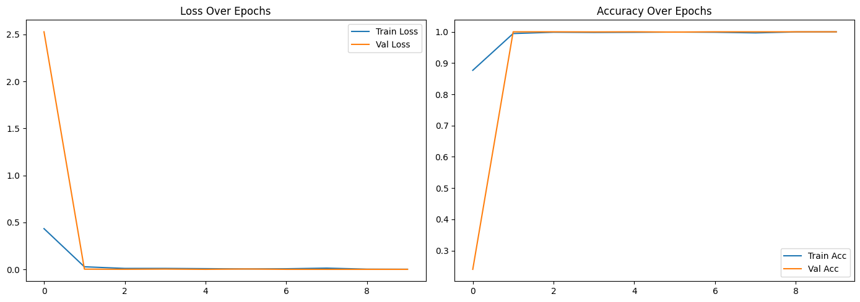
Figure 7: Loss and accuracy of the CNN for each epoch.
The updated plot shows that training accuracy became very high and validation accuracy reached 100%. The validation score is unusually high compared with the final test accuracy of 94.85%. This difference shows why the separate test set is important for evaluating performance on unseen data.

Updated validation setup
This issue has now been corrected in the updated notebook. I split the original 27,455 training images into 21,964 training images and 5,491 validation images (an 80/20 split). The validation set is used by model.fit, EarlyStopping and ReduceLROnPlateau. The original 7,172 test images are kept separate and are used only for the final evaluation. This gives a more reliable test result because the test set is no longer used to select the model weights.

Test results
Table 13: CNN results on the 7,172 test images
Metric | Value
Test accuracy | 0.9485 (6,803 of 7,172 images correct)
Test loss (categorical cross-entropy) | 0.1696
Macro average precision / recall / F1 | 0.95 / 0.95 / 0.94
Weighted average precision / recall / F1 | 0.95 / 0.95 / 0.95
Letters with recall of 1.00 | 13 of 24
Table 14: Precision, recall and F1 for each letter
Letter | Prec. | Recall | F1 | Support | Letter | Prec. | Recall | F1 | Support
A | 0.89 | 1.00 | 0.94 | 331 | N | 0.91 | 0.71 | 0.80 | 291
B | 1.00 | 1.00 | 1.00 | 432 | O | 1.00 | 0.91 | 0.96 | 246
C | 1.00 | 1.00 | 1.00 | 310 | P | 1.00 | 1.00 | 1.00 | 347
D | 1.00 | 1.00 | 1.00 | 245 | Q | 1.00 | 1.00 | 1.00 | 164
E | 1.00 | 1.00 | 1.00 | 498 | R | 0.60 | 1.00 | 0.75 | 144
F | 1.00 | 1.00 | 1.00 | 247 | S | 0.92 | 1.00 | 0.96 | 246
G | 0.89 | 0.94 | 0.92 | 348 | T | 0.94 | 0.82 | 0.88 | 248
H | 0.92 | 0.91 | 0.91 | 436 | U | 1.00 | 0.84 | 0.91 | 266
I | 1.00 | 0.99 | 0.99 | 288 | V | 0.94 | 0.94 | 0.94 | 346
K | 1.00 | 0.90 | 0.95 | 331 | W | 0.92 | 1.00 | 0.96 | 206
L | 0.96 | 1.00 | 0.98 | 209 | X | 0.93 | 1.00 | 0.96 | 267
M | 0.93 | 0.95 | 0.94 | 394 | Y | 0.99 | 0.88 | 0.93 | 332

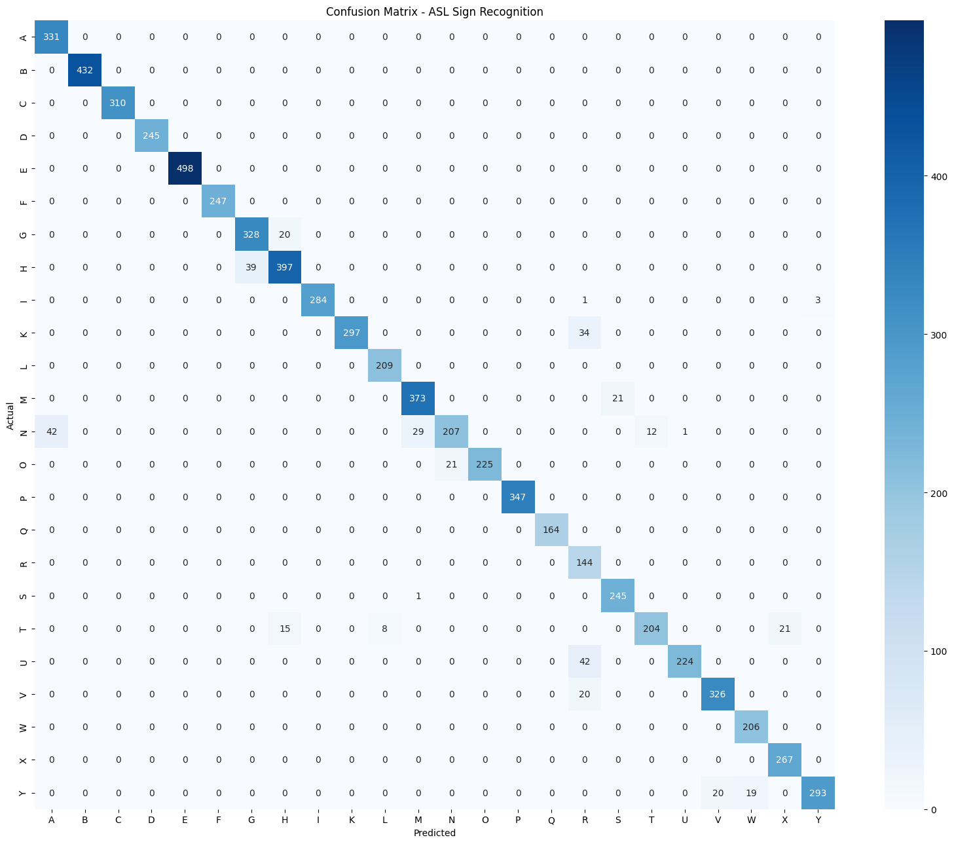
Figure 8: Confusion matrix of the CNN on the test set.

Looking at the errors
The model made 369 mistakes in total. The updated confusion matrix shows which letters were most often confused:
Table 15: All the wrong predictions
True letter | Predicted as | Count | Recall of the true letter
G | H | 20 | 0.94
H | G | 39 | 0.91
I | R | 1 | 0.99
I | Y | 3 | 0.99
K | R | 34 | 0.90
M | S | 21 | 0.95
N | A | 42 | 0.71
N | M | 29 | 0.71
N | T | 12 | 0.71
N | U | 1 | 0.71
O | N | 21 | 0.91
S | M | 1 | 1.00
T | H | 15 | 0.82
T | L | 8 | 0.82
T | X | 21 | 0.82
U | R | 42 | 0.84
V | R | 20 | 0.94
Y | V | 20 | 0.88
Y | W | 19 | 0.88

The weakest letter by recall is N (0.71), followed by U (0.84) and T (0.82). The weakest precision is R (0.60), because several K, U and V images are predicted as R. The confusion matrix also shows errors between N and A/M, and between H and G. These results suggest that some hand shapes are harder for the model to distinguish at the small 28 x 28 image size.
The updated confusion matrix shows 369 incorrect predictions out of 7,172 test images. The largest individual confusion is N predicted as A (42 images), followed by U predicted as R (42 images), H predicted as G (39 images), and Y predicted as V (20 images) or W (19 images). The model may find these signs difficult because their hand shapes can look similar in small grayscale images.

Prediction on new images
In the notebook I also tried the model on test images. For test image 42 the real letter was I, and the model predicted I with 100.00% confidence. I also showed 12 random test images with the real letter, the predicted letter and the confidence (green title when correct and red when wrong). Like in the first model, I saved the model together with the label map and the label binarizer in a .joblib file, loaded it again and checked that it gives the same prediction (I).
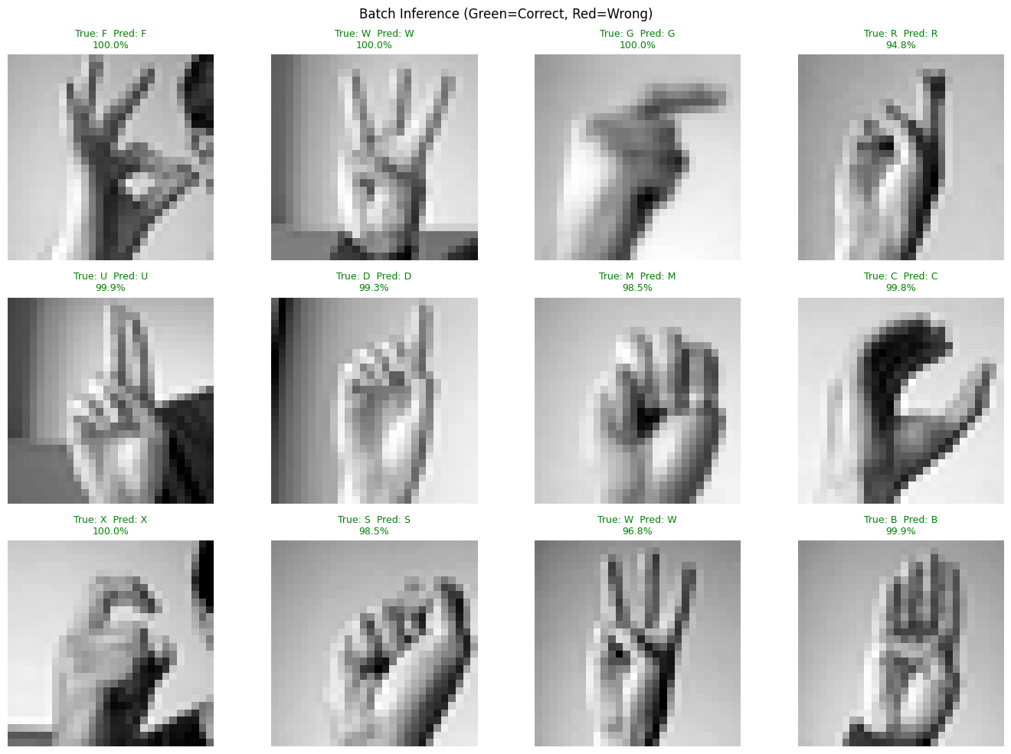
Figure 9: Predictions on 12 random test images (green = correct, red = wrong).

2.7 Conclusion
In this part I trained a CNN with two convolutional blocks, batch normalization and dropout to recognise 24 ASL letters from 28 x 28 grayscale images. On the separate test set of 7,172 images, it achieved 94.85% accuracy, a test loss of 0.1696 and a macro F1-score of 0.94. Thirteen of the 24 letters had a recall of 1.00. The most noticeable errors involved N, U, H, G, R and T. EarlyStopping and ReduceLROnPlateau helped control training, and the saved model gave the same prediction after it was loaded again.
Some limitations and things I would improve:
- The original test set is now kept separate from validation. A 20% validation split is taken from the original training data, and the test set is used only for final evaluation.
- The validation accuracy reached 100%, while test accuracy was 94.85%. This difference suggests that performance on the validation split may not fully represent performance on unseen test images. Data augmentation (small rotations, shifts and zooms, but no flipping) and a smaller dense layer could be explored in future work.
- I did not train a normal dense network on the flattened pixels, so I did not measure how much the convolution layers really help.
- The images are small (28 x 28), in grayscale and without J and Z. In the future this could be extended with transfer learning (for example MobileNetV2), bigger images and real-time recognition with a webcam.

