**Architecture Design**

**Airbnb Data Analysis**

Revision Number: 1.0

Last Date of Revision: 25/03/2024

AYUSH TRIPATHI

**Content List**

1. Introduction
   * 1.1 What is Architecture Design Document?
   * 1.2 Scope
2. Architecture
   * 2.1 Power BI Architecture
   * 2.2 Power BI Desktop
   * 2.3 Power BI Service
   * 2.4 Power BI Gateway
3. Deployment
   * 3.1 Deployment Options in Power BI
   * 3.2 Power BI Desktop Deployment
   * 3.3 Power BI Service Deployment
   * 3.4 Power BI Gateway Deployment
4. **Introduction**
   1. **What is Architecture Design Document?**

Any software needs the architectural design to represents the design of software. IEEE defines architectural design as “the process of defining a collection of hardware and software components and their interfaces to establish the framework for the development of a computer system.” The software that is built for computer-based systems can exhibit one of these many architectures.

Each style will describe a system category that consists of :

• A set of components (eg: a database, computational modules) that will perform a function

required by the system.

• The set of connectors will help in coordination, communication, and cooperation between

the components.

• Conditions that how components can be integrated to form the system.

• Semantic models that help the designer to understand the overall properties of the system.

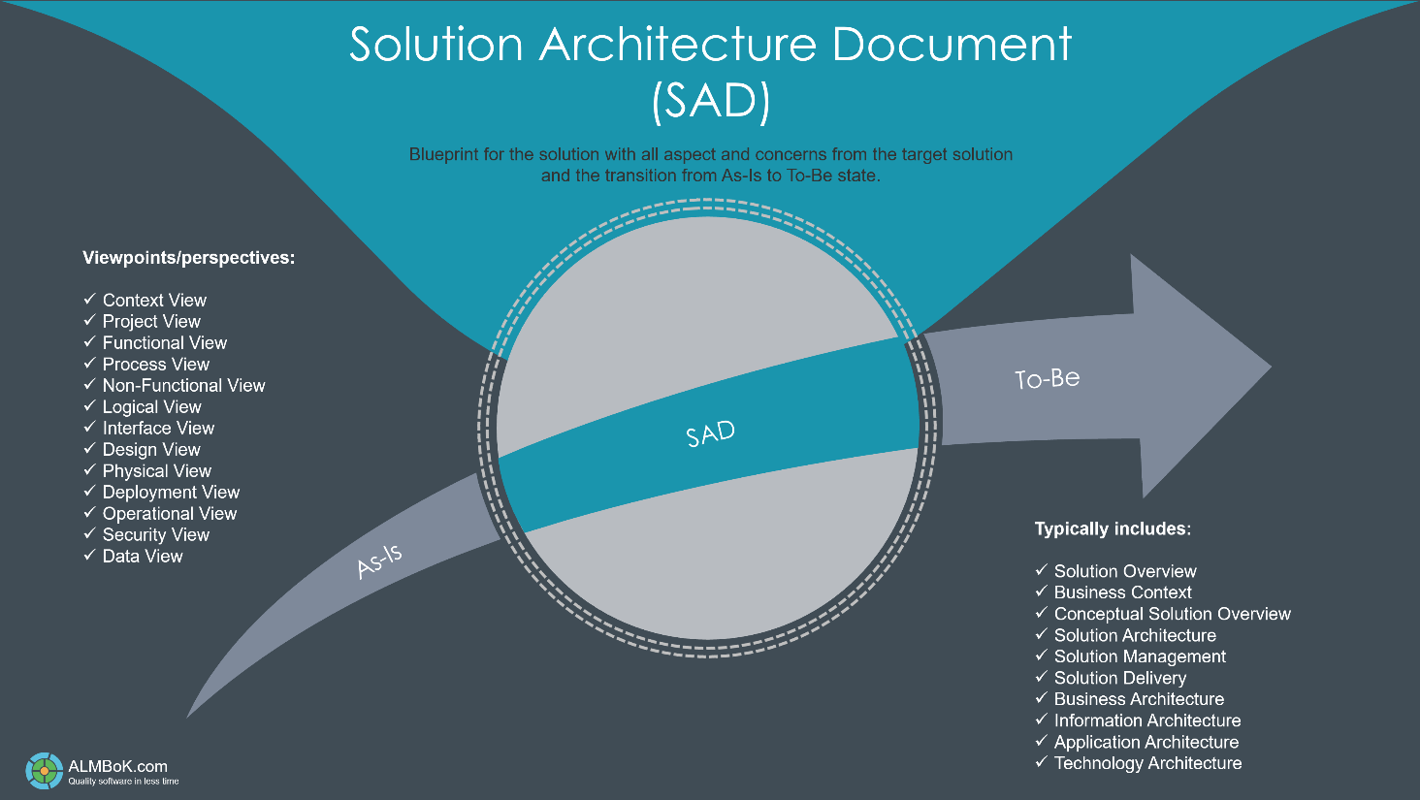

* 1. **Scope?**

This ADD delineates the architecture of the Airbnb Data Analysis Project, focusing on its design principles, data processing flow, and deployment strategies within the Power BI environment. It aims to provide a detailed roadmap for system development, ensuring scalability, reliability, and performance.

1. **Architecture**

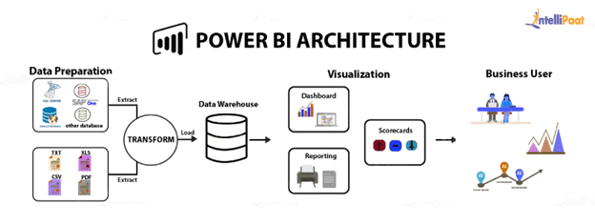

* 1. **Power BI Architecture**

The architecture of the Airbnb Data Analysis Project revolves around the Power BI ecosystem, comprising Power BI Desktop, Power BI Service, and Power BI Gateway. This architecture leverages the inherent capabilities of Power BI for data visualization, analysis, and reporting.

* 1. **Power BI Desktop**

Power BI Desktop serves as the cornerstone of the architecture, offering a robust environment for data modelling, transformation, and visualization. It provides a rich set of features for connecting to diverse data sources, shaping data, and creating interactive reports and dashboards.

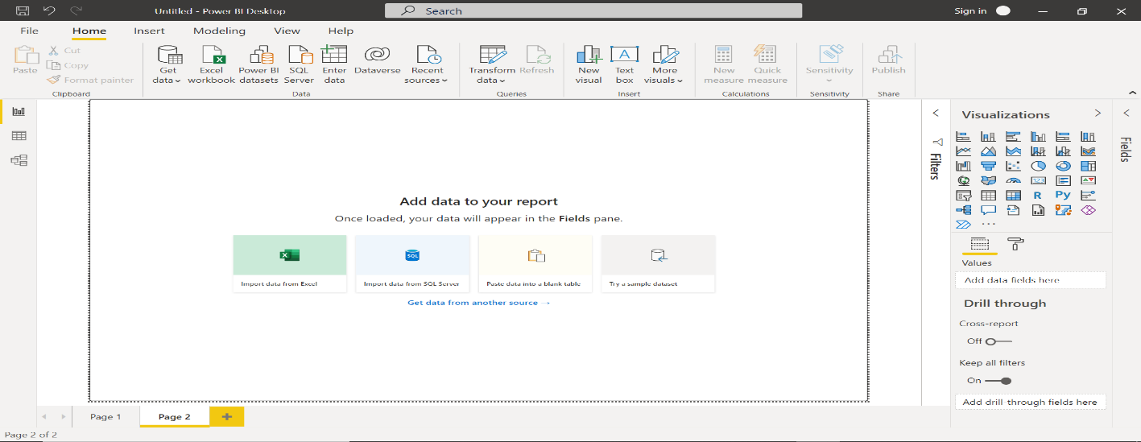

* 1. **Power BI Service**

Power BI Service extends the functionality of Power BI Desktop by providing a cloud-based platform for publishing, sharing, and collaborating on reports. It offers centralized access to reports via web browsers and mobile devices, facilitating seamless collaboration and data-driven decision-making.

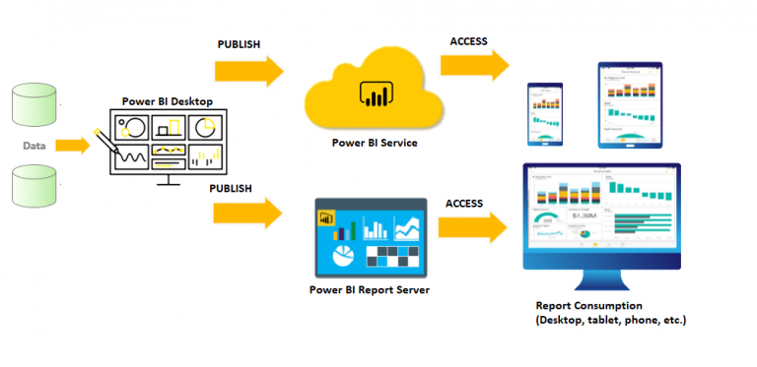

* 1. **Power BI Gateway**

Power BI Gateway plays a pivotal role in the architecture by enabling secure connections between on-premises data sources and Power BI Service. It ensures data integrity and privacy while enabling real-time data refreshes and analysis, thereby empowering organizations to harness the full potential of their data assets.

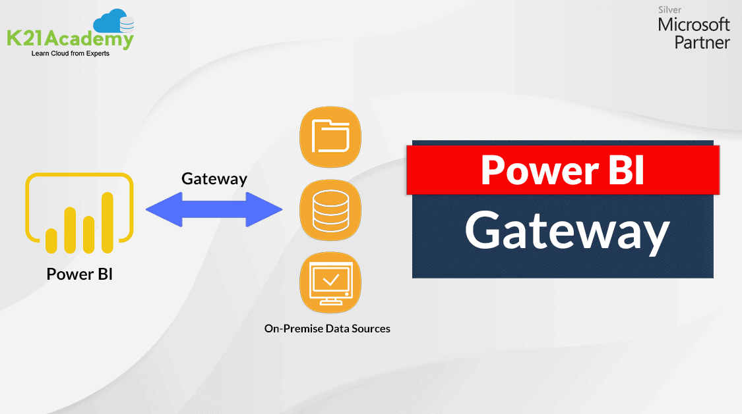

1. **Deployment**
   1. **Deployment Options in Power BI**

Power BI offers flexible deployment options tailored to varying user requirements and organizational needs. These deployment options include Power BI Desktop for individual use, Power BI Pro for small teams, and Power BI Premium for enterprise-grade deployments.

* 1. **Power BI Desktop Deployment**

Power BI Desktop is deployed on individual workstations, providing users with a free version for data exploration and report creation. It serves as the entry point for data analysis, enabling users to connect to data sources, model data, and design compelling visualizations.

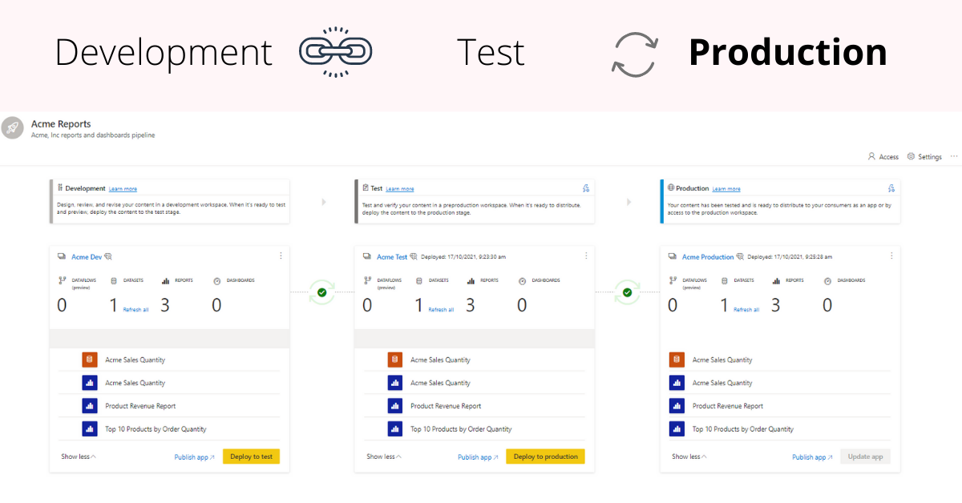

* 1. **Power BI Service Deployment**

Power BI Service is deployed on Microsoft Azure cloud infrastructure, offering a centralized platform for publishing, sharing, and consuming reports and dashboards. It provides accessibility via web browsers and mobile apps, facilitating seamless collaboration and decision-making across teams.

* 1. **3.4 Power BI Gateway Deployment**

Power BI Gateway is deployed on-premises within organizational networks to establish secure connections between Power BI reports and on-premises data sources. It ensures data security and compliance while enabling real-time data analysis and insights generation.

