**High-Level Design (HLD)**

**Airbnb Data Analysis**

Revision Number: 1.0

Last Date of Revision: 24/03/2024

AYUSH TRIPATHI

Table of Contents:

1. Introduction

-1.1 Why this High-Level Design Document?

-1.2 Scope

2. General Description

-2.1 Product Perspective and Problem Statement

3. Design Details

- 3.1 Functional Architecture

- 3.2 Data Flow Diagram

4. Visualization Tools Used

5. Deployment

6. Conclusion

**Abstract**

In today's dynamic hospitality industry, understanding the underlying trends, preferences, and factors influencing consumer behavior is paramount for businesses to stay competitive. The Airbnb Data Analysis internship project, powered by Power BI, delves into the extensive dataset provided by Airbnb to uncover valuable insights that can inform strategic decision-making and drive business growth. Through meticulous data cleaning, preprocessing, analysis, and visualization, this project aims to unravel patterns in booking trends, pricing dynamics, user preferences, and geographical patterns within the Airbnb marketplace. By leveraging advanced analytics techniques and interactive visualizations, stakeholders in the hospitality sector can gain actionable insights into demand-supply dynamics, pricing strategies, and customer segmentation, thus empowering them to make informed decisions and enhance their competitive edge in the ever-evolving marketplace.

1. **Introduction**

**1.1 Why this High-Level Design Document?**

The High-Level Design (HLD) document for the Airbnb Data Analysis internship project serves as a crucial blueprint, outlining the project's architecture, objectives, and design considerations. It provides a comprehensive overview of the project's scope, guiding principles, and technical requirements, ensuring alignment with stakeholder expectations. By detailing design aspects, interface descriptions, and performance requirements, the HLD facilitates efficient development, early detection of potential issues, and adherence to best practices. Moreover, it serves as a reference manual for developers, aiding in the consistent implementation of design features and ensuring the robustness and scalability of the solution. The HDD focuses on:

- Clarity of project scope

- Detection of contradictions prior to implementation

- Reference manual for development

- Description of user interface

- Specification of hardware and software interfaces

- Outline of performance requirements

- Explanation of design features and architecture

- Listing and description of non-functional attributes

**1.2 Scope**

The scope of this project encompasses a comprehensive analysis of Airbnb data, focusing on various aspects such as booking trends, pricing dynamics, user preferences, and geographical patterns. By exploring these facets, the project aims to address key questions surrounding the Airbnb marketplace, including demand-supply dynamics, pricing strategies, and customer segmentation.

1. **General Description**

The Airbnb Data Analysis project unfolds through several interconnected stages:

- Data Collection: Gathering Airbnb datasets containing information on listings, bookings, reviews, and host details.

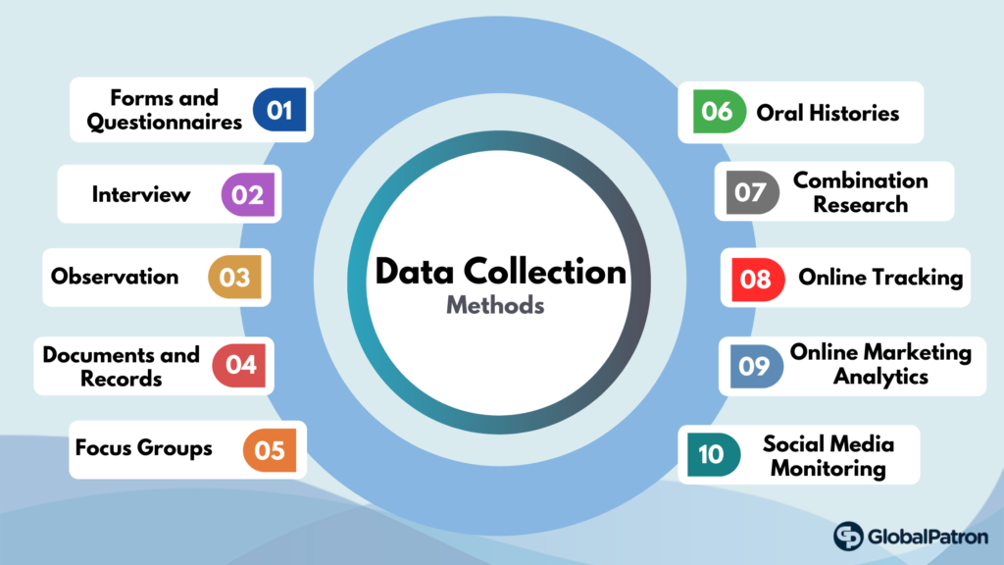

- Data Cleaning: Preprocessing raw data to handle missing values, outliers, and inconsistencies to ensure data integrity.

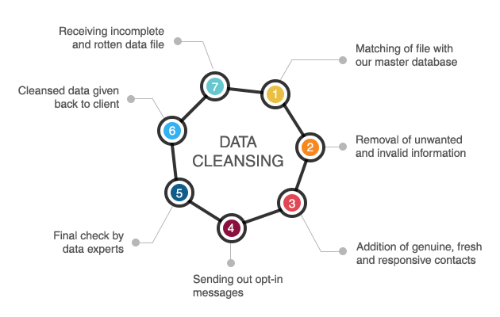

- Data Preprocessing: Transforming and structuring data for analysis, including feature engineering, normalization, and data aggregation.

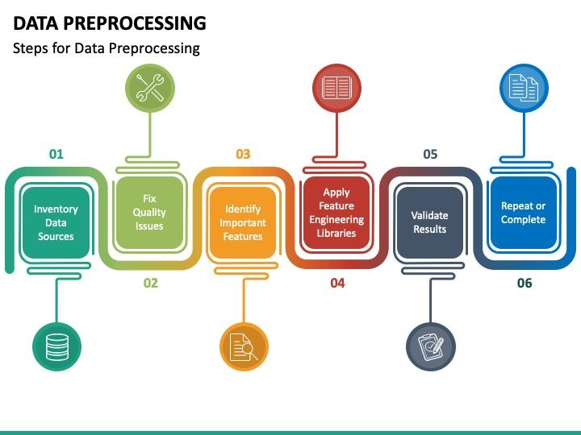

- Data Analysis: Applying statistical techniques and machine learning algorithms to derive insights from the dataset.

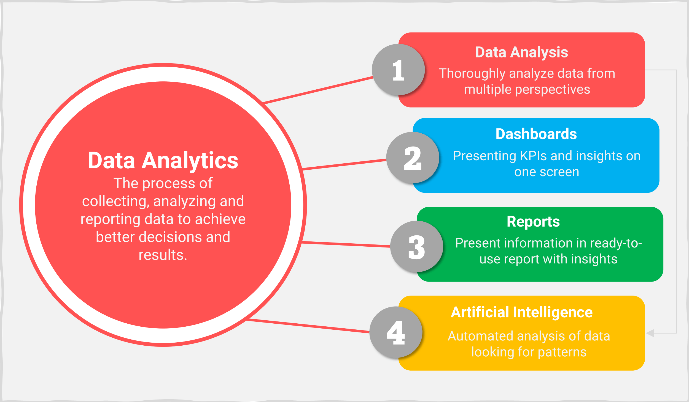

- Data Visualization: Creating interactive and insightful visualizations using Power BI to present findings in an intuitive manner.

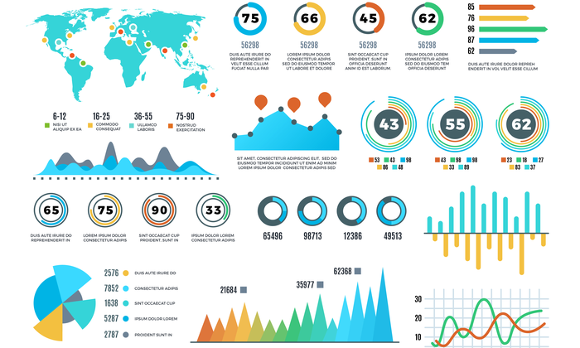

1. **Design Details**

**3.1 Functional Architecture**

The project's functional architecture comprises distinct modules:

- Data Collection Module: Responsible for sourcing Airbnb datasets from various sources and formats.

- Data Cleaning Module: Handles data preprocessing tasks such as data cleaning, deduplication, and standardization.

- Data Preprocessing Module: Executes data transformation and feature engineering processes to prepare data for analysis.

- Data Analysis Module: Performs statistical analysis, machine learning modeling, and hypothesis testing to extract insights.

- Data Visualization Module: Utilizes Power BI's visualization tools to create interactive dashboards and reports.

**3.2 Data Flow Diagram**

The data flow diagram illustrates the sequential flow of data through the different modules, highlighting the transformation and processing steps involved from data collection to visualization.

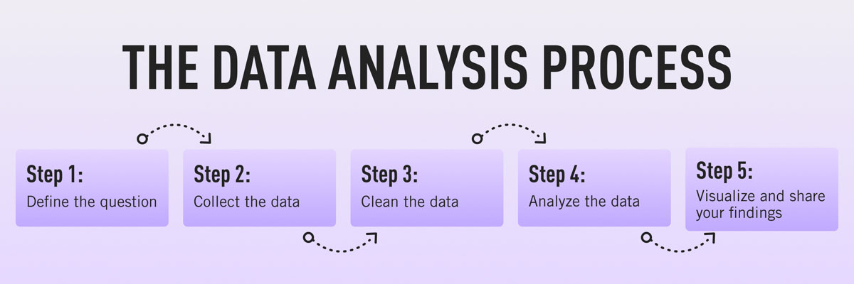

1. **Visualization Tools Used**

Power BI offers a plethora of visualization tools tailored for data exploration and storytelling, including but not limited to:

- Clustered Column Chart: Ideal for comparing categorical data across different groups or categories.

- Stacked Column Chart: Visualizes data as stacked columns, facilitating comparison of part-to-whole relationships.

- Donut Chart: Presents data in a circular format, allowing for easy visualization of proportions and percentages.

- Clustered Bar Chart: Similar to clustered column chart but uses bars instead of columns for comparison.

- Cards: Displays single key metrics or KPIs prominently.

- Table: Presents detailed data in tabular format, suitable for displaying raw data or summary statistics.

- Slicers: Enables interactive filtering of data based on user-defined criteria.

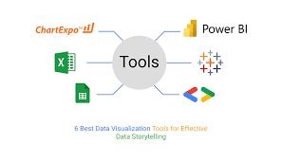

1. **Deployment**

Deployment strategies for the Power BI reports involve considerations such as:

- Publishing to Power BI Service: Hosting reports on the Power BI cloud service for easy access and sharing with stakeholders.

- Embedding in Web Applications: Integrating Power BI reports into web applications or portals for seamless user experience.

- Sharing via Email: Distributing reports via email with embedded visuals or links to interactive dashboards.

1. **Conclusion**

The Airbnb Data Analysis internship project, developed using Power BI, represents a concerted effort to explore and derive insights from Airbnb data. By leveraging advanced analytics and visualization capabilities, this project aims to provide actionable insights for stakeholders in the hospitality industry, thereby contributing to informed decision-making and strategic planning.