**Wireframe**

**Airbnb Data Analysis**

Revision Number: 1.0

Last Date of Revision: 26/03/2024

AYUSH TRIPATHI

**Dashboard**

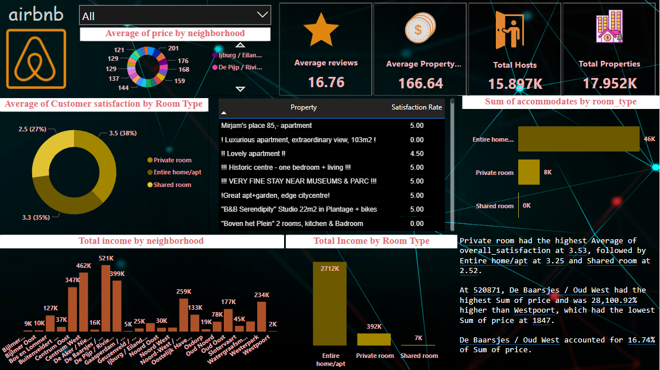

1. Average of price by neighbourhood

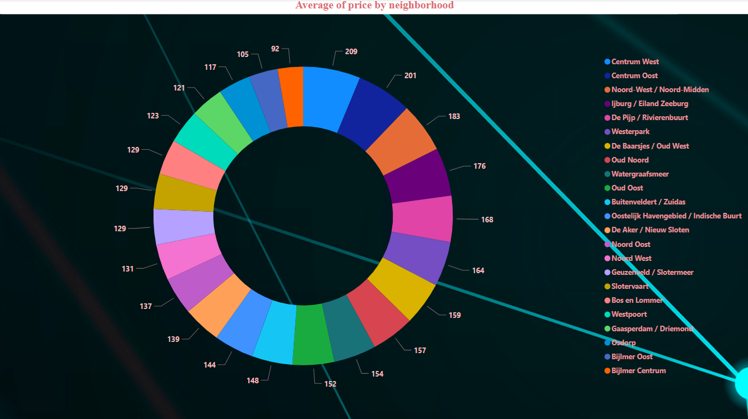

1. Average of Customer Satisfaction by Room Type

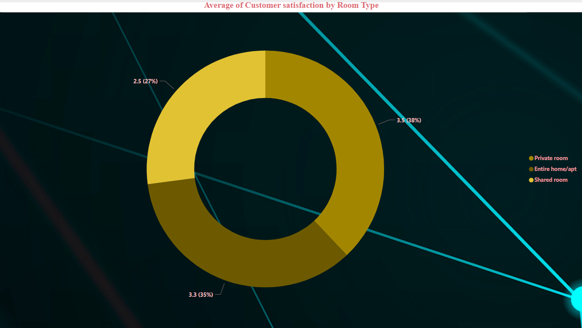

1. Total Income by Neighborhood

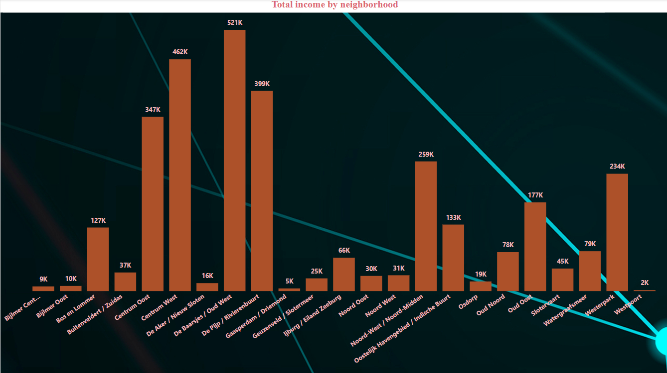

1. Total Income by Room Type

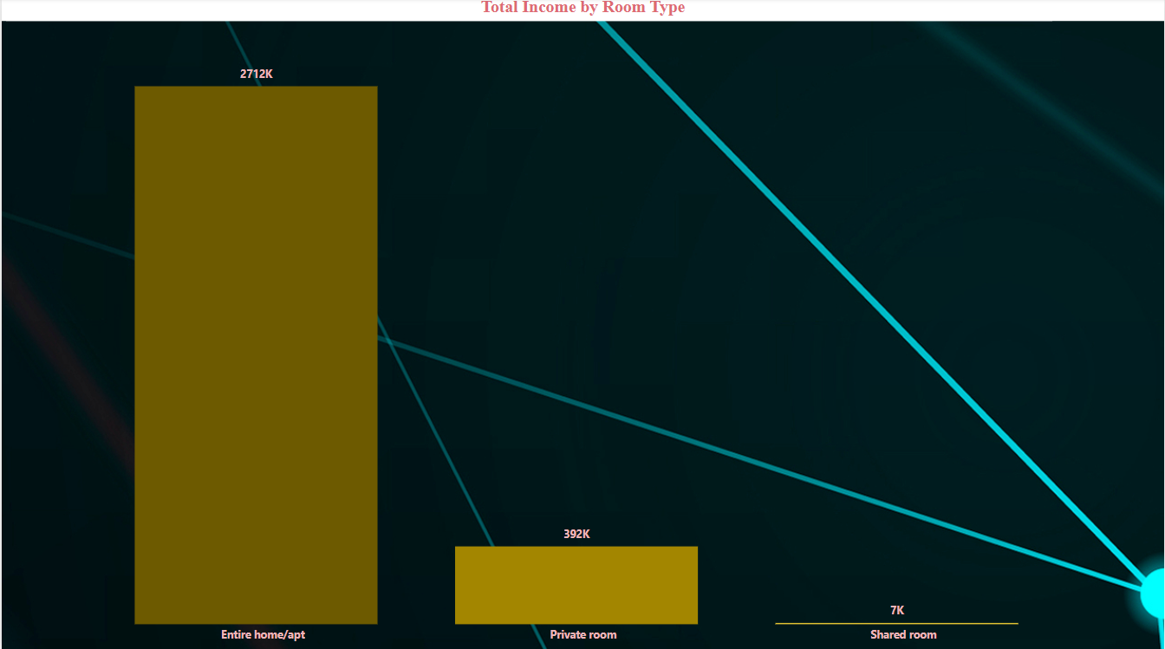

1. Sum of accommodates by Room Type

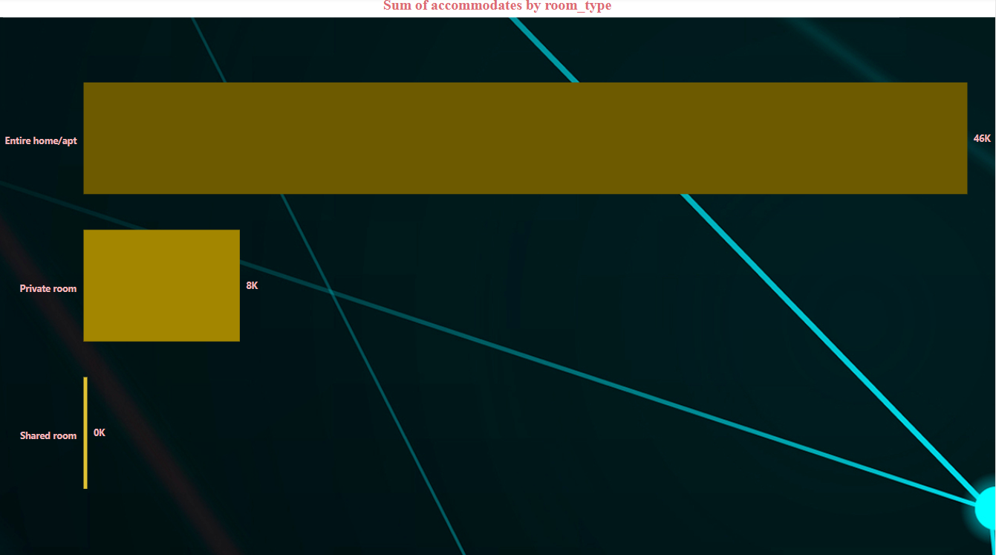

1. Property and Satisfaction Rate Representation

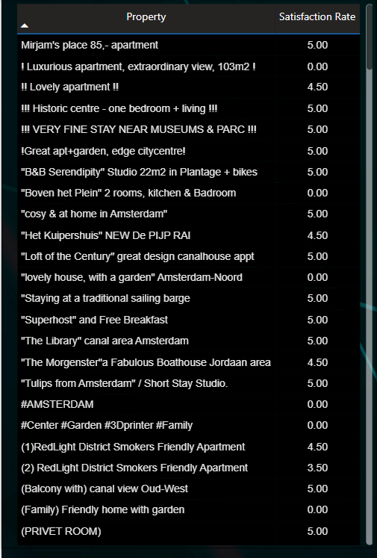

1. Basic KPI

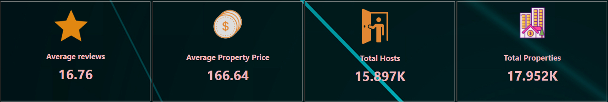

1. Slicer

