Movie Rental Data Warehouse Design
From OLTP Schema to Dimensional Model and ETL Design
Data Warehousing / Data Architecture

Prepared By:
Ayham Aqel, Ola Odeh
Instructor:
Dr. Moamin Abughazaleh
University:
An-Najah National University
Faculty:
Faculty of Information Technology and Artificial Intelligence
Department:
Computer Science
Semester:
Second Semester 2025/2026
Submission Date:
15 May 2026

1. Introduction
The movie rental OLTP database is designed for daily operational transactions such as customer registration, film rentals, payments, inventory management, and staff activities. Although the OLTP system is efficient for transaction processing, it is not optimized for analytical reporting and business intelligence analysis.
Business managers need a centralized Data Warehouse that can support analytical queries, reporting, trend analysis, and decision-making. A dimensional data warehouse improves query performance and simplifies complex operational data into an analytical structure.
This project proposes a Movie Rental Data Warehouse based on dimensional modeling principles using fact tables, dimension tables, and ETL processes. The warehouse supports business analysis related to rental activity, customer behavior, film popularity, revenue generation, store performance, and time-based trends.
The project also includes an ETL pipeline implemented using Python, Pandas, and MySQL. The ETL process extracts data from the OLTP Sakila database, transforms and cleans the data, and loads it into a dimensional warehouse schema designed for analytics and reporting.
Additionally, analytical charts and dimensional model diagrams were created to support business intelligence visualization and reporting.

2. Business Questions
The warehouse is designed to answer the following business questions:
Which films are rented most frequently?
Which stores generate the highest revenue?
How does revenue change by month, quarter, or year?
These business questions help management analyze film popularity, store financial performance, and revenue trends over time in order to support business intelligence and decision-making.

3. Dimensional Model Design
3.1 Selected Business Processes
Business Process | Why Selected | Business Process
Rental analysis and late return tracking. | Core business activity of the system. | Rental Transactions
Revenue and payment analytics. | Main source for revenue analysis. | Payment Transactions
Inventory availability statistics. | Supports inventory monitoring. | Inventory Availability

3.2 Fact Tables
Related Dimensions | Measures | Grain | Fact Table
Dim_Date, Dim_Customer, Dim_Film, Dim_Store, Dim_Staff | rental_count, rental_duration_days, late_return_flag | One row per rental transaction | Fact_Rental
Dim_Date, Dim_Customer, Dim_Film, Dim_Store, Dim_Staff | payment_amount, payment_count | One row per payment transaction | Fact_Payment
Dim_Film, Dim_Store | inventory_count, available_flag | One row per inventory item per store | Fact_Inventory

3.3 Dimension Tables
Purpose | Main Attributes | Dimension Table
Time analysis | date_key, full_date, month, year | Dim_Date
Customer analysis | customer_key, full_name, city, country | Dim_Customer
Film analysis | film_key, film_title, rental_rate | Dim_Film
Store analysis | store_key, store_id, city | Dim_Store
Staff analysis | staff_key, full_name | Dim_Staff
Category analysis | category_key, category_name | Dim_Category
Actor analysis | actor_key, full_name | Dim_Actor

3.4 Bridge Tables
Purpose | Keys | Bridge Table
Handles film-category relationships | film_key, category_key | Bridge_Film_Category
Handles film-actor relationships | film_key, actor_key | Bridge_Film_Actor

3.5 Schema Type
The proposed warehouse follows a hybrid star schema design that combines traditional star-schema principles with bridge tables to handle many-to-many relationships between films, categories, and actors.

4. Dimensional Model Diagram
The following diagram illustrates the final dimensional model of the Movie Rental Data Warehouse. The model includes fact tables, dimension tables, and bridge tables used to support analytical reporting and business intelligence analysis.
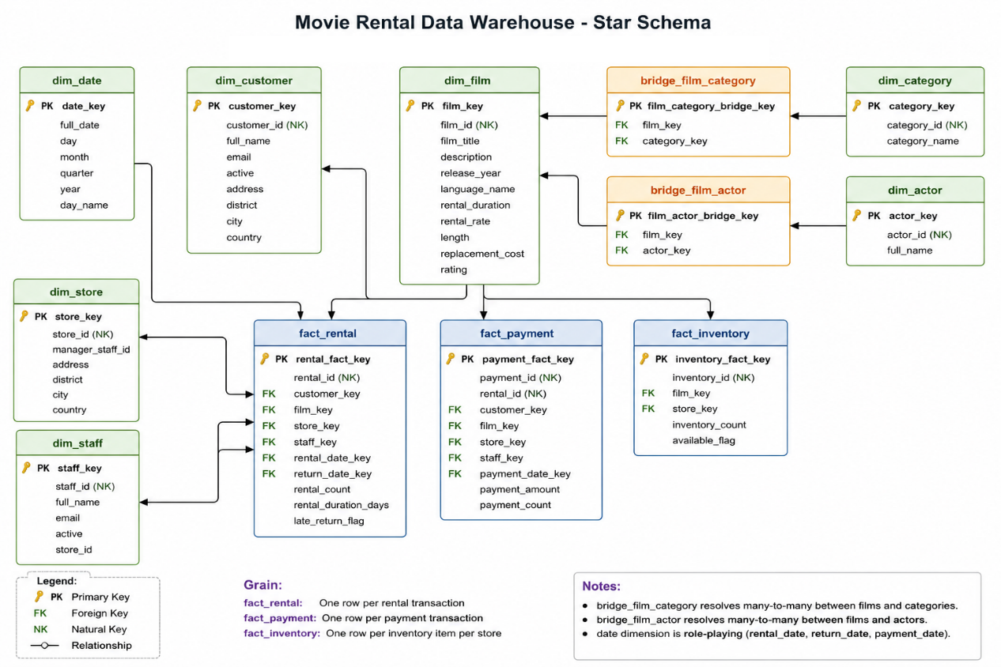
5. ETL Design
The ETL pipeline was implemented using Python, Pandas, SQLAlchemy, and MySQL. The purpose of the ETL process is to extract operational data from the Sakila OLTP database, transform it into a dimensional model, and load it into the Movie Rental Data Warehouse.
5.1 Extract
Used For | Source OLTP Table
Building Dim_Customer | customer
Adding customer and store address details | address
Adding city information | city
Adding country information | country
Building Dim_Film and film-related facts | film
Adding film language information | language
Building Dim_Category | category
Building Bridge_Film_Category | film_category
Building Dim_Actor | actor
Building Bridge_Film_Actor | film_actor
Building Fact_Inventory and connecting films to stores | inventory
Building Fact_Rental | rental
Building Fact_Payment | payment
Building Dim_Staff | staff
Building Dim_Store | store
5.2 Transform
Description | Transformation
Removed operational columns such as last_update where not needed. | Drop unnecessary columns
Combined first_name and last_name for customers, staff, and actors. | Create full names
Created warehouse keys such as customer_key, film_key, staff_key, category_key, and actor_key. | Generate surrogate keys
Built dim_date from rental, return, and payment dates. | Create date dimension
Created customer, film, store, staff, category, actor, and date dimensions. | Build dimensions
Created bridge tables for film-category and film-actor relationships. | Build bridge tables
Calculated rental_duration_days from rental and return dates. | Calculate rental duration
Created late_return_flag by comparing actual rental duration with expected rental duration. | Detect late returns
Created measures such as rental_count, payment_count, payment_amount, inventory_count, and available_flag. | Create measures
Exported transformed warehouse tables as CSV files inside transformed_data. | Save CSV outputs

5.3 Load
The loading stage loads the transformed tables into the MySQL data warehouse database named movie_rental_warehouse.
dim_date | 1
dim_customer | 2
dim_film | 3
dim_category | 4
dim_actor | 5
dim_store | 6
dim_staff | 7
bridge_film_category | 8
bridge_film_actor | 9
fact_rental | 10
fact_payment | 11
fact_inventory | 12

The dimension tables are loaded before the fact tables so that fact tables can reference existing surrogate keys. Bridge tables are also loaded before facts to support many-to-many relationships between films, categories, and actors.

6. Data Quality Considerations
Several data quality considerations were addressed during the ETL process to improve analytical accuracy and consistency within the Movie Rental Data Warehouse.
Solution Applied | Data Quality Issue
Removed unnecessary columns such as last_update. | Duplicate operational columns
Combined first and last names into unified full-name attributes. | Missing full names
Converted dates into standardized datetime formats. | Inconsistent date formats
Created surrogate keys for all dimensions and fact tables. | Missing analytical structure
Implemented bridge tables for film-category and film-actor relationships. | Many-to-many relationships
Calculated rental duration using rental and return dates. | Rental duration inconsistency
Created late_return_flag to identify delayed returns. | Late rental detection
Combined multiple OLTP tables into unified analytical dimensions. | Data integration complexity
Data Quality Summary
The ETL pipeline improves data consistency, dimensional integration, analytical usability, and reporting quality. The final warehouse structure supports reliable business intelligence analysis and simplifies complex operational relationships.
7. Charts and Analytics
The following charts were generated from the Movie Rental Data Warehouse to support analytical reporting and business intelligence analysis
7.1 Top Rented Films
This chart shows the films with the highest rental activity. It helps identify the most popular films and customer preferences.
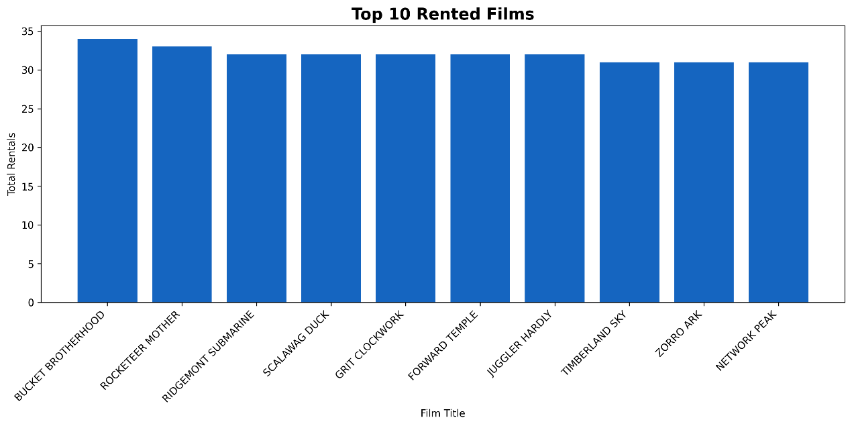
7.2 Revenue by Store
This chart compares total revenue generated by each store. It supports store performance and financial analysis.
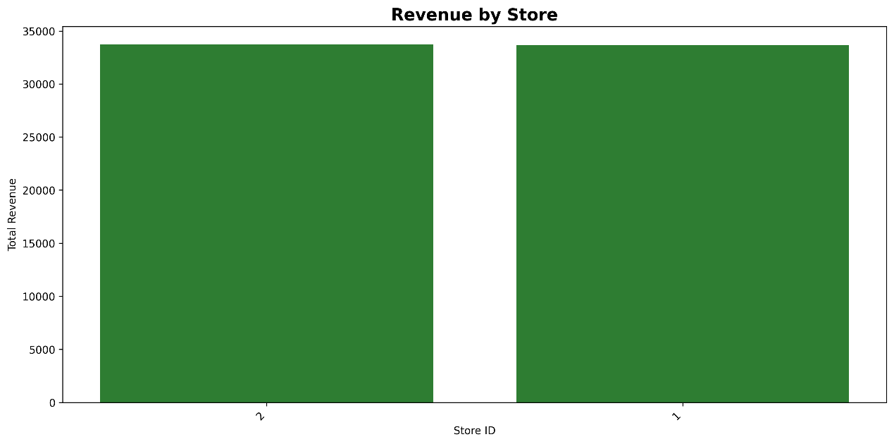
7.3 Monthly Revenue Trend
This chart illustrates how revenue changes over time by month. It helps analyze business growth and seasonal trends.
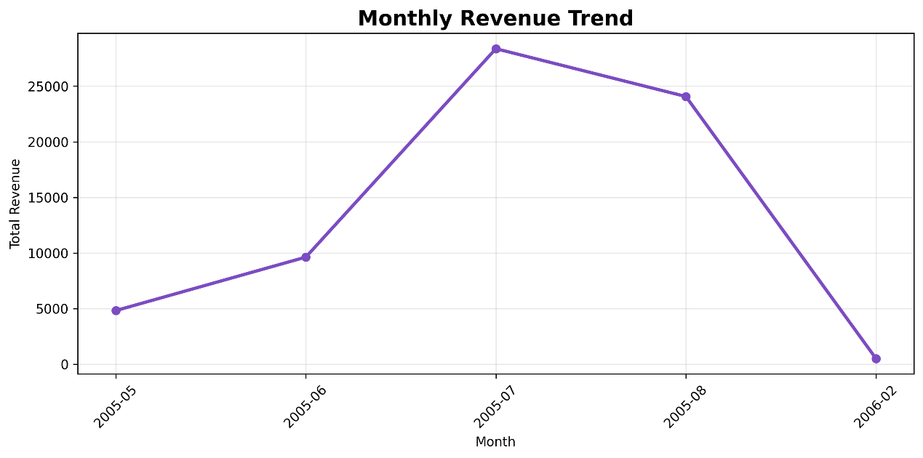
7.4 Rentals by Film Category
This chart displays rental activity by film category. It helps identify the most popular categories among customers.
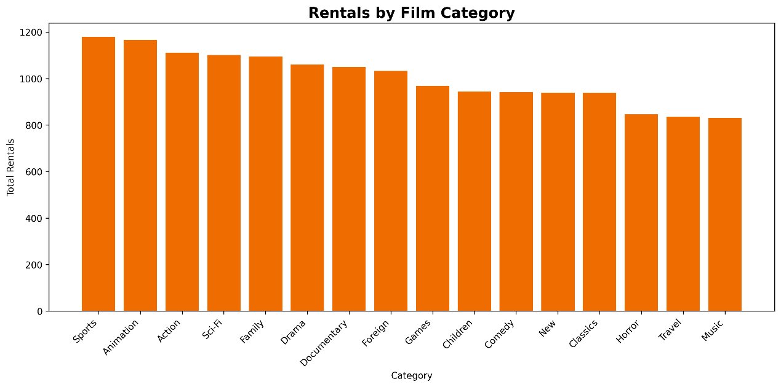
7.5 Top Customers by Rentals
This chart identifies the customers with the highest rental activity. It supports customer behavior and loyalty analysis.
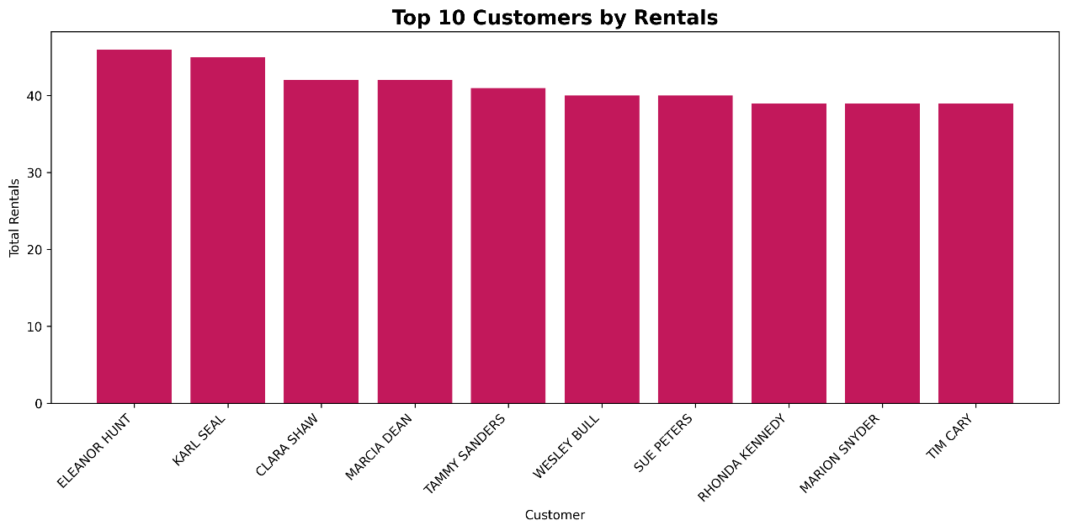
8. Conclusion
The proposed Movie Rental Data Warehouse successfully transforms the Sakila OLTP database into a dimensional analytical structure suitable for reporting and business intelligence analysis.
The warehouse design includes fact tables, dimension tables, and bridge tables to support rental analysis, revenue analysis, inventory tracking, customer behavior analysis, and time-based reporting.
The ETL pipeline extracts operational data, transforms it into analysis-ready structures, generates surrogate keys and analytical measures, and loads the final data into the warehouse. In addition, charts and dimensional diagrams were created to support visualization and decision-making.
The final dimensional model simplifies complex operational relationships and improves analytical performance, reporting capabilities, and business intelligence support.

