**BodyDMI MATLAB package steps**

1. Open Matlab and type Reconpackage
   1. Type in dataset name and press enter. If you press enter without typing anything dataset will automatically named as TESTdataset.
   2. Type in number of dynamics acquired during the session, including the baseline.
   3. Select the datasets as in acquisition order and set the acquisition parameters(TE and acquisition bandwidth).
   4. Type in number of channels. If the data is acquired with more than 1 channel, you will be asked to select the noise data for channel combination.
   5. All dynamics will be reconstructed.
2. After Reconstruction step is finished. Type in MaskPackage
   1. Type in dataset name, it needs to be same with the one you have in Matlab workspace.
   2. You will be asked for the Dicom images, go to the folder that contains exported dicom images and click the number corresponds to ‘T1w_TRA_match_CSI’. It could be handy if you could open the dicom folder in a dicom viewer program and note the export number(ie IM_0027).

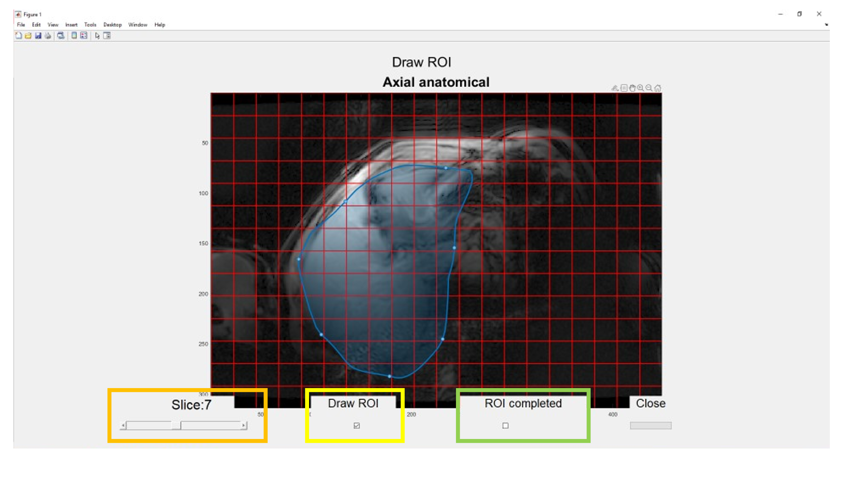

* 1. Once you select the dicom file, a new window will appear. First, check the slices by using the Slider on the left slide. This will help avoiding matlab errors. Once you know which slices to include to go highest or lowest slide, it doesn’t matter which as long as you make it to one end.
  2. Click Draw ROI and start drawing ROI on the axial image. Start drawing by click-and-holding the mouse until you finish drawing. When you release the mouse, matlab will automatically enclose the ROI by the shortest path between start and finish points.
  3. Move on to the next slide and repeat the drawing process. You don’t need to click anywhere else in between. When you are done change slide and repat until you draw ROI on the last axial slice of you mask.
  4. when you are finished with drawing the whole mask, click ROI completed. You can now close the window.

1. Now, we have the mask to fit metabolites using AMARES. Type in Quantifypackage.
   1. Matlab will ask you dataset name, and it will be followed by a pop-up that has fitting options. Change the priorknowledge file(which is located in Quantify folder) you will like to use and select if you want to use raw or denoised signal to fit.
   2. Two excel files with fitting results( in arbitrary units and normalized to baseline water/metabolite #4) will be generated in the current folder.
   3. If you want to use a different prior knowledge, please use one the current ones as a template and save it in the same directory.
2. All processing is finished at his point. You plot the spectra with Show_Dicom_Spectra function, ie Show_Dicom_Spectra(V1111).

