**Software Requirements Specification**

**For**

**Usability Testing Platform**

**Version 1.0**

**Prepared by**

**Project D**

**16.04.2024**

Contents

1.1 Purpose 4

1.2 Scope of Project 4

1.3 Definitions,Acronyms, and Abbreviations 4

1.4 References 4

1.5 Overview 4

2.General Description 4

2.1 Product Perspective 4

2.2 Product Functions 5

2.3 Users and Characteristics 5

2.4 General Constraints 5

3. The Specific Requirements 6

3.1.Externel Interface Requirements 6

3.1.1. User Interfaces 6

3.1.2 Communication Interfaces 13

3.2 Functional Requirements 13

3.2.1 Usability Problem Submission Process 14

3.2.1.1 Tester Submits a Usability Problem 14

3.2.1.2 Admin reviews usability problems 16

3.2.2 Data Model…………………………………………………………………………………………..17

3.2.3 Use Case Diagram…………………………………………………………………………………18

4. Other Nonfunctional Requirements 188

4.1 Performance Requirements 188

4.2 Security Requirements 199

4.3 Software Quality Attributes 199

Revision History

|  |  |  |  |
| --- | --- | --- | --- |
| **Name** | **Date** | **Reason For Changes** | **Version** |
| SRS | 22.12.2021 | First Version created | 1.0 |
|  |  |  | 1.1. |
|  |  |  | 1.2 |

1.Introduction

## 1.1 Purpose

The purpose of this document is to provide a comprehensive overview of web-based usability testing platform that allows users to register as testers, evaluate software usability, submit findings and collaborate with software owners.

## 1.2 Scope of Project

This software system will be a website consisting of an easy interface where users can register as testers, evaluate software usability, and manage usability problems they indetify. It also encompasses functionalities for guest users, software owners, and admins. The platform is completely under the admins’ control; they can manage software additions,findings approval, user registirations, and blog posts.Software owners can register using their company email comment on findings related to their profile and comments while guest users can browse and rate findings without registiration.

## 1.3 Definitions,Acronyms, and Abbreviations

## 1.4 References

1. "IEEE Guide for Software Requirements Specifications," in IEEE Std 830-1984 , vol., no., pp.1-26, 10 Feb. 1984, doi: 10.1109/IEEESTD.1984.119205.

## 

## 1.5 Overview

This SRS contains all requirements and constraints of OTL project.

Section 2 describes the general factors that affect the product and its requirements.

Section 3 contains all the details software developer needs to create the software.

Section 4 defines technologies, infrastructure, performance, scalability, quality attr,butes and other non-functional requirements.

# 2.General Description

## 2.1 Product Perspective

This software is a security critical web application and will be accessible from any browser. Users can register as testers, assess the usability of software, and handle issues related to usability in a secure environment on this site. The platform functions in the context of web applications, following security guidelines and guranteeing browser compatibility for borad accessibility and usability testing capabilities.

## 

## 2.2 Product Functions

1. User Registiration: Allows new users to create accounts on the platform by providing necessary information such as username,email address, password, city(optional), and gender(optional).
2. User Authentication: Verifies user credentials againts the database to grant Access.
3. Forgot Password:Provides a link for users to reset their passwords if forgotten.
4. Software Listing: Lists available software titles for testing
5. Software Usability Information: Displays detailed information about a specific software
6. Usability Problem Submission: Allows testers to submit usability issues
7. Commenting System: Enables software owners to comment on findings
8. Rating System: Allows users to rate findings.
9. Admin Functions: Provides administrators with control over platform management.
10. Dashboard: Responsible for managing the platform.

## 

## 2.3 Users and Characteristics

The platform accommodates multiple user roles, each with distinct characteristics and actions accordimng to their specific requirements.

1. Testers: Individuals who register on the platform to evaluate software usability and submit findings.
2. Guest Users: Unregistered individuals who can read and rate findings without creating accounts.
3. Software Owners: Companies or individuals who own software products and wish to receive feedback from testers.
4. Administrators: Responsible for managing the platform, including user accounts, software listings, and blog posts.

## 2.4 General Constraints

1. Robust security measures must protect user data, including encryption and protection against common web vulnerabilities.
2. The system should accommodate growth in user base and data volume. Considerations should be taken into account in database design and application architecture.
3. The platform should optimize for fast response times and smooth user experience.
4. Prioritize intuitive and user-friendly design for clear navigation and effective use.

# 3. The Specific Requirements

## 3.1.Externel Interface Requirements

### 3.1.1. User Interfaces

#### 3.1.1.1. Homepage

The Homepage serves as the main interface for users accessing the usability testing platform. It provides essential information and navigation options to guide users effectively.

The Homepage begins with an overview section, designed to introduce visitors to the platform's mission and objectives. This section emphasizes the significance of usability testing in software development, setting the context for users' interactions with the platform.

metin, ekran görüntüsü, yazı tipi, sayı, numara içeren bir resim

Açıklama otomatik olarak oluşturulduThen it contains an informative contains part that; highlights the platform's key features and benefits. This content gives an overview of the platforms’ functionality and will direct to pages when licked to a button such as; user registration, software listing, blog page, profile page, and login page.

#### 3.1.1.2. User Registration Page

A key element of the usability testing platform is the User Registration Page, which is made to make the registration process easier for new users. Its main goal is to make account creation easy for users while maintaining data security and accuracy.

The User Registration Page presents users with a structured registration form, including fields for essential user details such as username, email address, password, city (optional), and gender (optional). These fields will be valitated. Validation mechanisms are integrated into the User Registration Page to verify the correctness and completeness of user input. This involves verifying the format of emails, ensuring the strength of passwords, and, depending on platform specifications, perhaps checking other variables like username, city, and gender.

metin, ekran görüntüsü, ekran, görüntüleme, sayı, numara içeren bir resim

Açıklama otomatik olarak oluşturuldu

#### 3.1.1.3. Login Page

Login page is for serving as the gateway for registered users to access their accounts.

When users visit the Login Page, they are greeted with a simple login form. Users are prompted to provide their email address and password in certain fields on this form. There will be also "Forgot Password" link as an additional function. This link takes users to a password reset page where they can safely reset their passwords to get back into their accounts.

Authentication mechanisms are implemented within the Login Page to verify user credentials against the platform's database. This process involves validating the provided email address and password.

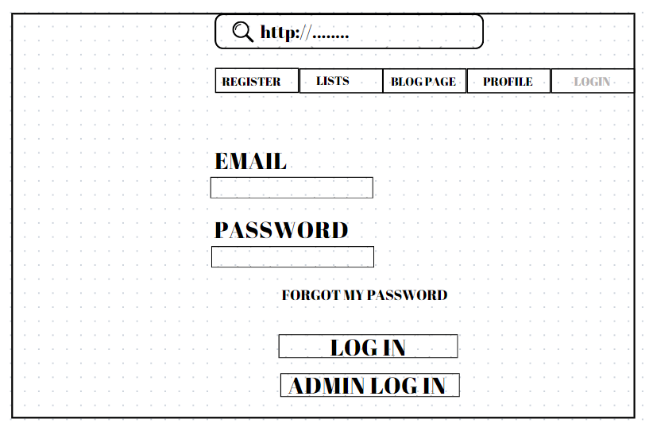

##### 3.1.1.3.1 Admin panel

It provides a range of features including adding new software, approving/rejecting findings submitted by testers, managing user accounts, and posting blog content.

Access to the Admin Panel requires authentication through admin login credentialsç

Additionally, the Dashboard provides administrators with an overview of platform activity and statistics

#### 3.1.1.4 Software Listing Page

Users can browse and access available software titles for testing within the usability testing platform by using the Software Listing Page as the core center.

The Software Listing Page prominently displays a list of available software titles, allowing users to browse and select from a range of options. This includes essential information such as the software name, description, and potentially ratings.

Users can click on any software title listed on the page to navigate to the corresponding usability page for that software.

#### metin, ekran görüntüsü, yazı tipi, sayı, numara içeren bir resim Açıklama otomatik olarak oluşturuldu

#### 3.1.1.5 Software Usability Page

Software Usability Page, which provides users with detailed information and insights regarding the availability of specific software products. Its main goals are to provide comprehensive information about the selected software, list the findings submitted by testers regarding the usability of the software, allow software owners to add comments or updates, and allow users to rate and interact with the findings.

In this page it displays detailed information about the selected software, offering users a comprehensive understanding of its features, functionalities, and purpose. This information may include the software's name, description, version, release date, and any other relevant details.

Software owners are the only ones able to provide updates or comments in response to the thorough explanations of usability issues provided by testers. Comments open in a pop-up window and are accessible only to the corresponding testers. All users can also like findings to rate them.

metin, sayı, numara, ekran görüntüsü, yazı tipi içeren bir resim

Açıklama otomatik olarak oluşturuldu

#### 3.1.1.6 Usability Problem Submission Page

With the help of Usability Problem Submission page, testers can offer insightful feedback on the usability of particular applications within the platform with a simplified interface. Testers can select the program they examined and a variety of evaluation techniques, such as user testing, heuristic evaluation, observation, and interviews, using a structured form. They list the specific usability standards that have been broken, including efficiency, effectiveness, learnability, memorability, error prevention, error tolerance, and aesthetics. They also include thorough explanations of the usability problems that have been observed. Testers can choose to include screenshots or images to their submissions as an optional feature, which gives their results visual context.

Once submitted, findings undergo an approval process by the admin before being displayed on the respective software's page.

metin, ekran görüntüsü, ekran, görüntüleme, sayı, numara içeren bir resim

Açıklama otomatik olarak oluşturuldu

#### 3.1.1.7 Blog Page

The Blog Page serves as a repository of informative content, displaying blog posts that delve into topics related to usability and user experience.

metin, ekran görüntüsü, ekran, görüntüleme, yazı tipi içeren bir resim

Açıklama otomatik olarak oluşturuldu

#### 3.1.1.8 Software Owner Registration Page

The Software Owner Registration Page offers a thorough form that makes it easier for software owners to create accounts on the platform. This form has fields for a username, email address, password, and optional fields for gender and city. It also as a text field for extra owner details and a drop-down list for software selection.

metin, ekran görüntüsü, ekran, görüntüleme, sayı, numara içeren bir resim

Açıklama otomatik olarak oluşturuldu

#### 3.1.1.9 Error Page

Error Pages are intended to quickly resolve user issues such as 500 (Internal Server Error) and 404 (Page Not Found) by presenting relevant error messages. These pages will directing users back to their intended pages with helpful navigation cues.

metin, ekran görüntüsü, yazı tipi, sayı, numara içeren bir resim

Açıklama otomatik olarak oluşturuldu

### 3.1.2 Communication Interfaces

The Usability Testing Platform facilitates communication primarily through email notifications, serving as vital communication channels between users and the platform.

These email notifications are essential for maintaining user awareness of the progress of their actions on the platform, encouraging openness, and enabling effective communication between administrators and users.

## 3.2 Functional Requirements

In this section, the functional requirements for the Usability Testing Platform are delineated, defining the system features and services provided by the product.

## 3.2.1 Usability Problem Submission Process

### 3.2.1.1 Tester Submits a Usability Problem

REQ1- Tester lists available software titles for testing

REQ2- Testers shall be able to select any software title from the list for evaluation.

REQ3- Upon selecting a software title, the system shall prompt the tester to choose a usability evaluation method abd tester should select.

REQ4- After selecting the evaluation method, the system shall prompt the tester to specify the usability criteria to be assessed.

REQ5- Violations shall be identified based on predefined rules corresponding to each usability criterion.

REQ6-Tester shall have the option to support their findings with screenshots/ images

REQ7- Evaluation findings shall be submitted to the admin to further review through the platform.

### 3.2.1.2 Admin reviews usability problems

REQ1- After receiving findings from testers, admin shall review reported usability problems.

REQ2-If admin determines that the submitted review is valid, the system shall mark the submission as valid.

REQ3- If admin determines that the submitted review is invalid, the system shall mark the submission as invalid.

REQ4- The system shall notify the respective tester about the status update.

3.2.2 Data Model

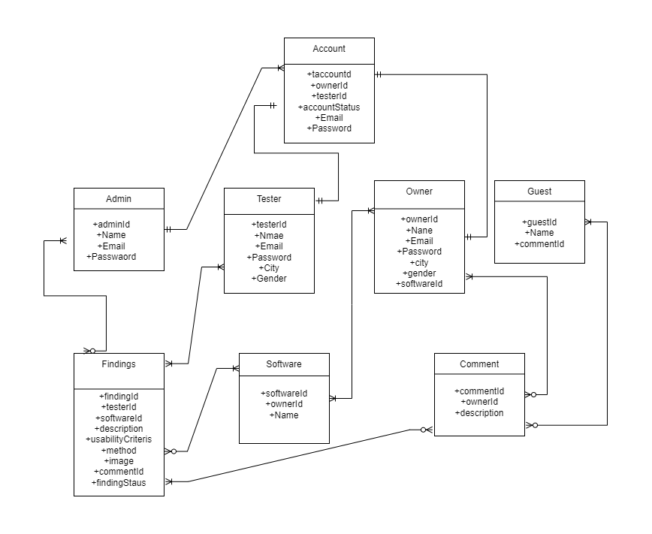

Our data model defines the underlying data structure and relationships of our usability testing platform. This model provides the structure of the database and organization of data elements to be used on the platform. It includes major components such as users, software, usability findings, and administrative actions. When registering on the platform, users can be appointed as testers or software owners. Each user is identified by a unique ID and account information. Software represents software products that users will test and evaluate. Usability findings include usability issues identified by testers and confirmed by administrators. Administrator operations provide administration of the platform and include a wide range of functionality, from adding new software to managing user accounts. This data model provides a basic guide for understanding the operation and data flow of the platform so that consistency and data integrity can be ensured throughout the development process.

3.2.3 Use Case Diagram

diyagram, taslak, çizim, çizgi içeren bir resim

Açıklama otomatik olarak oluşturuldu

## 4. Other Nonfunctional Requirements

### 4.1 Performance Requirements

The performance requirements of the Usability Testing Platform are crucial for ensuring its responsiveness, scalability, and efficient utilization of system resources.

* For the platform to handle simultaneous interactions without experiencing performance degradation, it must support at least 500 concurrent users.
* The system should maximize the retrieval of relevant information and usability results for certain software titles.
* Utilize database caching mechanisms to cache frequently accessed data and reduce data load on the server.
* Optimize the system to efficiently retrieve blog posts based on user requests.

### Security Requirements

1. The system shall encrypt sensitive user data such as passwords and personal information to ensure confidentiality.
2. Utilize encryption such as HTTPS to secure data transmission between the user’s browser and the web server.
3. User authentication mechanism shall be implemented securely to prevent unauthorized access to user accounts.
4. Enforce role-based access control (RBAC) to restrict user access to functionalities and data based on their roles.

### 4.3 Software Quality Attributes

The product should have the following attributes:

* Reliability
* Maintability
* Easy to use
* Efficiency
* A pleasant user experience
* Ability to achieve the purpose with the least effort and time
* Error handling