Web Technologies

Assignment#2

Name: Ayima Ejaz Cheema
Roll No: FA24-BCS-025

Output: Logo:
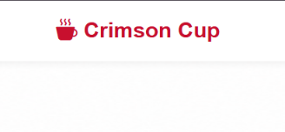

Homepage :

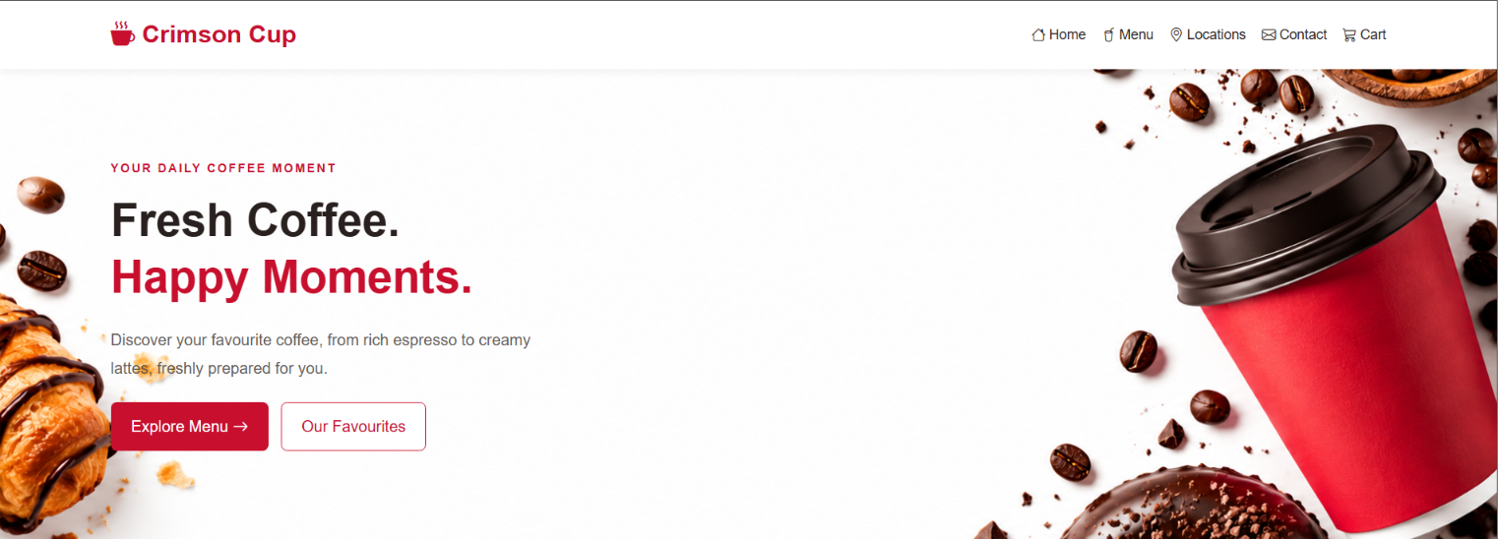
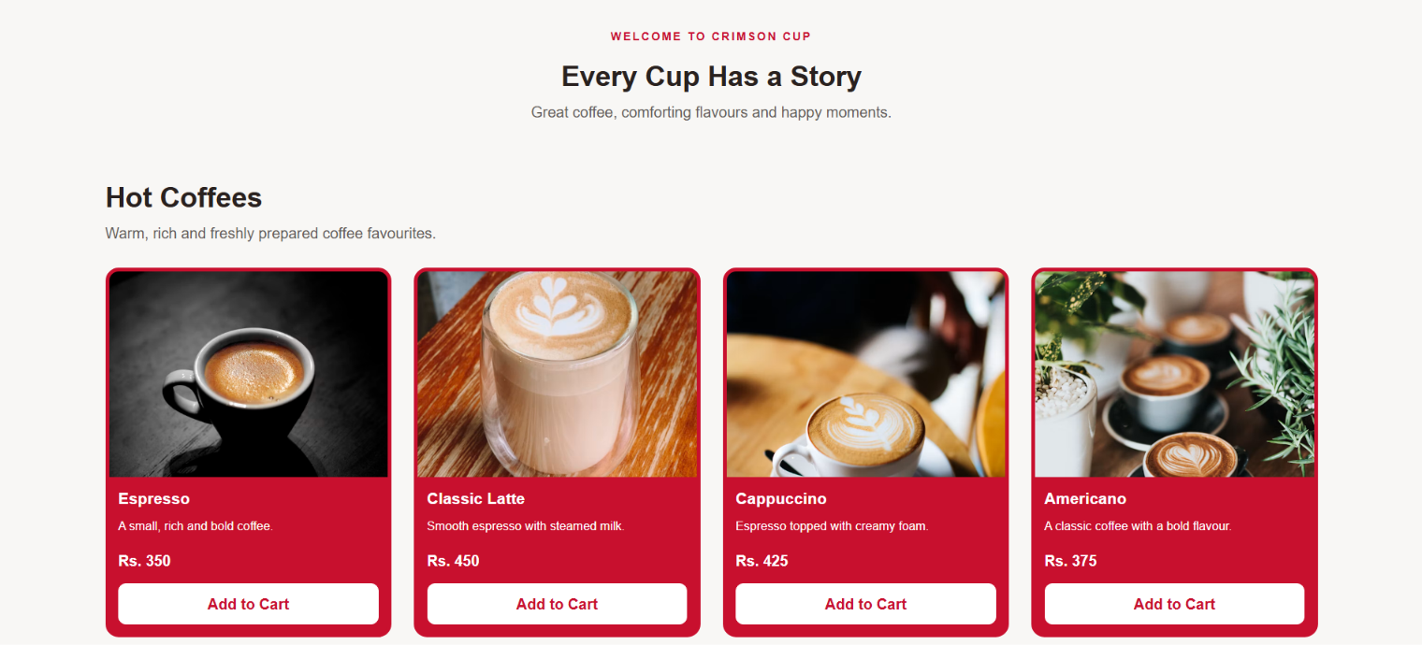
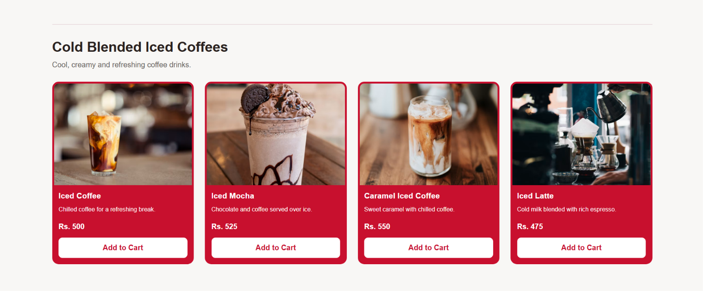
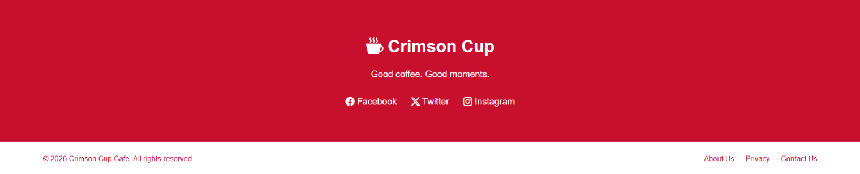

One product description:
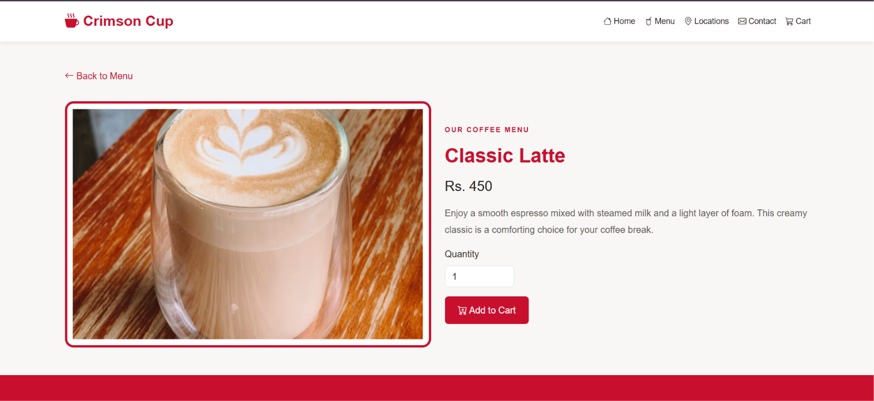

Footer:

Responsiveness Homepage

375 PX responsiveness
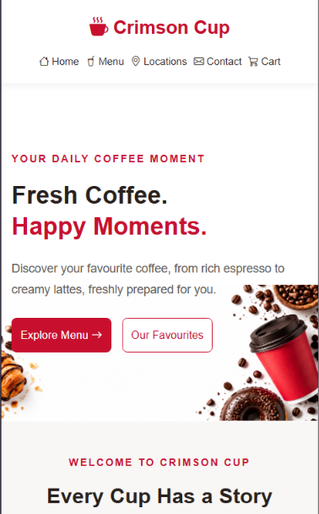

768 px responsiveness

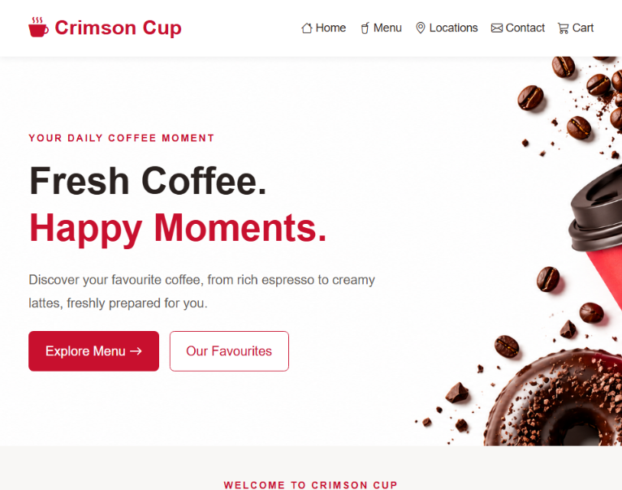

1440 PX responsiveness

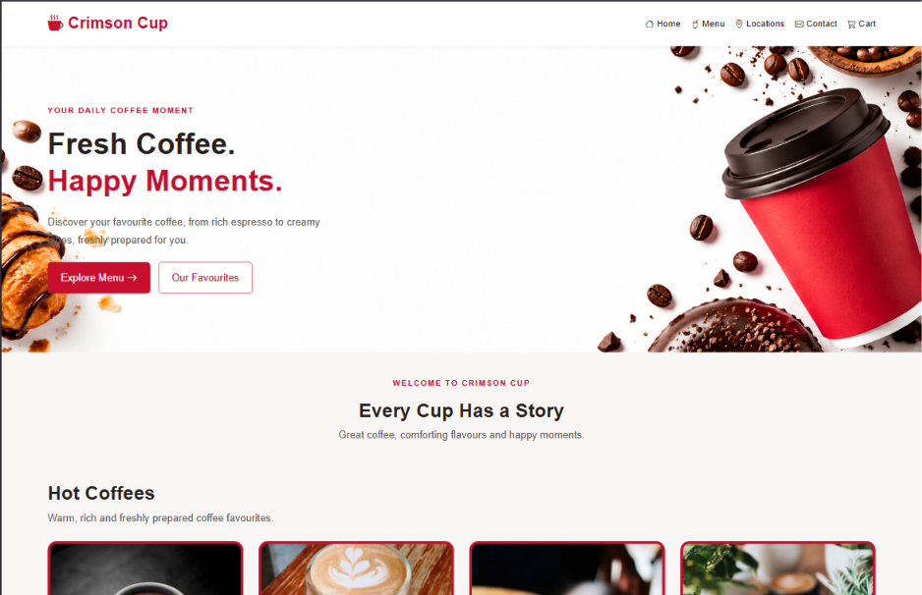

Product Page :

375 PX responsiveness
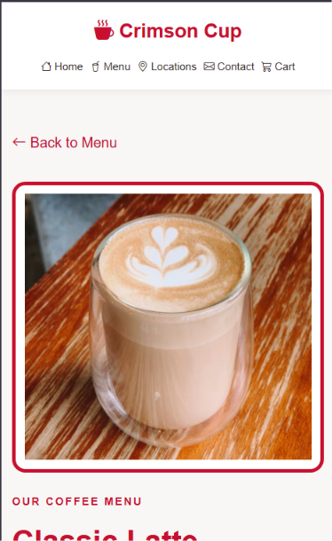

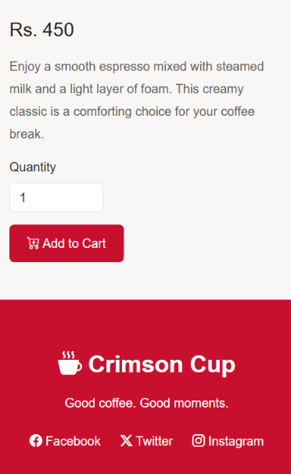

768 px responsiveness

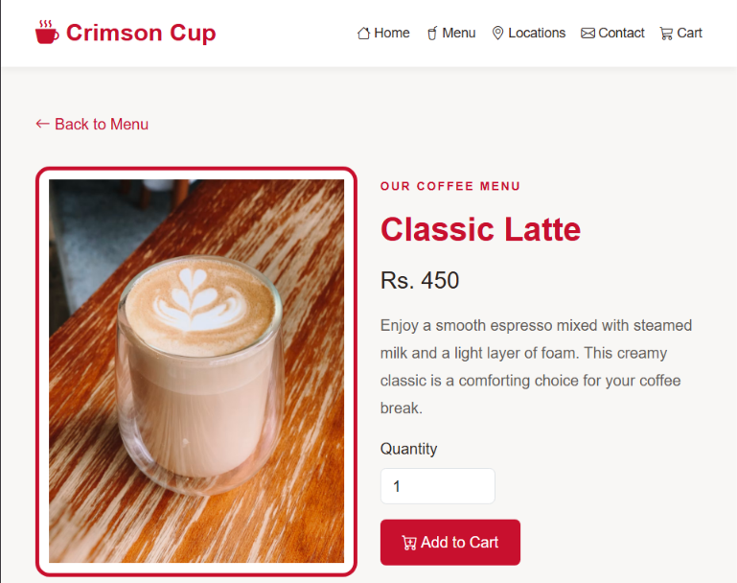

1440 px responsiveness
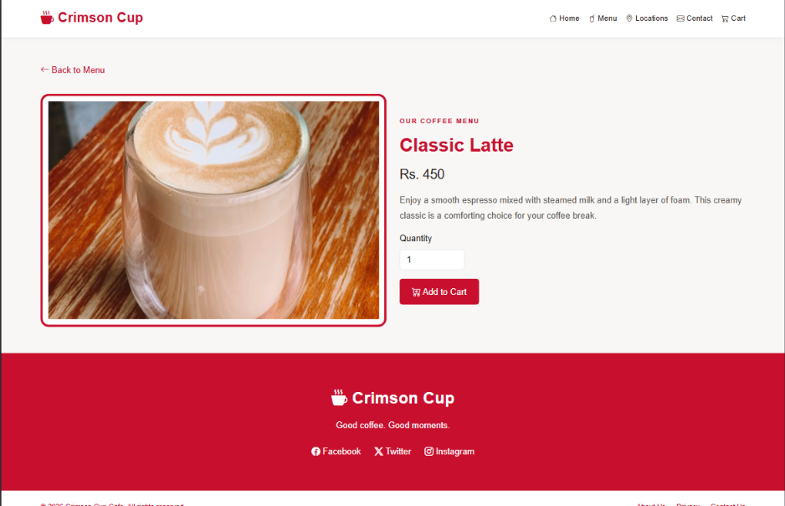

Index.html
<!doctype html>
<html lang="en">
<head>
<meta charset="UTF-8" />
<meta name="viewport" content="width=device-width, initial-scale=1.0" />
<title>Crimson Cup Cafe</title>

<link
href="https://cdn.jsdelivr.net/npm/bootstrap@5.3.3/dist/css/bootstrap.min.css"
rel="stylesheet"
/>

<link
rel="stylesheet"
href="https://cdn.jsdelivr.net/npm/bootstrap-icons@1.11.3/font/bootstrap-icons.min.css"
/>

<!-- Custom CSS -->
<link rel="stylesheet" href="style.css" />
</head>

<body>
<!-- HEADER -->
<nav class="navbar bg-white">
<div class="container header">
<a href="index.html" class="logo">
<i class="bi bi-cup-hot-fill"></i> Crimson Cup
</a>

<div class="nav-links">
<a href="index.html"><i class="bi bi-house"></i> Home</a>
<a href="#menu"><i class="bi bi-cup-straw"></i> Menu</a>
<a href="#footer"><i class="bi bi-geo-alt"></i> Locations</a>
<a href="#footer"><i class="bi bi-envelope"></i> Contact</a>
<a href="#menu"><i class="bi bi-cart3"></i> Cart</a>
</div>
</div>
</nav>

<!-- HERO SECTION -->
<section class="hero">
<div class="container hero-content">
<p class="small-heading">YOUR DAILY COFFEE MOMENT</p>

<h1>
Fresh Coffee.<br />
<span>Happy Moments.</span>
</h1>

<p class="hero-text">
Discover your favourite coffee, from rich espresso to creamy lattes,
freshly prepared for you.
</p>

<a href="#menu" class="btn red-button">
Explore Menu <i class="bi bi-arrow-right"></i>
</a>

<a href="#hot-coffees" class="btn white-button"> Our Favourites </a>
</div>
</section>

<!-- INTRODUCTION -->
<section class="intro text-center">
<div class="container">
<p class="small-heading">WELCOME TO CRIMSON CUP</p>
<h2>Every Cup Has a Story</h2>
<p>Great coffee, comforting flavours and happy moments.</p>
</div>
</section>

<!-- PRODUCT MENU -->
<main class="container product-section" id="menu">
<!-- HOT COFFEES -->
<section id="hot-coffees">
<div class="section-heading">
<h2>Hot Coffees</h2>
<p>Warm, rich and freshly prepared coffee favourites.</p>
</div>

<div class="row g-4">
<!-- PRODUCT 1 -->
<div class="col-12 col-sm-6 col-lg-3">
<div class="product-card">
<a href="product.html">
<img
src="https://images.unsplash.com/photo-1510707577719-ae7c14805e3a?auto=format&fit=crop&w=600&q=85"
alt="Espresso coffee"
class="product-image"
/>
</a>

<div class="product-info">
<h3><a href="product.html">Espresso</a></h3>
<p>A small, rich and bold coffee.</p>
<strong>Rs. 350</strong>
<button type="button" class="btn add-button">
Add to Cart
</button>
</div>
</div>
</div>

<!-- PRODUCT 2 -->
<div class="col-12 col-sm-6 col-lg-3">
<div class="product-card">
<a href="product.html">
<img
src="https://images.unsplash.com/photo-1570968915860-54d5c301fa9f?auto=format&fit=crop&w=600&q=85"
alt="Classic latte in a cup"
class="product-image"
/>
</a>

<div class="product-info">
<h3><a href="product.html">Classic Latte</a></h3>
<p>Smooth espresso with steamed milk.</p>
<strong>Rs. 450</strong>
<button type="button" class="btn add-button">
Add to Cart
</button>
</div>
</div>
</div>

<!-- PRODUCT 3 -->
<div class="col-12 col-sm-6 col-lg-3">
<div class="product-card">
<a href="product.html">
<img
src="https://images.unsplash.com/photo-1534778101976-62847782c213?auto=format&fit=crop&w=600&q=85"
alt="Cappuccino coffee"
class="product-image"
/>
</a>

<div class="product-info">
<h3><a href="product.html">Cappuccino</a></h3>
<p>Espresso topped with creamy foam.</p>
<strong>Rs. 425</strong>
<button type="button" class="btn add-button">
Add to Cart
</button>
</div>
</div>
</div>

<!-- PRODUCT 4 -->
<div class="col-12 col-sm-6 col-lg-3">
<div class="product-card">
<a href="product.html">
<img
src="https://images.unsplash.com/photo-1509042239860-f550ce710b93?auto=format&fit=crop&w=600&q=85"
alt="Americano coffee"
class="product-image"
/>
</a>

<div class="product-info">
<h3><a href="product.html">Americano</a></h3>
<p>A classic coffee with a bold flavour.</p>
<strong>Rs. 375</strong>
<button type="button" class="btn add-button">
Add to Cart
</button>
</div>
</div>
</div>
</div>
</section>

<!-- COLD COFFEES -->
<section class="cold-section" id="cold-coffees">
<div class="section-heading">
<h2>Cold Blended Iced Coffees</h2>
<p>Cool, creamy and refreshing coffee drinks.</p>
</div>

<div class="row g-4">
<!-- PRODUCT 5 -->
<div class="col-12 col-sm-6 col-lg-3">
<div class="product-card">
<a href="product.html">
<img
src="https://images.unsplash.com/photo-1461023058943-07fcbe16d735?auto=format&fit=crop&w=600&q=85"
alt="Iced coffee in a glass"
class="product-image"
/>
</a>

<div class="product-info">
<h3><a href="product.html">Iced Coffee</a></h3>
<p>Chilled coffee for a refreshing break.</p>
<strong>Rs. 500</strong>
<button type="button" class="btn add-button">
Add to Cart
</button>
</div>
</div>
</div>

<!-- PRODUCT 6 -->
<div class="col-12 col-sm-6 col-lg-3">
<div class="product-card">
<a href="product.html">
<img
src="https://images.unsplash.com/photo-1572490122747-3968b75cc699?auto=format&fit=crop&w=600&q=85"
alt="Iced mocha coffee"
class="product-image"
/>
</a>

<div class="product-info">
<h3><a href="product.html">Iced Mocha</a></h3>
<p>Chocolate and coffee served over ice.</p>
<strong>Rs. 525</strong>
<button type="button" class="btn add-button">
Add to Cart
</button>
</div>
</div>
</div>

<!-- PRODUCT 7 -->
<div class="col-12 col-sm-6 col-lg-3">
<div class="product-card">
<a href="product.html">
<img
src="https://images.unsplash.com/photo-1517701604599-bb29b565090c?auto=format&fit=crop&w=600&q=85"
alt="Caramel iced coffee"
class="product-image"
/>
</a>

<div class="product-info">
<h3><a href="product.html">Caramel Iced Coffee</a></h3>
<p>Sweet caramel with chilled coffee.</p>
<strong>Rs. 550</strong>
<button type="button" class="btn add-button">
Add to Cart
</button>
</div>
</div>
</div>

<!-- PRODUCT 8 -->
<div class="col-12 col-sm-6 col-lg-3">
<div class="product-card">
<a href="product.html">
<img
src="https://images.unsplash.com/photo-1442512595331-e89e73853f31?auto=format&fit=crop&w=600&q=85"
alt="Iced latte coffee"
class="product-image"
/>
</a>

<div class="product-info">
<h3><a href="product.html">Iced Latte</a></h3>
<p>Cold milk blended with rich espresso.</p>
<strong>Rs. 475</strong>
<button type="button" class="btn add-button">
Add to Cart
</button>
</div>
</div>
</div>
</div>
</section>
</main>

<!-- FOOTER -->
<footer id="footer">
<div class="footer-main text-center">
<a href="index.html" class="footer-logo">
<i class="bi bi-cup-hot-fill"></i> Crimson Cup
</a>

<p>Good coffee. Good moments.</p>

<div class="social-links">
<a href="#"><i class="bi bi-facebook"></i> Facebook</a>
<a href="#"><i class="bi bi-twitter-x"></i> Twitter</a>
<a href="#"><i class="bi bi-instagram"></i> Instagram</a>
</div>
</div>

<div class="footer-bottom">
<p>© 2026 Crimson Cup Cafe. All rights reserved.</p>

<div>
<a href="#footer">About Us</a>
<a href="#footer">Privacy</a>
<a href="#footer">Contact Us</a>
</div>
</div>
</footer>
</body>
</html>

product.html
!doctype html>
<html lang="en">
<head>
<meta charset="UTF-8" />
<meta name="viewport" content="width=device-width, initial-scale=1.0" />
<title>Classic Latte | Crimson Cup</title>

<link
href="https://cdn.jsdelivr.net/npm/bootstrap@5.3.3/dist/css/bootstrap.min.css"
rel="stylesheet"
/>
<link
rel="stylesheet"
href="https://cdn.jsdelivr.net/npm/bootstrap-icons@1.11.3/font/bootstrap-icons.min.css"
/>
<link rel="stylesheet" href="style.css" />
</head>
<body>
<!-- HEADER -->
<nav class="navbar bg-white">
<div class="container header">
<a href="index.html" class="logo">
<i class="bi bi-cup-hot-fill"></i> Crimson Cup
</a>

<div class="nav-links">
<a href="index.html"><i class="bi bi-house"></i> Home</a>
<a href="index.html#menu"><i class="bi bi-cup-straw"></i> Menu</a>
<a href="#footer"><i class="bi bi-geo-alt"></i> Locations</a>
<a href="#footer"><i class="bi bi-envelope"></i> Contact</a>
<a href="index.html#menu"><i class="bi bi-cart3"></i> Cart</a>
</div>
</div>
</nav>

<!-- PRODUCT DETAILS -->
<main class="container py-5">
<a href="index.html#menu" class="back-link">
<i class="bi bi-arrow-left"></i> Back to Menu
</a>

<div class="row align-items-center g-4 mt-2">
<div class="col-12 col-md-6">
<div class="detail-image-box">
<img
src="https://images.unsplash.com/photo-1570968915860-54d5c301fa9f?auto=format&fit=crop&w=900&q=85"
alt="Classic latte"
class="detail-image"
/>
</div>
</div>

<div class="col-12 col-md-6">
<p class="small-heading">OUR COFFEE MENU</p>

<h1 class="detail-title">Classic Latte</h1>

<h2 class="detail-price">Rs. 450</h2>

<p class="detail-description">
Enjoy a smooth espresso mixed with steamed milk and a light layer of
foam. This creamy classic is a comforting choice for your coffee
break.
</p>

<label for="quantity" class="form-label">Quantity</label>

<input
type="number"
id="quantity"
class="form-control quantity-input"
value="1"
min="1"
/>

<button type="button" class="btn detail-button mt-3">
<i class="bi bi-cart-plus"></i> Add to Cart
</button>
</div>
</div>
</main>

<!-- FOOTER -->
<footer id="footer">
<div class="footer-main text-center">
<a href="index.html" class="footer-logo">
<i class="bi bi-cup-hot-fill"></i> Crimson Cup
</a>

<p>Good coffee. Good moments.</p>

<div class="social-links">
<a href="#"><i class="bi bi-facebook"></i> Facebook</a>
<a href="#"><i class="bi bi-twitter-x"></i> Twitter</a>
<a href="#"><i class="bi bi-instagram"></i> Instagram</a>
</div>
</div>

<div class="footer-bottom">
<p>© 2026 Crimson Cup Cafe. All rights reserved.</p>

<div>
<a href="#footer">About Us</a>
<a href="#footer">Privacy</a>
<a href="#footer">Contact Us</a>
</div>
</div>
</footer>
</body>
</html>

style.css

/* GENERAL */
body {
margin: 0;
background: #f8f7f5;
color: #29211f;
font-family: Arial, sans-serif;
}

a {
text-decoration: none;
}

/* HEADER */
.navbar {
padding: 16px 0;
box-shadow: 0 2px 8px #00000010;
}

.header {
display: flex;
justify-content: space-between;
align-items: center;
gap: 15px;
}

.logo {
color: #c8102e;
font-size: 25px;
font-weight: bold;
white-space: nowrap;
}

.nav-links {
display: flex;
flex-wrap: wrap;
gap: 16px;
}

.nav-links a {
color: #302725;
font-size: 14px;
}

.nav-links a:hover {
color: #c8102e;
}

/* HERO SECTION */
.hero {
min-height: 480px;
display: flex;
align-items: center;
background-color: white;
background-image: url("hero-coffee.png");
background-size: cover;
background-position: center;
background-repeat: no-repeat;
}

.hero-content {
padding-top: 65px;
padding-bottom: 65px;
}

.small-heading {
color: #c8102e;
font-size: 12px;
font-weight: bold;
letter-spacing: 2px;
}

.hero h1 {
font-size: 46px;
font-weight: bold;
line-height: 1.25;
}

.hero h1 span {
color: #c8102e;
}

.hero-text {
max-width: 430px;
line-height: 1.8;
color: #625956;
margin: 20px 0;
}

/* HERO BUTTONS */
.red-button {
background: #c8102e;
color: white;
padding: 12px 20px;
margin-right: 8px;
}

.red-button:hover {
background: #a50d25;
color: white;
}

.white-button {
background: white;
color: #c8102e;
border: 1px solid #c8102e;
padding: 12px 20px;
}

.white-button:hover {
background: #c8102e;
color: white;
}

/* INTRODUCTION */
.intro {
padding: 40px 0 20px;
}

.intro h2,
.section-heading h2 {
font-size: 30px;
font-weight: bold;
}

.intro p:last-child,
.section-heading p {
color: #625956;
}

/* PRODUCT SECTIONS */
.product-section {
padding-top: 25px;
padding-bottom: 60px;
}

.section-heading {
margin-bottom: 25px;
}

.cold-section {
margin-top: 55px;
padding-top: 30px;
border-top: 2px solid #eadde0;
}

/* PRODUCT CARDS */
.product-card {
height: 100%;
display: flex;
flex-direction: column;
overflow: hidden;
background: #c8102e;
color: white;
border: 4px solid #c8102e;
border-radius: 14px;
}

.product-image {
width: 100%;
height: 220px;
object-fit: cover;
display: block;
background: white;
}

.product-info {
padding: 14px 10px 10px;
display: flex;
flex-direction: column;
flex-grow: 1;
}

.product-info h3 {
font-size: 17px;
font-weight: bold;
}

.product-info h3 a {
color: white;
}

.product-info h3 a:hover {
text-decoration: underline;
}

.product-info p {
font-size: 13px;
line-height: 1.5;
}

.product-info strong {
margin-top: auto;
margin-bottom: 12px;
}

/* ADD TO CART BUTTON */
.add-button {
width: 100%;
background: white;
color: #c8102e;
border: 1px solid white;
border-radius: 8px;
padding: 9px;
font-weight: bold;
}

.add-button:hover {
background: #f1e8e9;
color: #a50d25;
}

/* PRODUCT DETAIL PAGE */
.back-link {
color: #c8102e;
}

.detail-image-box {
background: white;
border: 4px solid #c8102e;
border-radius: 15px;
padding: 10px;
}

.detail-image {
width: 100%;
height: 400px;
object-fit: cover;
display: block;
}

.detail-title {
color: #c8102e;
font-size: 34px;
font-weight: bold;
}

.detail-price {
font-size: 24px;
margin: 18px 0;
}

.detail-description {
color: #625956;
line-height: 1.8;
}

.quantity-input {
max-width: 120px;
}

.detail-button {
background: #c8102e;
color: white;
padding: 11px 22px;
}

.detail-button:hover {
background: #a50d25;
color: white;
}

/* FOOTER */
.footer-main {
background: #c8102e;
color: white;
padding: 60px 15px;
}

.footer-logo {
color: white;
font-size: 30px;
font-weight: bold;
}

.footer-logo:hover {
color: #ffe2e7;
}

.footer-main p {
margin: 15px 0 25px;
}

.social-links {
display: flex;
justify-content: center;
flex-wrap: wrap;
gap: 25px;
}

.social-links a {
color: white;
}

.social-links a:hover {
color: #ffe2e7;
}

/* FOOTER BOTTOM */
.footer-bottom {
background: white;
color: #c8102e;
padding: 20px 5%;
display: flex;
justify-content: space-between;
align-items: center;
gap: 15px;
}

.footer-bottom p {
margin: 0;
font-size: 13px;
}

.footer-bottom div {
display: flex;
flex-wrap: wrap;
gap: 20px;
}

.footer-bottom a {
color: #c8102e;
font-size: 13px;
}

/* TABLET */
@media (max-width: 767px) {
.header {
flex-direction: column;
}

.nav-links {
justify-content: center;
gap: 10px;
}

.nav-links a {
font-size: 12px;
}

/* HERO BACKGROUND ON TABLETS AND PHONES */
.hero {
min-height: 400px;
background-color: white;
background-size: 100% auto;
background-position: center bottom;
background-repeat: no-repeat;
}

.hero-content {
padding-top: 45px;
padding-bottom: 45px;
}

.hero h1 {
font-size: 34px;
}

.intro h2,
.section-heading h2 {
font-size: 25px;
}

.detail-image {
height: 300px;
}

.footer-bottom {
flex-direction: column;
text-align: center;
}
}

/* SMALL MOBILE PHONES */
@media (max-width: 400px) {
.logo {
font-size: 22px;
}

.nav-links {
gap: 8px;
}

.hero {
min-height: 400px;
background-size: 100% auto;
background-position: center bottom;
background-repeat: no-repeat;
}

.hero h1 {
font-size: 29px;
}

.hero-text {
font-size: 14px;
}

.red-button,
.white-button {
padding: 10px;
font-size: 13px;
}

.product-image {
height: 200px;
}
}

