Web Development

LAB 2

Name: Ayima Ejaz Cheema

Roll No: FA24-BCS-025

Responsive Navbar and Grid Drill

A focused, smaller-scale rehearsal for Assignment 2: build just a responsive navbar (logo left, links center, cart icon right, collapsing into a hamburger menu below 768px) and a 4-column-desktop / 2-column-tablet / 1-column-phone product grid, using Flexbox or Grid plus Bootstrap or Tailwind. Content can be placeholder text/images — the point is the responsive mechanics, not the final design.

Responsiveness Screenshots

Mobile: 1-column:
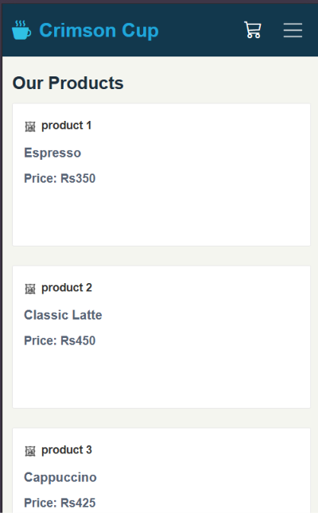
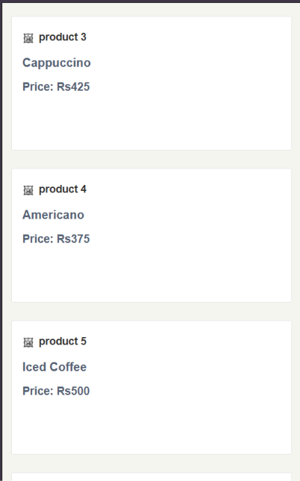

Tablet: 2-column
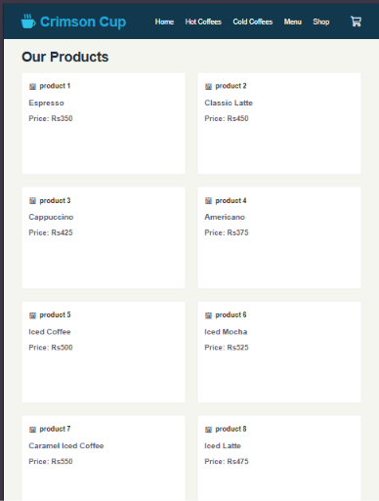

Desktop: 4-column
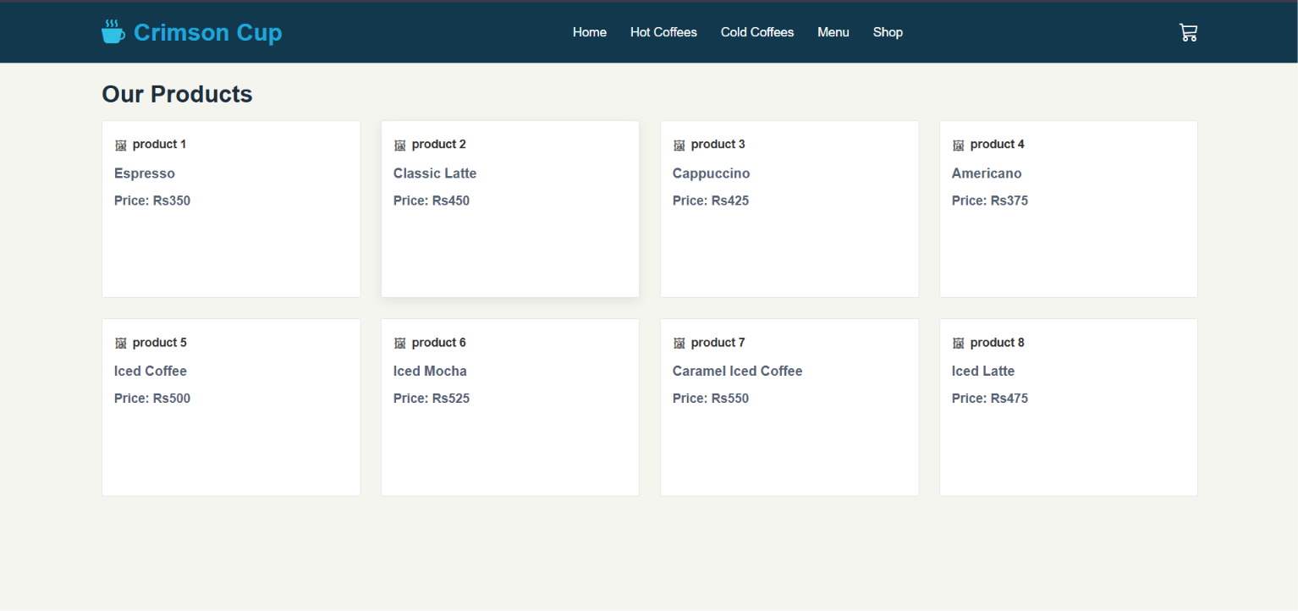

Code

Index.html
<!DOCTYPE html>
<html lang="en">
<head>
<meta charset="UTF-8">
<meta name="viewport" content="width=device-width, initial-scale=1.0">
<title>Lab 2 - Responsive Navbar and Grid</title>

<!-- Bootstrap CSS -->
<link
href="https://cdn.jsdelivr.net/npm/bootstrap@5.3.3/dist/css/bootstrap.min.css"
rel="stylesheet"
>

<!-- Bootstrap Icons -->
<link
rel="stylesheet"
href="https://cdn.jsdelivr.net/npm/bootstrap-icons@1.11.3/font/bootstrap-icons.min.css"
>

<!-- Custom CSS -->
<link rel="stylesheet" href="style.css">
</head>
<body>

<!-- NAVBAR -->
<nav class="navbar navbar-expand-md custom-navbar">
<div class="container">

<!-- Logo -->
<a class="navbar-brand logo" href="#">
<span class="logo-icon"><i class="bi bi-cup-hot-fill"></i></span>
<span class="logo-text">Crimson Cup</span>
</a>

<!-- Cart + Hamburger -->
<div class="mobile-actions d-flex align-items-center gap-3">
<a href="#products" class="cart-icon d-md-none">
<i class="bi bi-cart3"></i>
</a>

<button
class="navbar-toggler"
type="button"
data-bs-toggle="collapse"
data-bs-target="#mainNavbar"
aria-controls="mainNavbar"
aria-expanded="false"
aria-label="Toggle navigation"
>
<span class="navbar-toggler-icon"></span>
</button>
</div>

<!-- Collapsible Navbar -->
<div class="collapse navbar-collapse" id="mainNavbar">
<ul class="navbar-nav nav-center mx-auto">
<li class="nav-item">
<a class="nav-link" href="#">Home</a>
</li>
<li class="nav-item">
<a class="nav-link" href="#products">Hot Coffees</a>
</li>
<li class="nav-item">
<a class="nav-link" href="#cold-products">Cold Coffees</a>
</li>
<li class="nav-item">
<a class="nav-link" href="#products">Menu</a>
</li>
<li class="nav-item">
<a class="nav-link" href="#products">Shop</a>
</li>
</ul>

<!-- Desktop Cart -->
<a href="#products" class="cart-icon desktop-cart d-none d-md-inline-flex">
<i class="bi bi-cart3"></i>
</a>
</div>
</div>
</nav>

<!-- MAIN -->
<main class="main-wrapper">
<section class="products-section container" id="products">
<h2 class="section-title">Our Products</h2>

<div class="row g-4">

<!-- Product 1 -->
<div class="col-12 col-md-6 col-lg-3">
<div class="product-card">
<div class="product-image-box">
<div class="placeholder-top">
<span class="fake-img-icon">🖼</span>
<span class="placeholder-label">product 1</span>
</div>
</div>
<div class="product-content">
<h3>Espresso</h3>
<p>Price: Rs350</p>
</div>
</div>
</div>

<!-- Product 2 -->
<div class="col-12 col-md-6 col-lg-3">
<div class="product-card">
<div class="product-image-box">
<div class="placeholder-top">
<span class="fake-img-icon">🖼</span>
<span class="placeholder-label">product 2</span>
</div>
</div>
<div class="product-content">
<h3>Classic Latte</h3>
<p>Price: Rs450</p>
</div>
</div>
</div>

<!-- Product 3 -->
<div class="col-12 col-md-6 col-lg-3">
<div class="product-card">
<div class="product-image-box">
<div class="placeholder-top">
<span class="fake-img-icon">🖼</span>
<span class="placeholder-label">product 3</span>
</div>
</div>
<div class="product-content">
<h3>Cappuccino</h3>
<p>Price: Rs425</p>
</div>
</div>
</div>

<!-- Product 4 -->
<div class="col-12 col-md-6 col-lg-3">
<div class="product-card">
<div class="product-image-box">
<div class="placeholder-top">
<span class="fake-img-icon">🖼</span>
<span class="placeholder-label">product 4</span>
</div>
</div>
<div class="product-content">
<h3>Americano</h3>
<p>Price: Rs375</p>
</div>
</div>
</div>

<!-- Product 5 -->
<div class="col-12 col-md-6 col-lg-3">
<div class="product-card">
<div class="product-image-box">
<div class="placeholder-top">
<span class="fake-img-icon">🖼</span>
<span class="placeholder-label">product 5</span>
</div>
</div>
<div class="product-content">
<h3>Iced Coffee</h3>
<p>Price: Rs500</p>
</div>
</div>
</div>

<!-- Product 6 -->
<div class="col-12 col-md-6 col-lg-3">
<div class="product-card">
<div class="product-image-box">
<div class="placeholder-top">
<span class="fake-img-icon">🖼</span>
<span class="placeholder-label">product 6</span>
</div>
</div>
<div class="product-content">
<h3>Iced Mocha</h3>
<p>Price: Rs525</p>
</div>
</div>
</div>

<!-- Product 7 -->
<div class="col-12 col-md-6 col-lg-3">
<div class="product-card">
<div class="product-image-box">
<div class="placeholder-top">
<span class="fake-img-icon">🖼</span>
<span class="placeholder-label">product 7</span>
</div>
</div>
<div class="product-content">
<h3>Caramel Iced Coffee</h3>
<p>Price: Rs550</p>
</div>
</div>
</div>

<!-- Product 8 -->
<div class="col-12 col-md-6 col-lg-3" id="cold-products">
<div class="product-card">
<div class="product-image-box">
<div class="placeholder-top">
<span class="fake-img-icon">🖼</span>
<span class="placeholder-label">product 8</span>
</div>
</div>
<div class="product-content">
<h3>Iced Latte</h3>
<p>Price: Rs475</p>
</div>
</div>
</div>

</div>
</section>
</main>

<!-- Bootstrap JS -->
<script src="https://cdn.jsdelivr.net/npm/bootstrap@5.3.3/dist/js/bootstrap.bundle.min.js"></script>
</body>
</html>

Style.css:
/* GENERAL */
* {
margin: 0;
padding: 0;
box-sizing: border-box;
}

body {
background: #f4f5ef;
font-family: Arial, sans-serif;
color: #1f2f3d;
}

a {
text-decoration: none;
}

/* NAVBAR */
.custom-navbar {
background: #12384d;
padding: 10px 0;
}

.logo {
display: flex;
align-items: center;
gap: 10px;
color: #2fc0e5 !important;
font-weight: 700;
font-size: 28px;
}

.logo:hover {
color: #2fc0e5 !important;
}

.logo-icon {
font-size: 28px;
}

.logo-text {
color: #1fa6d9;
}

.nav-center .nav-link {
color: #ffffff !important;
font-size: 15px;
margin: 0 6px;
}

.nav-center .nav-link:hover {
text-decoration: underline;
}

.cart-icon {
color: #ffffff;
font-size: 22px;
}

.cart-icon:hover {
color: #ffffff;
}

.navbar-toggler {
border: none;
padding: 4px 8px;
}

.navbar-toggler:focus {
box-shadow: none;
}

.navbar-toggler-icon {
filter: brightness(0) invert(1);
}

/* MAIN */
.main-wrapper {
padding: 10px 0 40px;
}

.products-section {
margin-top: 10px;
}

.section-title {
font-size: 28px;
font-weight: 700;
margin-bottom: 14px;
color: #1f2f3d;
}

/* PRODUCT CARD */
.product-card {
background: #ffffff;
border: 1px solid #e5e5e5;
border-radius: 2px;
overflow: hidden;
min-height: 210px;
transition: 0.3s ease;
}

.product-card:hover {
box-shadow: 0 4px 14px rgba(0, 0, 0, 0.08);
}

.product-image-box {
padding: 14px 14px 0 14px;
}

.placeholder-top {
display: flex;
align-items: center;
gap: 6px;
color: #333;
font-size: 14px;
min-height: 28px;
}

.fake-img-icon {
font-size: 16px;
opacity: 0.8;
}

.placeholder-label {
font-weight: 600;
}

.product-content {
padding: 10px 14px 18px;
}

.product-content h3 {
font-size: 16px;
color: #556274;
margin-bottom: 12px;
font-weight: 700;
}

.product-content p {
font-size: 15px;
color: #556274;
margin-bottom: 0;
font-weight: 600;
}

/* MOBILE NAVBAR LOOK */
@media (max-width: 767px) {
.logo {
font-size: 24px;
}

.logo-icon {
font-size: 24px;
}

.navbar-collapse {
background: #12384d;
margin-top: 10px;
padding: 10px 0;
}

.nav-center {
text-align: center;
}

.nav-center .nav-link {
padding: 10px 0;
display: block;
}

.section-title {
font-size: 22px;
margin-bottom: 12px;
}

.product-card {
min-height: 180px;
}
}

/* TABLET */
@media (min-width: 768px) and (max-width: 991px) {
.nav-center .nav-link {
font-size: 14px;
margin: 0 4px;
}
}

