XSS Vulnerability Fix Report:
HTML Escaping in Advanced Finance Tracker
Section 2: Deficiency Analysis
2.1 Detection
The XSS vulnerability was identified through manual code review. The renderTransactionItem function in main.js (line 467) constructs HTML via template literals that interpolate user-supplied data — tx.title and tx.category — directly into the DOM through innerHTML. An attacker can inject <img src=x onerror="alert('XSS')"> as a transaction title. When rendered, the browser parses the <img> tag and executes the onerror handler — a classic Stored XSS attack. No sanitization was present at any rendering point.
2.2 Literature
Two sources guided the remediation. Tang et al. [1] identify XSS root cause as the browser’s inability to distinguish legitimate code from injected code. Their paper demonstrates (Section III-B, Fig. 4–5) that replacing innerHTML with textContent — or equivalently, escaping HTML entities before DOM insertion — prevents the browser from parsing special symbols in tags, neutralizing malicious code. This is illustrated through MISP vulnerability CVE-2023-24027, where the fix replaced innerHTML with textContent on line 165 of action_table.js. Cloudflare’s XSS prevention documentation [2] reinforces this, emphasizing that character escaping — converting <, >, &, ", and ' to HTML entities — is a foundational defense. Both sources agree: treat all user data as untrusted text, not executable code.
2.3 Implementation
Guided by the literature, the fix introduces an escapeHtml function that sanitizes user data at render time:
const escapeHtml = (str) =>
String(str)
.replace(/&/g, "&")
.replace(/</g, "<")
.replace(/>/g, ">")
.replace(/"/g, """)
.replace(/'/g, "&#039;");
The function is applied at every DOM insertion point. In renderTransactionItem, the title and category are wrapped: const safeTitle = escapeHtml(tx.title). Month-group labels in renderTransactions are similarly sanitized. The fix exists in both main.js (lines 8–14) and utils.js (lines 4–10).
Before vs. After code comparison:
Aspect | Before (Vulnerable) | After (Protected)
Rendering | <p>${tx.title}</p> | <p>${escapeHtml(tx.title)}</p>
Input | <img src=x onerror="alert(1)"> | <img src=x onerror="alert(1)">
Output | Image rendered, script executes | <img src=x onerror="alert(1)"> as text
The fix is tested in main.test.js (lines 27–61) with 8 test cases covering < > escaping, ampersand, quotes, XSS payloads, null/number coercion, and safe strings. This aligns with Tang et al.’s defense-in-depth principle [1] and Cloudflare’s best practices [2].
3. References
[1] Tang, C., Wang, Q., Cheng, G., Liang, H., Peng, J., Yang, M., Liu, W., Liu, M., & Sha, L. (2024). A Cross-Site Scripting Attack Protection Framework Based on Managed Proxy. 2024 IEEE 23rd International Conference on Trust, Security and Privacy in Computing and Communications (TrustCom), pp. 1896–1903. DOI: 10.1109/TrustCom63139.2024.00262.
[2] Cloudflare. How to prevent XSS attacks. Available at: https://www.cloudflare.com/learning/security/how-to-prevent-xss-attacks/
Appendix: Supporting Figures
Figure 1: MISP Vulnerability Disclosure (CVE-2023-24027) — Tang et al. [1] Fig. 4
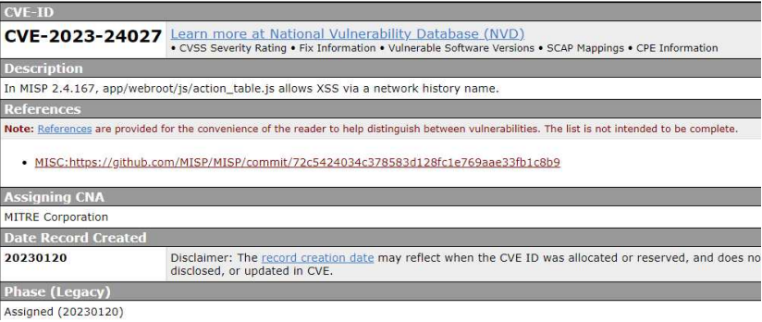
This figure from Tang et al. [1] shows the MISP vulnerability CVE-2023-24027, where innerHTML renders user-controlled data (network address names), creating an XSS vector. This mirrors the vulnerability found in our application before the fix.
Figure 2: MISP Vulnerability Fix — Tang et al. [1] Fig. 5
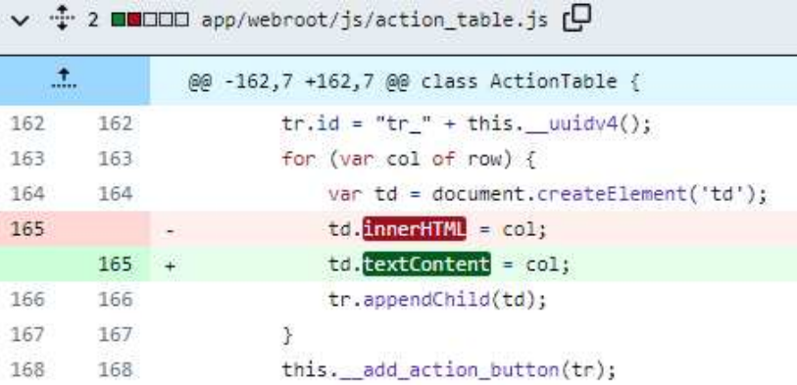
This figure illustrates the fix: replacing innerHTML with textContent on line 165 of action_table.js, preventing the browser from parsing special symbols in tags. Our escapeHtml function achieves the same protective effect by encoding HTML entities before DOM insertion.

