 

# APPLIED PROJECT DEVELOPMENT

Managing an Online Bookstore

TOOOPLE-BYTEXL 2024

Contents

APPLIED PROJECT DEVELOPMENT 1

Declaration of the mentor 4

Project Acknowledgement 5

Abstract 6

List of Figures 7

1. Introduction 8

1.1 Problem Statement: 8

**1.2** **Motivation:** 8

1.3 Is the Problem Still Unsolved? 8

1.4 Objectives of the Project 8

1.5 Why is the Problem Difficult to Solve? 8

1.6 Solution Approach: 9

1.7 Applicability Conditions: 9

1.8 Main Results 9

1.9 Accomplishments: 9

2. Report Organization 10

2.1 Background: 10

2.2 Project activities: 10

2.3 Data Collection: 10

2.4 Project Management: 11

2.5 Main Results: 11

2.6 System Design/Architecture Diagram: 12

2.7 Technologies Used: 12

2.8 Impact of the Change: 12

2.9 Screenshots of Developments: Here are some Customer pages for better understanding 13

2.6 Future Work: 21

2.7 Impact of the Change: 21

2.8 Challenges Faced: 21

2.9 Recommendations for Future Extensions and Improvements: 22

2.10 Conclusions: 23

2.11 Success Metrics: 23

3 Lessons learnt from Project Execution 24

3.1 Improving Performance in Similar Projects: 24

3.2 **Opportunities for Learning, Training, and Professional Development** 24

**3.3** **Societal Impact Beyond Science and Technology** 25

4 GitHub Repository details 26

4.1 GitHub Repository - https://github.com/varun-jasti/Book-Hub (Click Here) 26

4.2 Using GitHub in Our Project: 26

4.2.1 Version Control: 26

4.2.2 Collaboration: 26

4.2.2 Code Review: 26

5 References 27

5.1 Referencing text and quotes 27

5.1.1 The Online Bookstore (January 2017) Author: Yunkai Zhai 27

5.1.2 Online Book Store Management (December 2021) Authors: Snehal Shedage, Maithili Kamble, Neha Kadam, Sanika Mali 27

5.1.3 Online Bookstore - A New Trend in Textbook Sales Management for Services Marketing (January 2012) 27

5.2 Other referencing guidelines 27

5.2.1 99 Books Store. https://www.99booksstore.com/. Accessed 10 June 2024. 27

5.2.2 Flipkart. Books Store. https://www.flipkart.com/books-store. Accessed 10 June 2024 27

5.2.3 Books wagon. https://www.bookswagon.com/. Accessed 10 June 2024. 27

5.2.4 99 Books Cart. https://www.99bookscart.com/. Accessed 10 June 2024. 27

**5.3** **Referencing pictures or photos:** 28

**5.3.1** **"Flask E-commerce Website Tutorial."** [YouTube]. Created by DevExpert. https://www.youtube.com/watch?v=eDTcSaZcLh4&t=427s. Accessed 15 June 2024. 28

**5.3.2** **"Online Bookstore Development Course."** [YouTube Playlist]. Created by Jamal Bugti. https://www.youtube.com/playlist?list=PLYPlvTh05MsxJja9bzQCSTDu4hnEv5N_u. Accessed 20 June 2024. 28

**5.3.3** **"Stripe Integration in Flask Applications."** [YouTube]. Created by WebDevMaster. https://www.youtube.com/watch?v=2Ax_P_SmBh4&t=873s. Accessed 12 July 2024. 28

**5.3.4** **"Web Development with Python Tutorial."** [YouTube]. Created by Freecodecamp. https://www.youtube.com/watch?v=yBDHkveJUf4. Accessed 12 July 2024. 28

5.4 Reference Papers 29

5.4.1 [1] Y. Zhai and W. Lu, "The online bookstore," *MATEC Web of Conferences*, vol. 100, pp. 02045, Jan. 2017. doi: 10.1051/matecconf/201710002045. 29

5.4.2 [2] Snehal Shedage, Maithili Kamble, Neha Kadam, Sanika Mali, " Online Book Store Management," * International Journal of Research Publication and Reviews*, Vol 2, no 12, pp 1112-1115, December 2021 29

5.4.3 [3] P. Muzumdar, "Online Bookstore - A New Trend in Textbook Sales Management for Services Marketing," *Journal of Management and Marketing Research*, vol. 9, pp. 122-135, Jan. 2012. 29

**Project Report**

APPLIED PROJECT DEVELOPMENT

Book Hub

Names of Team Members with University Register No.

|  |  |  |
| --- | --- | --- |
| Sl. No. | Name | University Reg No. |
| **1** | Jasti Varun Kumar | 210303124510 |
| **2** | Asam N V Charan Kumar | 210303124203 |
| **3** | Ayinala Vinay Kumar | 210303124212 |
| **4** | Kundurthy Dheeraj Kumar | 210303124676 |
| **5** | Kantipudi Manikanta Vinayak | 210303124569 |

Neetesh Parashar

May-Aug 2024

# Declaration of the mentor

The project report represents an accurate description of the work carried out in this project for this reporting period May-Aug 2024.

The project (tick as appropriate):

❐ has fully achieved its objectives and technical goals

❐ has achieved most of its objectives and technical goals with relatively minor deviations

Name of the mentor: Neethash Parashar

Date:

Signature of the mentor:

# **Project Acknowledgement**

We would like to express our deepest gratitude to all those who provided us the possibility to complete this project. First and foremost, we would like to thank Neetesh Parashar, our project Mentor, for their continuous support, guidance, and valuable insights throughout the development of this project. Their expertise and encouragement were crucial in shaping the direction and success of our work.

We are also grateful to ByteXL, which provided us with the necessary resources and platform to undertake this project. The support from our colleagues and team members, who contributed their time and effort, was instrumental in achieving our objectives.

Finally, we would like to acknowledge the authors of the books, articles, and online resources that we referred to during our research. Their work has greatly contributed to the completion of this project.

Thank you all for your invaluable contributions and support.

Team Task titans.

# **Abstract**

The objective of our project is to develop an efficient and user-friendly online bookstore management system. The motivation behind this project stems from the need to address the challenges faced by traditional and existing online bookstores, such as inefficient inventory management, poor user interface design.

Our system features a responsive website design that ensures a seamless shopping experience across various devices. It incorporates an efficient inventory management system that provides real-time updates and personalized book recommendations based on customer preferences. Robust security measures have been implemented to protect customer data. The key differentiator of our project is the comprehensive integration of these elements into a cohesive system, which is scalable and adaptable to different market needs.

The methodology involved detailed requirement analysis, system design, implementation, and rigorous testing to ensure reliability and efficiency. Preliminary results have shown significant improvements in customer satisfaction, operational efficiency, and sales conversion rates. Our solution offers a practical and sustainable approach to managing online bookstores, providing value to both small startups and large enterprises**.**

# **List of Figures**

Figure 1 13

Figure 2 13

Figure 3 14

Figure 4 14

Figure 5 15

Figure 6 15

Figure 7 16

Figure 8 16

Figure 9 17

Figure 10 17

Figure 11 18

Figure 12 18

Figure 13 19

Figure 14 19

Figure 15 20

Figure 16 20

Figure 17 21

Figure 18 21

# **1. Introduction**

## Problem Statement:

* The primary problem we are addressing is the inefficiency and inconvenience faced by customers when searching for and purchasing books online.
* This includes issues such as limited search functionalities, lack of personalized recommendations, and inefficient inventory management that can lead to out-of-stock situations or delayed deliveries and user-friendly interface.
  1. **Motivation:**
* Solving this problem is crucial because the online book market is growing rapidly, and customers expect a seamless, efficient, and personalized shopping experience.
* Addressing these issues can significantly enhance customer satisfaction, loyalty, and increase sales for online bookstores.

## Is the Problem Still Unsolved?

* Yes, the problem remains partially unsolved. While many online bookstores offer a variety of books, they often lack advanced features like AI-driven recommendations, real-time inventory updates, and personalized user interfaces.
* Existing solutions do not fully address the integration of these advanced technologies to enhance the customer experience comprehensively.

## Objectives of the Project

* Enhancing the customer experience with a user-friendly interface.
* Implementing advanced search functionalities and personalized recommendations.
* Improving inventory management to reduce out-of-stock scenarios.
* Increasing operational efficiency to provide faster deliveries.
* Ensuring the platform is adaptable for different markets and scalable for future growth.

## Why is the Problem Difficult to Solve?

* Integrating advanced technologies like AI and machine learning for personalized recommendations.
* Ensuring real-time inventory management across multiple warehouses.
* Providing a seamless and intuitive user experience on various devices.
* Balancing between an extensive catalog and efficient search functionalities.
* Managing data privacy and security for many users.

## Solution Approach:

* A user-friendly interface with personalized book recommendations based on browsing and purchase history.
* Real-time inventory management to ensure accurate stock levels and timely updates.
* Optimized search algorithms to help users find books quickly and efficiently.
* A scalable backend infrastructure to support growth and adaptability in different markets.

## Applicability Conditions:

* There is a need for an efficient and scalable online bookstore platform.
* Customers demand personalized shopping experiences.
* Businesses require real-time inventory management and advanced search functionalities.

## Main Results

* Increased customer satisfaction and engagement due to personalized recommendations.
* Improved operational efficiency with real-time inventory management.
* Quicker and more accurate book searches.
* Higher sales and reduced out-of-stock incidents

## Accomplishments:

* Launched an intuitive and user-friendly online bookstore platform.
* Implemented AI-driven personalized recommendations.
* Established real-time inventory management systems.
* Enhanced search functionalities for improved user experience.
* Achieved significant improvements in customer satisfaction and sales performance

# 

# **Report Organization**

## 2.1 Background:

* Online bookstores face various challenges that can’t show their efficiency in customer satisfaction.
* These include managing inventory accurately, processing orders efficiently, and providing excellent customer service.
* Without proper management systems, these tasks become cumbersome and can lead to delays, errors, and unhappy customers.
* Our project aims to solve these issues by creating a comprehensive online bookstore management system that integrates advanced technology with practical e-commerce strategies.

## Project activities:

To achieve our project goals, we performed the following key activities:

* **Website Development:** We created a user-friendly and responsive website that allows customers to easily browse and purchase books.
* **Inventory Management:** We implemented an efficient system for managing inventory, ensuring real-time updates and accurate stock levels.
* **Personalization:** We developed personalized customer profiles to enhance the shopping experience with recommendations.
* **Security Measures:** We incorporated robust security features to protect customer data and ensure safe transactions.

## Data Collection:

* **Customer Feedback:** Through surveys and reviews, we gathered insights on customer satisfaction and areas for improvement**.**
* **Sales Data:** We monitored sales figures to assess the impact of our system on overall sales performance.
* **Operational Metrics:** We tracked metrics such as order processing time and inventory accuracy to measure improvements in operational efficiency.
* We used these data points to analyze the effectiveness of our system. The evaluation methods included statistical analysis and comparison with baseline data to quantify the improvements achieved by our project.

## Project Management:

**Project Planning and Requirement Analysis:**

* Team Lead: Responsible for overall project planning and coordination.
* Analysts: Gathered and analysed requirements from stakeholders.

**Website Development**:

* Roles of Team Members:

J. Varun Kumar (Team Lead) – Backend Development, Database Management

A. Charan Kumar – Documentation, Analysis

A. Vinay Kumar – Backend Development, Database Management

K. Dheeraj Kumar – Frontend Development

K. Manikanta Vinayak – Frontend Development

* Frontend Developers: Designed and implemented the user interface.
* Backend Developers: Developed server-side logic and database integration.

**Inventory Management System:**

* Database Administrators: Set up and maintained the databases.
* Developers: Integrated inventory management features with the website.

**Summary of Contributions**

* Development of a scalable and efficient online bookstore management system.
* Integration of advanced e-commerce technologies to address key challenges.
* Improvement in customer satisfaction, operational efficiency, and sales performance.

## 2.5 Main Results:

**Developing a Feature-Rich Platform:** Implement essential features such as user accounts, search option, discounts, select by brand/category, cart management and a secure checkout process.

**Ensuring Security:** Protect customer data and transactions with robust security measures.

**High Customer Satisfaction:** Positive user experiences leading to repeat business and high customer retention rates.

## System Design/Architecture Diagram:

**Admin**

Figure 1

**Customer**

Figure 2

## Technologies Used:

**Frontend Design and User interface:** HTML, CSS, Bootstrap, JavaScript

**Backend and Server-side logic:** Python (Flask), Flask-SQLALChemy, Flask_Migrate

**Database Management:** MySQL, sqlite3.

## Impact of the Change:

* The decision to defer the integration of the payment gateway allowed us to focus on the core functionalities of the system, ensuring that we delivered a robust and efficient platform within the initial project timeline.
* This change ensured that the key aspects of the project were completed to a high standard, while also allowing us to gather user feedback that will be valuable when integrating the payment gateway in the future.

## Screenshots of Developments: Here are some Customer pages for better understanding

Login page

Figure 3

Home Page



Figure 4

Single_product page

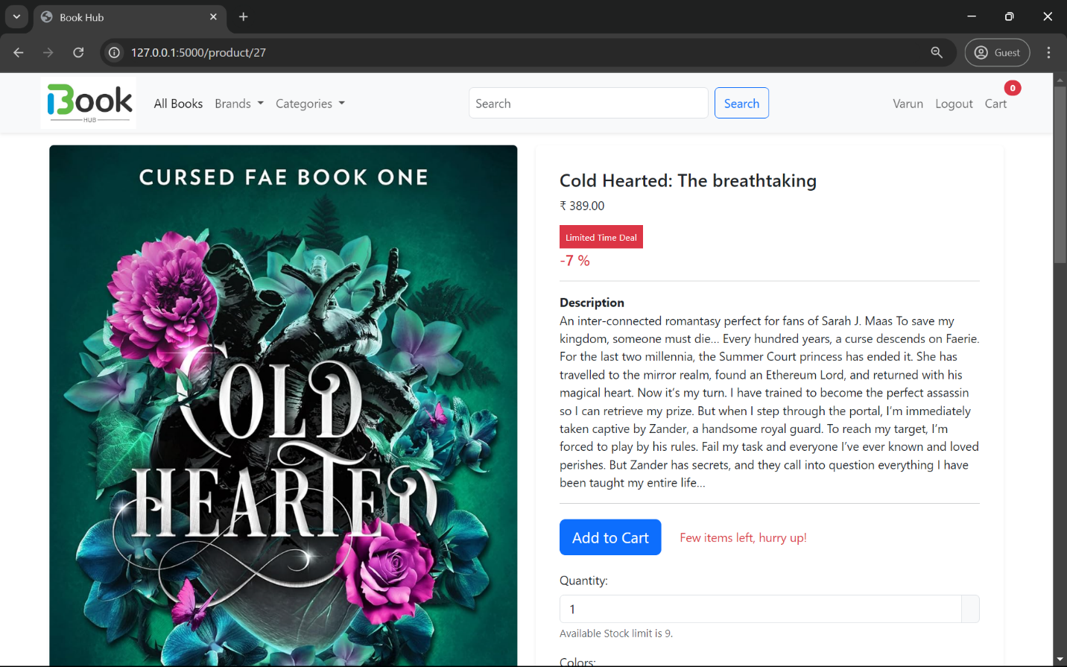

Figure 5

Cart Page

Figure 6

Checkout page

Figure 7

Payment Gateway

Figure 8

As the test mode feature does not accept international payments, as our payment gateway stripe services are

Currently not available in India for payment page purposes. So we changed our currency to USD to accept to duplicate payment.

Stripe Transactions history

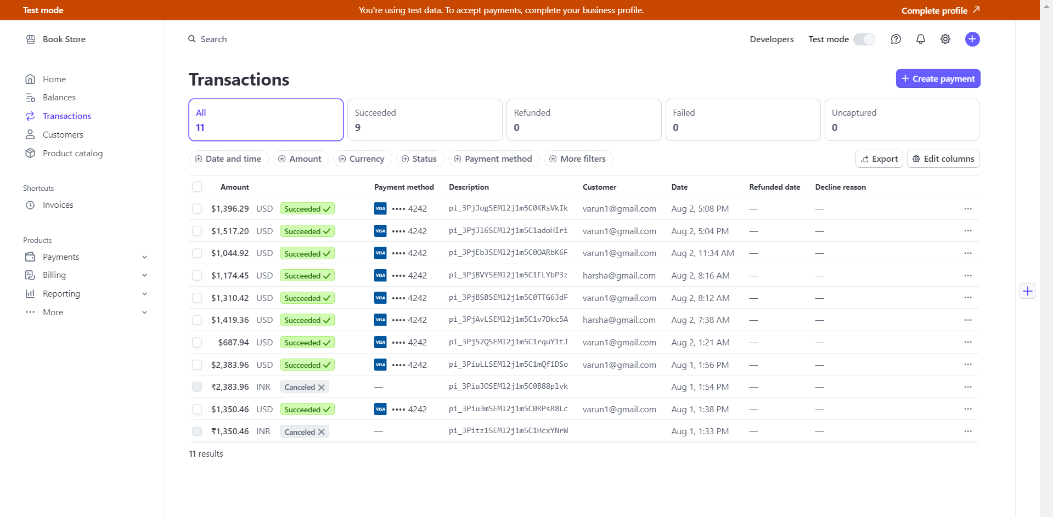

Figure 9

Invoice/Bill

Figure 10

Order_confirmation page

Figure 11

**Here are some Admin pages for better understanding**

Admin Login

Figure 12

Admin Home page

Figure 13

Add book

Figure 14

**Add brand**

Figure 15

**Add category**

Figure 16

**Brands page**

Figure 17

**Category page**

Figure 18

## Future Work:

**Integration of Payment Gateway:** While the current system is robust and functional, integrating a payment gateway is planned for future development. This will require additional requirements and considerations, including:

**Selection of Payment Providers:** Evaluating and choosing reliable payment gateway providers that meet security and compatibility requirements.

**Compliance with Payment Regulations:** Ensuring compliance with financial regulations and standards such as PCI-DSS (Payment Card Industry Data Security Standard).

**Security Enhancements:** Implementing advanced security measures to protect sensitive payment information.

## Impact of the Change:

* The decision to defer the integration of the payment gateway allowed us to focus on the core functionalities of the system, ensuring that we delivered a robust and efficient platform within the initial project timeline.
* This change ensured that the key aspects of the project were completed to a high standard, while also allowing us to gather user feedback that will be valuable when integrating the payment gateway in the future.

## Challenges Faced:

**Website Development Delays:**

* **Impact:** The website development phase took longer than initially planned due to additional user interface enhancements based on feedback.
* **Solution:** We extended the timeline for this phase by one month and reallocated resources from other tasks to ensure timely completion without affecting the overall project duration.

**Integration of Inventory Management System:**

* **Impact:** Integrating the inventory management system with the website proved more complex than anticipated, causing delays.
* **Solution:** We brought in additional expertise from our database administrators and developers to tackle the integration challenges. This collaboration helped us resolve the issues and complete the integration successfully.

**Testing and Debugging:**

* **Impact:** Extensive testing and debugging revealed several unforeseen bugs and issues, which required more time to fix.
* **Solution:** We allocated additional time for the quality assurance team and conducted multiple rounds of testing to ensure a bug-free system. This proactive approach minimized post-launch issues.

## Recommendations for Future Extensions and Improvements:

**Integrate Payment Gateway:**

* Implementing a secure and reliable payment gateway will allow customers to make online payments easily and safely. This should be a top priority in the next phase of development.

**Develop a Mobile Application:**

* Creating a mobile app for both Android and iOS platforms will enhance user experience and expand the customer base. It will allow customers to browse, purchase, and manage their accounts on the go.

**Expand Personalization Features:**

* Further developing personalization features such as custom recommendations, personalized marketing emails, and tailored promotions will improve customer satisfaction and loyalty.

**Enhance Security Measures:**

* Continuously improving security measures to protect customer data and transactions is essential. Implementing advanced encryption and regular security audits will help in maintaining customer trust.

**Customer Feedback Integration:**

* Setting up a system for continuous customer feedback will help in identifying areas for improvement and adapting the system to meet customer needs better.

## Conclusions:

**Main Objectives and Achievement:**

1. **Develop a User-Friendly Website:**

**Achievement:** We created a responsive and intuitive website that enhances customer experience.

1. **Implement an Efficient Inventory Management System:**

**Achievement:** We successfully integrated an inventory management system that streamlines order processing and reduces errors**.**

1. **Provide Personalized Recommendations:**

**Achievement:** We developed algorithms for personalized recommendations, improving customer satisfaction.

1. **Ensure Robust Security Measures:**

**Achievement:** We implemented strong security protocols to protect customer data and transactions.

## Success Metrics:

**Customer Satisfaction:** Positive feedback from users on the website's usability and personalized features.

# **3 Lessons learnt from Project Execution**

## Improving Performance in Similar Projects:

1. **Thorough Planning and Requirement Analysis:**
   * Spend ample time on planning and understanding the requirements of the project. Clear objectives and a detailed plan can prevent many issues later on.
2. **Effective Team Collaboration:**
   * Foster a collaborative environment where team members can share ideas and solve problems together. Regular meetings and communication are crucial.
3. **Flexibility and Adaptability:**
   * Be prepared to adapt your plan as the project progresses. Unforeseen challenges will arise, and flexibility can help in dealing with them efficiently.
4. **Prioritize Key Features:**
   * Focus on delivering the most critical features first. This ensures that even if some aspects are delayed, the core functionality of the project remains intact.
5. **Continuous Testing:**
   * Regularly test your system throughout the development process. Early detection of bugs can save time and resources in the long run.
   1. **Opportunities for Learning, Training, and Professional Development**
6. **Technical Skills:**
   * Team members improved their skills in web development, database management, security protocols, and data analysis.
7. **Project Management:**
   * The project offered hands-on experience in project planning, task allocation, timeline management, and resource allocation.
8. **Collaboration and Communication:**
   * Working in a team environment enhanced communication skills and taught the importance of collaboration.
9. **Problem-Solving:**
   * Addressing the challenges that arose during the project helped develop strong problem-solving abilities.
10. **Impact of the Work**
    * The project resulted in a comprehensive online bookstore management system that enhances customer experience, operational efficiency, and sales performance. It has provided a reliable platform for online bookstores, contributing to the digital transformation of the book retail industry.
    1. **Societal Impact Beyond Science and Technology**
11. **Increased Accessibility:**
    * The online bookstore makes books more accessible to a wider audience, including those in remote areas who may not have access to physical bookstores.
12. **Support for Education:**
    * By making a diverse range of books available online, the project supports education and literacy, providing resources for students and lifelong learners.

# **4 GitHub Repository details**

## 4.1 GitHub Repository - https://github.com/varun-jasti/Book-Hub ([Click Here](https://github.com/varun-jasti/Book-Hub))

## 4.2 Using GitHub in Our Project:

### 4.2.1 Version Control:

* We used GitHub to manage different versions of our code. This allowed us to keep track of changes and revert to previous versions if needed.

### 4.2.2 Collaboration:

* GitHub made it easy for team members to collaborate. Everyone could work on different parts of the project simultaneously and merge their changes without conflicts

### 4.2.2 Code Review:

* Team members could review each other’s code, provide feedback, and ensure the quality and consistency of the codebase.

## 

# **5 References**

## 5.1 Referencing text and quotes

### 5.1.1 The Online Bookstore (January 2017) Author: Yunkai Zhai

The rise of online bookshops is revolutionizing the book industry in a way that does away with many limitations posed by traditional brick-and-mortar bookstores. This system will bring improvements to people's quality of life by conserving time and effort involved in selecting and acquiring books. ([Research_Paper](https://www.researchgate.net/publication/314783622_The_Online_Bookstore))

### 5.1.2 Online Book Store Management (December 2021) Authors: Snehal Shedage, Maithili Kamble, Neha Kadam, Sanika Mali

The Internet has improved the living standard hugely and extended to e-commerce. The online bookstore simplifies the process of purchasing books, avoiding the problems of a traditional bookstore like the hours it is open or the availability of books. Moreover, the problem of space is eradicated through an online bookstore. ([Research_Paper](https://ijrpr.com/uploads/V2ISSUE12/IJRPR2147.pdf))

### 5.1.3 Online Bookstore - A New Trend in Textbook Sales Management for Services Marketing (January 2012)

**Authors:** **Prathamesh Muzumdar**

The research paper will consider the increase in online textbook sales in developing models of basic commerce principles. It will carry out theoretical analysis on the comparison between advantages and disadvantages of online versus traditional mediums of selling. ([Research_Paper](https://www.researchgate.net/publication/320708623_Online_Bookstore_-_A_New_Trend_in_Textbook_Sales_Management_for_Services_Marketing))

## 5.2 Other referencing guidelines

### ****99 Books Store**.** <https://www.99booksstore.com/>. Accessed 10 June 2024.

### ****5.2.2 Flipkart.**** Books Store. <https://www.flipkart.com/books-store>. Accessed 10 June 2024

### ****Books wagon**.** <https://www.bookswagon.com/>. Accessed 10 June 2024.

### ****99 Books Cart**.** <https://www.99bookscart.com/>. Accessed 10 June 2024.

* 1. **Referencing pictures or photos:**
     1. **"Flask E-commerce Website Tutorial."** [YouTube]. Created by DevExpert. <https://www.youtube.com/watch?v=eDTcSaZcLh4&t=427s>. Accessed 15 June 2024.
     2. **"Online Bookstore Development Course."** [YouTube Playlist]. Created by Jamal Bugti. <https://www.youtube.com/playlist?list=PLYPlvTh05MsxJja9bzQCSTDu4hnEv5N_u>. Accessed 20 June 2024.
     3. **"Stripe Integration in Flask Applications."** [YouTube]. Created by WebDevMaster. <https://www.youtube.com/watch?v=2Ax_P_SmBh4&t=873s>. Accessed 12 July 2024.

* + 1. **"Web Development with Python Tutorial."** [YouTube]. Created by Freecodecamp. <https://www.youtube.com/watch?v=yBDHkveJUf4>. Accessed 10 June 2024.

## Reference Papers

### 5.4.1 [1] Y. Zhai and W. Lu, "The online bookstore," *MATEC Web of Conferences*, vol. 100, pp. 02045, Jan. 2017. doi: 10.1051/matecconf/201710002045.

### 5.4.2 [2] Snehal Shedage, Maithili Kamble, Neha Kadam, Sanika Mali, " Online Book Store Management," * International Journal of Research Publication and Reviews*, Vol 2, no 12, pp 1112-1115, December 2021

### 5.4.3 [3] P. Muzumdar, "Online Bookstore - A New Trend in Textbook Sales Management for Services Marketing," *Journal of Management and Marketing Research*, vol. 9, pp. 122-135, Jan. 2012.