Mini Sentrix Hackathon
Mini SOC — Complete Pipeline & Progress Report
Detect → Correlate → Control Access → Respond Automatically
Report date: 25 June 2026
Realm: sentrix-mini-soc · Network: 192.168.56.0/24 (host-only)
Status: Gold tier achieved · Brownie Points Day 1–3 implemented

1. Executive Summary
This report documents the Mini Sentrix Security Operations Center built for the Sentrix Hackathon: a connected, fully open-source SOC that detects live attacks, correlates the evidence in a SIEM, enforces identity-based access control, and responds to threats automatically with no human intervention after the trigger. All four mandatory layers — Perimeter & Detection, SIEM & Visibility, Identity & Access, and Automated Response — are present and connected, with real data flowing end to end.
The environment spans four functional roles on a shared host-only network: an attack-and-detection node that also hosts the Web Application Firewall, a central Wazuh SIEM, a Keycloak identity service, and a Shuffle automation engine. As of 25 June 2026 the system meets the Gold success tier — Shuffle executes an automated, gated IP block on a live attack, and Keycloak enforces role-based access with brute-force lockout. Three Brownie Points are implemented with working evidence: Day 1 (time-based correlation), Day 2 (behaviour-analytics rules), and Day 3 (multi-gate response prioritisation).
Note on scope: the optional AI agentic-automation layer is not implemented in the current system and is intentionally excluded from this report. The automated response described here is a deterministic, rule-based Shuffle workflow.

2. System Architecture & Complete Pipeline
The SOC is organised into four roles connected over a single host-only LAN. The Web Application Firewall, originally planned as a separate node, is consolidated onto the attack-and-detection host alongside Suricata so that all web traffic to the target passes through inspection before reaching the application.
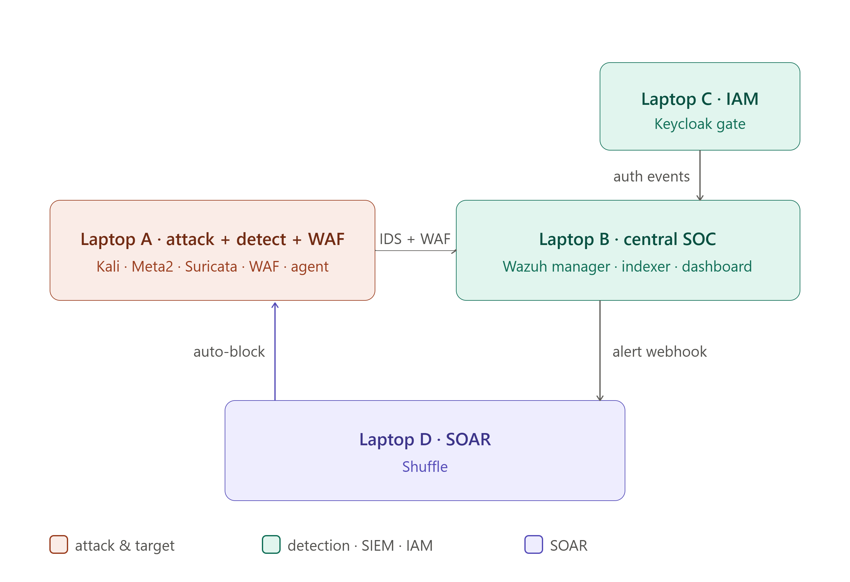
Figure 1. Logical SOC architecture. Laptop A runs the attacker, vulnerable target, Suricata IDS, the Wazuh agent and the Nginx/ModSecurity WAF; Laptop B is the central Wazuh SIEM; Laptop C provides Keycloak identity; Laptop D runs the Shuffle SOAR engine. IDS and WAF logs and Keycloak auth events feed the SIEM, which drives the auto-block back at the sensor.

2.1 End-to-End Data Flow
- Attack. Kali generates nmap scans, Hydra SSH brute force, and SQLMap/curl web attacks. Web requests are routed through the Nginx + ModSecurity WAF in front of DVWA.
- Perimeter detection. ModSecurity inspects each HTTP request and blocks malicious payloads with an HTTP 403. Suricata, attached to the host-only segment, inspects all packets and writes alerts to eve.json.
- Log shipping. The Wazuh agent forwards Suricata and WAF logs to the Wazuh Manager; Keycloak forwards authentication events. IDS, WAF and IAM appear as three separate labelled sources (agents ubuntu, waf-agent, keycloak-agent).
- Correlation & SIEM. The Wazuh Manager applies its rule engine plus custom behaviour-analytics rules, scores each event by level and MITRE ATT&CK technique, and indexes it. Dashboards present alert volume, attack types, severity, and top attacking IPs.
- Alerting. An OpenSearch per-query monitor (“High Severity Security Alert”) evaluates the alert index every minute and pushes qualifying alerts to the Shuffle webhook.
- Automated response. The Shuffle “SOC-automation” workflow normalises the alert and passes it through five sequential gates before executing an SSH iptables block on the sensor, dropping the attacker IP.
- Identity & access. Keycloak (realm sentrix-mini-soc) gates the SIEM dashboard with admin/user RBAC and temporarily locks accounts after three failed logins.

2.2 Network & Host Map
Address / Identifier | Role | Evidence
192.168.56.101 | Metasploitable2 + DVWA (vulnerable target) | nmap fingerprint (vsftpd 2.3.4, OpenSSH 4.7); SQLMap against /dvwa
192.168.56.102 | Kali Linux (attacker) | Source IP across Suricata alerts and Top Attacking IPs panel
192.168.56.103 | Detection node: Suricata + Wazuh agent + Nginx/ModSecurity WAF | eve.json SQLi alerts; nginx 1.30.1 403 blocks; SIEM dashboard on :443
10.0.3.15 | Wazuh agent address (ubuntu / 002) | Agent enrollment shown in Wazuh endpoint summary and Discover
ubuntu · waf-agent · keycloak-agent | Three labelled SIEM sources (IDS / WAF / IAM) | Top 5 agents panel in Threat Hunting dashboard

Consolidation note: the current build runs several roles on the 192.168.56.0/24 host-only network rather than on five physically separate laptops. The logical separation of layers (detection, SIEM, IAM, response) is preserved and each is enforced as an independent stage in the pipeline.

3. Attack Simulations & Detection Evidence
Three attack classes were run from Kali and verified through the detection stack: network reconnaissance, credential brute force, and web application attacks. All were detected; web attacks were additionally blocked at the WAF.

3.1 Reconnaissance — Nmap
A SYN scan against the detection node enumerates open services and is captured by Suricata as a SYN flood / scan pattern.
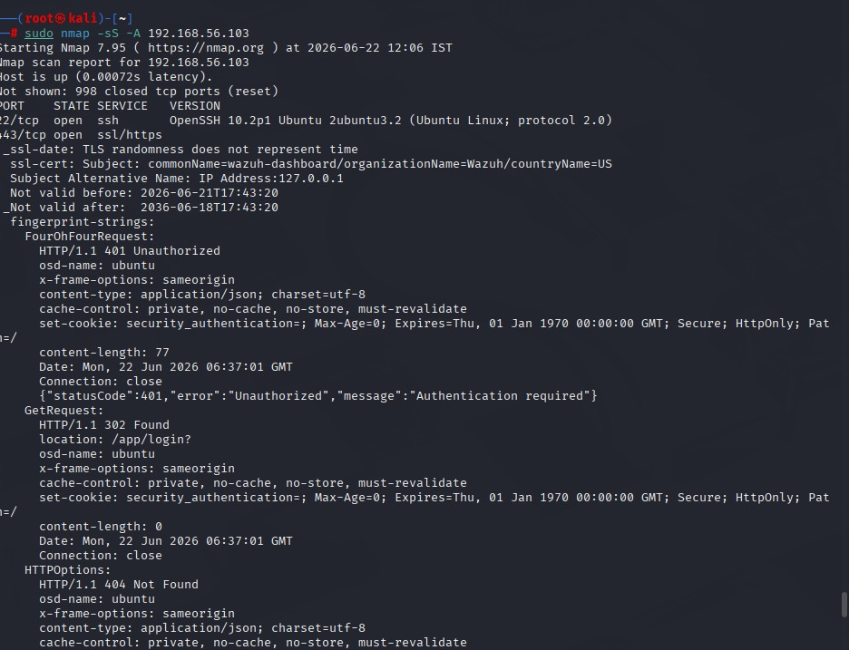
Figure 2. Nmap -sS -A against 192.168.56.103 — OpenSSH 10.2p1 and the Wazuh dashboard on port 443 (HTTP 401 Unauthorized, confirming Keycloak/auth in front of the dashboard).

3.2 Suricata IDS — live packet detection
Suricata writes per-packet alerts to fast.log and eve.json. The scan and brute-force traffic from 192.168.56.102 is detected as TCP SYN and SSH events, including an explicit “SSH Brute Force Attempt” signature.
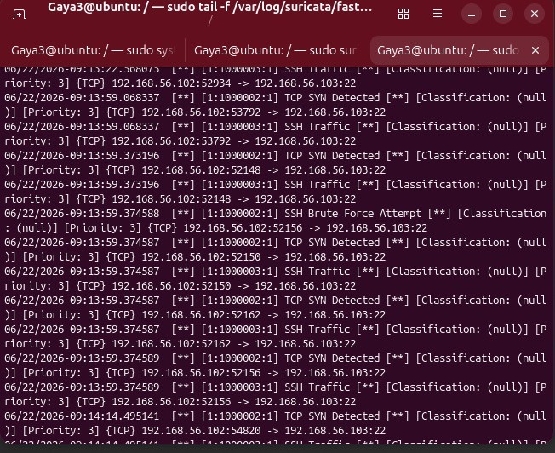
Figure 3. Suricata fast.log showing “SSH Brute Force Attempt” and TCP SYN detections from 192.168.56.102 → 192.168.56.103:22.
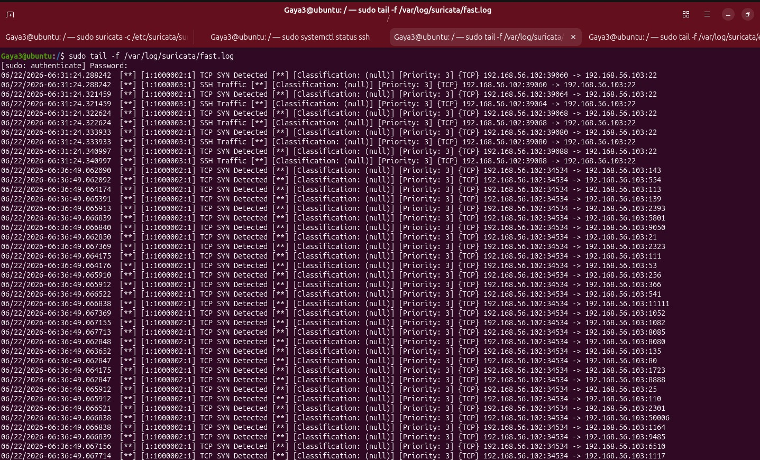
Figure 4. Suricata fast.log — high-volume TCP SYN detection stream during the scan (custom rules 1:1000002 / 1:1000003).
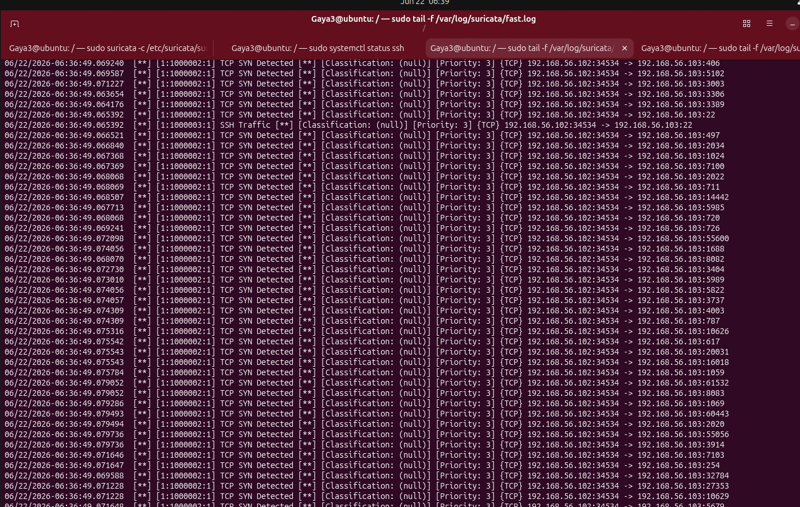
Figure 5. Suricata fast.log — continued SYN-scan detection, demonstrating sustained visibility of attacker traffic.

3.3 Credential Brute Force — Hydra
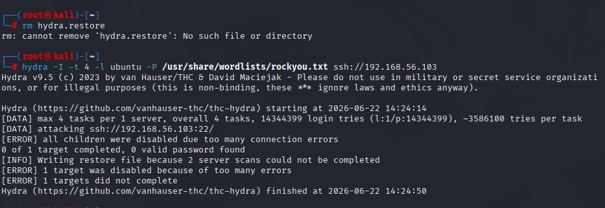
Figure 6. Hydra SSH brute force against 192.168.56.103 using rockyou.txt. The attempt generates the authentication-failure burst that Suricata and the Wazuh behaviour rules detect.

3.4 Web Application Attacks — SQLMap & WAF Blocking
SQLMap reaches DVWA on the target (a connectivity issue from earlier in the project has been resolved), and direct web-attack payloads are blocked by ModSecurity at the WAF.
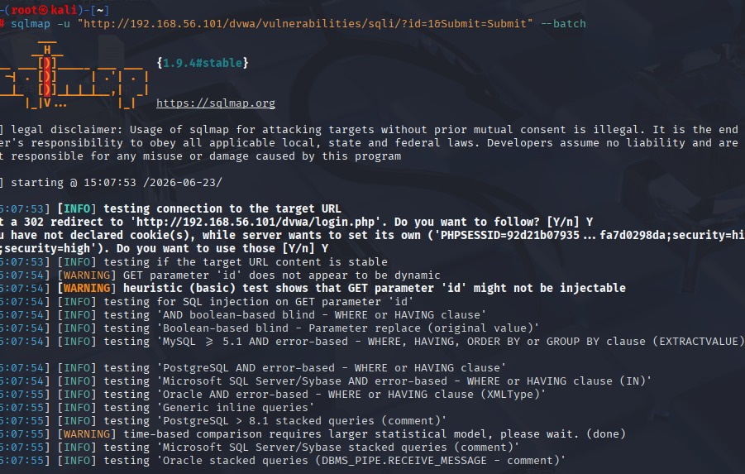
Figure 7. SQLMap against http://192.168.56.101/dvwa — the tool now connects, follows the login redirect, and tests the id parameter (target reachable).
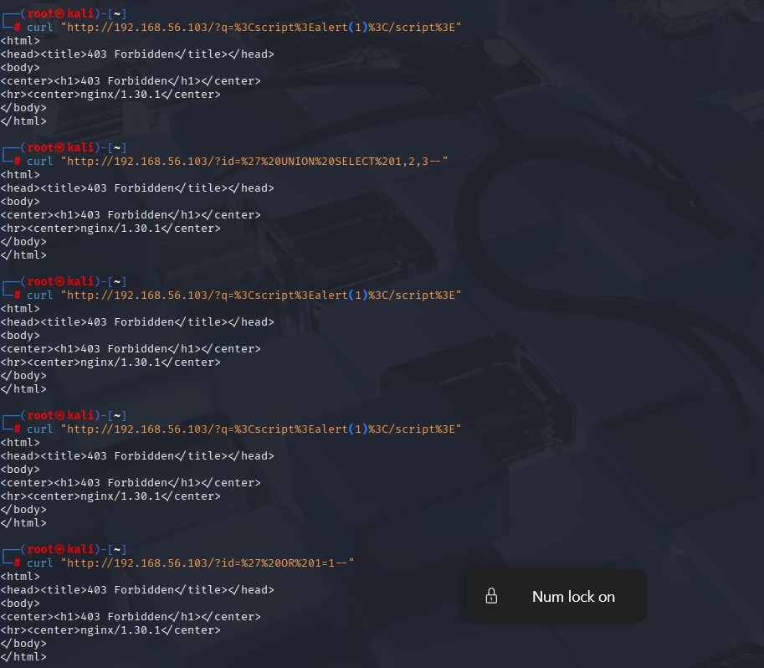
Figure 8. WAF blocking confirmed: XSS (<script>alert(1)</script>) and SQL-injection (UNION SELECT, OR 1=1) payloads to the WAF return HTTP 403 Forbidden from nginx 1.30.1 / ModSecurity. (An identical second capture was consolidated.)
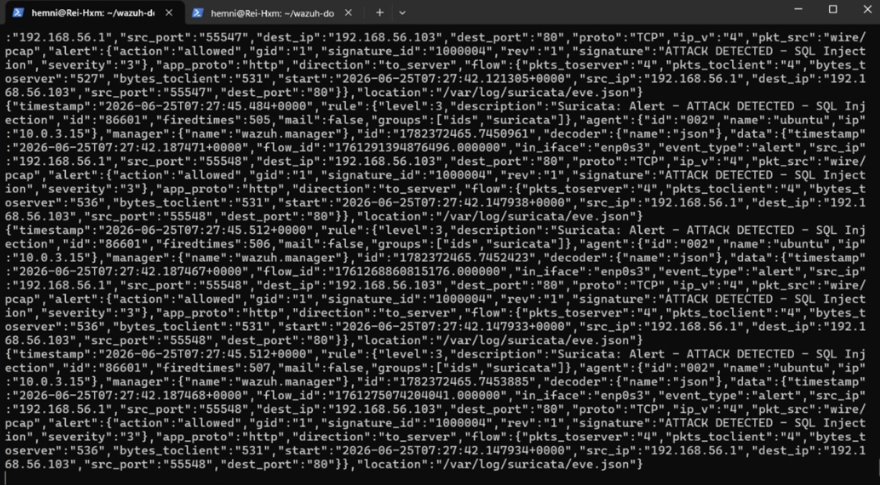
Figure 9. Suricata eve.json — “ATTACK DETECTED - SQL Injection” (custom signature 1000004, rule 86601) on HTTP traffic to 192.168.56.103:80, shipped to Wazuh as a labelled IDS source.

4. SIEM & Visibility (Wazuh)
The Wazuh Manager, Indexer and Dashboard form the central visibility layer. A custom IDS dashboard and the built-in Threat Hunting view present IDS, WAF and authentication data as distinct sources, satisfying the requirement that at least two sources are visible and separable.
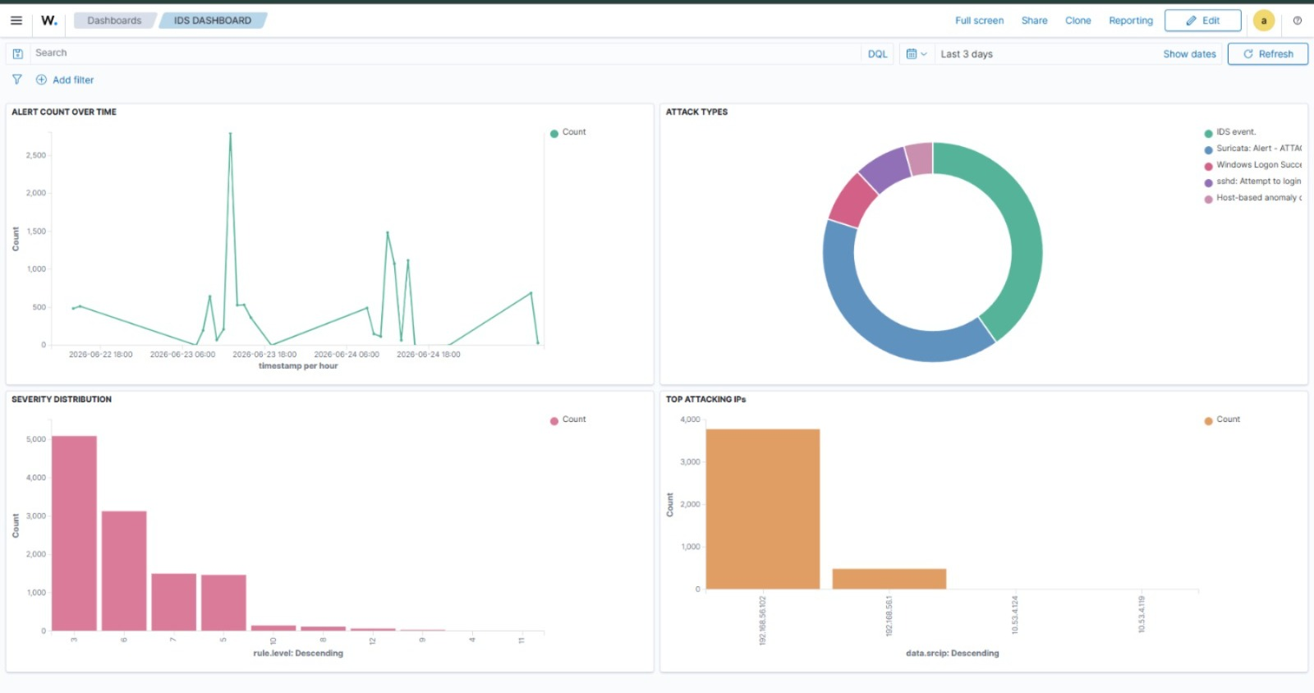
Figure 10. Custom IDS dashboard — Alert Count Over Time, Attack Types, Severity Distribution, and Top Attacking IPs. The Top Attacking IPs panel (192.168.56.102 dominant) is the core of the Day 1 correlation Brownie.
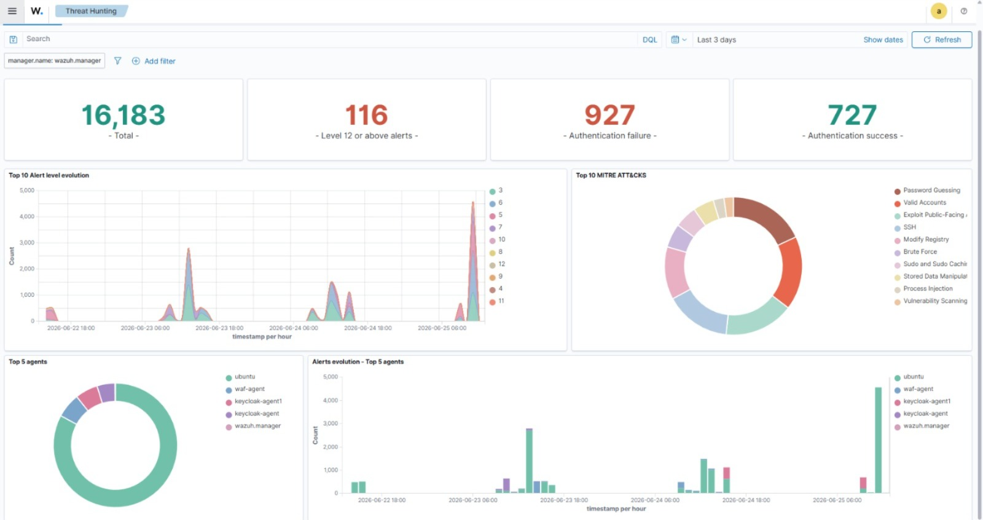
Figure 11. Threat Hunting dashboard — 16,183 total alerts, 116 at level 12+, 927 authentication failures, 727 successes; MITRE ATT&CK breakdown and the Top 5 agents (ubuntu, waf-agent, keycloak-agent) confirming three independent log sources.
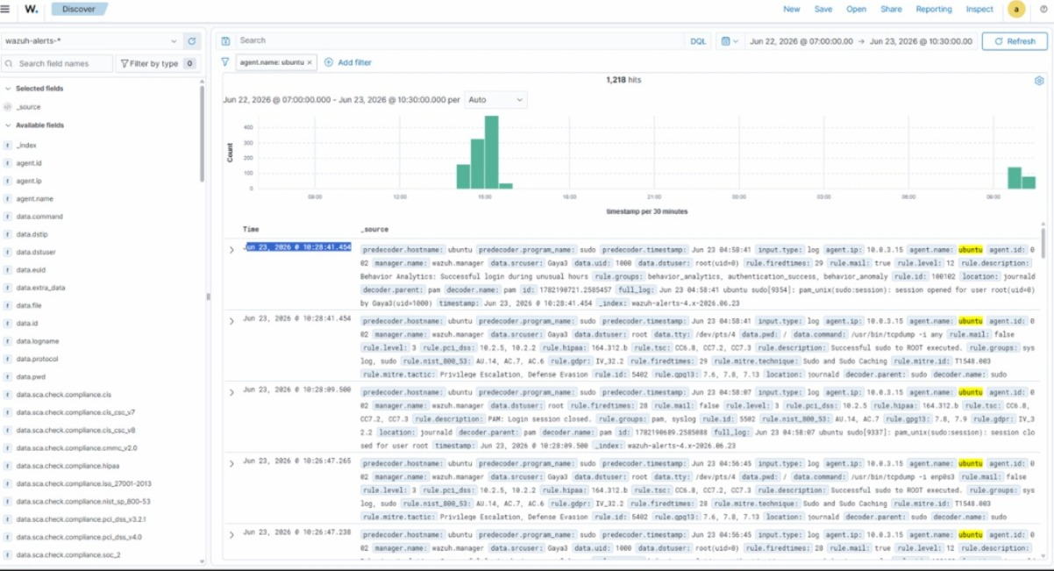
Figure 12. Discover view of the wazuh-alerts-* index filtered to the ubuntu agent (1,218 hits), showing fully parsed behaviour-analytics events available for investigation.
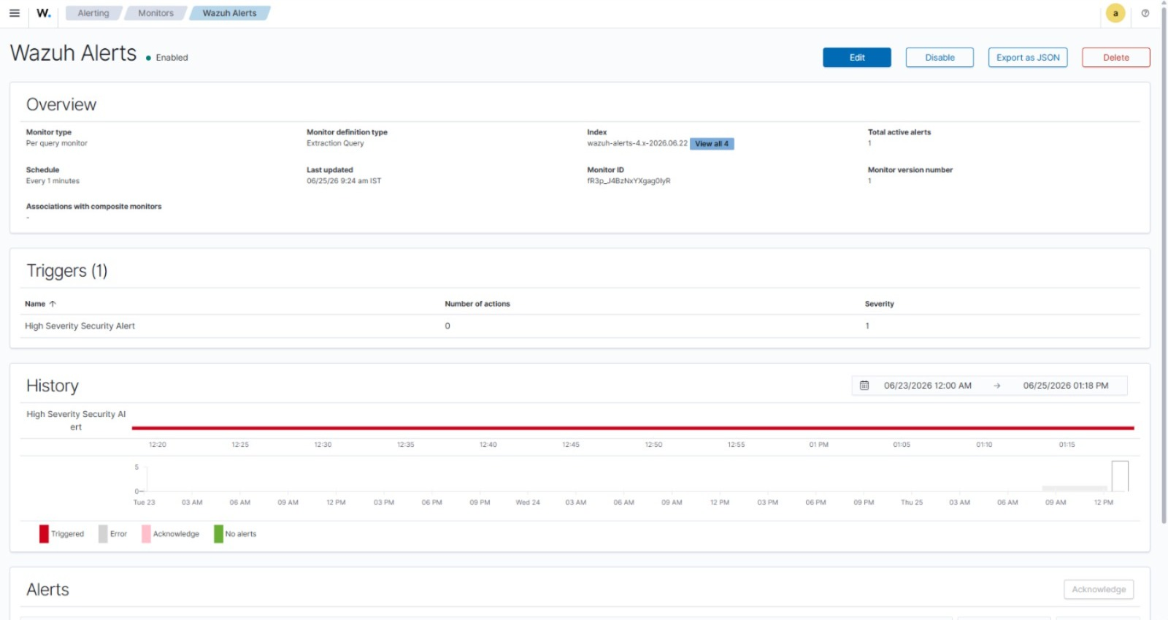
Figure 13. OpenSearch alerting monitor “Wazuh Alerts” — a per-query monitor running every minute with the “High Severity Security Alert” trigger that forwards qualifying alerts to the Shuffle webhook.

5. Automated Response Pipeline (Shuffle SOAR)
The response layer is a deterministic Shuffle workflow named “SOC-automation”. A Wazuh alert arrives on the “Alerts” webhook, is normalised, and then passes through five sequential gates before any enforcement occurs. This gating is what converts raw alerts into safe, prioritised action.
- Gate 1 — Severity threshold. Workflow variable LEVEL_THRESHOLD = 8; only alerts at Wazuh level 8 or higher continue. Routine noise is recorded but stopped.
- Gate 2 — Source-IP presence. The alert must carry a usable attacker source IP; host/identity events with no IP cannot be blocked and are routed to monitoring only.
- Gate 3 — Route guard. Behaviour-analytics categories are treated as monitor-only and are not auto-blocked, preventing false enforcement on visibility-only signals.
- Gate 4 — Lab-scope rail. LAB_SCOPE_CIDR restricts blocking to approved lab ranges; any IP outside scope halts the workflow.
- Gate 5 — Enforcement. With DRY_RUN controlling live-versus-test mode, Shuffle connects over SSH and runs an iptables rule to drop the attacker IP at the sensor.
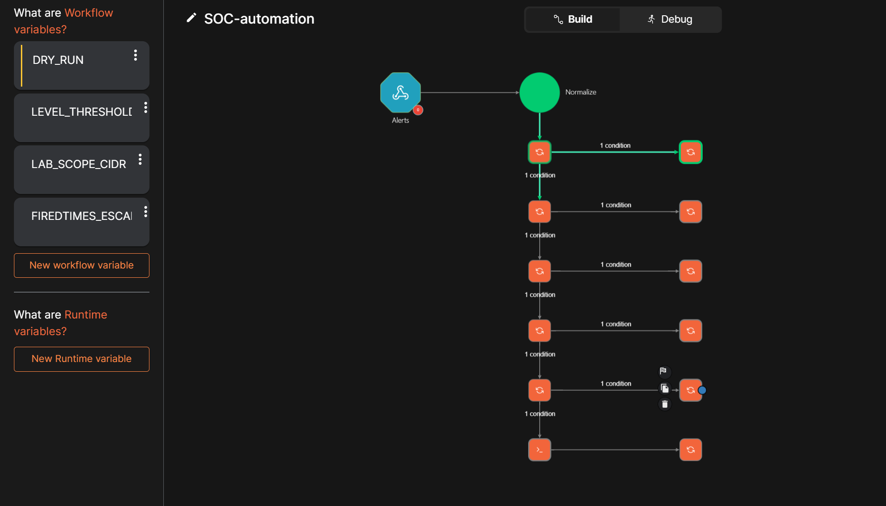
Figure 14. Shuffle “SOC-automation” workflow: Alerts webhook → Normalize → five sequential condition gates → SSH enforcement. Workflow variables DRY_RUN, LEVEL_THRESHOLD, LAB_SCOPE_CIDR and FIREDTIMES_ESCALATION drive the gating logic.
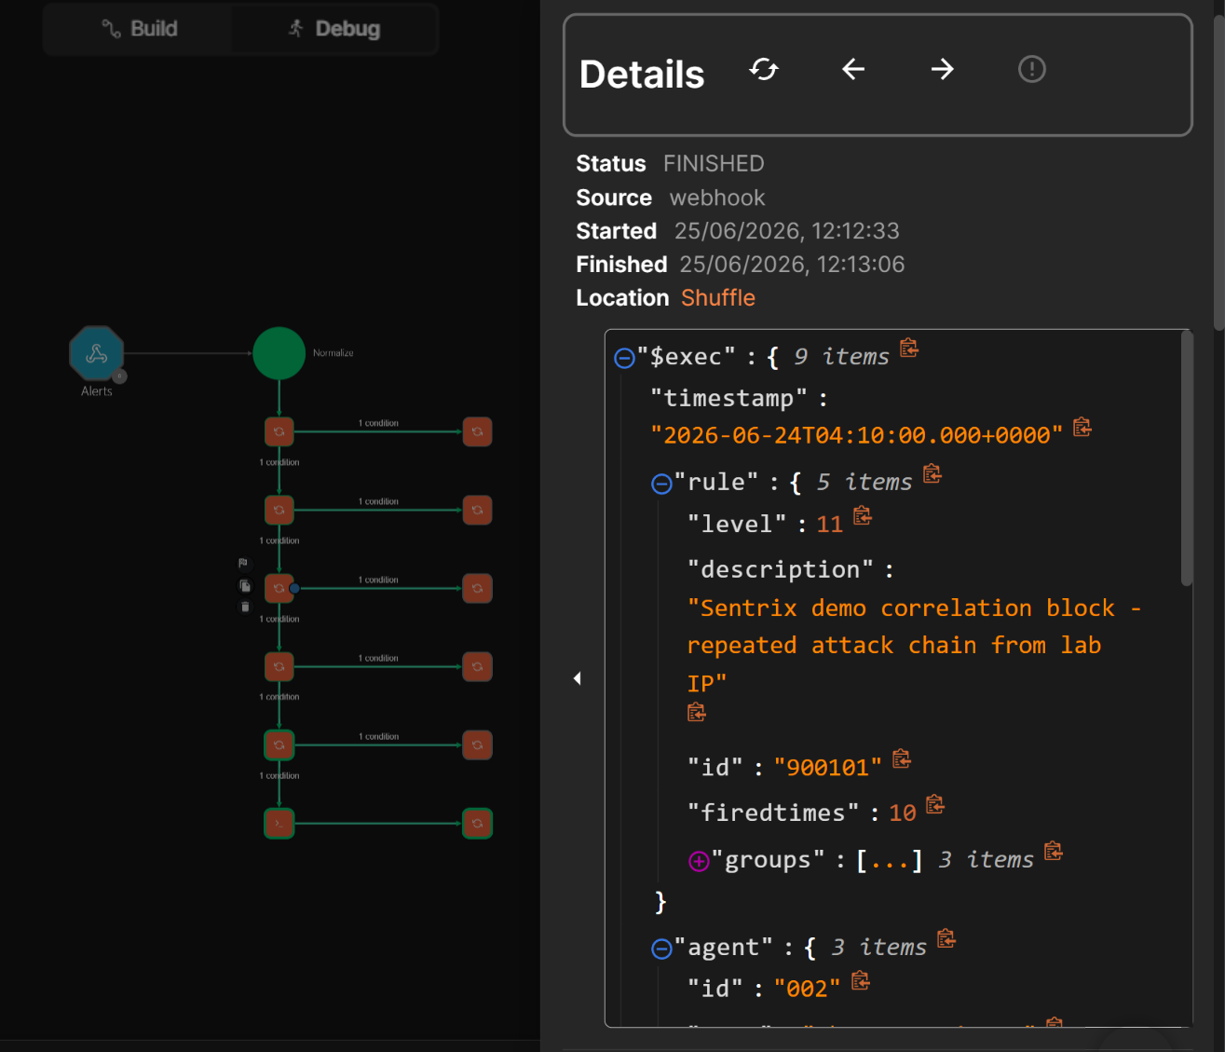
Figure 15. A completed workflow run (status FINISHED, source webhook) processing a level-11 correlation alert (id 900101, “Sentrix demo correlation block — repeated attack chain from lab IP”), demonstrating the end-to-end pipeline executing without human intervention.

6. Brownie Points Implemented

6.1 Day 1 — “The Sleepwalker’s Diary” (correlation over time)
Decode: the problem is not a lack of alerts but a lack of memory and correlation. An attacker who spreads activity over time avoids notice if each alert is viewed in isolation.
Implementation: a correlation-focused IDS dashboard (Figure 10) whose Top Attacking IPs, Alert Count Over Time and Attack Types panels make repeated activity from a single source immediately visible — connecting events across the monitoring window rather than treating each as fresh.

6.2 Day 2 — “The Loyal Guard Who Lets Everyone In” (behaviour after authentication)
Decode: authentication alone is insufficient; a login can be valid by credentials yet suspicious by behaviour. The system must monitor how access happens, not just whether the password was correct.
Implementation: custom Wazuh behaviour-analytics rules in local_rules.xml — multiple successful logins within five minutes (rule 100101, level 12), successful login during unusual hours 00:00–05:00 (rule 100102, level 12), and repeated authentication failures (rule 100103). These move the IAM layer from credential validation to behaviour-aware monitoring.
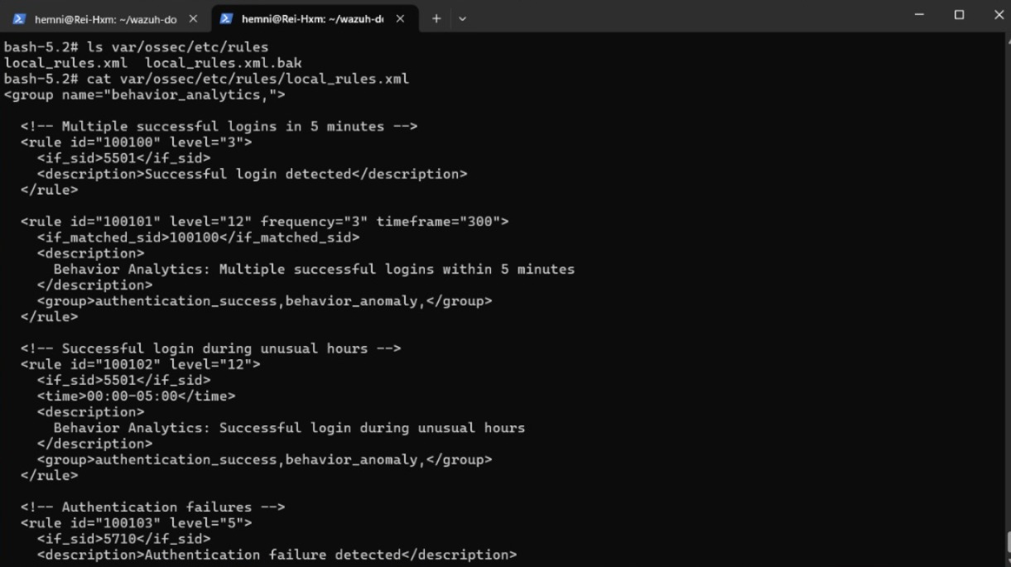
Figure 16. Custom behaviour-analytics rules in local_rules.xml (group behavior_analytics): repeated-login, unusual-hours and authentication-failure detection beyond simple success/fail checks.

6.3 Day 3 — “The Alarm That Cried Wolf” (prioritisation before response)
Decode: the problem is the absence of filtering and prioritisation before automated response — a SOC should not react to every alert equally, or attackers will hide in the noise.
Implementation: the five-gate Shuffle workflow (Figures 14–15). Severity, source-IP, route-guard and lab-scope checks ensure only serious, actionable, in-scope alerts reach enforcement; everything else is recorded but not acted on. This adds prioritisation in front of the automated block.

6.4 Day 4 — “The Map That Only Shows Roads You’ve Already Walked”
Decode: signature-based detection only recognises known patterns and is blind to genuinely novel, low-and-slow behaviour that must be judged against a baseline of normal activity.
Status: decoded and designed; anomaly/behaviour-baseline detection is identified as future work and is not claimed as implemented in the current system.

7. Success-Tier Assessment
Tier | Criteria | Status
Bronze | Suricata alerts in Wazuh; WAF alerts in Wazuh; dashboard functioning | Achieved
Silver | All three attacks visible (Nmap, Hydra, SQLMap); WAF block confirmed; Suricata detection confirmed; dashboard displays all sources | Achieved
Gold | Shuffle triggers an automated action; Keycloak enforcing access with RBAC and brute-force lockout | Achieved

In addition to the Gold tier, three Brownie Points (Day 1 correlation, Day 2 behaviour analytics, Day 3 response prioritisation) are implemented and demonstrable, exceeding the two-Brownie eligibility requirement.

8. Conclusion & Next Steps
The Mini Sentrix SOC demonstrates a complete, working pipeline: a live attack is detected at the network and web layers, correlated and scored in Wazuh, surfaced on purpose-built dashboards, and answered by a gated, automated SSH block — while Keycloak enforces who may access the SOC itself. The design choices are defensible at every stage: the WAF sits in front of the target so web attacks are inspected before they land; Suricata sits where it can see all attacker traffic; the response is gated so the system reacts only to serious, in-scope, actionable alerts.
Next steps: (1) extend detection toward anomaly/behaviour baselines to address the Day 4 Brownie; (2) continue shipping WAF and IAM logs as clearly separated dashboard panels; (3) rehearse the full attack-to-block path end to end so the live demo runs without manual steps.

