DAY 2 PROGRESS REPORT
Sentrix Mini SOC Lab
Wazuh SIEM | Suricata IDS | DVWA/Metasploitable2 | Nginx WAF | Keycloak IAM | SOAR/AI Plan
Date: 22 June 2026
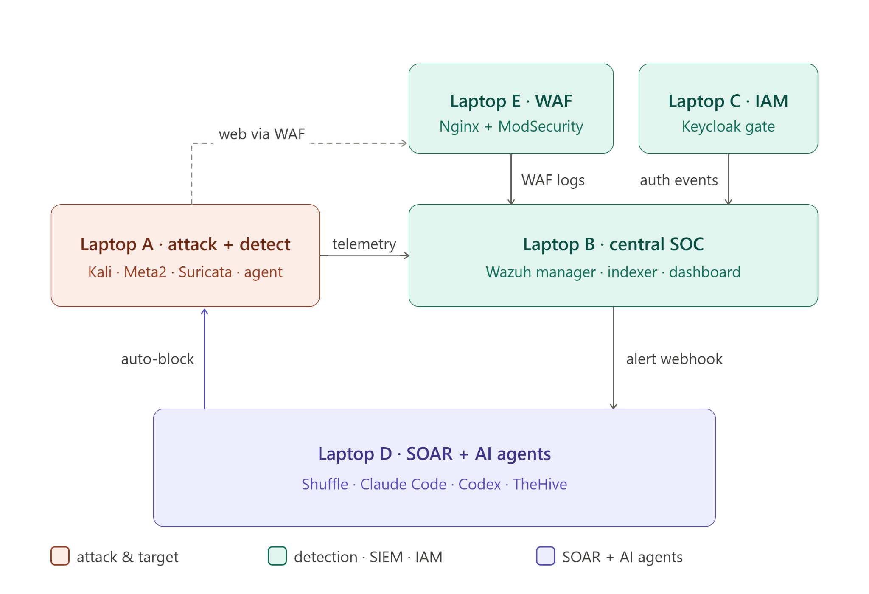
Figure 1. Five-laptop SOC architecture used as the Day 2 integration framework.
The architecture separates attack/detection, central SOC, IAM, WAF, and SOAR functions. This is the correct structure for a judge-facing mini-SOC demo because each security layer has its own responsibility and evidence path.

Straight assessment
Day 2 shows real progress: Wazuh is running, an Ubuntu agent is active, Suricata is producing alerts, DVWA is reachable in the lab, Keycloak has users/groups/roles and brute-force lockout evidence, and the architecture is clear. The weak points are also clear: WAF blocking evidence is not yet proven, SCA scans are missing, SQLMap routing failed in one attempt, Hydra evidence is not visible in the screenshots, and IAM/WAF logs still need to be cleanly separated inside Wazuh.

1. Executive Summary
Area | Progress shown | Current status | Evidence
Central SOC / Wazuh | Wazuh dashboard is accessible; Ubuntu agent 002 is active; alert dashboards are populated. | Working, but SCA scan panel is not generating results. | Wazuh endpoint and IDS dashboard screenshots
IDS / Suricata | Suricata fast.log records TCP SYN, SSH traffic, SSH brute-force attempt, and scan traffic. | Working on host-only segment. | Suricata terminal logs
Attack validation | Nmap scans and DVWA command execution are demonstrated. SQLMap was attempted but hit a network-reachability issue. | Partially working; routing fix needed for SQLMap path. | Kali terminal + DVWA screenshots
WAF / Reverse proxy | Nginx proxy config forwards traffic to DVWA at 10.53.4.58/dvwa/. | Configuration shown; ModSecurity/CRS block proof still required. | proxy.conf screenshot
IAM / Keycloak | Keycloak runs via Docker; realm/users/groups/roles configured; login events and brute-force temporary lockout shown. | Good setup progress; still needs full enforcement in front of Wazuh dashboard and log shipping to SIEM. | Keycloak DOCX evidence
SOAR / AI agent layer | Architecture and role plan are defined for Wazuh -> Shuffle -> notification/analysis/remediation. | Planned; live trigger not evidenced yet. | Project framework MD + architecture diagram
Bottom line: Bronze is close, Silver is partly demonstrated, Gold is not complete yet. The team should not spend time on the agentic AI stretch layer until WAF blocks, IAM logs, and basic SOAR notification are visibly working.

2. Project Framework From the Day 2 Plan
The Day 2 framework defines a five-laptop LAN-based mini SOC. The important design choice is that Suricata visibility comes from the VM-level host-only/internal segment on Laptop A, while the WAF and SOC components communicate over the physical LAN. This prevents the IDS proof from depending on campus Wi-Fi behavior.
Node | Role | Main components | Day 2 responsibility
Laptop A | Attack + Detection | Kali, Metasploitable2/DVWA, Suricata, Wazuh Agent | Run Nmap/Hydra/SQLMap, prove Suricata sees attacks, ship logs to Wazuh.
Laptop B | Central SOC | Wazuh Manager, Indexer, Dashboard | Build SIEM panels and integrate IDS, WAF, and IAM as separate sources.
Laptop C | IAM | Keycloak or Authelia | Protect access to the dashboard, configure admin/viewer roles, ship auth events.
Laptop D | SOAR | Shuffle, later AI agents/TheHive | Design trigger/action logic and later connect Wazuh alerts to automation.
Laptop E | WAF | Nginx, ModSecurity, OWASP CRS | Reverse-proxy DVWA and prove at least one SQLi/XSS block.

2.1 Verification Checklist Against the Plan
Test from framework | Expected result | Observed evidence | Status
Test 1: Meta2 has two interfaces | One host-only IP and one LAN/bridged IP. | No direct ip a screenshot is included. | Not evidenced
Test 2: Laptop E reaches Meta2/DVWA | ping/curl returns DVWA response. | Nginx proxy points to 10.53.4.58/dvwa/ and DVWA command-exec page is reachable, but curl-through-WAF proof is not shown. | Partial
Test 3: Kali reaches Meta2 host-only | Nmap shows Meta2 services. | Nmap to 192.168.56.101 shows FTP, SSH, Telnet, SMTP, DNS and other Meta2 services. | Completed
Test 4: Suricata logs scan traffic | Alerts appear immediately after scan. | fast.log shows TCP SYN and SSH traffic from 192.168.56.102 to 192.168.56.103. | Completed
Test 5: Full attack path through WAF | DVWA accessed via Laptop E and ModSecurity logs a block. | Proxy config exists, but block log/screenshot is missing. | Pending

3. Central SOC and Wazuh Progress
The Wazuh dashboard is running locally and shows an active Ubuntu endpoint. The endpoint summary includes ID 002, IP address 10.0.3.15, Wazuh version 4.12.0, group default, Ubuntu 26.04 LTS, cluster node node01, and a recent keep-alive timestamp. This proves the endpoint is enrolled and reporting.
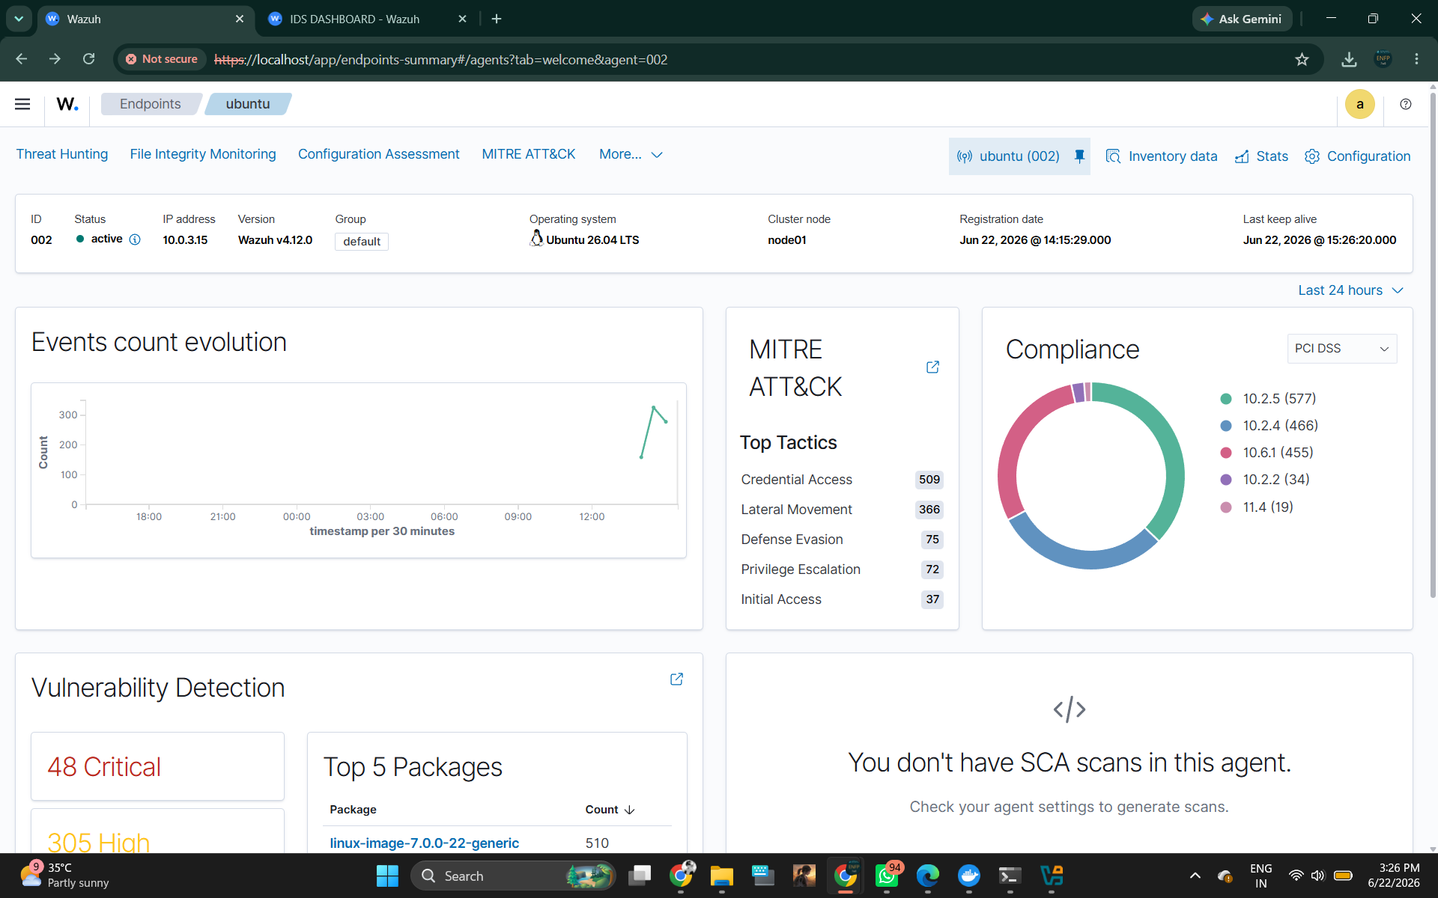
Figure 2. Wazuh endpoint summary for ubuntu agent 002.
Important observations: the agent is active, MITRE tactics are populated, compliance statistics exist, and vulnerability detection is showing 48 critical and 305 high findings. The dashboard also reports that SCA scans are not present for this agent, so configuration assessment still needs to be enabled or rechecked.

The custom IDS dashboard is populated with alert count over time, attack type distribution, severity distribution, and top attacking IP panels. The dominant source shown in the screenshot is 192.168.56.102, which matches the lab attack-source range used by Kali/host-only traffic.
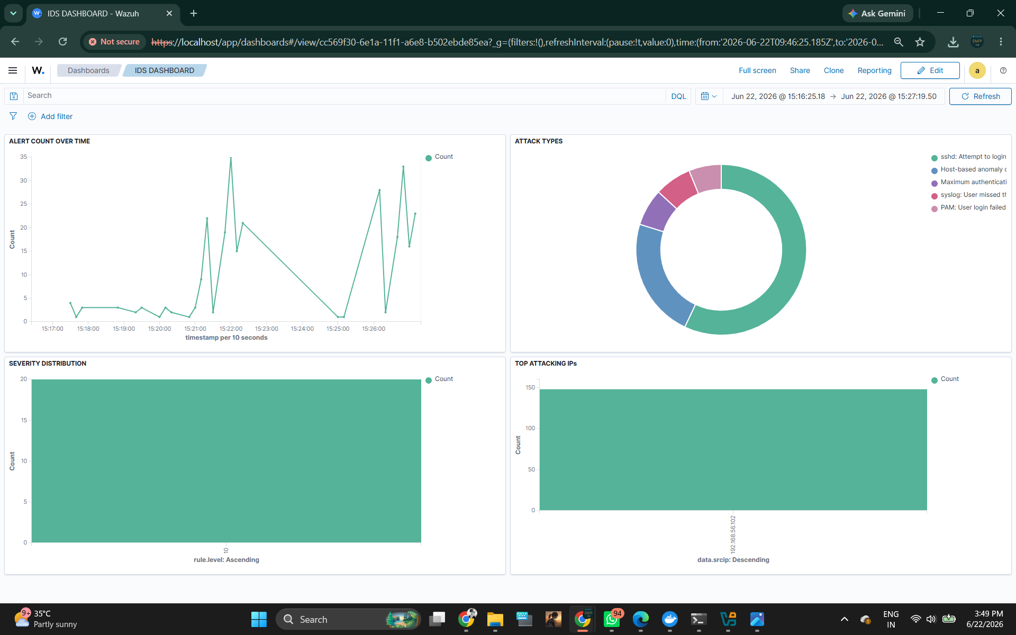
Figure 3. IDS dashboard showing alert count, attack categories, severity, and top attacking IP.
The panels are useful for a demo because they answer four judge questions quickly: when alerts occurred, what type they were, how severe they were, and which IP generated most traffic. The weakness is that the severity distribution appears mostly level 0/count-only, so rules should be tuned to show meaningful severity categories.

SOC deliverable | Progress | Hard improvement needed
Agent visibility | Ubuntu agent is active and reporting. | Keep screenshots of agent enrollment and Wazuh manager health.
Attack dashboard | Alert volume, attack types, severity, and top source IP panels are present. | Add separate panels for IDS, WAF, and IAM sources instead of mixing everything.
Vulnerability view | Critical/high package counts appear. | Enable/verify SCA scans because the dashboard explicitly says scans are missing.
Judge explanation | MITRE tactics and compliance views are available. | Prepare a 30-second explanation of why Credential Access/Lateral Movement events appeared.

4. WAF / Reverse Proxy Progress
The Nginx configuration forwards web requests to the DVWA path. This is the correct first step for placing a WAF in front of DVWA instead of attacking DVWA directly. The proxy headers preserve Host, X-Real-IP, and X-Forwarded-For, which is important because Wazuh/ModSecurity logs should retain the attacker source information.
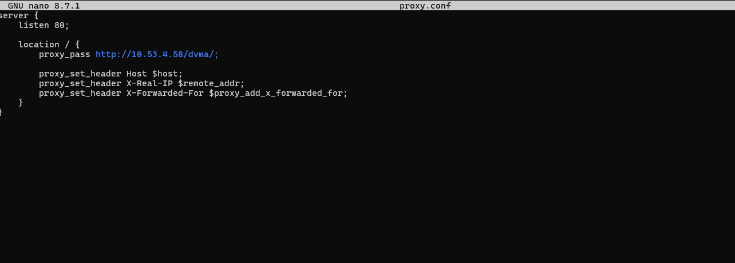
Figure 4. Nginx proxy.conf showing reverse proxy to http://10.53.4.58/dvwa/.
This proves reverse-proxy configuration work, not full WAF success. To claim WAF completion, the report still needs ModSecurity audit logs showing a blocked SQLi or XSS payload and that those logs were shipped to Wazuh.

WAF status
Configuration exists, but the evidence does not yet prove OWASP CRS blocking. The next proof should be: curl through Laptop E -> malicious payload -> HTTP 403/block -> ModSecurity audit.log entry -> Wazuh dashboard panel.

5. Suricata IDS and Attack Detection
Suricata is producing fast.log alerts for host-only lab traffic. The screenshots show TCP SYN detection, SSH traffic, and SSH brute-force attempt signatures involving 192.168.56.102 and 192.168.56.103. This matches the framework: Suricata watches the Kali-to-target internal segment.
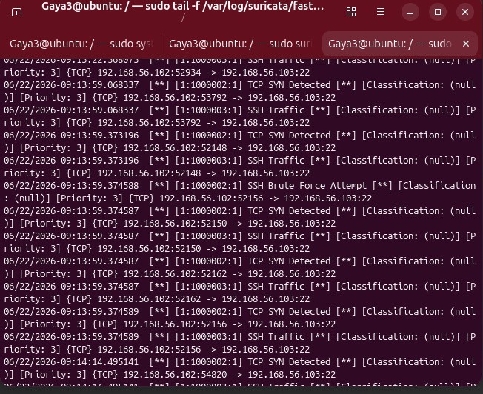
Figure 5. Suricata fast.log showing TCP SYN, SSH traffic, and SSH brute-force attempt events.
This is valid IDS evidence. The classification field is shown as null and priority 3, so rule metadata should be improved for a cleaner judge-facing dashboard.

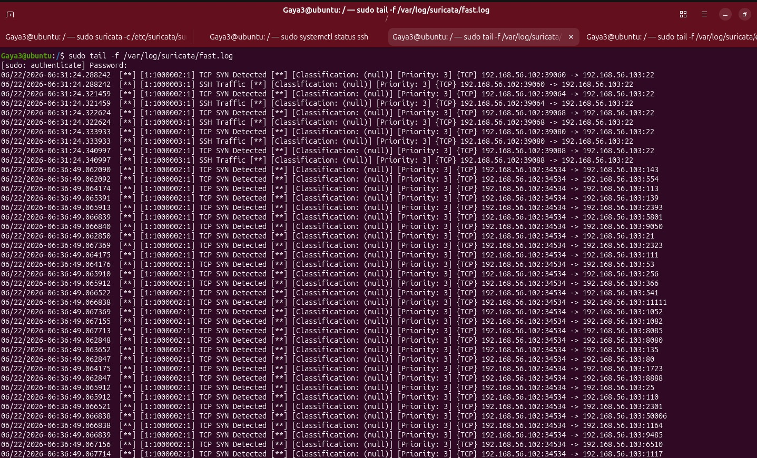
Figure 6. Suricata fast.log showing port-scan style TCP SYN events to multiple ports.
The repeated SYN events across ports such as 143, 113, 139, 5801, 9050, 21, 2323, 111, 53, 256, 366, 541, and others are consistent with scan traffic. This supports the Wazuh top-attacking-IP panel.

6. Attack Validation Evidence

6.1 Nmap scan against Ubuntu/Wazuh-related host
One scan against 192.168.56.103 shows SSH and HTTPS open. The HTTPS service returns Wazuh-style headers and an authentication-required response. This indicates the target is reachable and protected by the application login layer.
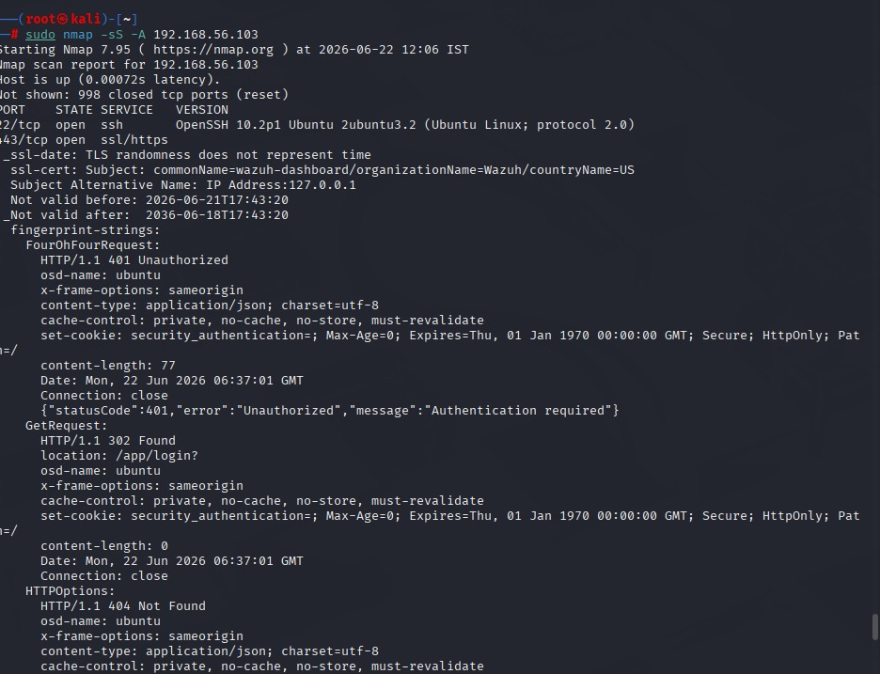
Figure 7. Nmap -sS -A scan against 192.168.56.103 showing SSH and HTTPS/Wazuh dashboard response.
The 401 Unauthorized and login redirect are expected for a protected Wazuh dashboard. Do not present this as a vulnerability; present it as reachability and service identification proof.

6.2 Nmap scan against Metasploitable2
The Metasploitable2 scan shows classic intentionally vulnerable services: anonymous FTP, OpenSSH 4.7p1, Telnet, Postfix SMTP, and ISC BIND. This is expected in a lab target and gives the attack operator multiple repeatable alert sources.
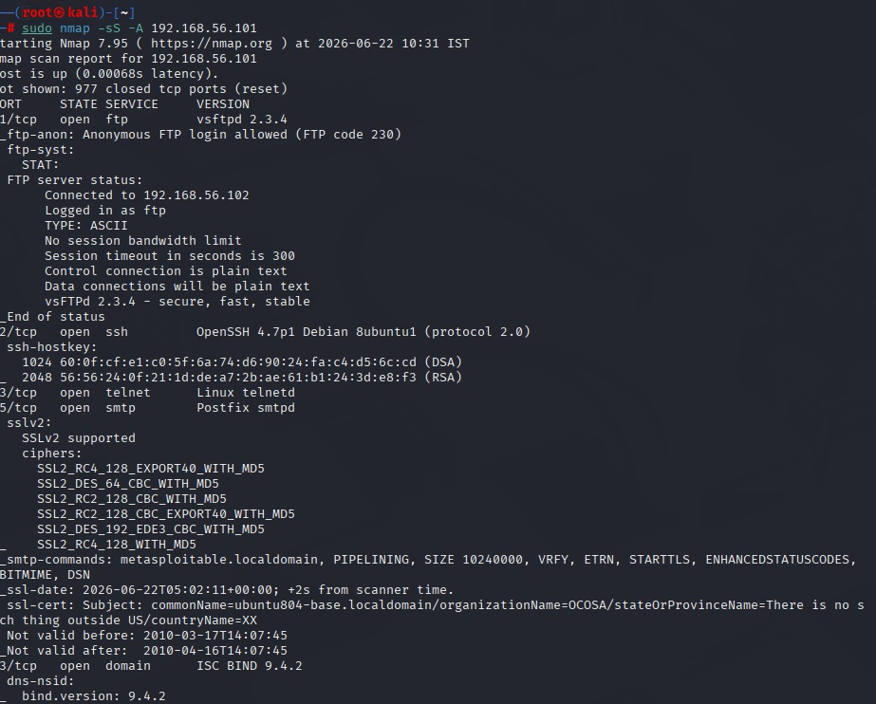
Figure 8. Nmap service enumeration against 192.168.56.101 / Metasploitable2.
This supports the host-only connectivity test and proves the vulnerable target is alive. Keep this target isolated; exposing Metasploitable2 to a real LAN or internet would be reckless.

6.3 DVWA command execution check
The DVWA command execution page is accessible and successfully ran a ping to 10.53.4.58 with three replies. This demonstrates that the DVWA lab is functioning and can be used to generate visible IDS/WAF events.
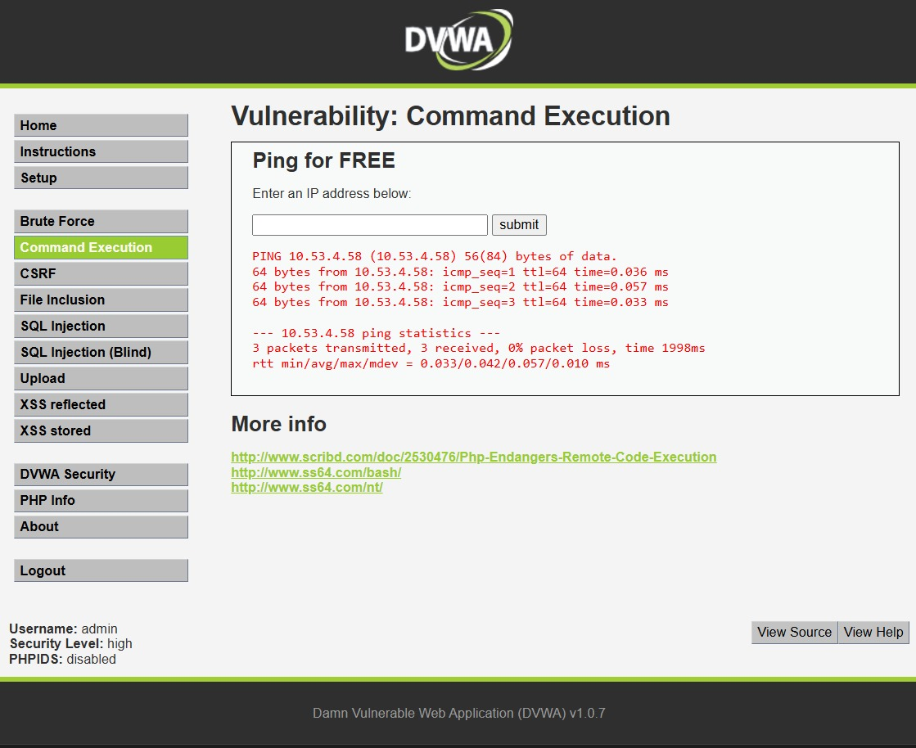
Figure 9. DVWA Command Execution module returning ping output.
This is useful demo evidence because it is simple, visible, and repeatable. It should still be used only in the isolated lab environment.

6.4 SQLMap attempt and routing issue
SQLMap was launched against a URL using 172.27.132.18:8080, but the terminal shows “Network is unreachable.” Meanwhile, Suricata still records TCP SYN attempts to 192.168.56.103 ports 443 and 80. The practical conclusion is simple: the attack tool ran, but the chosen route/target URL was wrong or unreachable from that VM.
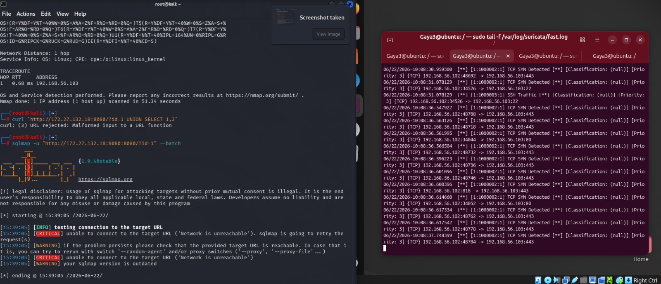
Figure 10. SQLMap attempt showing network unreachable while Suricata logs concurrent SYN traffic.
This screenshot should not be sold as successful SQL injection. It is evidence of attempted testing plus a routing problem that must be fixed before the final demo.

Attack item | Evidence status | What to fix before demo
Nmap scan | Working and visible. | Keep one exact command and target IP fixed for repeatability.
Suricata scan detection | Working in fast.log and Wazuh dashboard. | Add rule names/classifications so panels look professional.
DVWA command execution | Working. | Route it through WAF for proof instead of only direct access.
SQLMap | Attempted but failed due to network unreachable. | Use the reachable DVWA URL. Confirm cookie/session and WAF path before running.
Hydra brute force | No separate screenshot included. | Capture terminal command + Suricata/Wazuh alert before claiming it as complete.

7. IAM / Keycloak Progress
The Keycloak evidence file shows that the IAM component was deployed and configured with users, groups, realm roles, login events, and brute-force lockout settings. This is a strong Day 2 contribution, but it only becomes Gold-level when it enforces access to the Wazuh dashboard and sends auth events into Wazuh as a separate source.
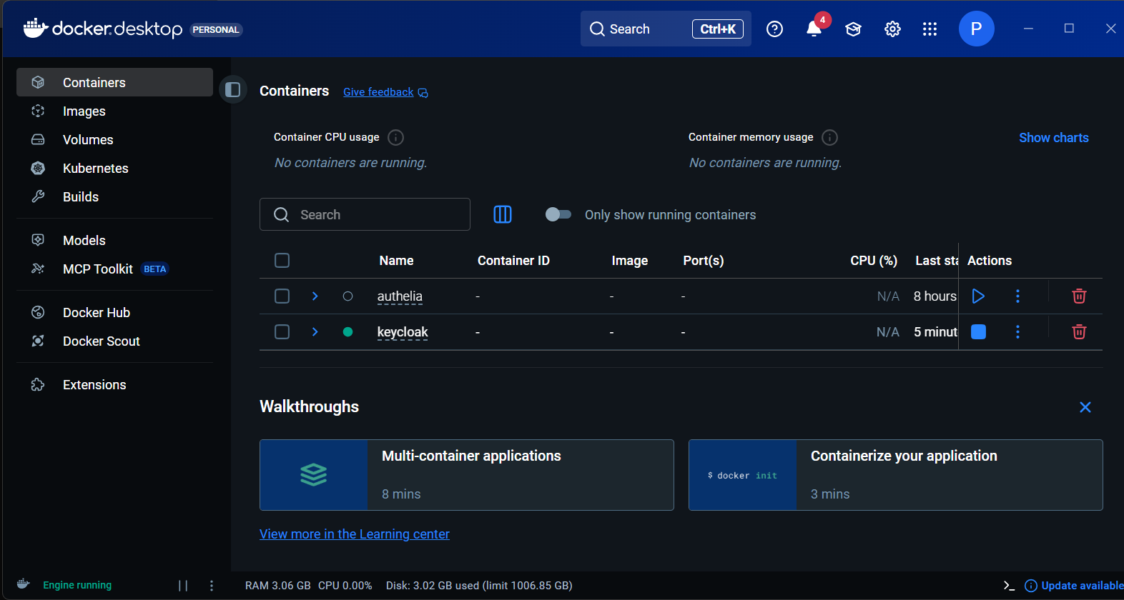
Figure 11. Docker Desktop showing the Keycloak container running.
The container view confirms that the Keycloak service was started from Docker and is available for IAM configuration work.

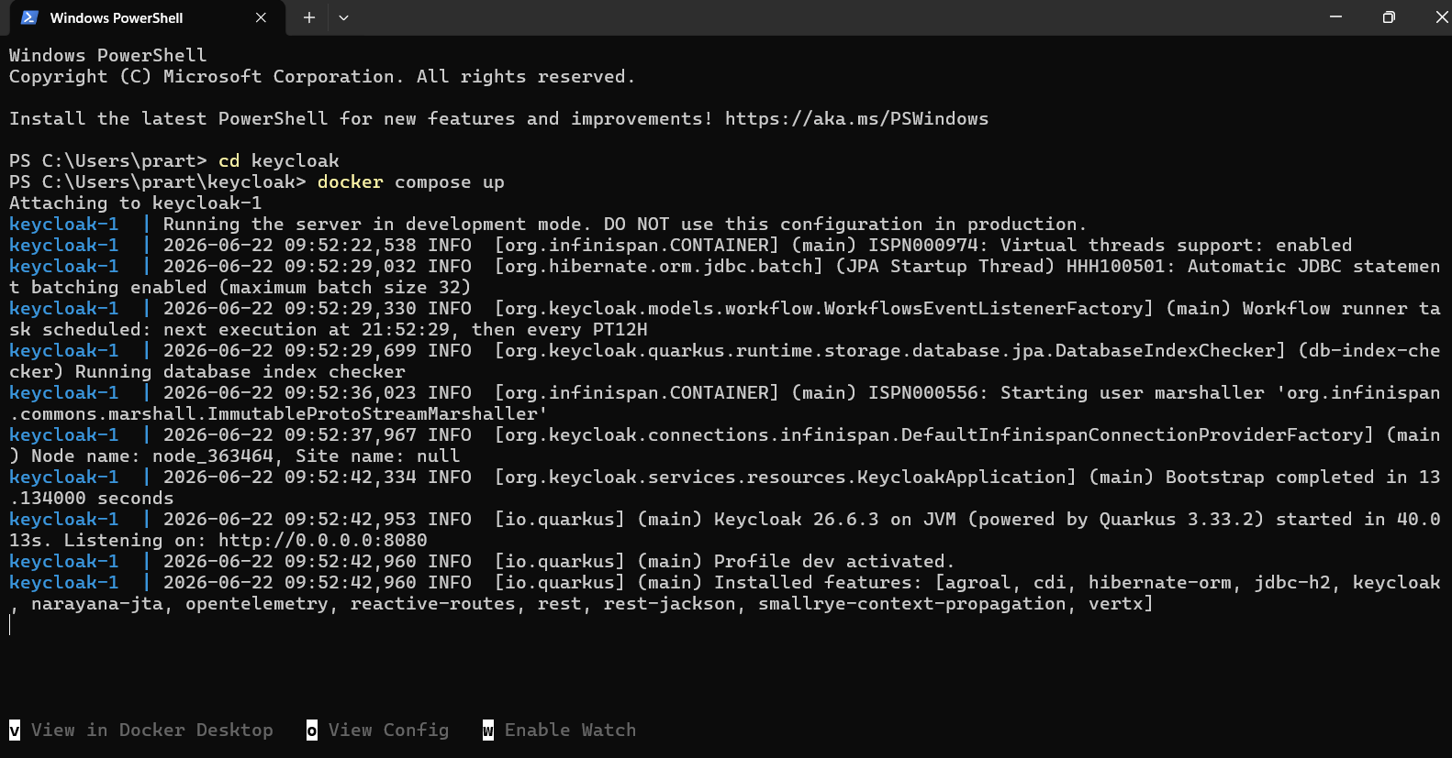
Figure 12. PowerShell docker compose startup logs for Keycloak.
The logs show Keycloak bootstrap and startup activity, including the service listening on port 8080.

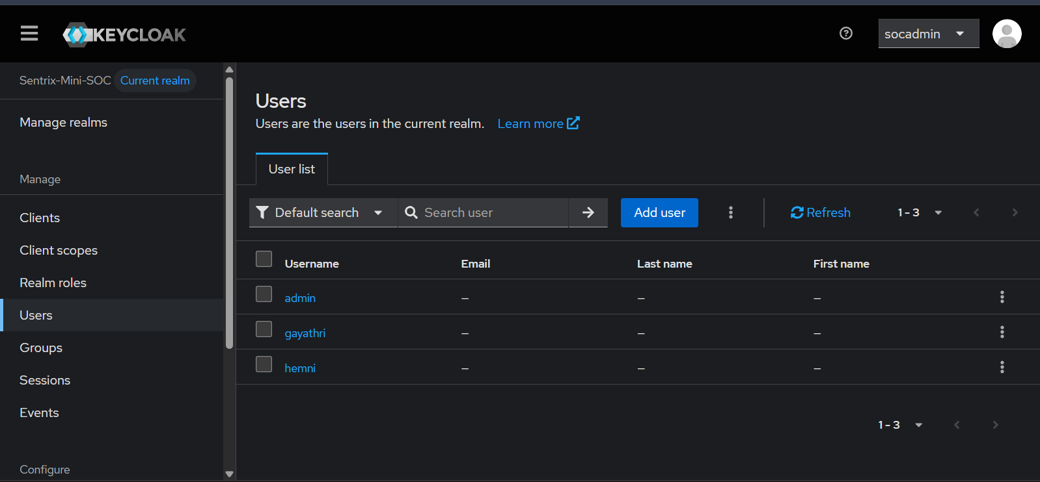
Figure 13. Keycloak user list in the Sentrix-Mini-SOC realm.
Users shown include admin, gayathri, and heman. This is enough for basic role-based demo accounts.

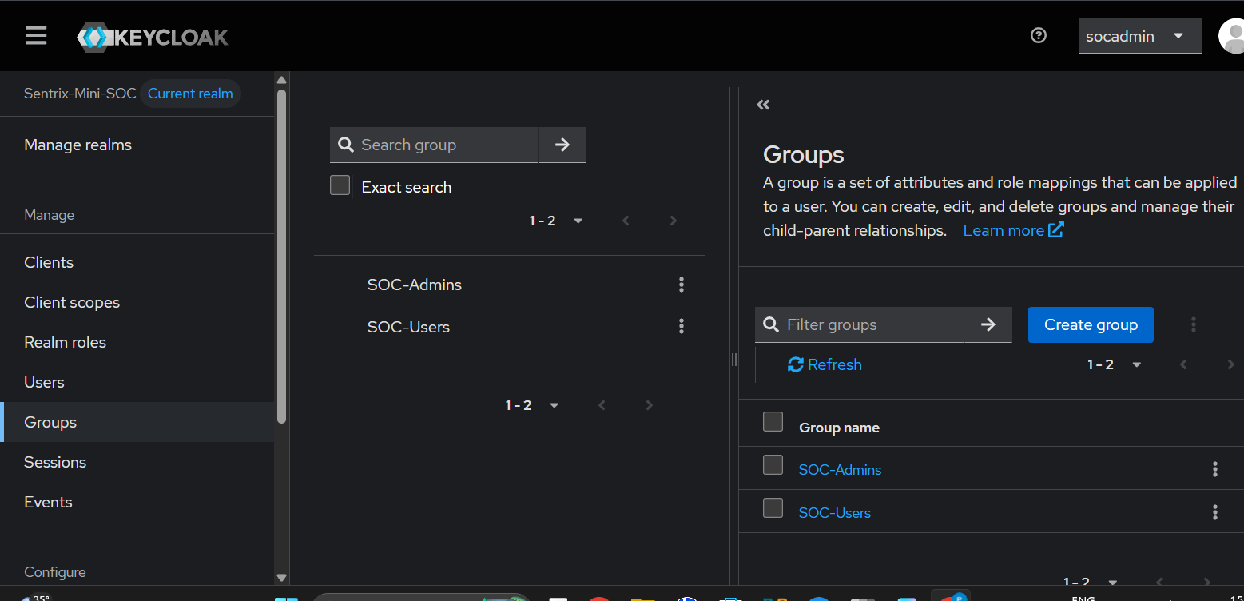
Figure 14. Keycloak groups SOC-Admins and SOC-Users.
Groups are defined, which is the right structure for assigning permissions consistently instead of manually per user.

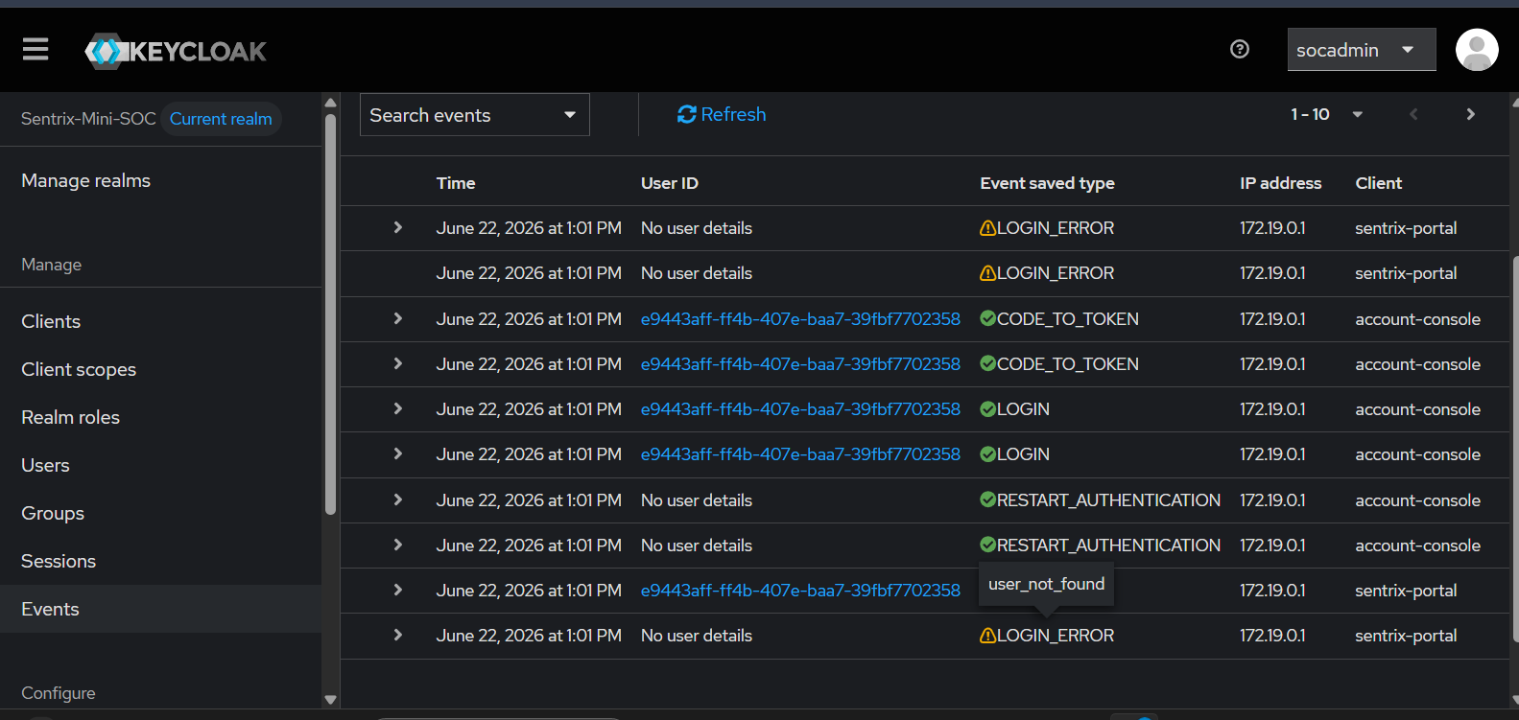
Figure 15. Keycloak events page showing login, token, restart-authentication, user-not-found, and login-error events.
This is important for SIEM integration: authentication success and failure events exist and can be shipped to Wazuh.

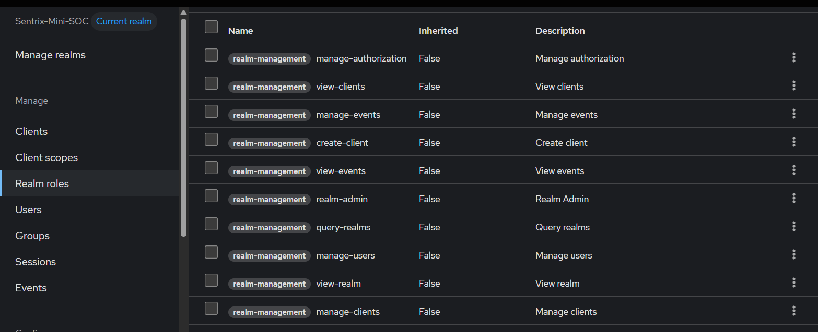
Figure 16. Admin role list under realm-management.
Roles such as manage-events, manage-users, view-realm, and manage-clients are visible. These should be restricted to admin users only.

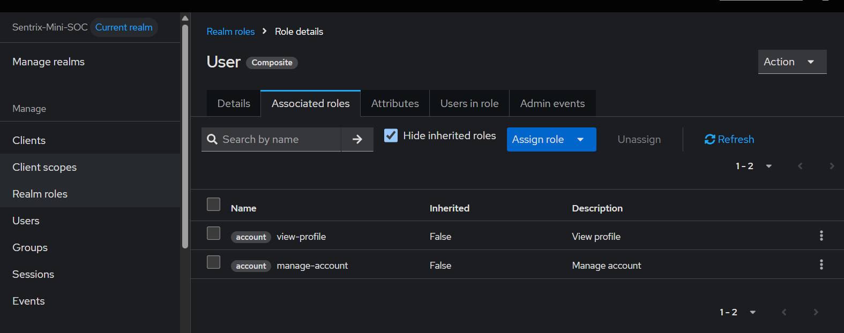
Figure 17. User role assignments for account view-profile and manage-account.
Basic user-level roles are present. This supports a viewer/user separation from admin-level management roles.

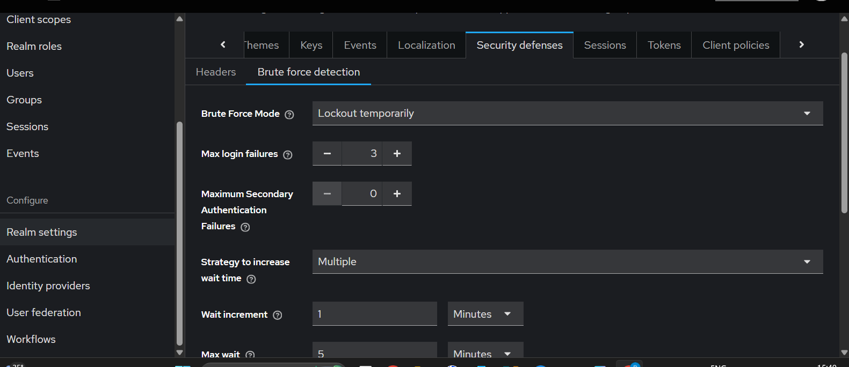
Figure 18. Brute-force detection settings: temporary lockout and max login failures set to 3.
This is the correct control for demonstrating IAM abuse detection. The setting directly supports the failed-login demo.

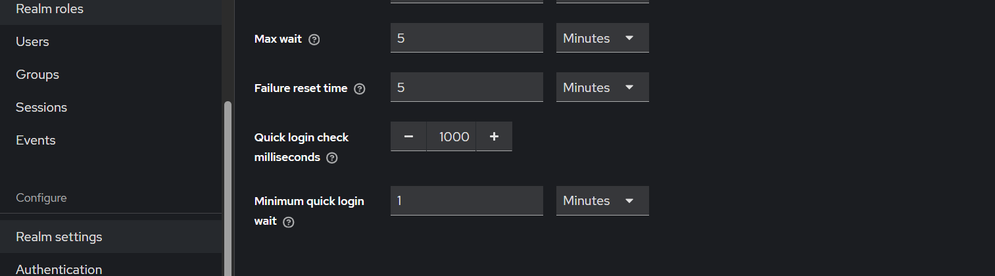
Figure 19. Additional brute-force timing settings.
Max wait/failure reset/quick-login controls are shown. These define how long the lockout behavior lasts and how quickly repeated attempts are treated.

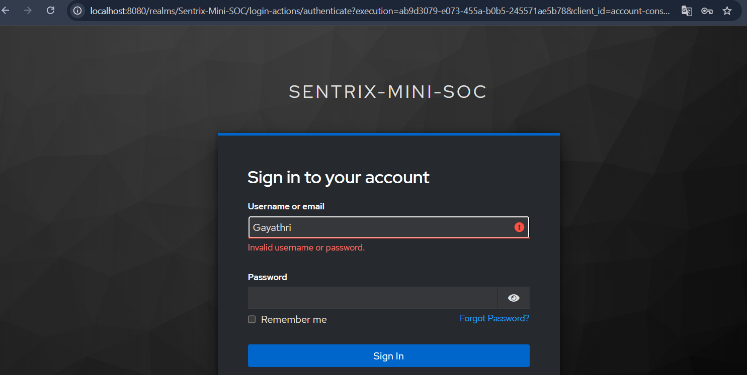
Figure 20. Failed login attempt on the Sentrix-Mini-SOC login page.
The login screen shows an invalid username/password condition, which is the input needed to trigger lockout events.

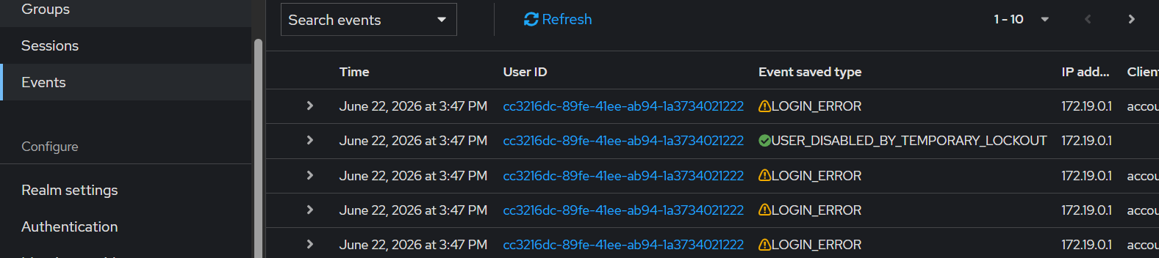
Figure 21. Keycloak event log showing USER_DISABLED_BY_TEMPORARY_LOCKOUT after repeated failures.
This is the strongest IAM evidence: failed logins produce a defensive action and an auditable event.

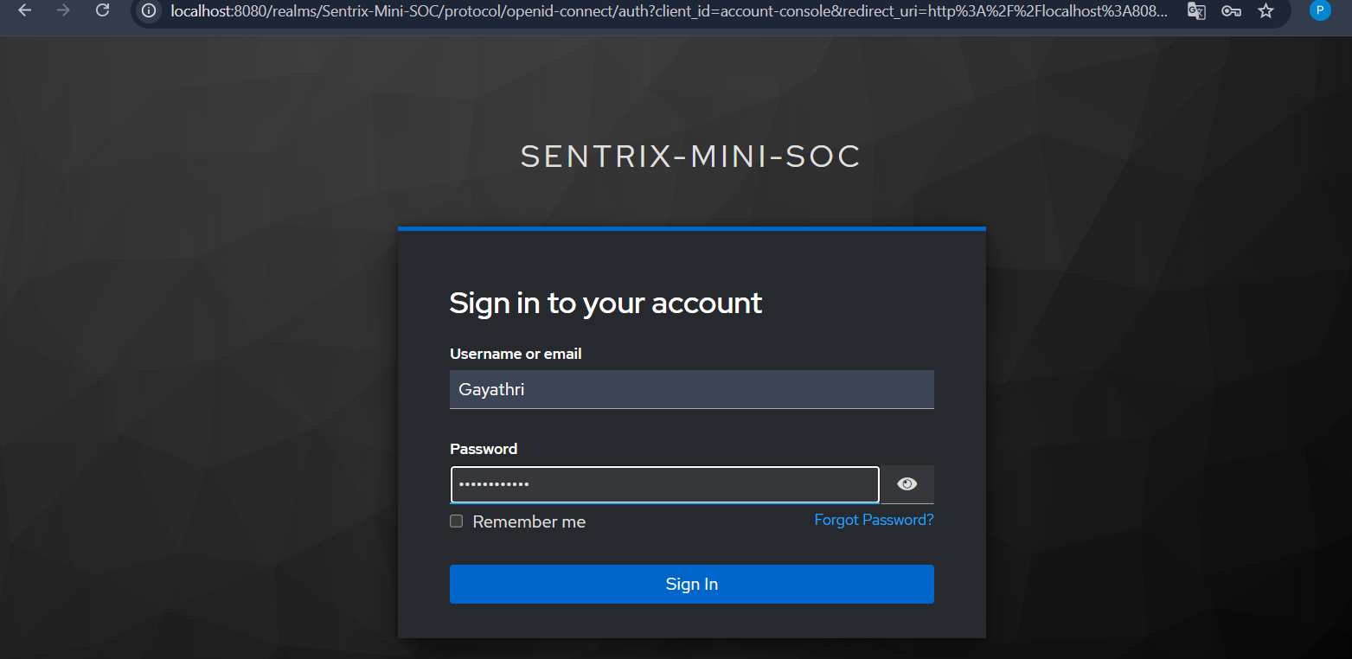
Figure 22. Successful Keycloak account-console login after authentication.
This proves the login flow works for a valid user.

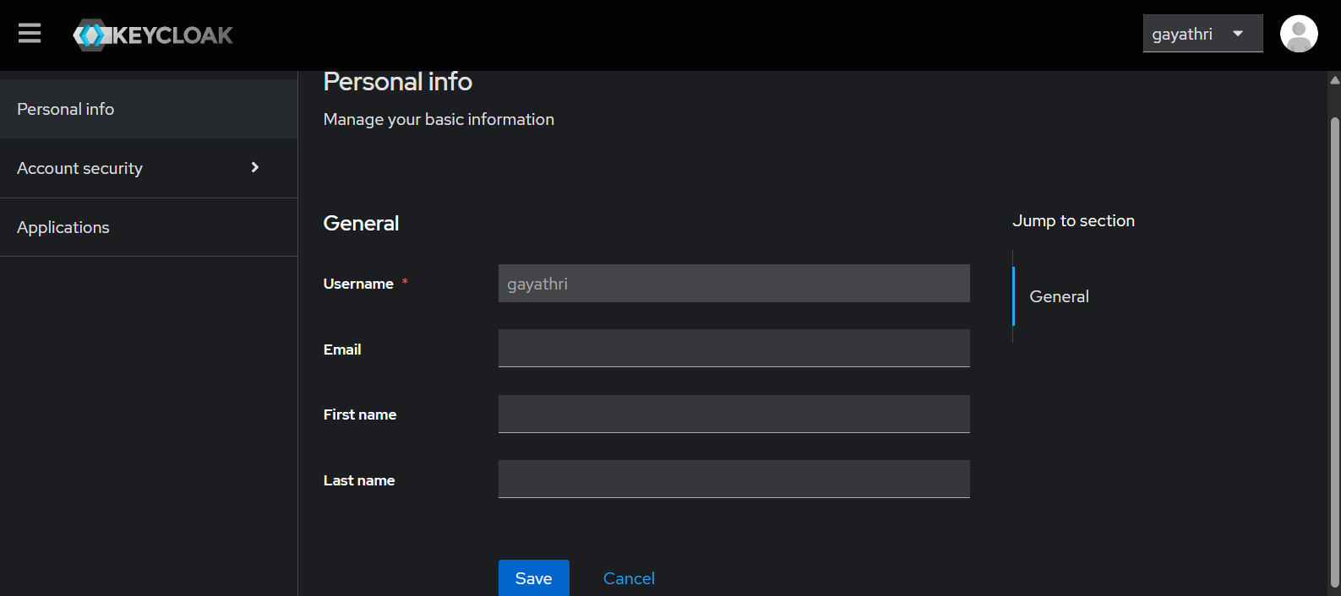
Figure 23. Keycloak account personal information page for user gayathri.
This proves access to the user account console after authentication.

IAM requirement | Progress | Remaining proof
Keycloak running | Container and startup logs are shown. | Keep docker compose ps / health evidence.
Users and groups | admin, gayathri, heman; SOC-Admins and SOC-Users. | Map users to groups in a visible screenshot if not already captured.
Role separation | Admin and account/user roles are visible. | Show one admin-only action denied for normal user, if possible.
Brute-force defense | Temporary lockout after 3 failures is shown. | Ship this event to Wazuh and show an IAM panel.
Dashboard protection | Not proven in images. | Put Keycloak in front of Wazuh/Kibana or clearly show protected service redirect and access control.

8. SOAR and Agentic AI Layer
The Day 2 framework correctly treats the agentic AI layer as future scope on top of a basic SOAR playbook, not as a replacement for the core demo. The safe build order is: Wazuh alert -> Shuffle notification first, then analyst-agent reasoning, then validated remediation only if time remains.
Tier | Target | Status for Day 2 | Judge-safe wording
Must have | Wazuh alert -> Shuffle -> Discord/Email/Slack notification. | Planned, not evidenced live. | “Our next integration step is an alert notification playbook.”
Nice to have | Claude-style alert analysis with human approval. | Architecture only. | “We designed the analyst layer but are keeping human approval.”
Stretch | Two-agent decide/validate/execute pipeline with TheHive case creation. | Future scope. | “This is the roadmap, not a live claim unless implemented.”
Do not overclaim SOAR/AI
A notification playbook that reliably fires is worth more than a fancy AI story that fails on stage. Build the fallback first. The two-agent design is good architecture, but it is not Day 2 proof unless the webhook and action are live.

9. Day 2 Completion Status
Success tier | Required items | Evidence present | Verdict
Bronze | Suricata alerts visible in Wazuh; WAF alerts visible in Wazuh; dashboard functioning. | Dashboard and Suricata are shown. WAF alerts in Wazuh are not shown. | Almost Bronze, missing WAF-to-Wazuh proof.
Silver | Nmap, Hydra, SQLMap visible; WAF blocks confirmed; Suricata detects confirmed; Wazuh displays it. | Nmap and Suricata visible; SQLMap attempted but failed routing; Hydra and WAF block missing. | Partial Silver.
Gold | Silver plus Shuffle automated action and Keycloak/Authelia enforcing dashboard access. | Keycloak setup is shown; enforcement and Shuffle action are not shown. | Not Gold yet.

10. Immediate Next Actions
- Fix the SQLMap target path. Use a URL that Kali can actually reach, preferably through the WAF path when proving WAF behavior.
- Capture one clean WAF block proof: request, HTTP response/block, ModSecurity audit.log, then Wazuh dashboard ingestion.
- Capture Hydra evidence separately or stop claiming Hydra as complete. Judges will ask for proof.
- Enable or troubleshoot Wazuh SCA scans because the dashboard explicitly says no SCA scans are present.
- Ship Keycloak login and lockout events into Wazuh as a separate IAM source. The Keycloak event screenshot is good, but SIEM correlation is the point.
- Create one Shuffle notification playbook before attempting any AI/autonomous response layer.
- Prepare a single fixed demo script with exact IPs, commands, expected alerts, and fallback screenshots.

Appendix A - Source Artifacts Reviewed
- day2-config-and-roles (3).md - Day 2 network layout, verification sequence, team roles, success tiers, and SOAR/AI plan.
- keycloak DAY2.docx - Keycloak deployment, users, groups, roles, brute-force defense, login failure, lockout, and account-console evidence.
- Wazuh endpoint summary screenshot - agent activity, MITRE, compliance, vulnerability and SCA status.
- IDS dashboard screenshot - alert volume, attack type distribution, severity, and top source IP.
- Nginx proxy.conf screenshot - reverse proxy to DVWA.
- Suricata fast.log screenshots - TCP SYN, SSH traffic, brute-force attempt and scan events.
- Kali terminal screenshots - Nmap enumeration and SQLMap attempt.
- DVWA command execution screenshot - application functionality proof.
- Five-laptop SOC LAN architecture image - high-level system design.

