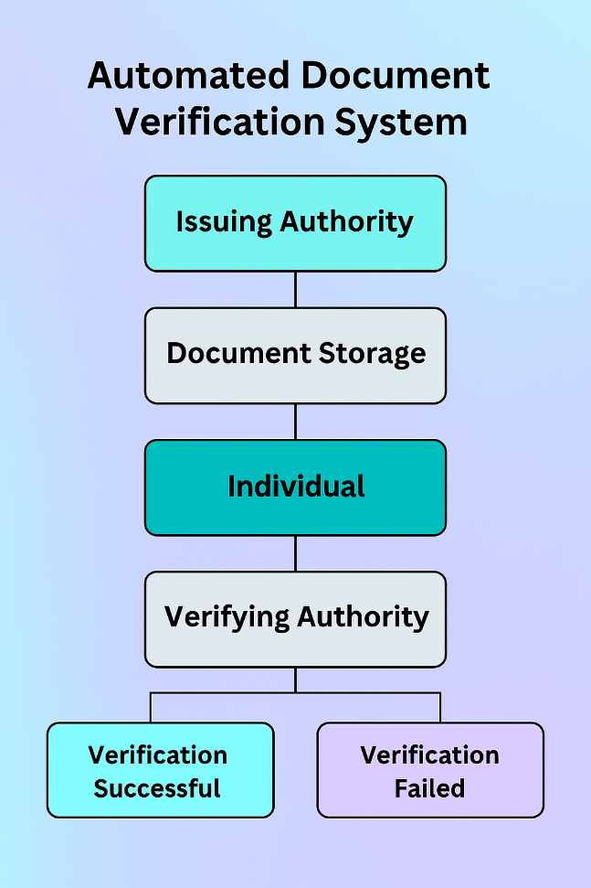

**Applications:**

**Automate Document Verification:**

Minimize human effort through the use of AI and OCR for real-time document authentication.

**Enhance Security & Fraud Detection:**

Identify forged or tampered documents through machine learning algorithms and cryptographic hashing

**Ensure Data Integrity with Blockchain:**

Employ Hyperledger Fabric to maintain document hashes, making verification tamper-proof and unalterable.

**Improve Efficiency & Accuracy:**

Reduce verification errors and return quick, precise results with less human intervention.

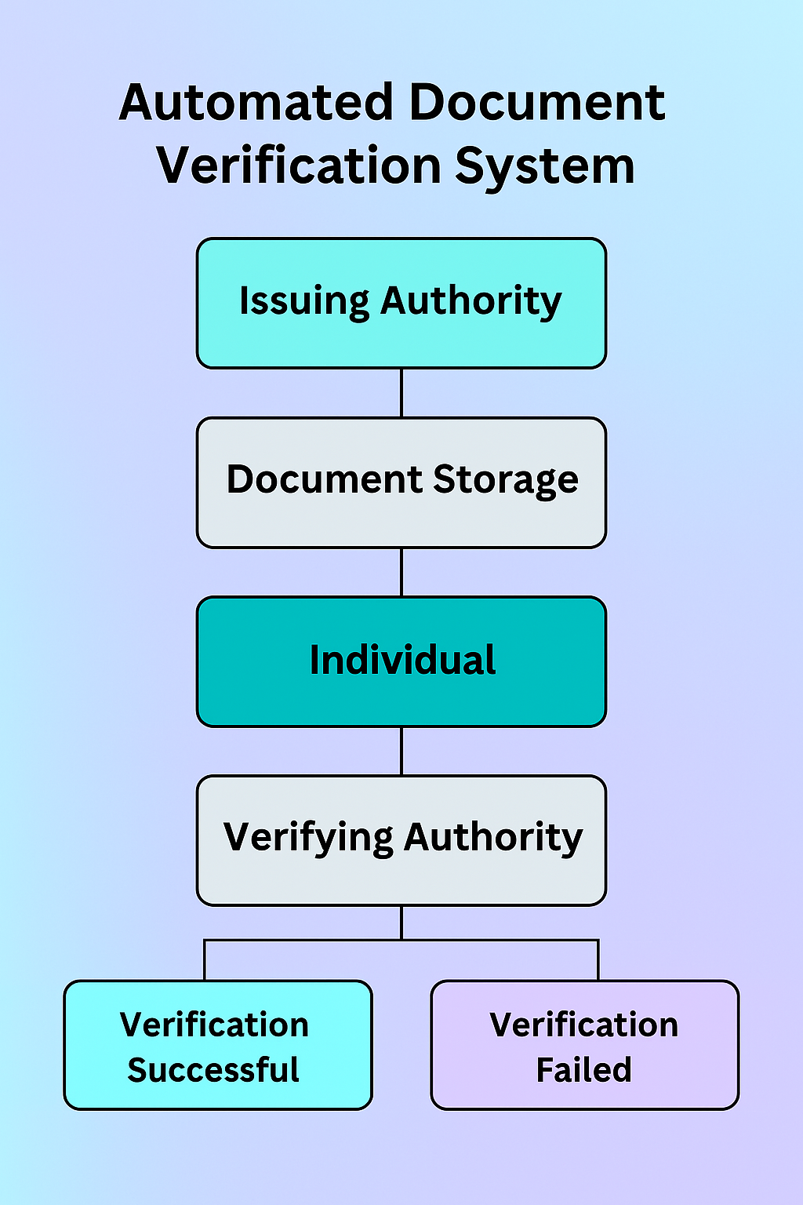

**Abstract:**

The Automated Document Verification System is a React-based web app that simulates secure document handling using blockchain-like storage. It includes three modules: Issuing Authority, Verifying Authority, and Individual Portal. Documents are uploaded, stored, and verified using local storage to mimic blockchain integrity. Users receive instant verification results based on document authenticity.

**Students Names:**

Ashwini S

Ayisha Tarannum

Chandana M

Kunuthuru Deepika

**Title of The Project:**

Comprehensive Automated Document Verification System for Official Documentation.