Factorial of a no

echo "enter the no :"
read n
fact=1
for (( i=1;i<=n;i++ ))
do
fact=$(( $fact * $i ))
done
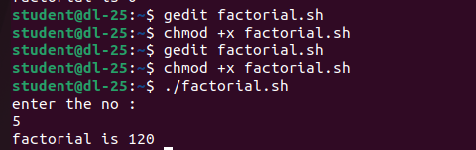
echo "factorial is $fact"

