palindrome

echo "enter the num :"
read n
reverse=0
temp=$n
while [ $temp -gt 0 ]
do
digit=$(( $temp%10 ))
reverse=$(( ($reverse*10)+$digit ))
temp=$(($temp/10))
done
if [ $n -eq $reverse ]
then
echo " the num is palindrom."
else
echo "the num is not a palindrom."
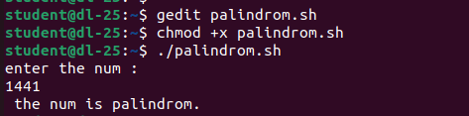
fi

