|  |  |  |  |  |
| --- | --- | --- | --- | --- |
| Lab [##] Assignment | |  | | --- | | ID | | Name | | Date | |

1. algorithm:

Obtain the card number entered by the user through Scanner, with a range limited to 1 to 52.

Convert the input card number to the corresponding playing card name using the getCardName method.

In the getCardName method, use the arrays suits and values to store the names of decor and points.

Based on the input card number, calculate the index of its corresponding color and number of points, and then use the index to obtain the corresponding name from the array.

Combine the suit and point names into a complete playing card name

1. code illustration

import java.util.Scanner;

public class CardDeck {

public static void main(String[] args) {

Scanner scanner = new Scanner(System.in);

for (int i = 0; i < 5; i++) {

System.out.print("Enter Card Number(1-52): ");

int cardNumber = scanner.nextInt();

if (cardNumber < 1 || cardNumber > 52){

System.out.println("Illegal card number");

continue;

}

String card = getCardName(cardNumber);

System.out.println("The card you picked is " + card);

}

}

public static String getCardName(int cardNumber) {

String[] suits = {"Clubs", "Diamonds", "Hearts", "Spades"};

String[] values = {

"Ace", "2", "3", "4", "5", "6", "7", "8", "9", "10",

"Jack", "Queen", "King"

};

int suitIndex = (cardNumber - 1) / 13;

int valueIndex = (cardNumber - 1) % 13;

return values[valueIndex] + " of " + suits[suitIndex];

}

}

In the main method, obtain the card number entered by the user through Scanner, and then call the getCardName method to obtain the corresponding card name and print it out.

The getCardName method uses arrays of suits and values to store the names of flowers and points.

In the getCardName method, calculate the index of the corresponding color and number of points based on the input card number, and then use the index to obtain the corresponding name from the array.

Finally, concatenate the suit and point names into a complete playing card name and return it to the caller

1. runresult

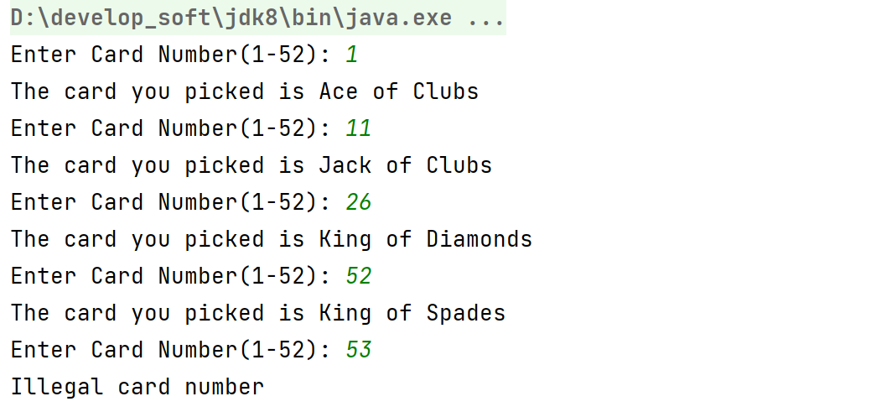

1. test cases

Input: 1

The card you picked is Ace of Clubs

Input: 11

The card you picked is Ace of Clubs

Input: 26

The card you picked is King of Diamonds

Input: 52

The card you picked is King of Spades

Input: 53

Illegal card number

Input: 0

Illegal card number