I created a min-heap to hold the data sets. Initially, I structured the heap with sequence as the key and data as the value, using a standard array representation to insert nodes and keep the structure as a min-heap. I implemented a standard DFS to traverse the entire heap and find the requested word. This was the most straightforward way to meet all functional requirements: reading the data set, implementing a heap data structure, and using a DFS algorithm for retrieval. After that, to minimize search time, I changed the heap to use the data string as the sorting key instead of the sequence. I updated the DFS algorithm to prune branches: since a min-heap guarantees that children are lexicographically greater than or equal to their parent, any time the current node's value is lexicographically greater than the target word, the algorithm halts traversal down that subtree. Without this change, DFS in a heap ordered by sequence operates in O(n) time regardless of the term being searched. By ordering the heap by the search term and pruning the DFS, the average search space is reduced, optimizing performance.
The solution met the requirements of the assignment: using a heap, using a DFS, reading the file, and displaying the following: records searched, labeled data fields, and not found indicators. The DFS pruning got me as much performance out of this combination of algorithms and data structures as I could without breaking the assignment guidleines. Any more optemizations are architectural rather than micro optemizations would just be going outside the assignment which would be unhelpful. Even rewriting in a faster language would be less optimal than using the correct data structure and algorithm. Time, complexity, and stability played a role in my decision making. The code remains simple, stable, and readable. Efficiency I kept in mind as much as I could with things like pruning, but ultimately, to meet the requirements, it could not be a practical focus.
The recursive DFS is simple to implement and maps to an array binary heap structure. The branch pruning skips superfluous traversals when the search word is lexicographically smaller than the current node. Satisfying both "use a heap and DFS" while also "optimizing to minimize search time" was inherently contradictory and therefore a difficult requirement to meet. Heaps are designed for priority queue operations like finding the minimum and maximum element quickly in O(1) time, not for searching arbitrary elements. DFS on a heap is fairly inefficient compared to other search methods. The algorithm does not scale perfectly with input size for worst case scenarios. If searching for a word that is lexicographically very large (e.g., "zzzzzz"), the pruning rarely, if ever, triggers, and the DFS degrades into an O(N) linear scan, searching every node in the heap. The chosen algorithm and data structure are fundamentally not appropriate for optimizing search performance. A heap provides no robust ordering guarantee for arbitrary searches, rendering DFS highly inefficient. The algorithm would absolutely benefit from a different data structure. If the goal is rapid searching, a Hash Table or a Binary Search Tree would be far more appropriate than a Heap.
I would recommend replacing the current algorithm with a hash table. The requirement to use a heap and DFS for an exact match search task is an anti-pattern. A hash table would solve the exact same problem in O(1) time regardless of the size of the data set, which would improve scalability, efficiency, and meeting the core objective of minimizing search time. Time complexity is O(n) in the worst case and O(n/2) on average. Space complexity is O(n) to store the array, plus O(log n) on the call stack for recursive DFS. The tradeoff is slightly higher memory overhead for hashing structures compared to a tightly packed array, and unordered iteration.
In my verification of this, I made the program so that it was able to take any of the data sets, read the data that has two pipe delimited fields with the integer sequence on the left and the single word, string data on the right of the pipe.
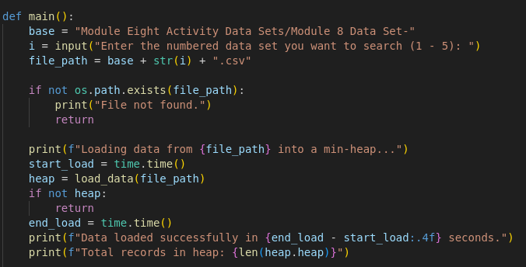
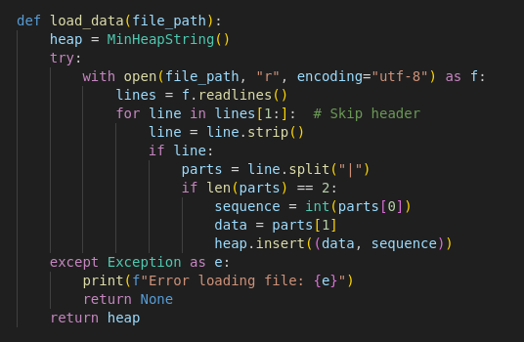
I verified that I could retrieve a specific record by letting the user enter a word to search for, executing the application with the provided word as a search criteria, and returning the completed search results. If the word was not found in the data set, the appropriate message would be returned, letting the user know that no such word was in the data set. In my main
function, I take the input from the user of what data set they want to search out of the 5 provided and then the user is in a while True loop. They can then enter the word to search for or “quit” to exit the program. I went through that process by hand, doing manual testing to verify correct behavior.
When a record is successfully retrieved, the integer sequence is hidden so that only the data field is shown. This data field is labeled in the output. The application also provides an exact count of how many records were traversed, indicated by the "Records searched:" line for both successful and unsuccessful searches.

