**LAB 2: CAT5 ETHERNET CABLE SETUP**

**OBJECTIVE**

* To setup Cat5 Cable Using RJ45 connectors

**THEORY**

**Cat5:** Cat5 cable is a type of twisted pair cable used for Ethernet networking. It consists of four pairs of copper wires, each color-coded and twisted to reduce interference. Cat5 cables transmit data at speeds up to 100 Mbps over short to medium distances, connecting devices within a LAN. They terminate with RJ45 connectors, ensuring proper connectivity. Proper installation practices, such as avoiding bends and kinks, ensure optimal performance. Overall, Cat5 cable is cost-effective and suitable for many home and small business networking needs.

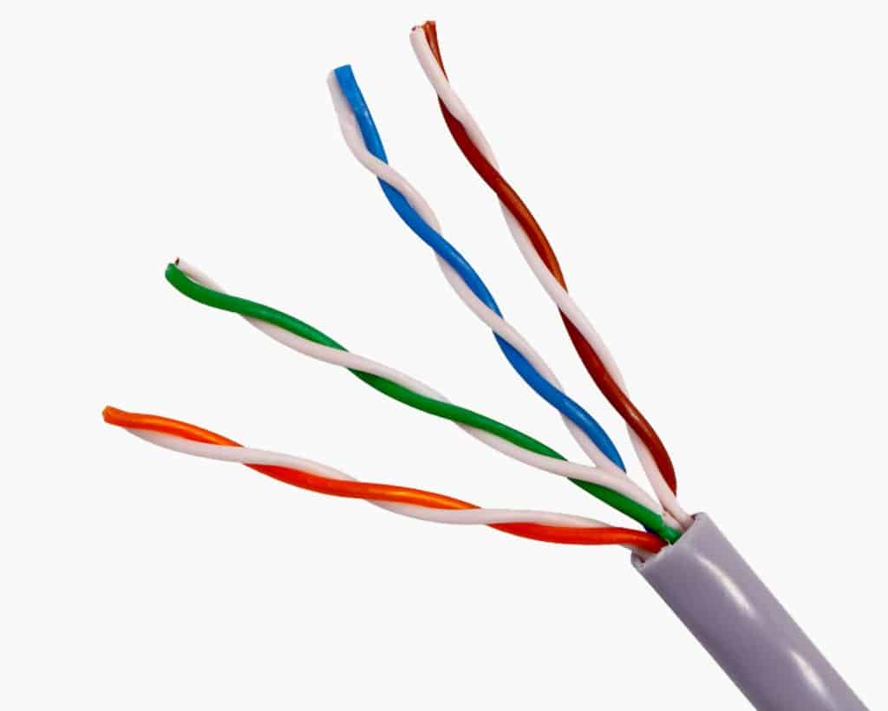

Figure 1: Cat5 Cable

**RJ45:** RJ45 connectors are commonly used in networking to terminate Ethernet cables. They have eight pins arranged in a modular plug, allowing them to securely connect to Ethernet ports on devices. RJ45 connectors ensure reliable data transmission by properly terminating twisted pair cables like Cat5. They are crucial for establishing connectivity in LAN environments. Proper installation of RJ45 connectors involves correctly aligning and crimping the cable, ensuring each wire contacts its corresponding pin.

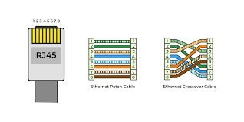

Figure 2: RJ45 Connectors

**Setup Up for Cat5 Ethernet Cable Using RJ45 Connectors**

**Requirements:**

* Cat5 Ethernet cable
* RJ45 connectors
* Crimping tool
* Cable tester

**Color Combination**

* **T568A (Ethernet Patch Cable):** Wires are arranged with the color code:

white-green, green, white-orange, blue, white-blue, orange, white-brown, brown.

* **T568B (Ethernet Crossover Cable):** Wires are arranged with the color code:

white-orange, orange, white-green, blue, white-blue, green, white-brown, brown.

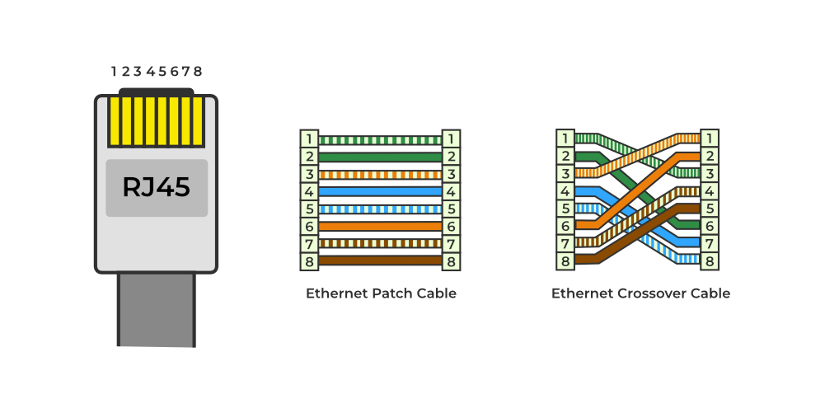

Figure 3: T568A vs T568B

**Steps:**

**Step 1: Measure and Cut the Cable**

* Measure the required length of Cat5 cable, adding a bit of extra length for flexibility.
* Use wire cutters to carefully cut the cable to the desired length.

**Step 2: Strip the Cable Jacket**

* Use a wire stripper to remove about 1-2 inches of the outer jacket from each end of the cable.
* Be careful not to nick or damage the inner wires.

**Step 3: Untwist and Arrange the Wires**

* Untwist the pairs of wires and arrange them according to the T568A or T568B wiring standard.
* The color order should be consistent at both ends of the cable.

**Step 4: Flatten the Wire Before Cutting**

* Lay the Cat5 cable flat on a smooth surface, such as a table or floor.
* Use your hand to gently flatten the cable along its length, ensuring it's straight and free of twists.
* This step helps prevent accidental kinks or bends in the cable during cutting.
* Measure the required length of the Cat5 cable, ensuring it's flattened and straightened.
* Use wire cutters to carefully cut the cable to the desired length.

**Step 5: Insert the Wires into the RJ45 Connector**

* Slide the wires into the RJ45 connector in the correct order, ensuring each wire reaches the end of the connector.

**Step 6: Crimp the Connector**

* Use a crimping tool to securely crimp the RJ45 connector onto the cable, ensuring a tight connection.

**Step 7: Repeat**

* Repeat all the above steps with the other end of the cable.

**Step 8: Test the Cable**

* Use a cable tester to verify that the cable is properly terminated and capable of transmitting data.
* Test both ends of the cable to ensure connectivity.

**CONCLUSION**

From this lab session, we learned how to set up a Cat5 Ethernet cable using RJ-45 connectors. By following proper steps, we successfully completed the setup and tested it, ensuring its functionality.