**Lab 4**

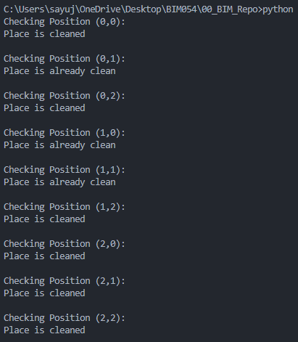

**Lab 5**

