**LAB 6**

1. **Prolog Queries**

**List Operations**

1. Membership check

1. Length



1. Concatenation/Insertion



1. Deletion



1. Append



**Factorial, Fibonacci Series, Tower of Hanoi**

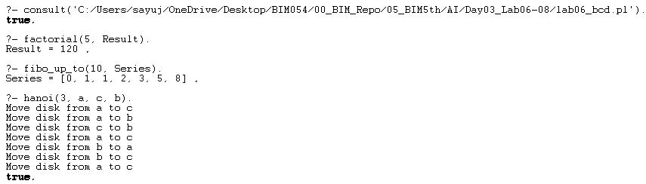

**Lab 7**

**Lab 8**

