**Lab 9**

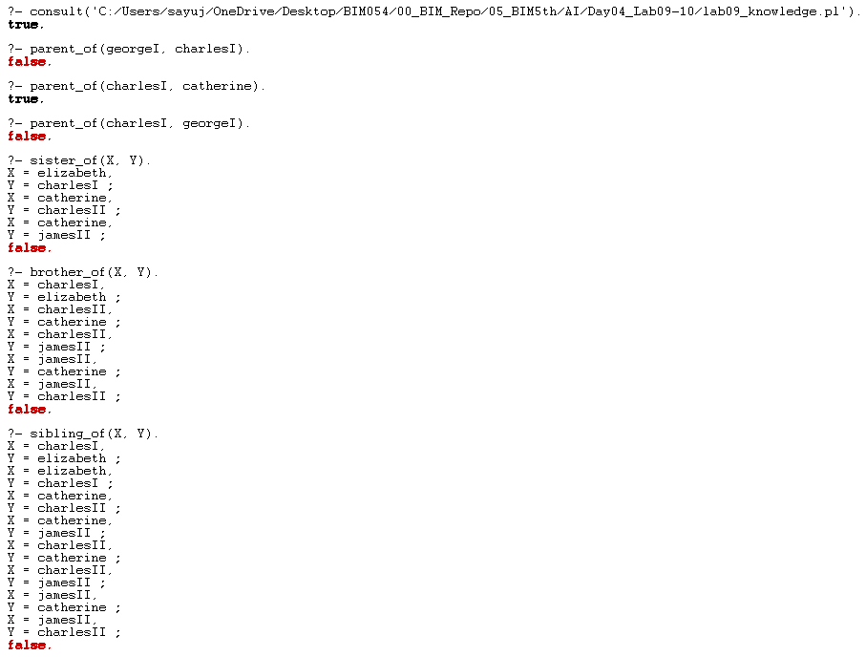

**Lab 10**

