1. **Installing Python**

We installed python from the official website python.org and added it to the system PATH during installation.



1. **Installing MSSQL and Setting up a new database**

SQL Server Express Edition was downloaded from Microsoft, and a database named BusinessInformationSystem was created.

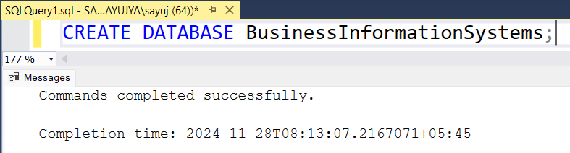

1. **Testing Important Libraries in Python**

Python libraries, numpy and math was imported and tested.

**Code:**

import numpy as np

import math

a = 16

randomArray = np.random.randint(10, size=5)

print(math.sqrt(a))

print(randomArray)

**Output:**

