

**Module 24**

**Notes:**

**Module Issues:**

**Quizes:**

Daniel Wallace:

<https://github.com/useradmn/BerkeleyAIML-Capstone>

Manish:

<https://github.com/manish237/AIMLCapstone>

Professional Certificate Berkeley, School of Engineering  Berkeley, Haas School of Business UNIVERSITY OF CALIFORNIA, BERKELEY

BerkeleyHaas-AIML-Capstone

Add feature importance: (21.1)

# permutation importance

# function to execute permutation importance!

def column_importance():

# fit model with training set

print('model r^2 :', voter2.score(X_test, y_test))

# permutation importance

r = permutation_importance(voter2, X_test, y_test, n_repeats = 50, random_state = 93)

print('importance:', r.importances_mean)

return pd.DataFrame({"Column":X.columns, "Importance":r.importances_mean}).sort_values(

by = "Importance", ascending = False)

%%time

fi = column_importance()

fi

fi.plot.barh(figsize=(9, 7))

plt.title('Feature Importance')

plt.xlabel('Importance Mean')

plt.axvline(x=0, color='.5')

#plt.subplots_adjust(left=0.3)

#plt.yticks(ticks=fi.index, labels=fi['Column'])

plt.yticks(ticks=fi.reset_index().sort_values(by='index')['Column'].index,

labels=fi.reset_index().sort_values(by='index')['Column'])

plt.show()

Dataset #1:

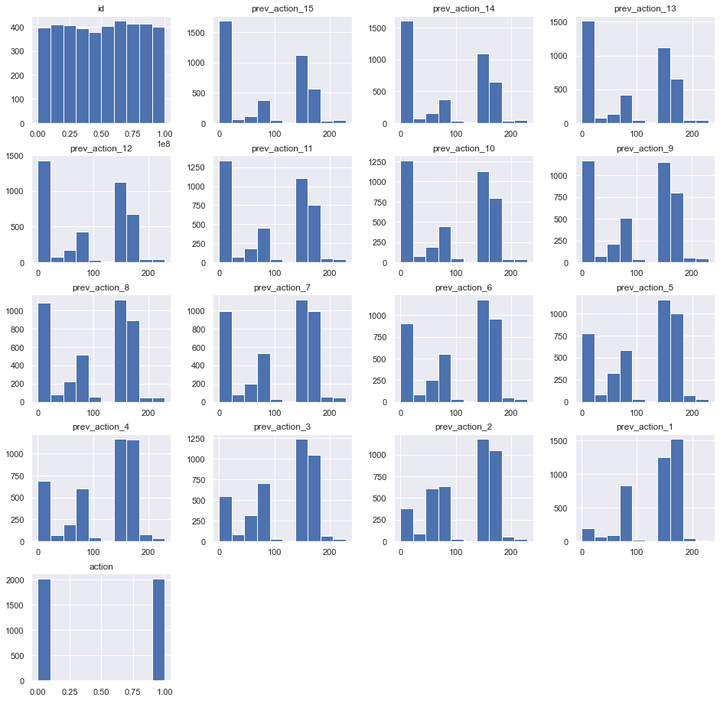

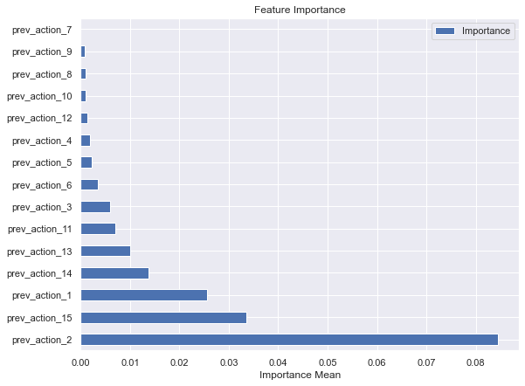

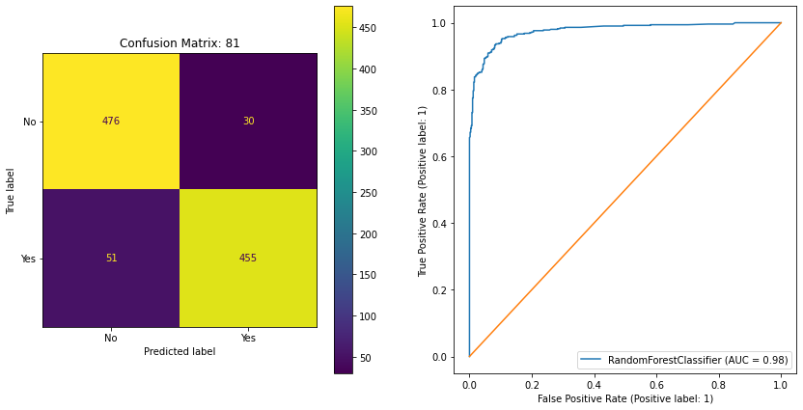

Dataset #2:

