**ÇANKAYA UNIVERSITY**

**FACULTY OF ENGINEERING**

**COMPUTER ENGINEERING DEPARMENT**

**CENG 407**

**SOFTWARE DESIGN DOCUMENT**

**(SDD)**

DETECTION OF OBSTRUCTIONS IN THE VESSELS IN FUNDUS IMAGES

By

201311018 - AYKUT ER

201411045 - EGEBERK ÖZBERK

Fall, 2017-2018

**Table of Contents**

**LIST OF FIGURES** **3**

**LIST OF TABLES** **3**

**1. INTRODUCTION** **4**

1.1 Purpose 4

1.2 Scope 4

1.3 Glossary 4

1.4 Overview of the Document 5

1.5 Motivation 5

**2. DESIGN OVERVIEW 5**

2.1 Description of Problem 5

2.2 Technologies Used 5

2.3 Architecture Design 5

2.3.1 Simulation Design Approach 5

2.3.1.1 Class Diagram5

2.3.2 Architecture Design of Obstruction Detection System 6

2.3.2.1 Options Menu6

2.3.2.2 Find Congestion7

2.4 System Operation 7

**3. USE CASE REALIZATIONS 8**

3.1 Obstruction Detection System Project 8

3.1.1 Brief Description of Figure 3.1.1 9

3.1.1.1 GUI Design9

3.1.1.2 Image Processing9

3.2 User Interface 9

3.2.1 Overview of User Interface 9

3.2.1.1 Main Menu Layout9

3.2.1.2 Upload Image Button10

3.2.1.3 Find Congestion Button11

3.2.1.4 Customize Markings Button12

3.2.1.5 Save Results Button14

**4. REFERENCES 16**

**List of Figures**

Figure 2.3.1 Class Diagram of Obstruction Detection System 6

Figure 3.1.1 Project Components of Obstruction Detection System8

Figure 3.2.1 Main Menu Layout System10

Figure 3.2.2 Upload Image Button11

Figure 3.2.3 Find Congestion Button12

Figure 3.2.4 Change Shape Button13

Figure 3.2.5 Change Color Button14

Figure 3.2.6 Save Results Button15

Figure 3.2.7 Results Folder15

**List of Tables**

Table 1.3.1 Glossary of SDD 4

**1. INTRODUCTION**

This document provides detailed information about the design of the obstructions detection system software. It will explain the working principles of the proposed method, and design of the user interface of this method. This document prepared to guide to users.

**1.1 Purpose**

The purpose of this document is providing the details of the proposed project "*Detection of obstruction in the vessels in fundus images*".

Fundus images (aka eye angiogram images) are the photographs that have been taken by fundus cameras after injecting a chemical called fluorescein inside patient's veins to provide better visuality by enhancing brightness of the vessels. Even with the latest technology is used to take angiographic photographs, the amount of human error and lack of precision is considerable while trying diagnosing the disease.

Our goal is to show the obstructions in vessels visible in the fundus images to the doctor who uses the software better than he/she can see himself/herself. The software to be developed will also be able to interpret the image to the user with the help of pre-prepared diagnostic estimates gathered from doctors who are our project partners.

**1.2 Scope**

During the work hours, considering the frequency of patient arrivals is excessive, a doctor has a very short period to commentate every single image brought in front of him/her. Main aim here in this project is to reduce the time spent on diagnosis to almost an instant.

The main motivation for the ophthalmologist to use this software is to allow the software to interpret the image much more quickly with immense accuracy and precision to reduce the time spent on a single patient so that the doctor can deal with more patients in the same time.

Image processing algorithms and methods that software needs will be implemented by using Matlab and the software itself will be developed using C#.

**1.3 Glossary**

|  |  |
| --- | --- |
| Term | Definition |
| Fundus Image | Fundus photographs are visual records which document the current ophthalmoscopic appearance of a patient's retina [1]. |
| Fluorescein | Chemical used for enhancing the brightness of the vessels. |
| Ophthalmologist | Doctor who specialized in eye and sight care. |
| SDD | Software Design Document. |
| Obstruction | Congestion resulting eye strokes. |
| Block Diagram | The type of schema that the components of the system are displayed in blocks |
| Matlab | Program to calculate mathematical operations and functions. |

Table 1.3.1 Glossary of SDD

**1.4 Overview of the Document**

This section provides information about the contents of the rest of the document as follows: Section 2 describes the problem and details the design of this project along with the class architecture. Section 3 displays and explains the block diagram of the system, which is designed according to use cases in SRS document.

**1.5 Motivation**

We are a group of senior students in computer engineering department who are interested in image processing. As a group, in this project we aimed to help the doctors in the treatment of the patients. Since we do not have knowledge about medical science, we received help from an ophthalmologist working in this area and we read the documents about this topic to find out the diseases in the eye. In order to find out where the illnesses in the eye are, we have been working on image processing and we have searched how to use Matlab to develop the necessary processes for this topic.

**2. DESIGN OVERVIEW**

**2.1 Description of Problem**

The length of time that doctors are able to deal with a patient is significantly reduced in the early hours of the day, especially when the hospital is crowded with waiting patients. Due to lack of time for diagnosis, doctors often miss important details. The software mentioned in this SDD shortens the time required to diagnose single patient and even show more accurate results than a doctor by showing even slightest details about the possible disease.

**2.2 Technologies Used**

This software will communicate with Matlab to run its image processing functions. Software itself will be developed with C# language. Software also requires a fundus camera to obtain high quality retinal images for best performance.

The target platform will be Microsoft Windows and development environment will be Microsoft Visual Studio 2013. Functions and methods for processing fundus image will be implemented on Matlab 2016.

**2.3 Architecture Design**

**2.3.1 Simulation Design Approach**

**2.3.1.1 Class Diagram**

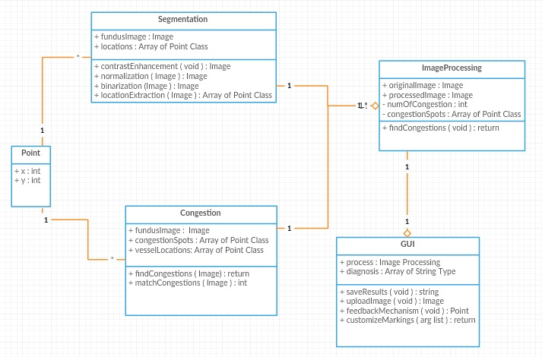Figure 2.3.1 Class Diagram of Obstruction Detection System

Figure 2.3.1 displays classes used in this system. GUI, master class here, is responsible of all main operations. It also runs main image processing operations segmentation and congestion detection. GUI class also generates a diagnosis for the processed image and creates a result file to be saved. The ImageProcessing class includes Segmentation and Congestion which are responsible for their individual image processing methods. Segmentation class runs first in order to give the location map of the vessels to the Congestion class. Congestion then processes the image with the vessel map and its congestion spot map to return processed image to the ImageProcessing class. Both Segmentation and Congestion classes will run their functions with the help of Matlab. Lastly, point class represents a single coordinate for the congestion spots.

**2.3.2 Architecture Design of Obstruction Detection System**

**2.3.2.1 Options Menu**

**Summary:** This system is used by participant. Participant can upload a new image file to the main screen, save the image and change marking shape and color.

**Actor:** User / doctor.

**Precondition:** Software system must be running.

**Basic Sequence:**

1. User can upload a new image file by selecting new image button.
2. User can save the image by selecting save button.
3. User can customize markings by selecting customize marking button.
4. User can customize color and shape of the marking by selecting shape or color button individually under customize marking button.

**Exception:** Save the image without any operations performed.

**Post Conditions:** None.

**Priority:** Medium

**2.3.2.2 Find Congestion**

**Summary:** This system is used by participant. Participant wants to see congestion spots in the fundus image.

**Actor:** User / doctor.

**Precondition:** Image must be uploaded.

**Basic Sequence:**

1. User pressed find congestions button.
2. System shows each congestion point.
3. Feedback mechanism starts running.
4. User can select each of the congestion point to give feedback.

**Exception:** No image has uploaded to perform operation.

**Post Conditions:** Feedback mechanism starts.

**Priority:** High.

**2.4 System Operation**

This system achieves its purpose by performing two major image processing operations when user clicks the find congestion button after uploading the patient’s fundus image. One operation is the blood vessel segmentation where system extracts vessel locations and other one is the congestion detection operation. Software performs these operations with using Matlab functions.

Segmentation part simply returns a vector of coordinates of the vessels to the find congestion function. After segmentation process is finished, congestion detection part creates another vector which consists of congestion spot coordinates. Then congestion detection eliminates false congestion spots by checking whether if congestion spot coordinate matches with the coordinates of the vessels and mark the actual congestion spots with desired marking shape or color.

After the completion of the image processing operations system will display the processed image with all congestion markings and process results to the user. User is now allowed to choose between either accept the given results or remove false markings with the feedback mechanism. After user gives his/her final feedbacks user can now save the results.

After user clicks save results button, system creates a package with user specified name (patient’s name expected) which consists of processed image file and a text file which includes number of markings, save date and estimated diagnosis recommended by the software.

**3. USE CASE REALIZATIONS**

**3.1 Obstruction Detection System Project**

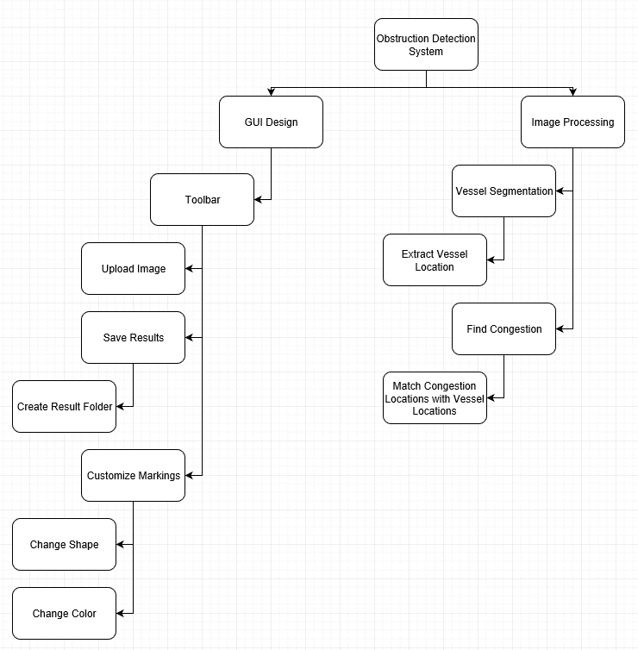

Figure 3.1.1 Project Components of Obstruction Detection System

**3.1.1 Brief Description of Figure 3.1.1**

Components of the Obstruction Detection System Project are shown in the Figure 3.1.1. All designed systems of the system are displayed in the block diagram in the figure. There are two main components of the system which have their own sub-systems.

**3.1.1.1 GUI Design**

GUI design is responsible for interaction between the actors and the system. There is one sub-system in this design which has Main Menu and Main Menu has its own subsystem called Toolbar and Toolbar has three subsystems which are Customize Markings, Upload Image, and Save Results which also has its own subsystem called Create Result Folder and also finally Customize Markings has its own subsystems which are change shape and change color.

Main Menu is a start page, participant can do various operations which are uploading a new image file to be processed, change markings and save the results after the congestion detection operation has done.

**3.1.1.2 Image Processing**

Image Processing is responsible for all sorts of main image operations and composed of two main parts which are segmentation part and congestion detection part. Vessel Segmentation has its own subsystem called Extract Vessel Location and Find Congestion has its own subsystem called Match Congestion Locations with Vessel Locations.

Vessel Segmentation simply returns a vector of coordinates of the vessels which will be used by congestion detection function. Find Congestion first finds all spots where possible congestion occurs then uses the vector returned from Vessel Segmentation to eliminate all congestion spots which are not inside of any blood vessel.

**3.2 User Interface**

In this section of the document, buttons and layout of the main menu is presented in below figures.

**3.2.1 Overview of User Interface**

**3.2.1.1 Main Menu Layout**

The main menu is the interface that the user of the software will see when opening the program. The user can access all the main operations through this user-friendly interface. The upper part of the interface contains basic operations. The middle pane contains the image with a button that will trigger the main action "Find Congestion". Finally, the bottom of the interface is responsible for showing the results to the user.

Main menu layout is shown below.

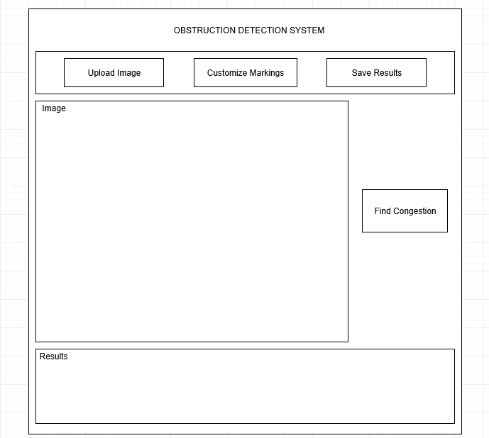

Figure 3.2.1 Main Menu Layout of the System

3.2.1.2 Upload Image Button

The upload image button allows the user to upload the fundus image. This operation will not be completed unless the image format is appropriate to the software.

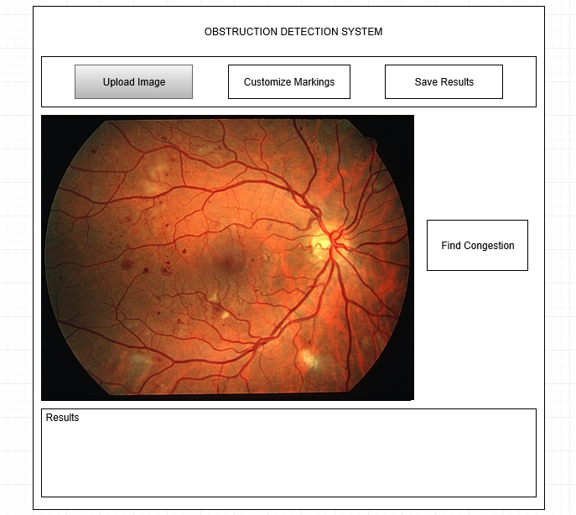

Figure 3.2.2 Upload Image Button

**3.2.1.3 Find Congestion Button**

The find congestion button allows the user to initiate the main operation. The operation will not start unless an image has already been loaded into the software. When the process is complete, the software will display the processed image, and in this image, the congestions will be marked like shown in below image, if any.

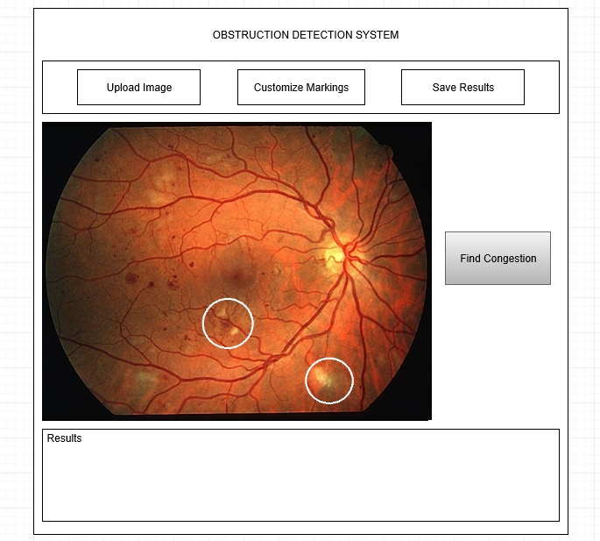

Figure 3.2.3 Find Congestion Button

**3.2.1.4 Customize Markings Button**

The general purpose of the button is to allow user to select the geometric shape and color of the markings of the point of congestion when the obstruction is present in the vein.

**3.2.1.4.1 Change Shape Button**

The purpose of the button is to ask the user what geometrical shape he/she wants software to show the obstruction. Shapes include triangle, circle and square.

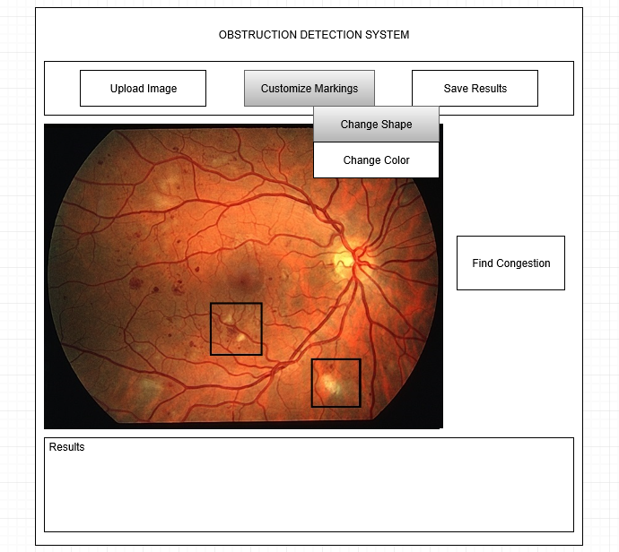

Figure 3.2.4 Change Shape Button

**3.2.1.4.2 Change Color Button**

The purpose of the button is to ask the user what color for the shape he/she wants software to show the obstruction. Any RGB supported color will be selectable.

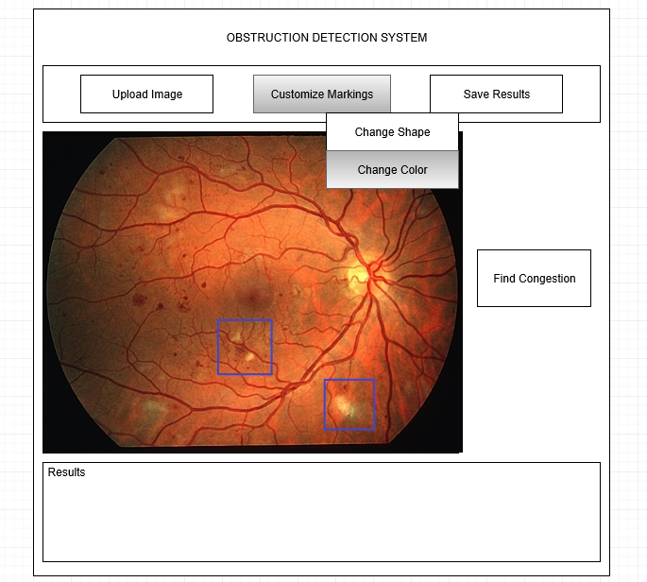

Figure 3.2.5 Change Color Button

**3.2.1.5 Save Results Button**

The Save Results button allows user to save the results in a desired location and with a desired name after the image is processed.

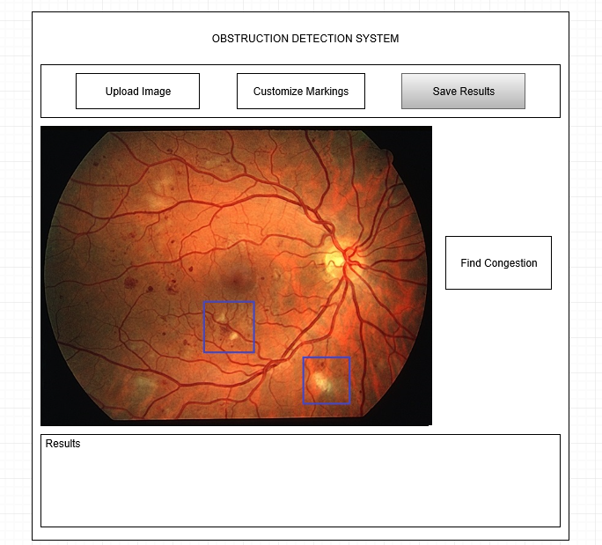

Figure 3.2.6 Save Results Button

When the save process is performed, the software creates a folder including a text file in which the diagnostic and results are stored, and the processed image.

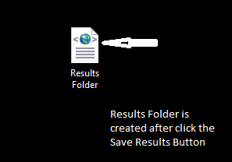

Figure 3.2.7 Results Folder

**4. REFERENCES**

1. Yang-Williams, K. (2002). Ophthalmic Photography: Retinal Photography, Angiography, and Electronic Imaging, 2nd ed. *Optometry and Vision Science,* *79*(8), 478. Doi: 10.1097/00006324-200208000-00008.
2. B. Sujithkumar, and V. Singh, (2012) “Automatic Detection of Diabetic Retinopathy in Non-dilated RGB Retinal Fundus Images”, International Journal of Computer Applications, Vol. 47, No. 19, pp. 26-32.
3. F. Zana, J. Klein, A multimodal registration algorithm of eye fundus images using vessels detection and Hough transform, IEEE Trans. Med. Imaging 18 (5) (1999) 419–429.
4. S. Chaudhuri, S. Chatterjee, N. Katz, M. Nelson, M. Goldbaum, Detection of blood vessels in retinal images using two-dimensional matched filters, IEEE Trans. Med. Imaging 8 (3) (1989) 263–269.
5. R. Nekovei, Y. Sun, Back-propagation network and its configuration for blood vessel detection in angiograms, IEEE Trans. Neural Networks 6 (1) (1995) 64–72.
6. Júnior, S. B., & Welfer, D. (2013). Automatic Detection of Microaneurysms and Hemorrhages in Color Eye Fundus Images. *International Journal of Computer Science and Information Technology,* *5*(5), 21-37. doi:10.5121/ijcsit.2013.5502.
7. T. A. Ciulla, A. G. Amador, and B. Zinman, (2003) “Diabetic Retinopathy and Diabetic Macular Edema: Pathophysiology, screening, and novel therapies”, Diabetes Care, Vol. 26, No. 9, pp. 26532664.
8. Y. Hatanaka, T. Nakagawa, Y. Hayashi, T. Hara, and H. Fujita, (2008) “Improvement of Automated Detection Method of Hemorrhages in Fundus Images”, Proceedings: 30th Annual International IEEE EMBS Conference, pp. 5429 - 5432.
9. T. Kauppi, V. Kalesnykiene, J. K. Kamarainen, L. Lensu, I. Sorri, A. Raninen, R. Voutilainen , H. Uusitalo, H. Kalviainen, and J. Pietila, (2007), “DIARETDB1: diabetic retinopathy database and evaluation protocol,” Technical report, Faculty of Medicine, University of Kuopio, Finland.