Login Page: This is the login page and by entering the right username and password users are able to login in the library. If you enter Username and Password correctly, it checks mysql database in users table. If Username and Password is added there it accepts. Otherwise it gives that error message ‘** Your User Name Or Password is Not Correct!!’. When they are both correct the library interface welcomes us. Also, we create our UI with PyQt5 so thats why we have loadUIType.

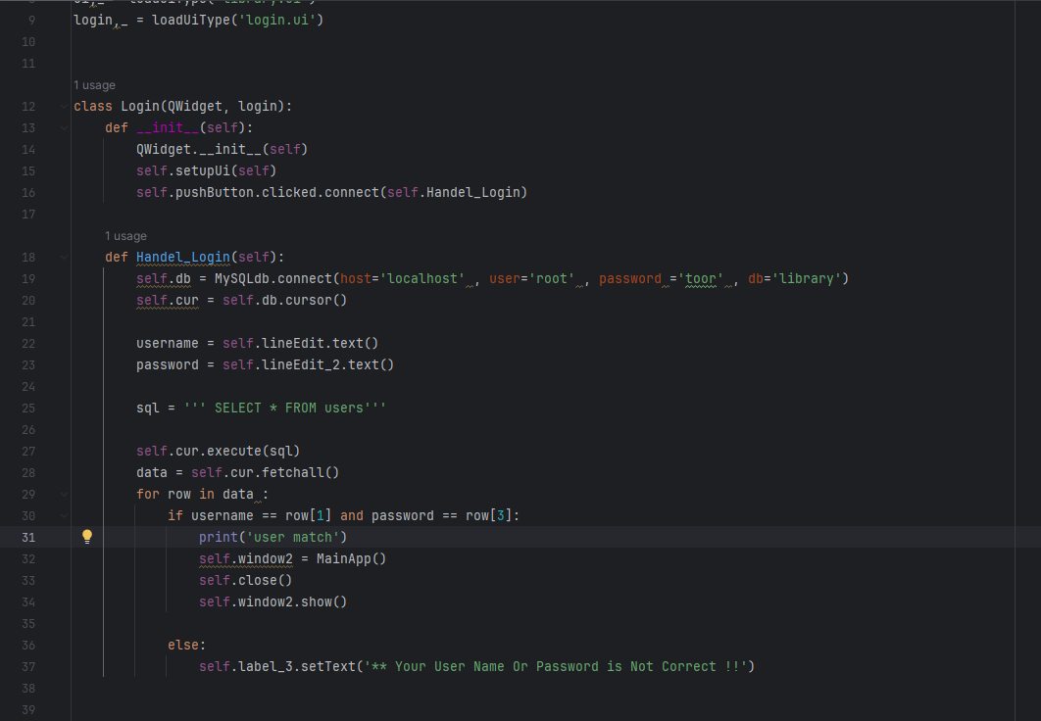

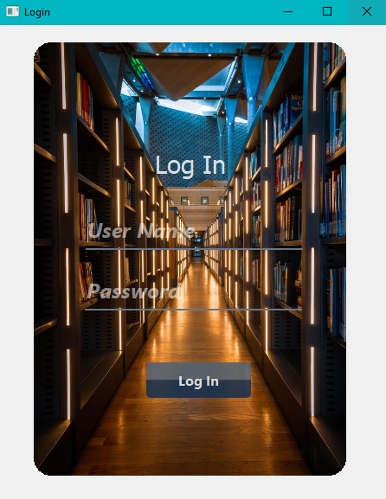

Add new user: I want to start with add new user button. Left hand side we can add new users in our library system. The information given from the user connects directly our mysql database. When we write our Username,Email,Password,Password(Again) and click Add user button it connects database and saves there. So, you can easily use our library management system. If you want you can edit your information. On the top right, you need to write your Username and password. After that, if your username and password match with databese information, bottom right designer welcomes to you. I mean it looks visible. So, you can change everything you want from there.

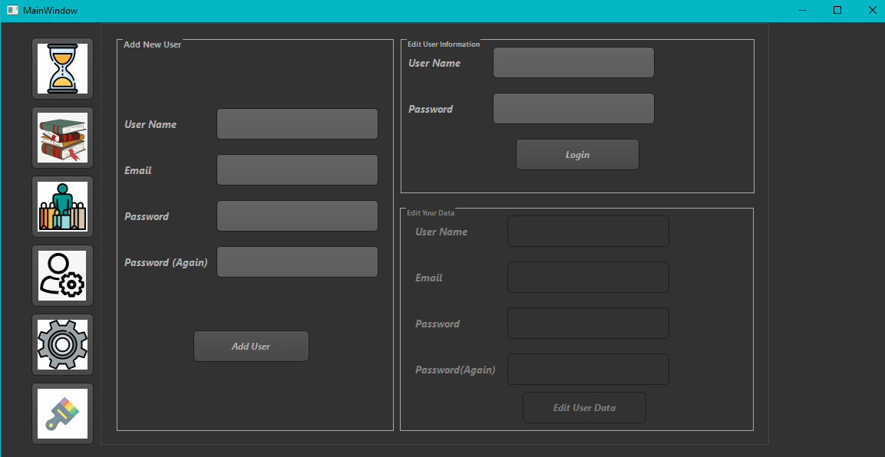

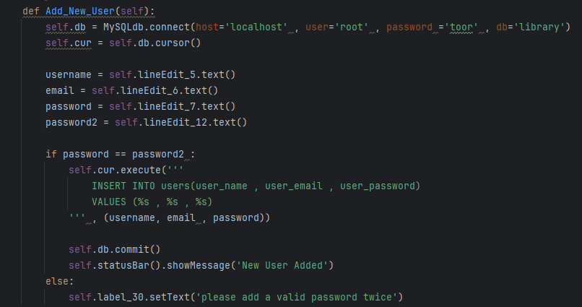

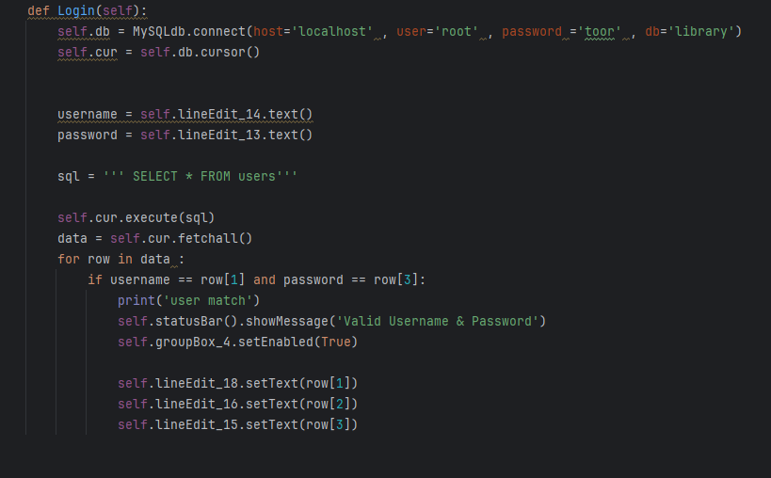

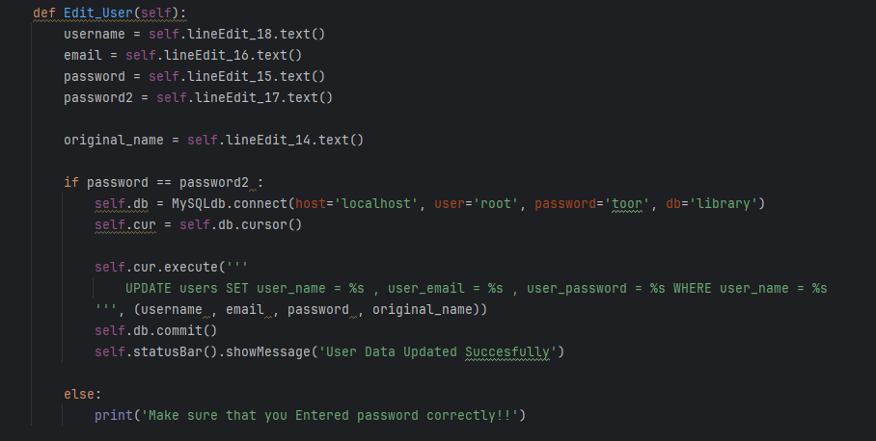

Adding Category Name, Author Name and Publisher Name:

Next Button which looks like settings is Adding Category Name, Author Name and Publisher Name buttons. In that part of the library system, we can add new category, new author and new Publisher with corresponding ids which helps us to add new book and maybe some other clients would like to retrieve book. So, we have to store that informations. We have Add_Category and Show_Category functions. In Add_Category function we can add new categorys to our database. After that, we have to show our database values in our library management program. For that, we defined Show_Category function. Since category id is primary key, when you enter same id with two category name, you will get error.

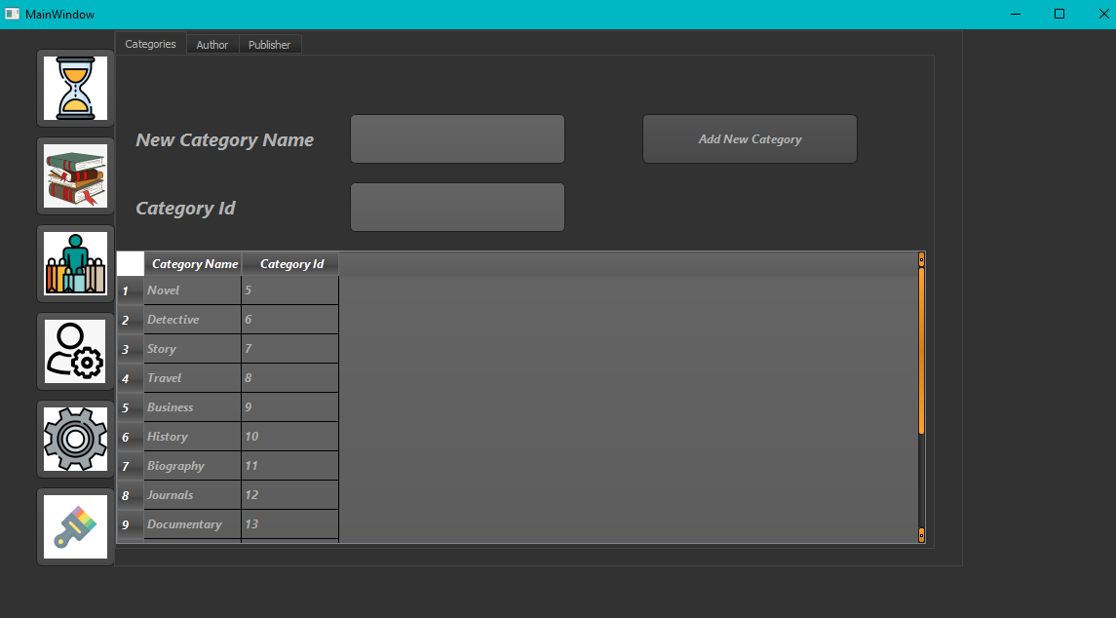

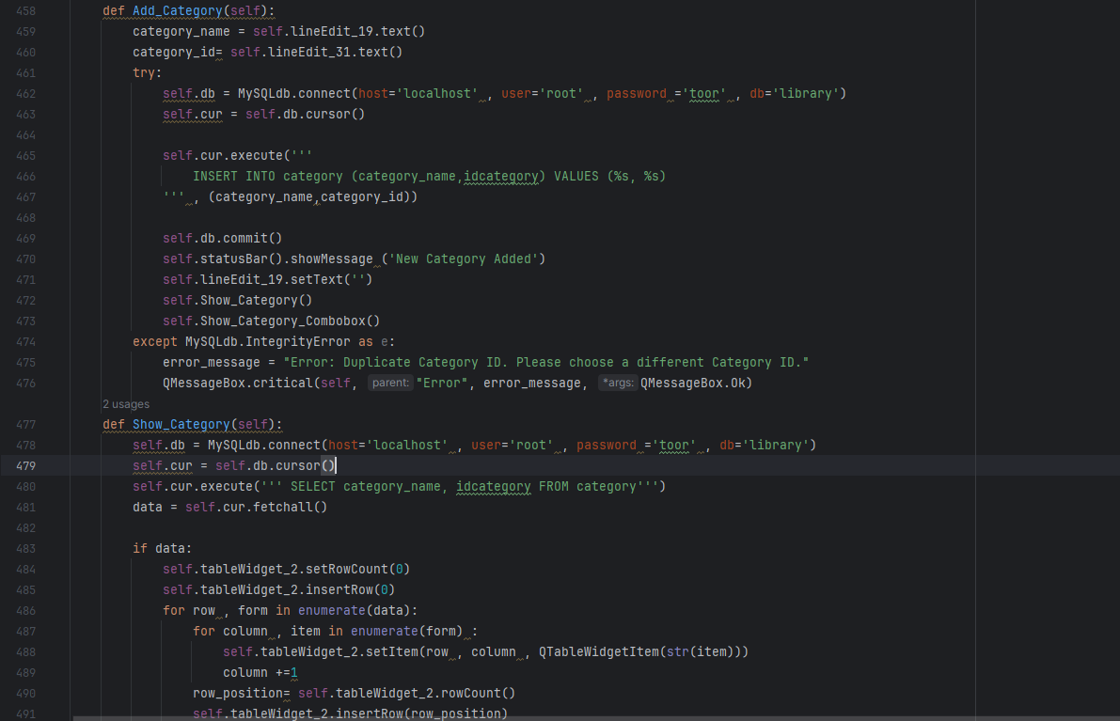

Lets continue with a author part. You can see 3 tab at the top side of the interface. It looks like Adding new category part. We did the same things actually. Again we have Add_Author and Show_Author functions with corresponding author ids. With Add_Author function we can add new authors in our database. After that, we have to show that authors in our database. For that, we create Show_author function. Since Author Id is primary key, we can not add 2 person with same ids. It gives an error.

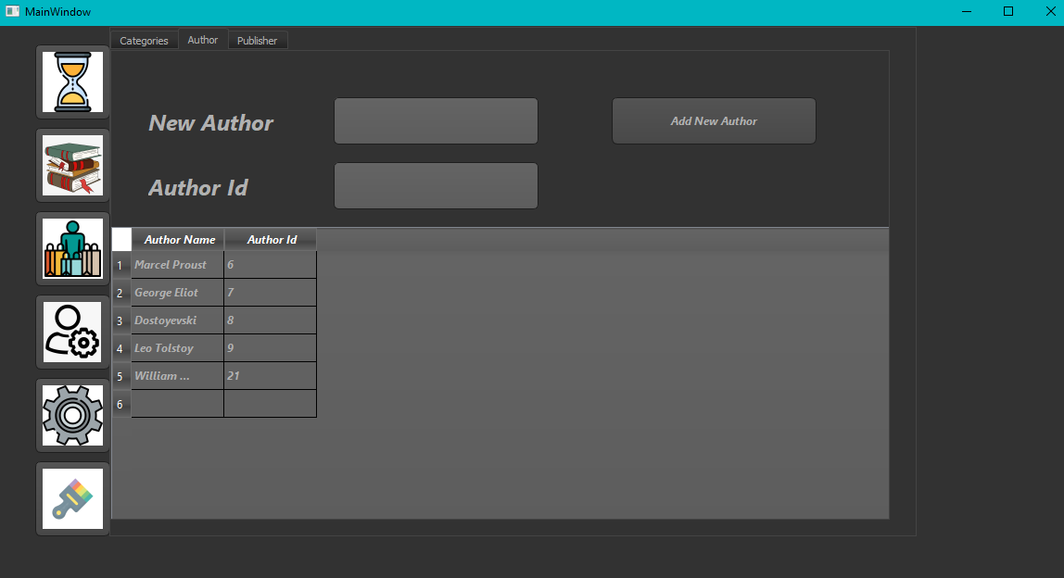

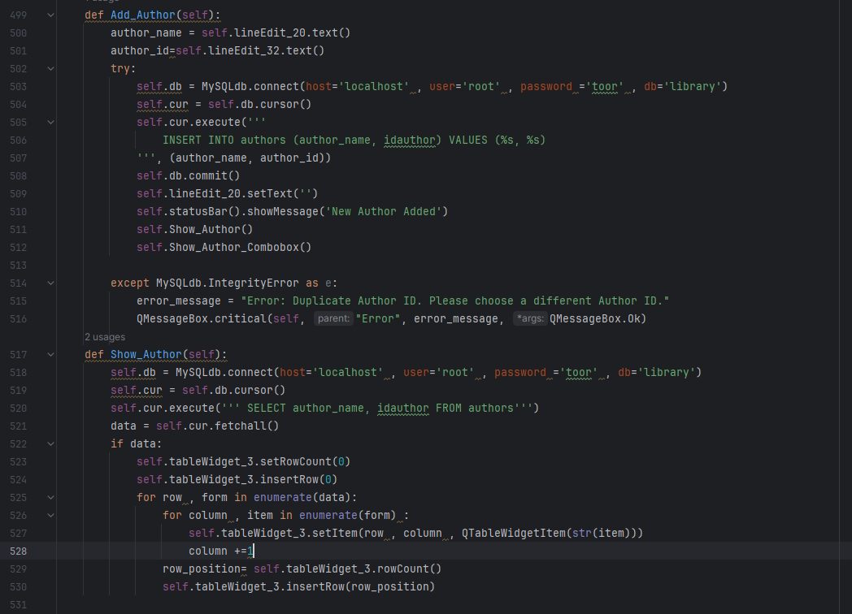

Again , we did the same thing. We have two functions Add_publisher and Show_Publisher. Since Publisher Id is primary key, we can not add 2 publisher with same ids. It gives an error.

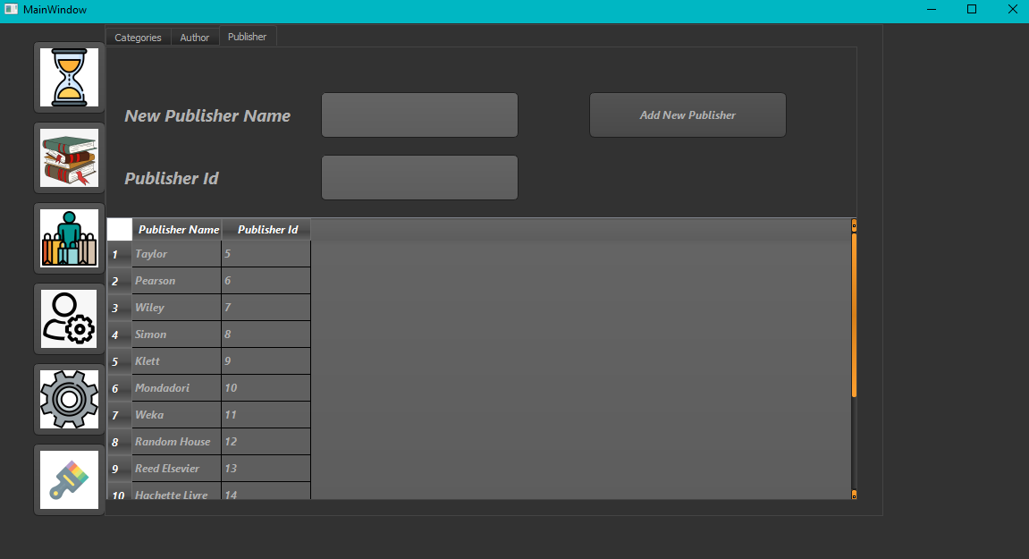

metin, ekran görüntüsü, yazılım içeren bir resim

Açıklama otomatik olarak oluşturuldu

Handle Buttons Function:

In that part, we are handling all of the buttons. We connect our buttons to the relating functions. For example ,pushButton_6 , we get this name from PyQt5 designer. For that, names are important.

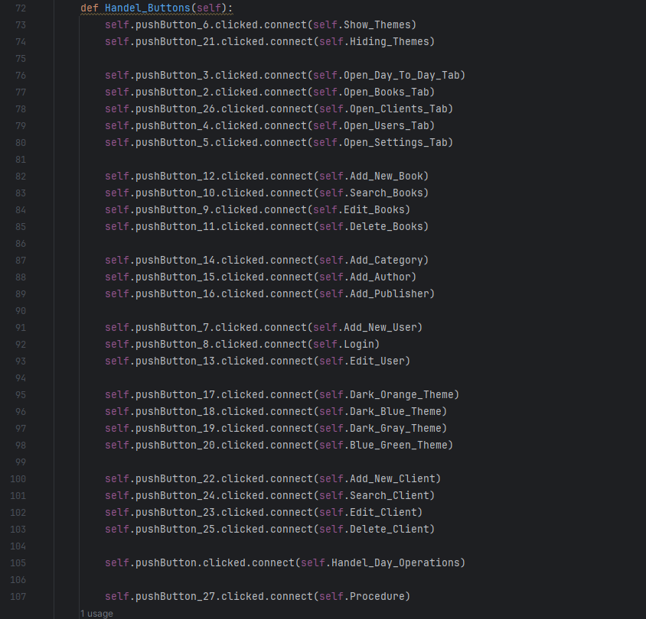

Clients button:

Next, we have client button. We have 3 tab in that button. All clients, Add New Client and Edit Or Delete A Client. In All Clients part, our interface shows us all clients name with client name, client e mail and client national id. Our interface can reach those informations from database.

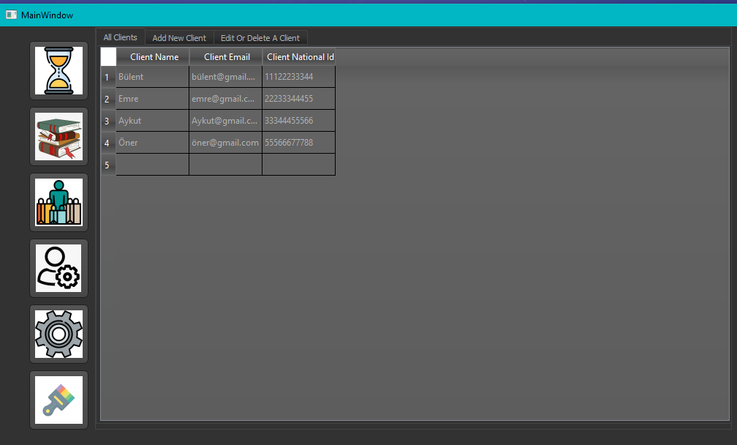

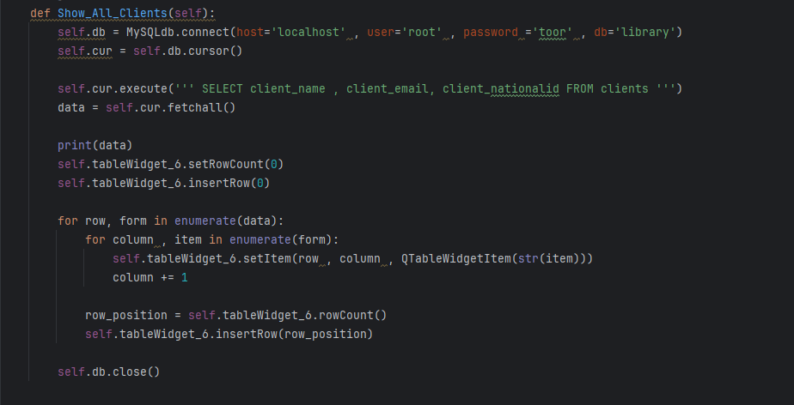

Next, we have Add New Client tab. We can add new clients to our database with Add New Client button. Just we need to do write Client Name, Client Email and Client National İd. Client National Id length should be 11 character. After succesfull addition, at the bottom site statusbar shows us ‘New Client Added’ message.

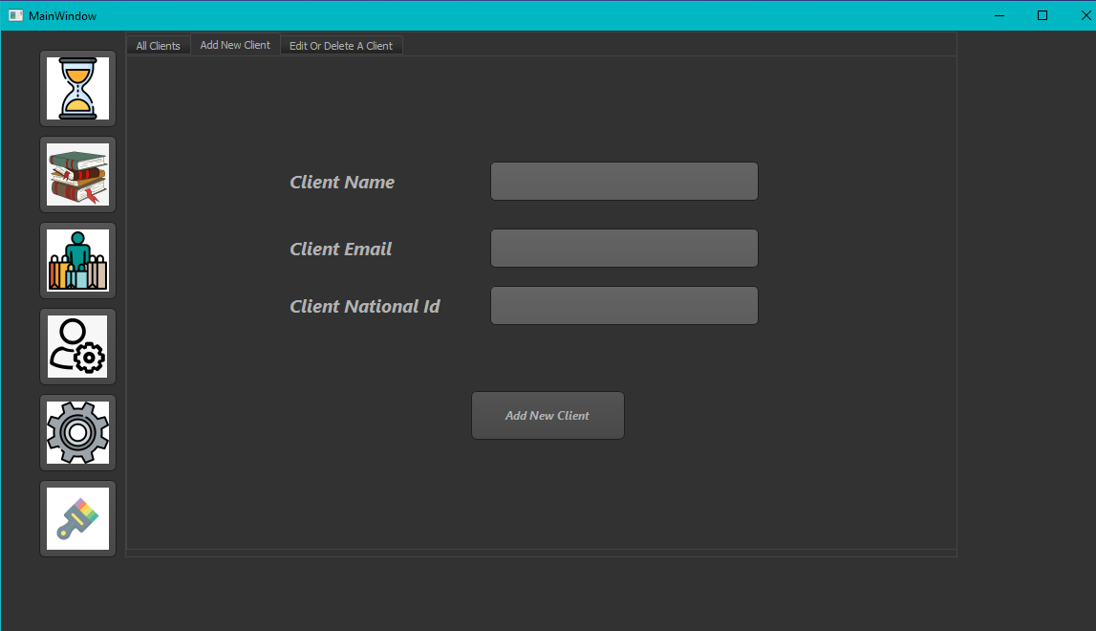

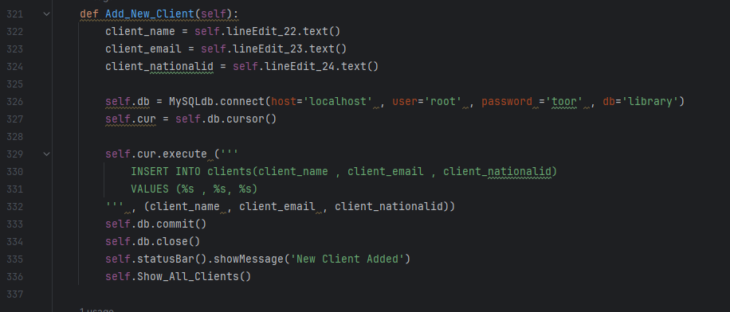

Lastly, we have Edit Or Delete A Client tab. When we write client’s national id and we clicked search button, we get all the information about the client. After that, we can edit or delete the client. If we try to delete client, messagebox welcomes to us. It shows us ‘You are deleting this client Are you sure’, after that yes or no messagebox shows itself. After updating client information, statusbar show us ‘Client Data Updated’ message and all the things that we do in these 2 tab(Add client and edit client) can be updated, saved to our database.

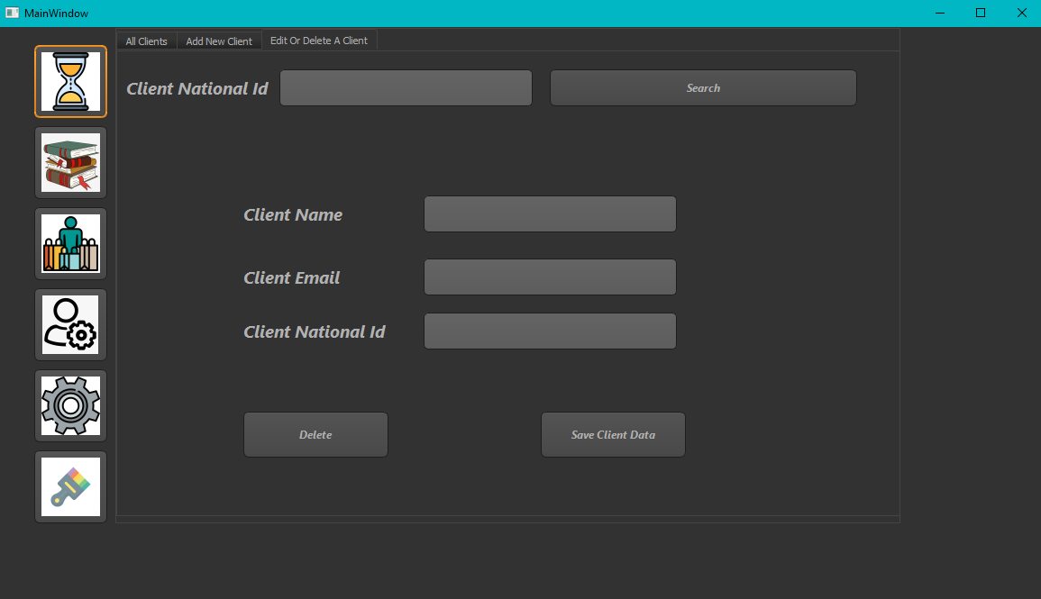

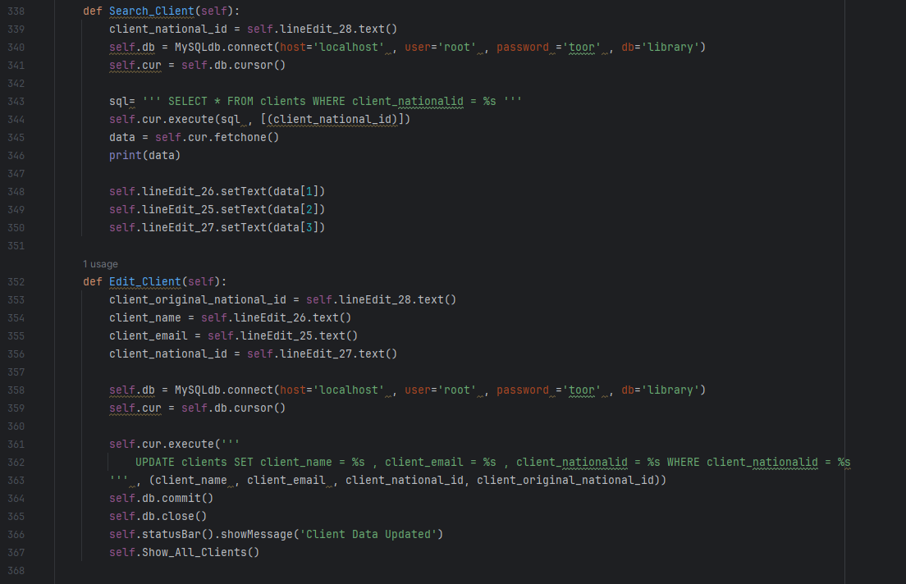

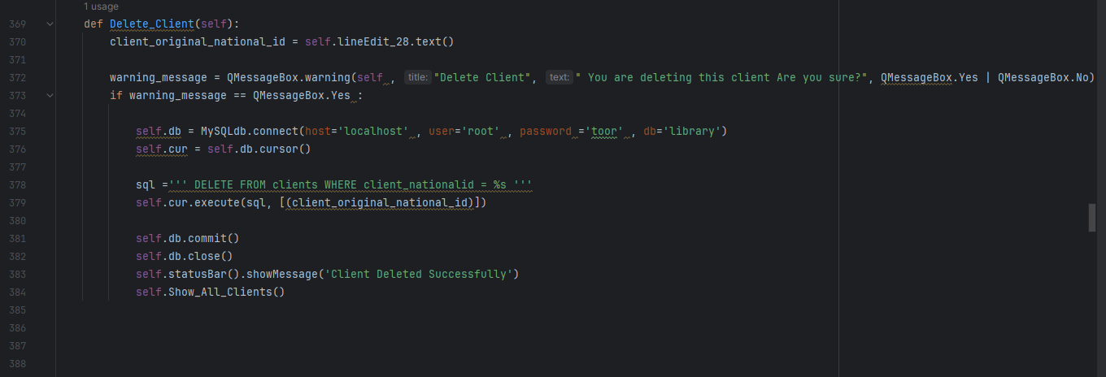

Books button:

In book button we have 4 tab All Books, Add New book and Edit Or Delete A Book and Author’s Other Books. In All Books part, our interface reads mysql book table and shows us every information.

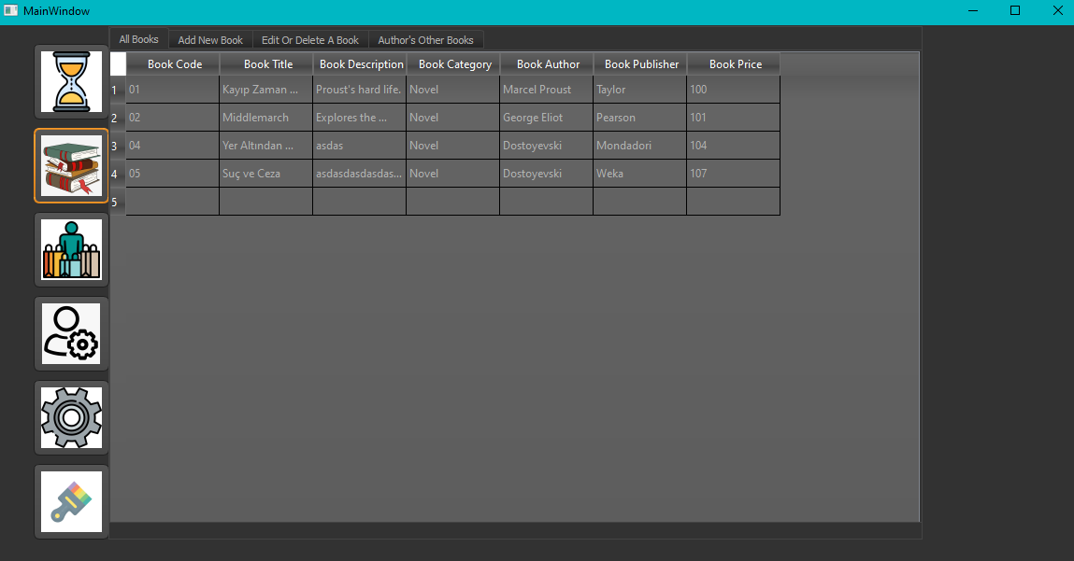

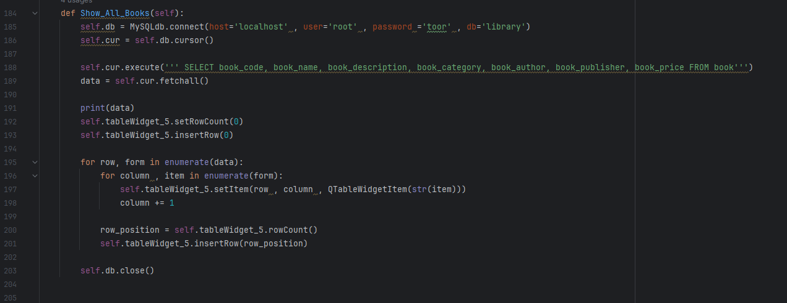

Secondly, we have Add New Book tab. In that tab we are able to add new book with book title, book decription, book code, choosing category, choosing author, choosing Publisher. As you remember, we mentioned before how we add Category, Author, Publisher. In choosing part, we can see our added Authors,Publisher and Category items. When we write all the information about book we can press Save button and it saves to MySQL book table. When saving is successfully at the bottom of the interface, it shows ‘New Book Added’ message.

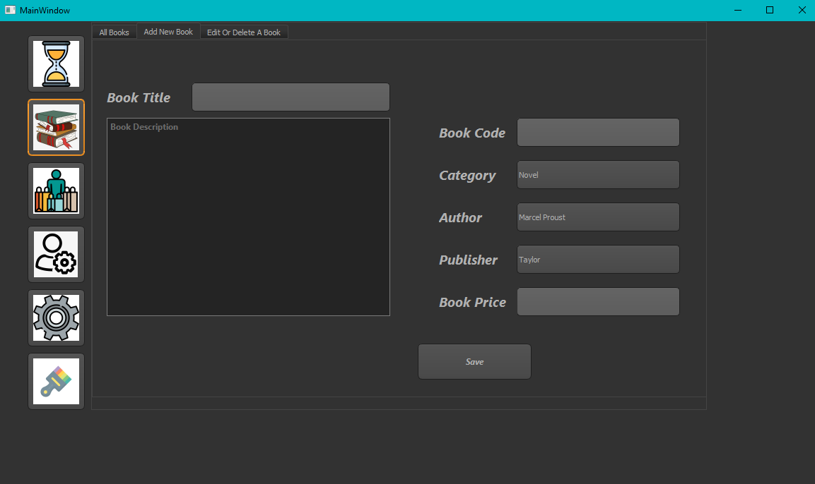

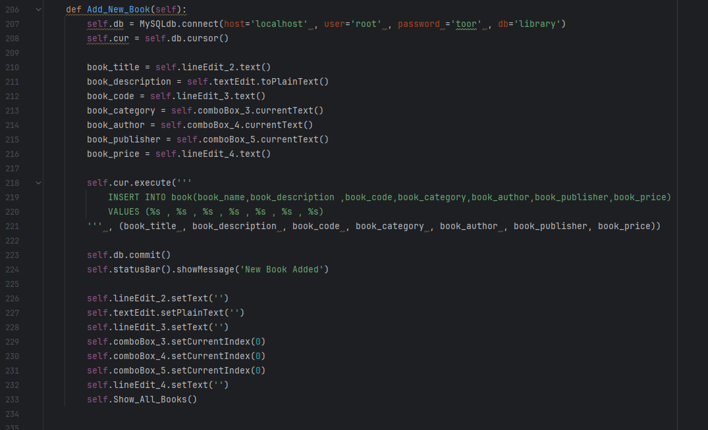

Next, we have Edit Or Delete A Book tab. When we write book title , top side one and press search button, our interface shows us to everything about this book. When we want to edit book name for example, we can use Edit Book Title and press Save button. Also, we can change other things like book code, book price… If we want to delete book. Just we need to type Book title and press search button. After that, press Delete button and warning should show itself. It shows this message ‘are you sure you want to delete this book’. Then, yes or no messageboxs show itself. You can choose what you desire. If you delete, ‘Book Deleted’ message should show itself at the bottom site of the interface.

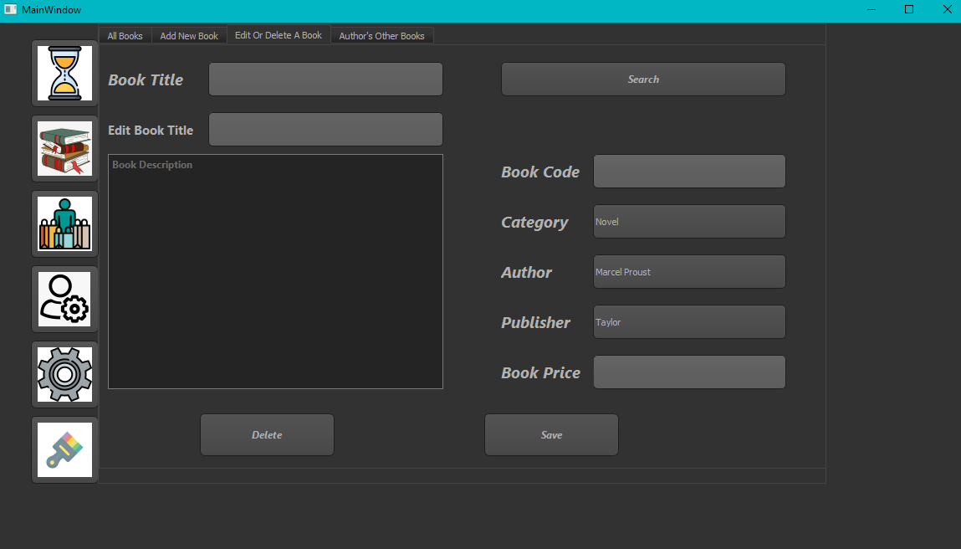

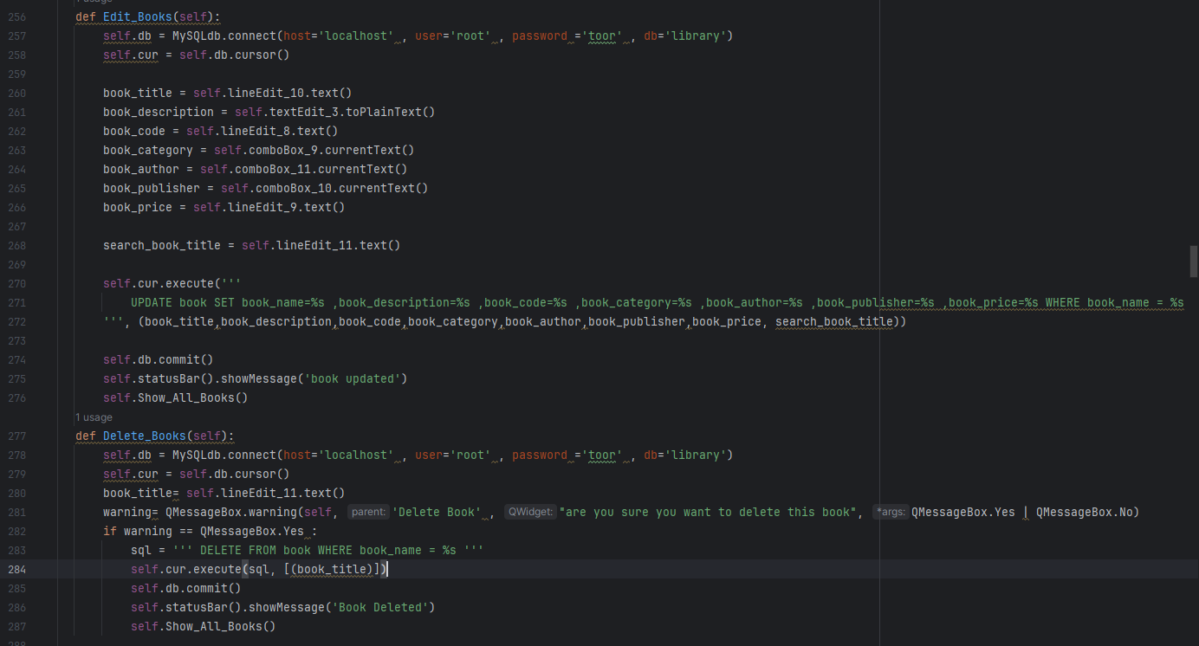

Lastly, we have Author’s Other Books tab. It is a procedure that created with mysql. It returns author’s other books. It takes Author Name as a parameter. Also, it shows Book Code, Book Author, Book Name, Book Category informations. It takes values from All Books part.

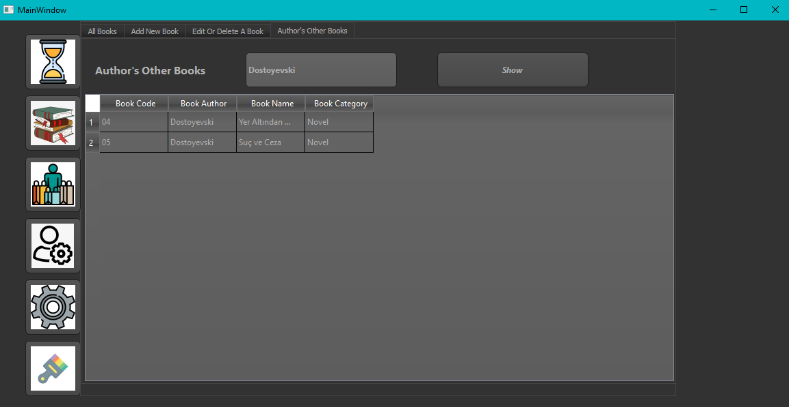

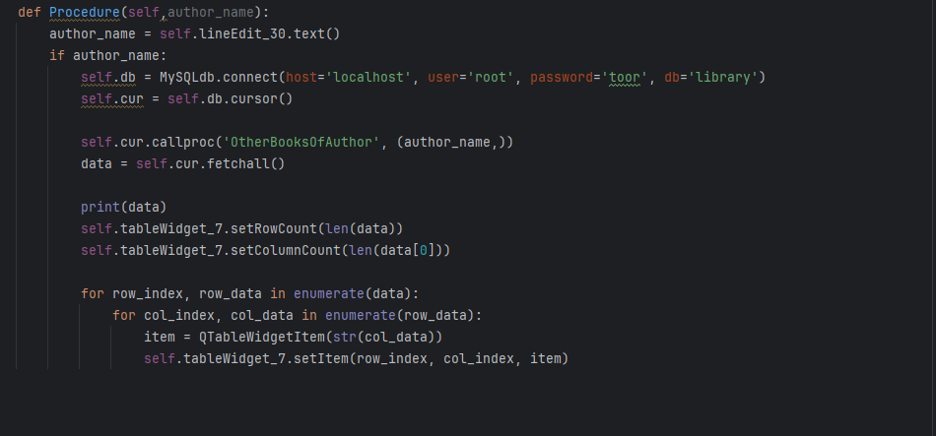

Retrieve/Rent part: To deal with Retrieve/ Rent part, we create a new tab. It has Book Name, Client_Name, Book Type, From(current date) and To (desired date). For example Aykut (client) wants to rent a book. We need to enter book title and client name and we have to choose rent in the Type part. Then, we need to choose days from there and press Add button. It saves informations to MySQL database in dayoperations table. Then, we can see everything in interface. After successfull addition, at the bottom side we can see ‘New Operation Added’ message.

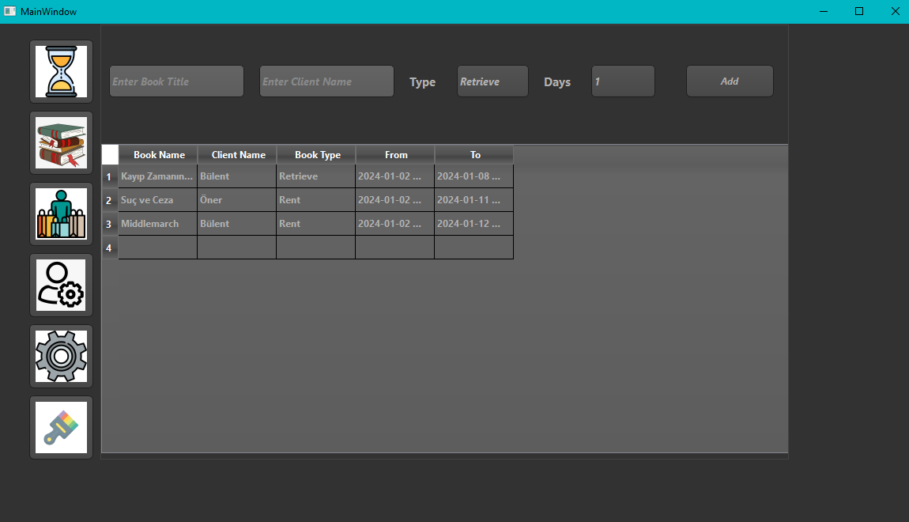

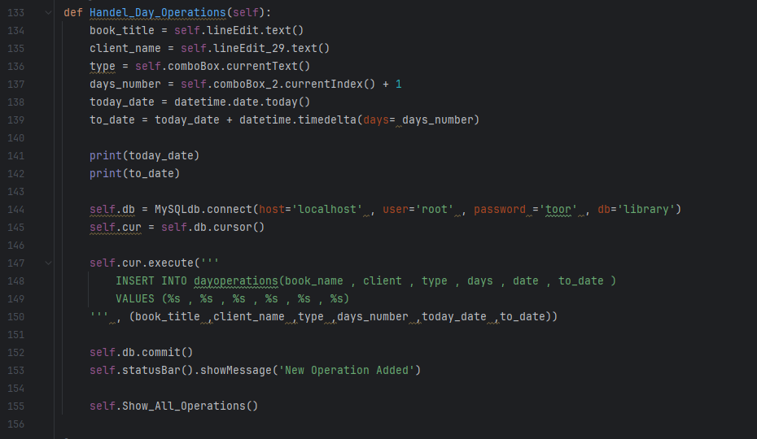

After addition, we need to show that database to our interface. For that, Show_All_Operations function helps us to show database information to our interface.

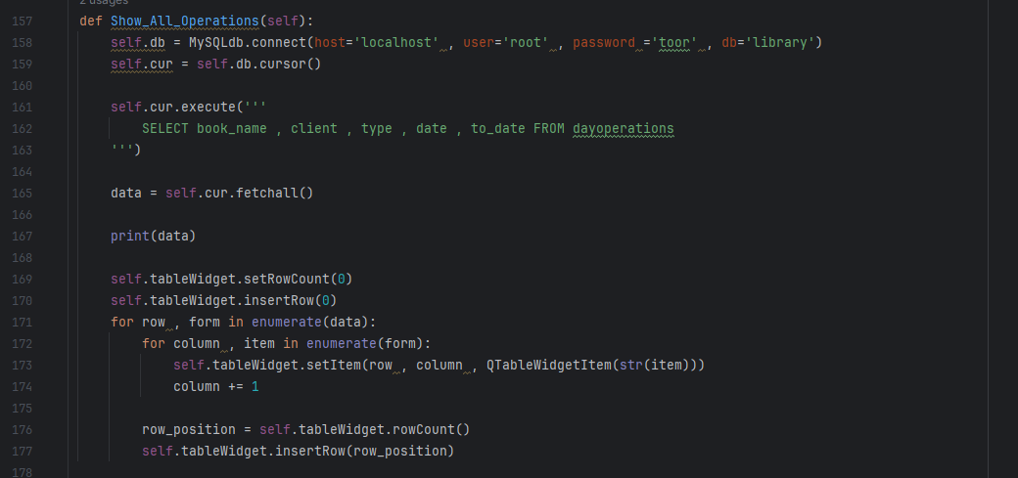

Applying Background Button:

We added background colors to our interface. We have 4 background colors. Since we keep the color files in the same directory, the interface can read easily.

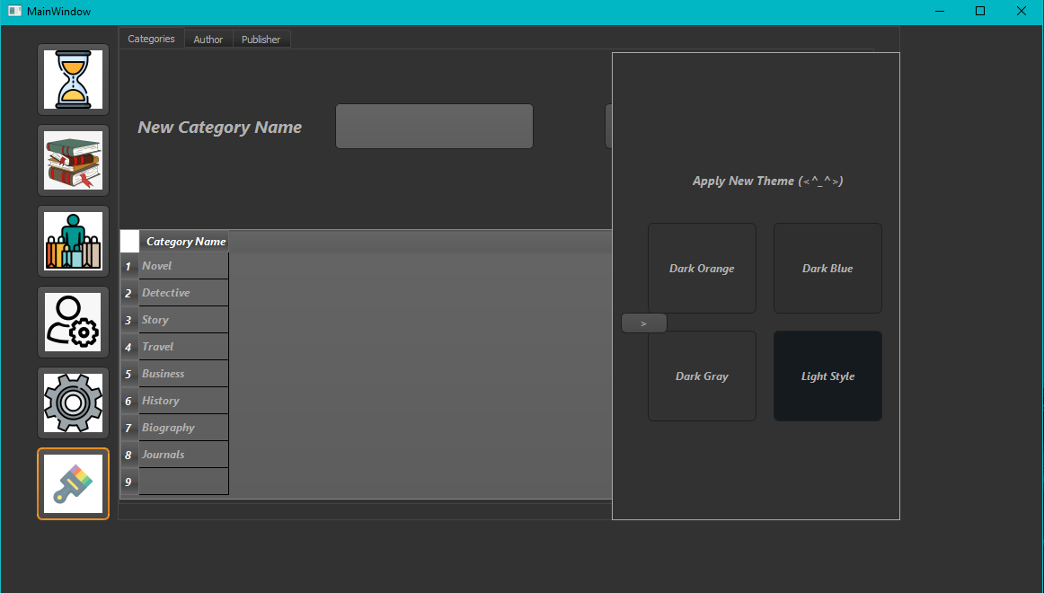

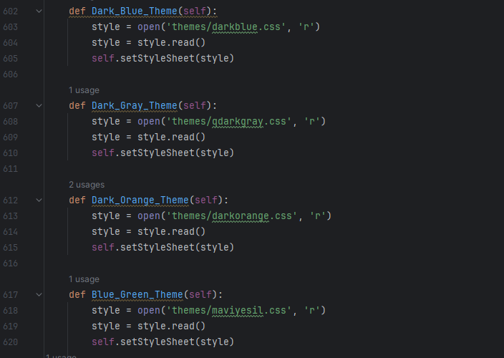

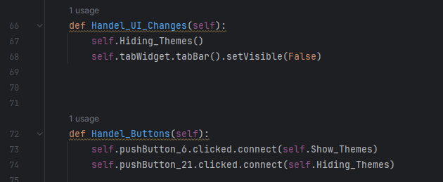

MySQL Qeury Codes

We added these codes into Project file. File Name is mysqlquerys.

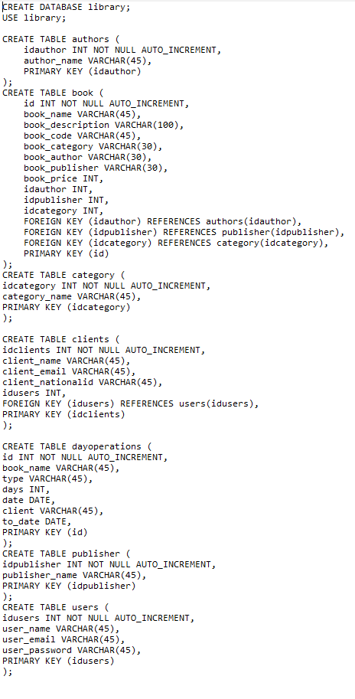

MySQL Stored Procedure Code

It returns other books of the authors.

