**Anomalous Expansion of Water Upon Freezing at High Pressure Defying Carnot Theorem**

**Abstract**

At standard conditions (0°C and 1 atm), water expands by approximately 9% when transitioning from liquid to solid state. Moreover, when water is spatially constrained, upon freezing, it exhibits a remarkable pressure increase up to 220 MPa before it becomes another form of ice. Notably, increased pressure further lowers the melting point, thereby amplifying the expansion. In other words, the expansion becomes even more significant due to the reduction in melting point caused by the increased pressure. At a pressure of 200 MPa, water freezes at about 253 Kelvin and undergoes a remarkable 16.8% expansion. Source: <https://water.lsbu.ac.uk/water/density_anomalies.html> -Density Anomalies of Water

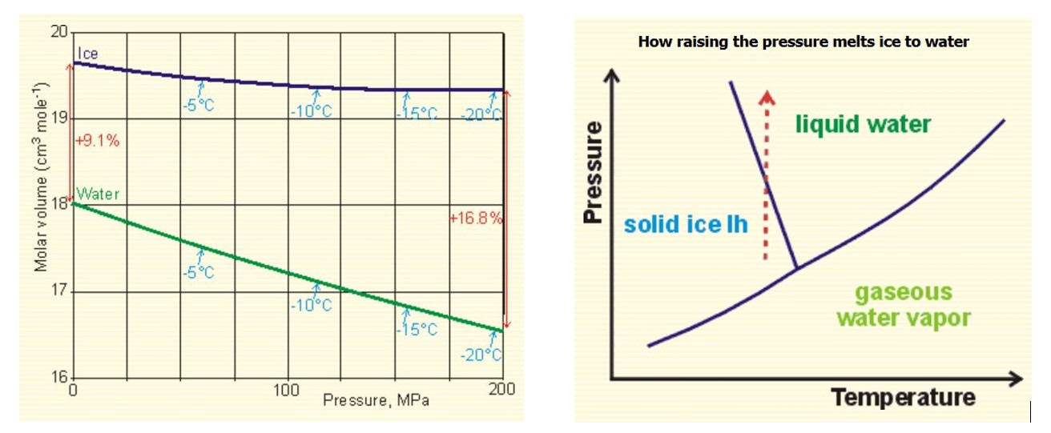

Contrary to typical liquids, water exhibits anomalous behaviour: its melting point decreases with increased pressure, as shown by the backward-sloping liquid-solid line in its phase diagram. This unique property enables a novel heat engine concept that leverages expanding ice to generate substantial work output. Notably, an engine can operate efficiently with extremely small temperature differences between its hot and cold reservoirs, as the phase change occurs at a constant temperature. By harnessing water's anomalous expansion, this discovery offers a new way to convert low-quality heat energy into work, challenging traditional thermodynamic limits.

**Arrangement and Working of the Proposed Heat Engine**

Consider 1 kg of water at STP (approximately 1000 cc). When subjected to 200 MPa, its volume reduces to approximately 922 cc. Cooling this water to 253 K under 200 MPa pressure defines the initial condition.

The cycle begins with the freezing process when the water container contacts the sink at 252 K (T₂), 1 Kelvin below the freezing point. The latent heat fusion of 1 kg of water is 334 kJ, released as heat to the sink (q₂ = 334 kJ/kg).

As the fluid freezes, it expands by approximately 16.8%, resulting in a volume increase to 1077 cc. The expanded ice delivers mechanical work, w₁ = 200 MPa × (1077 cc - 922 cc) = 200 MPa x 155 cc = 31,000 Nm = 31 kJ.

The total change in internal energy (ΔU) during the freezing process is ΔU = w₁ + q₂ = 31 kJ + 334 kJ = 365 kJ. The cycle completes when the frozen water absorbs energy (q₁ = ΔU = 365 kJ) from the hot body (source) at 254 K (T₁) for melting.

**Efficiency Comparison**

The Carnot cycle efficiency (E₁) is calculated as E₁ = 1 - (252/254) ≈ 0.8%, given the source temperature (T₁) of 254 K and sink temperature (T₂) of 252 K. In contrast, the proposed heat engine's efficiency (E₂) is E₂ = w₁/q₁ = 31 kJ / 365 kJ ≈ 8.5%. Notably, E₂ surpasses E₁, appearing to defy Carnot's theorem, which states that no heat engine can exceed the efficiency of a Carnot engine operating within the same temperature limits.

For more details, please visit https://slt03.wordpress.com