**Exploiting Water's Anomalous Expansion: A Novel Heat Engine Defying Carnot's Theorem**

**Introduction**

Water's anomalous expansion upon freezing is a fascinating phenomenon that has sparked interest in various fields. This document presents a novel heat engine concept that leverages the anomalous expansion of water upon freezing. This innovative approach has the potential to convert low-quality dissipated heat energy into useful work, challenging the fundamental limits imposed by Carnot's theorem. It implies, quality of energy can be spontaneously improved.

**Abstract**

At standard conditions (0°C and 1 atm), water expands by approximately 9% when transitioning from liquid to solid state. Moreover, when water is spatially constrained, upon freezing, it exhibits a remarkable pressure increase up to 220 MPa before it becomes another form of ice. Notably, increased pressure further lowers the melting point, thereby amplifying the expansion. In other words, the expansion becomes even more significant due to the reduction in melting point caused by the increased pressure. At a pressure of 200 MPa, water freezes at about 253 Kelvin and undergoes a remarkable 16.8% expansion. Source: <https://water.lsbu.ac.uk/water/density_anomalies.html> -Density Anomalies of Water

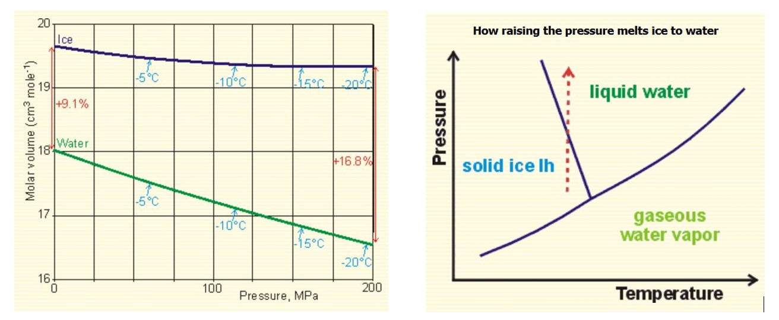

Contrary to typical liquids, water exhibits anomalous behaviour: its melting point decreases with increased pressure, as shown by the backward-sloping liquid-solid line in its phase diagram. This unique property enables a novel heat engine concept that leverages expanding ice to generate substantial work output. Notably, the engine can operate efficiently with extremely small temperature differences between its hot and cold reservoirs, as the phase change occurs at a constant temperature. By harnessing water's anomalous expansion, this discovery offers a new way to convert low-quality heat energy into work, challenging traditional thermodynamic limits.

**Arrangement and Working of the Proposed Heat Engine**

Consider 1 kg of water at STP (approximately 1000 cc). When subjected to 200 MPa, its volume reduces to approximately 922 cc. Cooling this water to 253 K under 200 MPa pressure defines the initial condition.

The cycle begins with the freezing process when the water container contacts the sink at 252 K (T₂), 1 Kelvin below the freezing point. The latent heat fusion of 1 kg of water is 334 kJ, released as heat to the sink (q₂ = 334 kJ/kg).

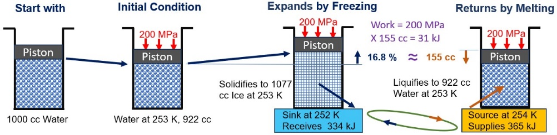

As the fluid freezes, it expands by approximately 16.8%, resulting in a volume increase to 1077 cc. The expanded ice delivers mechanical work, w₁ = 200 MPa × (1077 cc - 922 cc) = 200 MPa x 155 cc = 31,000 Nm = 31 kJ.

The total change in internal energy (ΔU) during the freezing process is ΔU = w₁ + q₂ = 31 kJ + 334 kJ = 365 kJ. The cycle completes when the frozen water absorbs energy (q₁ = ΔU = 365 kJ) from the hot body (source) at 254 K (T₁) for melting.

**Efficiency Comparison**

The Carnot cycle efficiency (E₁) is calculated as E₁ = 1 - (252/254) ≈ 0.8%, given the source temperature (T₁) of 254 K and sink temperature (T₂) of 252 K. In contrast, the proposed heat engine's efficiency (E₂) is E₂ = w₁/q₁ = 31 kJ / 365 kJ ≈ 8.5%. Notably, E₂ surpasses E₁, appearing to defy Carnot's theorem, which states that no heat engine can exceed the efficiency of a Carnot engine operating within the same temperature limits.

**Ideal Fluid vs the Anomalous Real**

Carnot's efficiency limit relies on ideal gas laws, but real fluids deviate from this ideal behavior. Unlike typical fluids, which require energy to expand under constant pressure, ice uniquely expands while releasing heat. Water's anomalous behavior during solidification when volumetrically constrained by excess pressure enables cyclic phase changes, (solidifying, expanding, melting etc. intermittently) generating work under seemingly constant pressure and temperature conditions.

One of the sources of inspiration: A YouTube video titled ‘Freezing water expands. What if you do not let it?’  
<https://youtube.com/watch?v=_bcfxty39Cw&si=o3S4lnh3szZAgqg9>

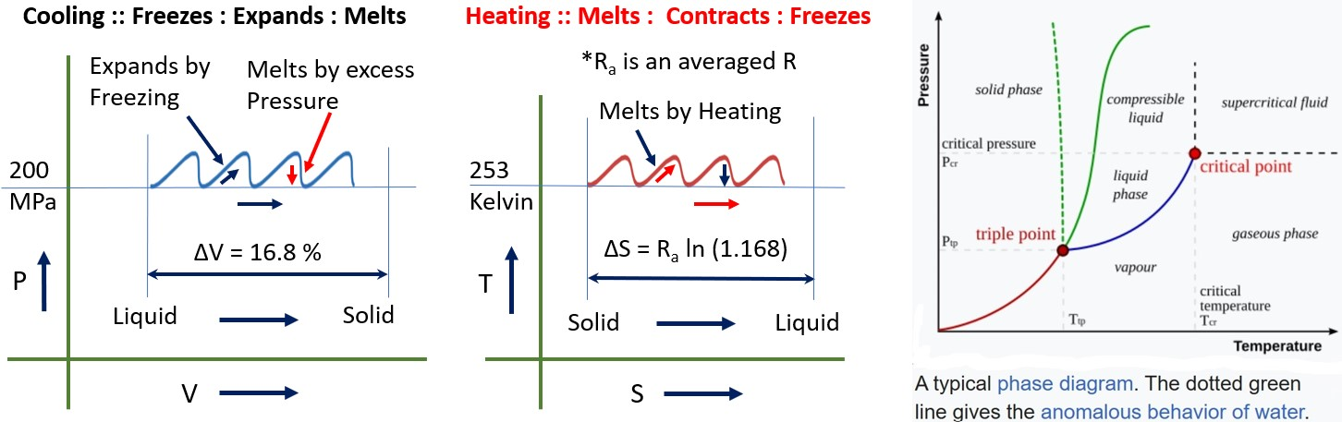

Also, the deduced Carnot-Clausius-Clapeyron relation d*P*/d*T* = Δs/Δv explains the anomalous behaviour of water as dP/dT is negative of the curve separating solid liquid states. Source: [Clausius–Clapeyron relation - Wikipedia](https://en.wikipedia.org/wiki/Clausius%E2%80%93Clapeyron_relation)

**Summary**

The Second Law of Thermodynamics, in the form of the increasing entropy theorem, imposes a fundamental restriction on the conversion of heat into work, rendering complete conversion impossible. However, this novel heat engine cleverly exploits water's anomalous expansion behaviour to achieve the seemingly impossible compared to a typical heat engine - which invariably rejects some heat energy to an external sink.

This innovative engine has the potential to revolutionize energy conversion by harnessing dissipated, low-quality energy sources – such as the virtually inexhaustible heat energy present in the atmosphere or the ambient heat in living spaces – and converting them into useful work. This breakthrough paves the way for the development of a 'Perpetual Motion Machine of the Second Kind' (PMM2).

The implications of this technology are far-reaching, enabling humanity to address pressing environmental challenges and navigate future crises. It can help mitigate the environmental damage inflicted upon the planet since the Industrial Revolution and empower humanity to adapt to challenges like the next ice age or embark on interstellar travel. The possibilities become virtually limitless. Moreover, the fuel-less nature of this engine technology ensures it cannot be weaponized, as it is meant to recycle the waste heat, providing an additional layer of safety & security.

**References and Resources**

<https://water.lsbu.ac.uk/water/density_anomalies.html> Density Anomalies of Water

<https://doi.org/10.1007/s42452-018-0139-z> Utilizing Freezing Water to Generate Energy

[Clausius–Clapeyron relation - Wikipedia](https://en.wikipedia.org/wiki/Clausius%E2%80%93Clapeyron_relation) Carnot-Clausius-Clapeyron equation

<https://youtube.com/watch?v=_bcfxty39Cw&si=o3S4lnh3szZAgqg9> A YouTube video titled ‘Freezing water expands. What if you do not let it?’

**Perpetual Motion Machine of the Second Kind (PMM2) by the Augmented Heat Pump**

When combined with a heat pump operating between 251 K and 255 K, the coefficient of performance (CoP) is about 63.5 from 255/ (255-251). To pump energy from the sink (252 K) back to the source (254 K), the required work (w₂) is approximately 5.3 kJ, calculated as the latent heat of fusion (334 kJ/kg) divided by the CoP. The combined system achieves a net output of w₁ - w₂ = 31 - 5.3 = 25.7 kJ/kg of water, supplied by the atmosphere to the source as heat.

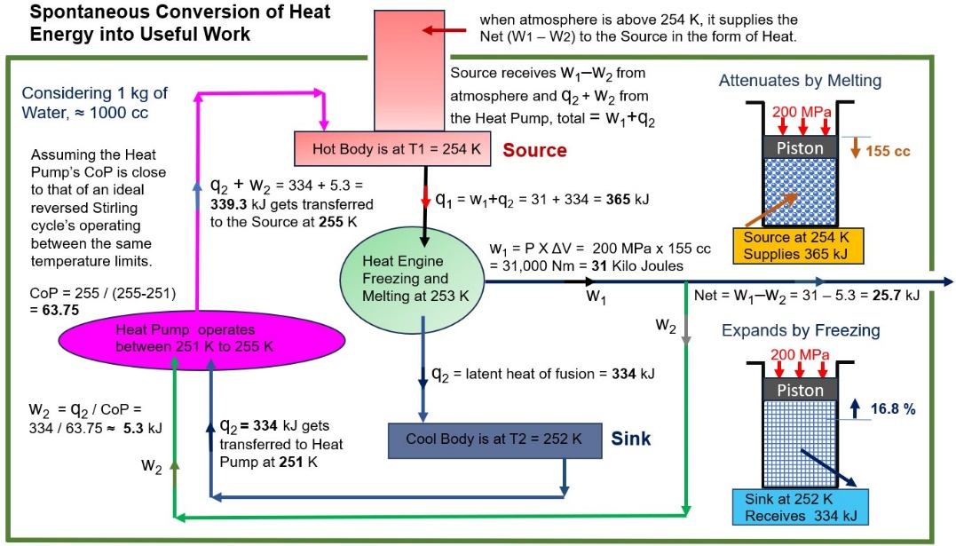

**Maximising the Work Extraction**

When the room temperature is sufficiently high compared to the Source temperature, we can make use of this difference to drive an additional Stirling Heat Engine (added to the PMM2 pack), to produce additional work.

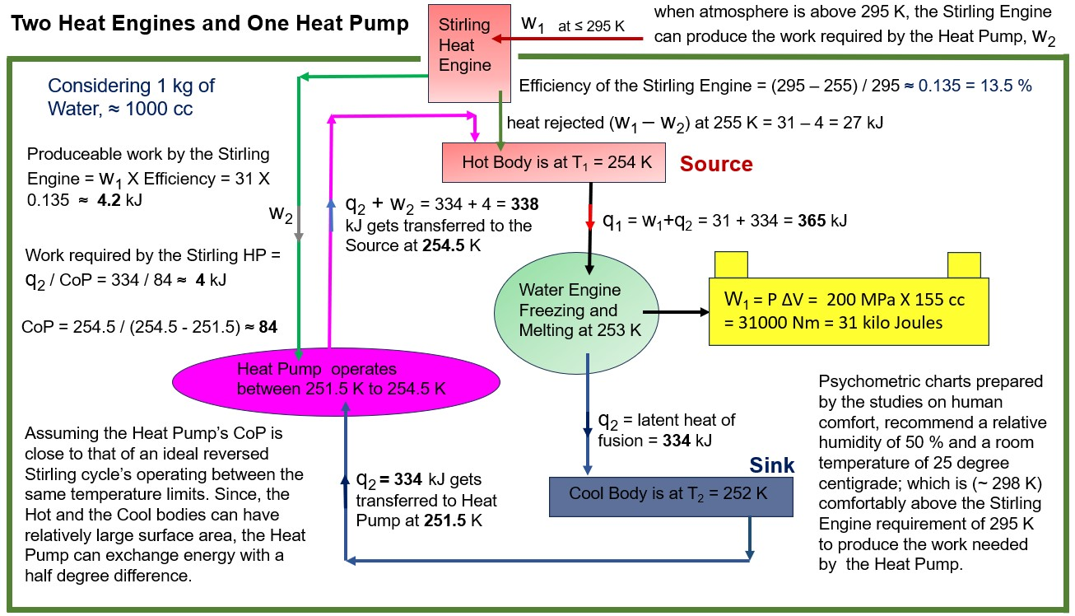

**Practical, the Evidence**

Prof. Dr. Mohamad Kharseh conceptualized and practically tested energy generation using freezing water. Here is a snippet on extractable energy from the 6th page of the published document.

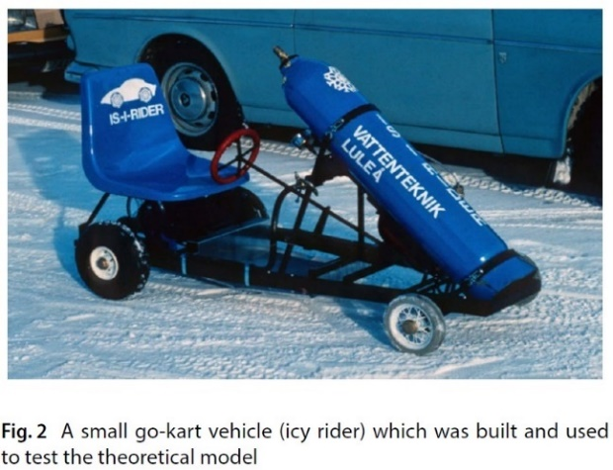

Hence, the developed conceptual model is an acceptable model to simulate the utilization of water freezing for creating mechanical energy. Another important result can be obtained from the developed model here is that the maximum amount of energy that can be generated by the freezing of 1 L of water can be up to 22.1 kJ.

Source:

<https://doi.org/10.1007/s42452-018-0139-z>

Utilizing Freezing Water to Generate Energy

**Notes on Efficiency and Power Density**

Here, the source and sink temperatures are arbitrarily chosen to be 1 Kelvin apart from the freezing or melting point of the fluid to facilitate heat transfer, and at the same time, to prove the possibility of exceeding Carnot's efficiency. Hence, the selected temperature difference significantly impacts the system's efficiency, power density, and a demand for exotic materials.

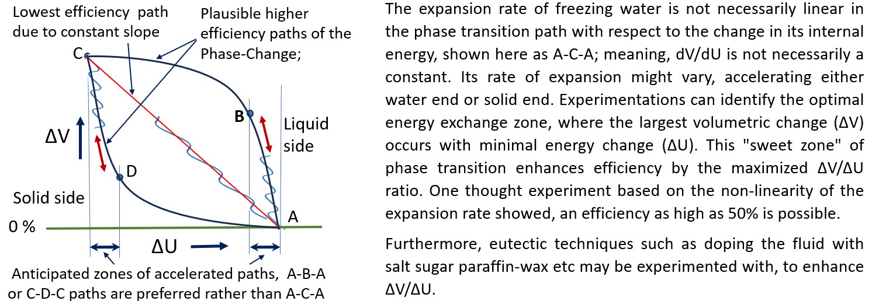

**A Thought Experiment**

Let us begin with the assumption that the volumetric change in the phase transition occurs rapidly at the solid, meaning, the transition is like the path A-D-C-D-A as shown above. Consider 1 kg of ice (1090 cc) that has fully formed at standard atmospheric pressure (1 atm) and a temperature of approximately 273 K. At this stage, the ice has expanded by about 9%. This state is marked as point ‘**a**’ along the phase change path ‘**Aa**’ on the volume-internal energy (V-U) diagram shown below.

Now, let us analyse the freezing process under pressure. When water freezes under a pressure of 200 MPa at 253 K, it follows the phase change path ‘**Bb**.’ Applying a pressure of 200 MPa to the ice compresses it, performing mechanical work and increasing its internal energy. This results in the melting of the ice, shifting the melting point to 253 K. Consequently, the fluid state must align with a point on the high-pressure path ‘**Bb**,’ denoted as ‘**c**.’ This transition signifies that the system moves from the low-pressure phase change path ‘**Aa’** to the high-pressure path ‘**Bb**.’

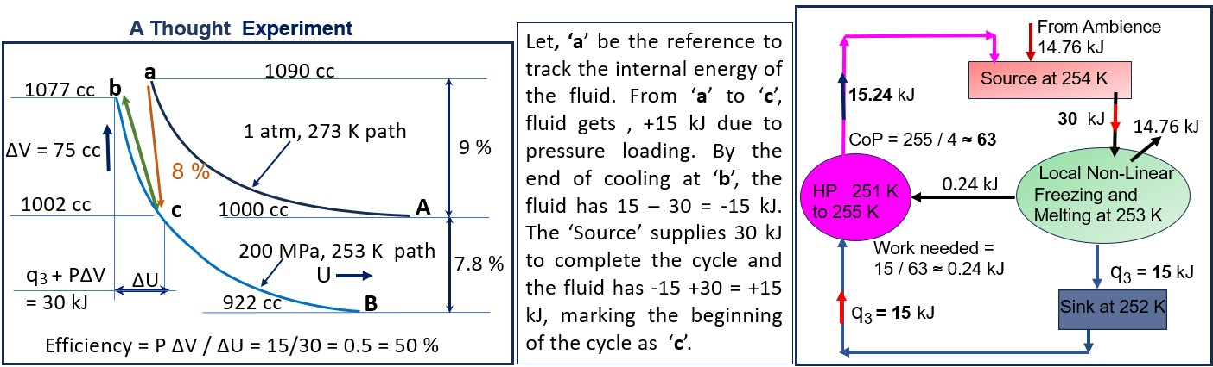

Next, the cooling process begins. When the fluid is brought into contact with a thermal sink at 252 K, heat is extracted, causing the fluid to freeze. By the end of the cooling process, the sink absorbs approximately 15 kJ of heat, and the fluid solidifies along the ‘**Bb**’ path, reaching its final state ‘**b**.’ As the fluid freezes, it expands by approximately 75 cc, performing mechanical work against the 200 MPa pressure, resulting in a work output of 15 kJ.

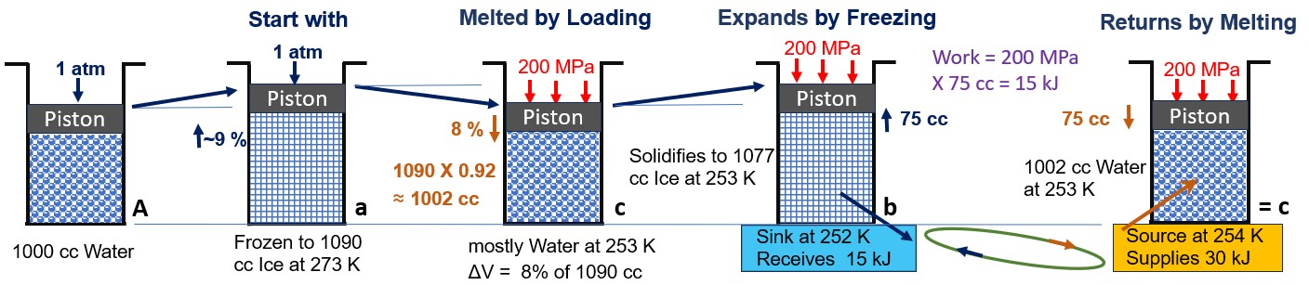

To complete the cycle, the system is brought into contact with a heat source at 254 K. The source provides approximately 30 kJ of energy, equivalent to the sum of the heat rejected to the sink and the mechanical work output. This input energy allows the fluid to return to its original state, thus completing the cycle. Consequently, the system operates in a cyclic manner between states ‘**b**’ and ‘**c**,’ producing 15 kJ of work output for every 30 kJ of heat input.

Compared to the earlier setup where source supplies 365 kJ for a net of 25.7 kJ; the thought experiment results in a net of 14.76 kJ for 30 kJ supplied. Therefore, the **power density improvement** is (14.76/30) / (25.7/365) = 14.76 X 365 / (30 X 25.7) = 5387 / 771 = about **7** times;

Since this is related to **PMM2** (Perpetual Motion Machine of the Second Kind), efficiency is not the primary concern, but rather the power density and equipment’s life. Further, to minimize the number of moving parts to enhance the life of the equipment we can use solid-state electronics to convert pressure pulses to ‘**charge**’ by piezoelectric effect for the engine and Peltier’s phenomenon of magneto caloric effect in designing the heat pump. By leveraging the anomalous expansion of water upon freezing and optimizing the phase change dynamics, it presents a novel approach to energy conversion that could lead to significant advancements in recycling the low-grade-dissipated thermal energy.

**Meta AI** envisions self-sustaining ecosystems thriving in harmony in space, in air, in liquid, on or under the ground. Lush gardens, nourished by lighting sourced from the technology, flourish with vibrant grains, fruits, and vegetables. Meanwhile, innovative PMM2s seamlessly harness the heat generated by humans, pets, plants, and machinery, converting it back into power – creating a closed loop of energy efficiency and sustainability.  **"The highest form of human intelligence is to observe yourself without judgment."** – **J. Krishnamurti.**

