1. **Deploying test databases**

cd dbs  
sudo docker-compose up –d

**2. Deploying Jenkins instance**

1. Build an image running Jenkins instance on JDK15 and MVN3 (from jenkins dir)  
   sudo docker build --tag="jenkins_mvn3_jdk14" .
2. Deploy Jenkins  
   sudo docker-compose up –d
3. Copy the auto-generated admin password from the Jenkins docker console  
   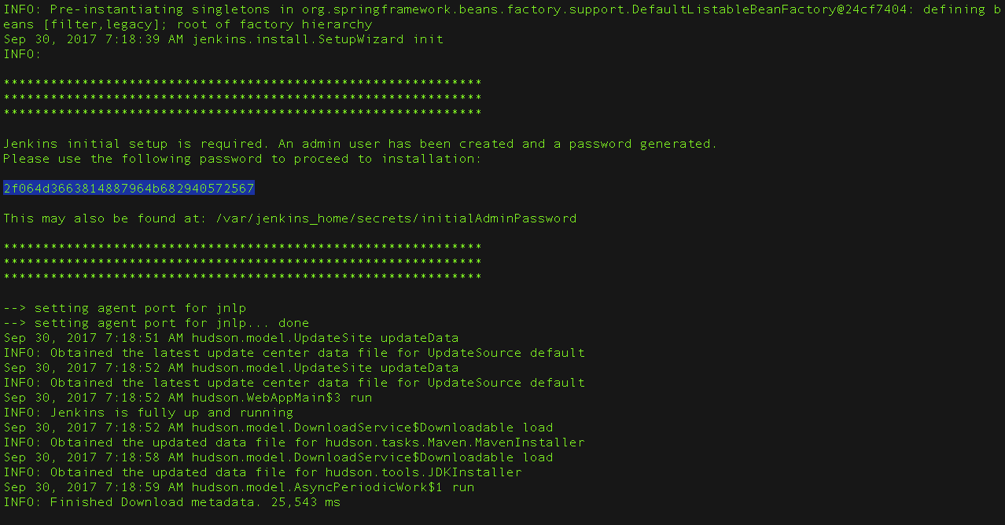
4. Go to the Jenkins main page (ex: <http://138.48.33.187:8081/>) and paste the copied password

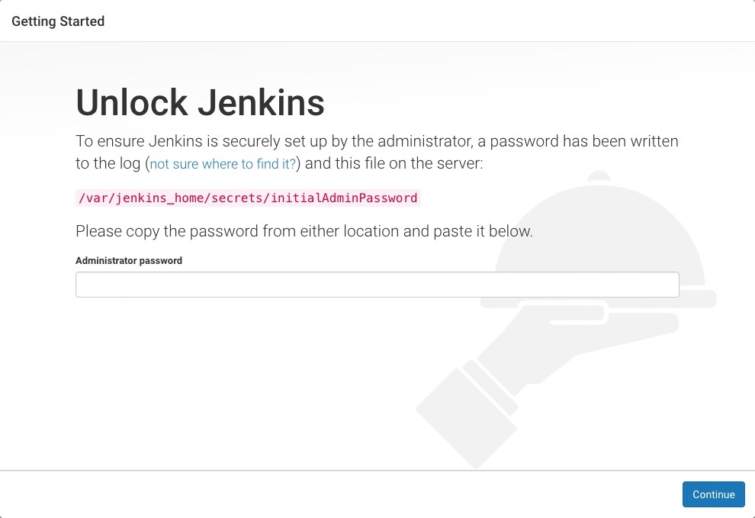

1. Install suggested plugins

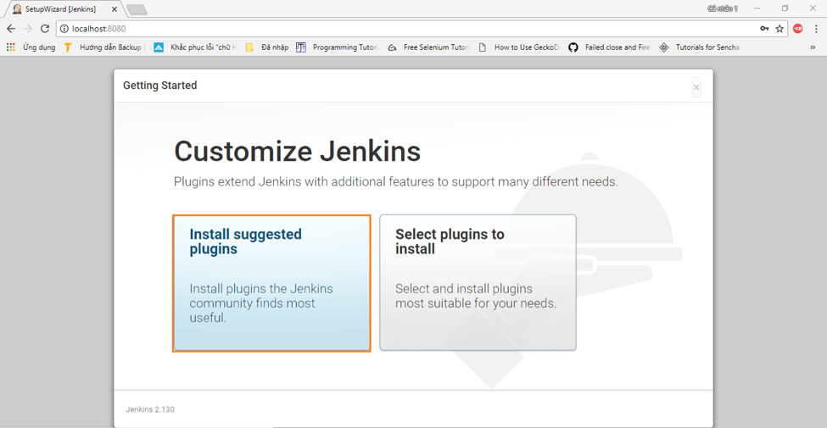  
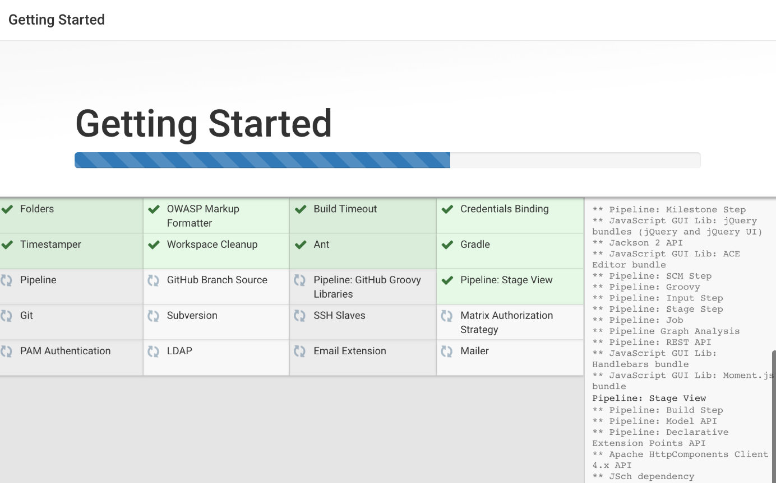

1. Create first user account  
   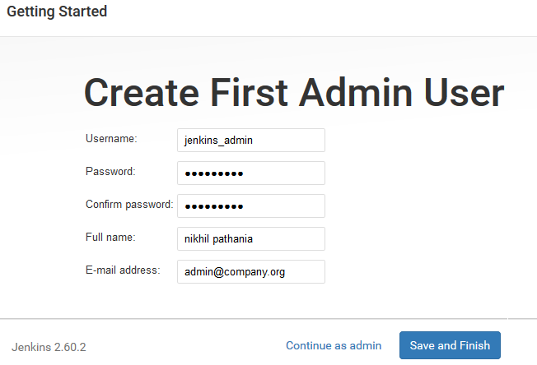
2. Configure Jenkins system  
   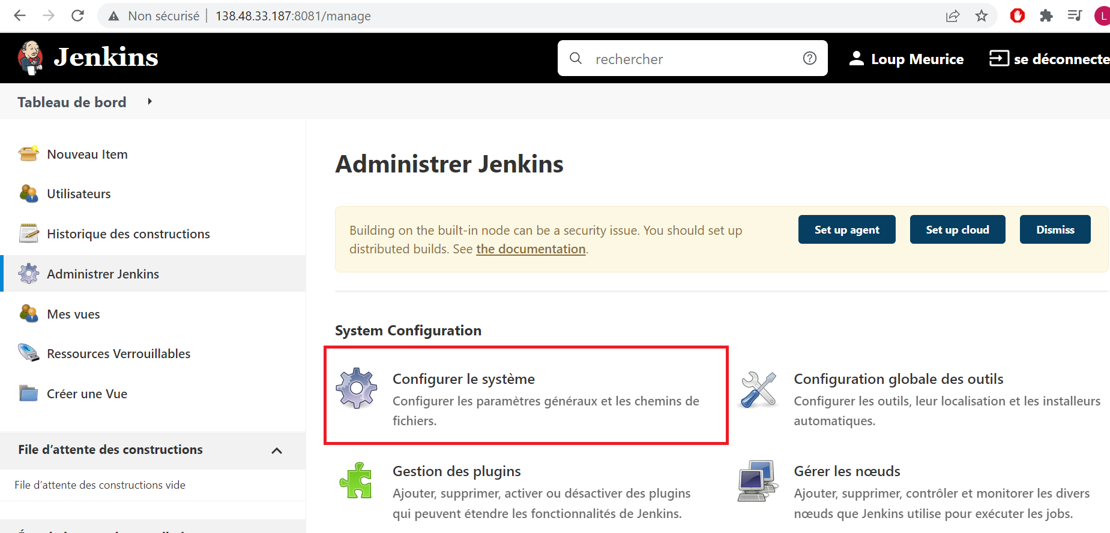  
     
   - Extended E-mail notification  
   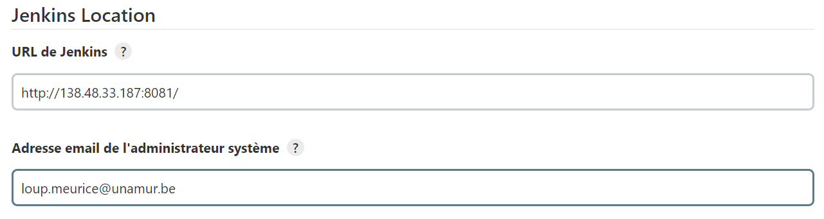  
   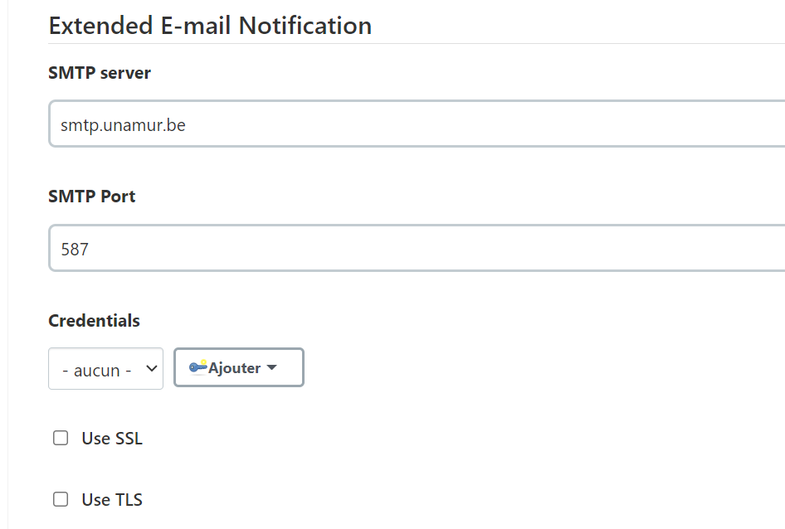  
   - Notification par email  
   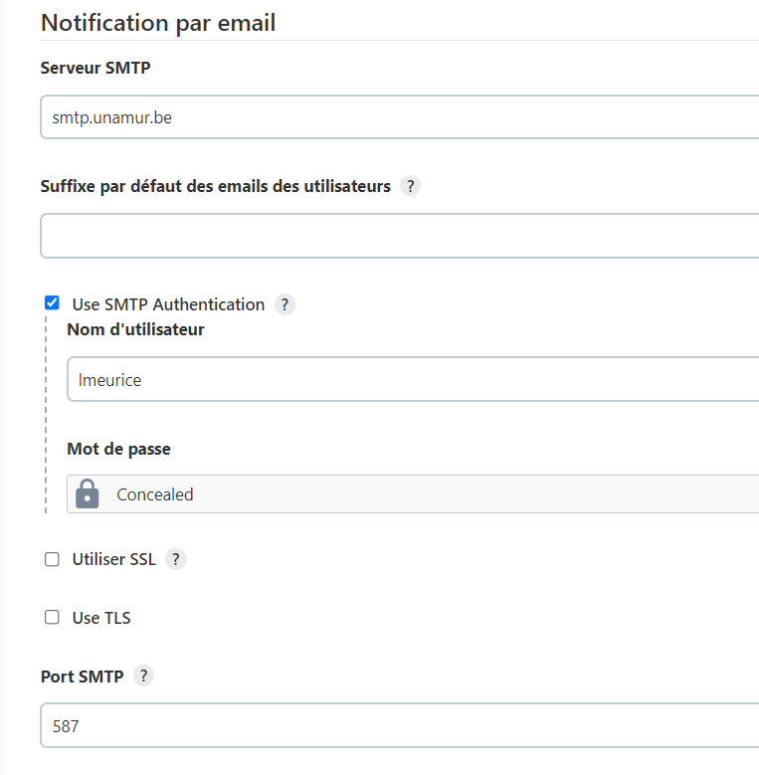
3. Configure JDK environment  
   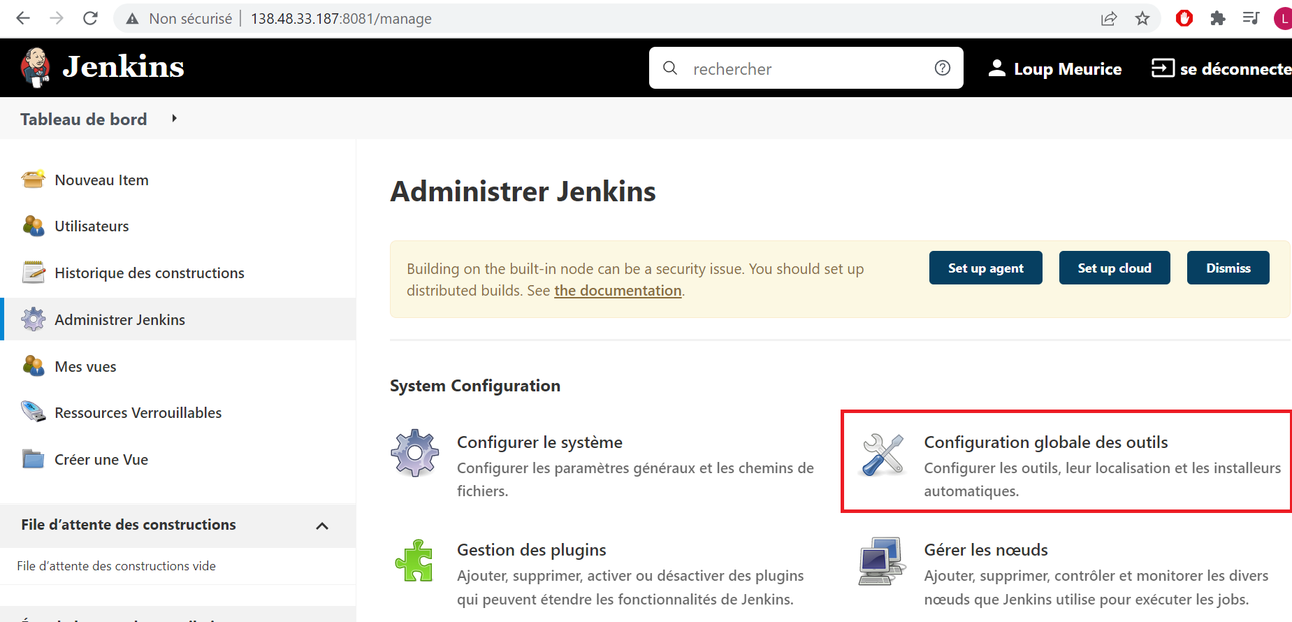  
   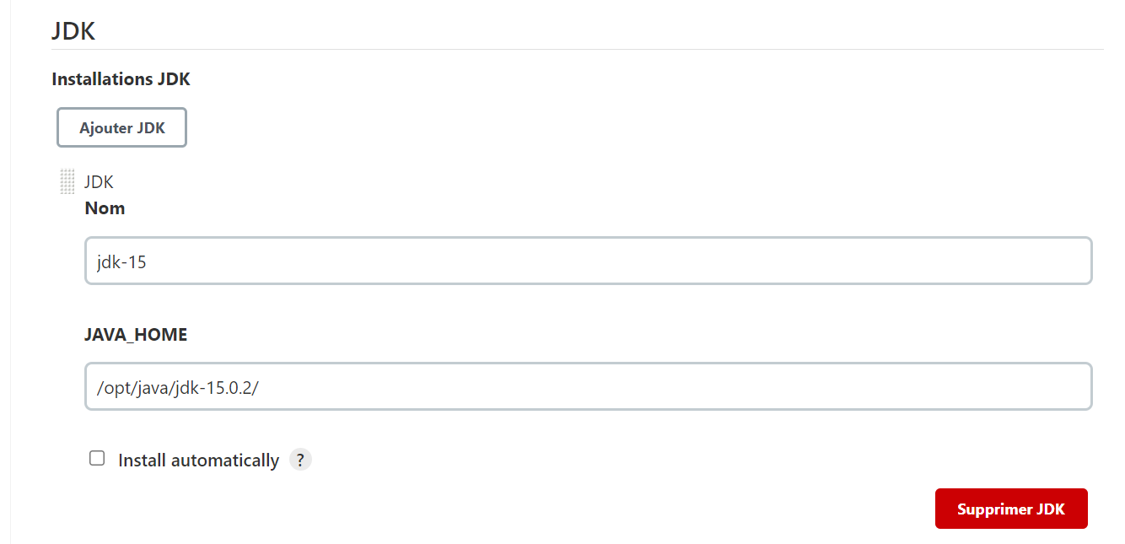
4. Create Jenkins job  
   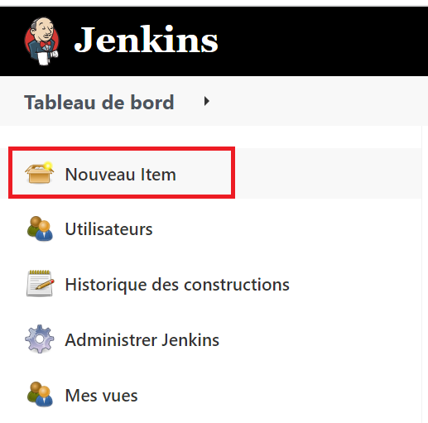  
   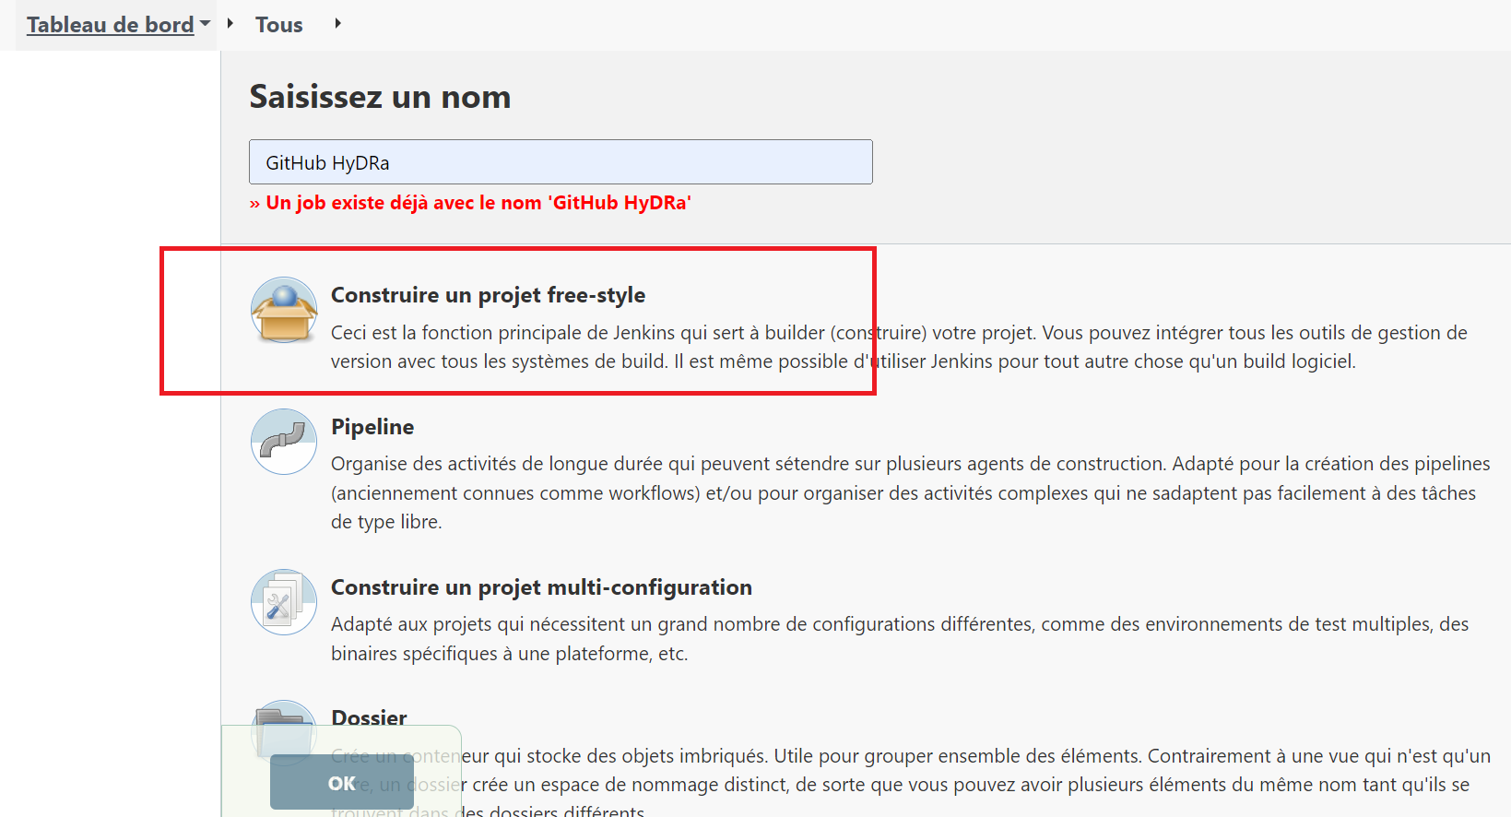  
   - Git configuration  
   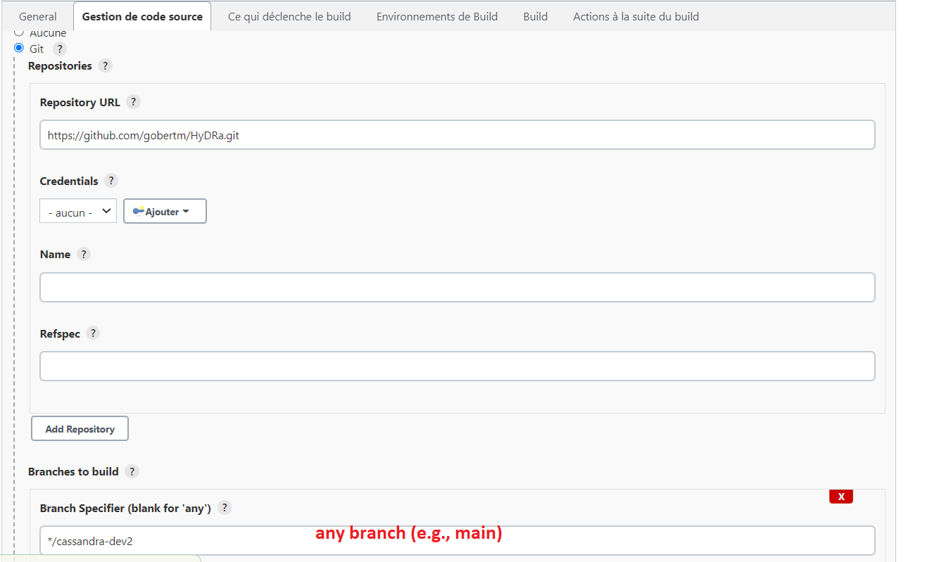  
   - daily trigger (every day at 16h05)  
   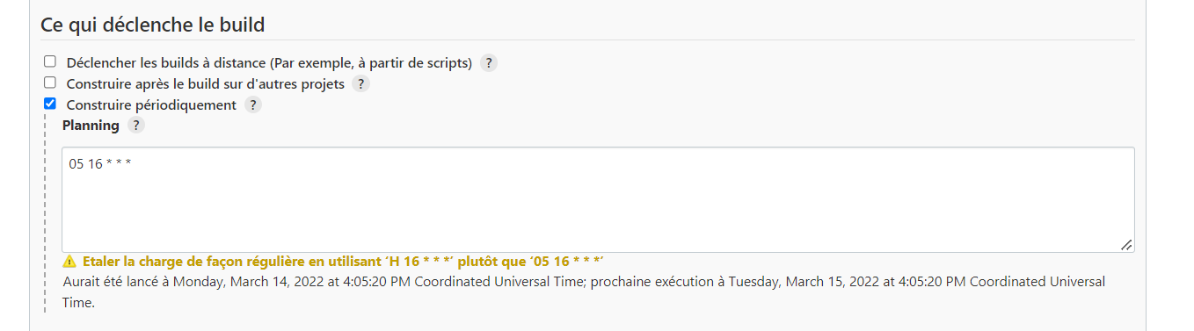  
   - build script  
   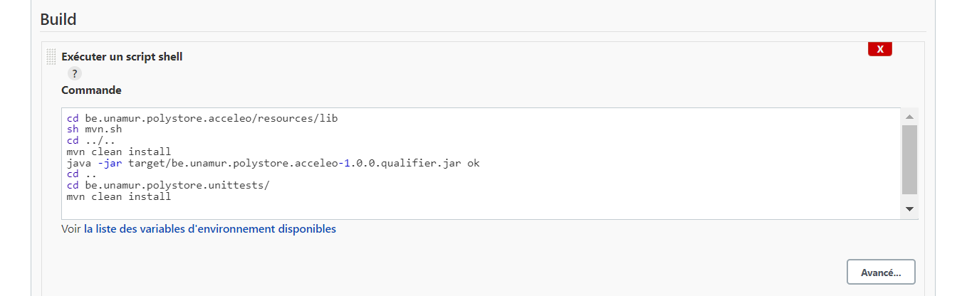  
   - e-mail notification at the end of the build  
   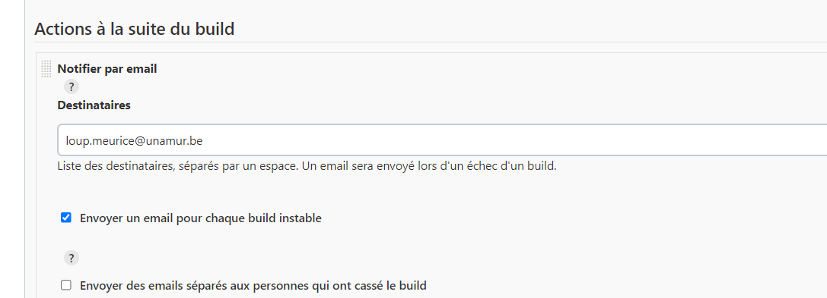  
   - start the build  
   