**Internship Report: Simple Calculator Component**

1. **Task Description**

Create a simple calculator component that performs basic arithmetic operations and use reuable common component for the button

1. **Task Output Screenshot**

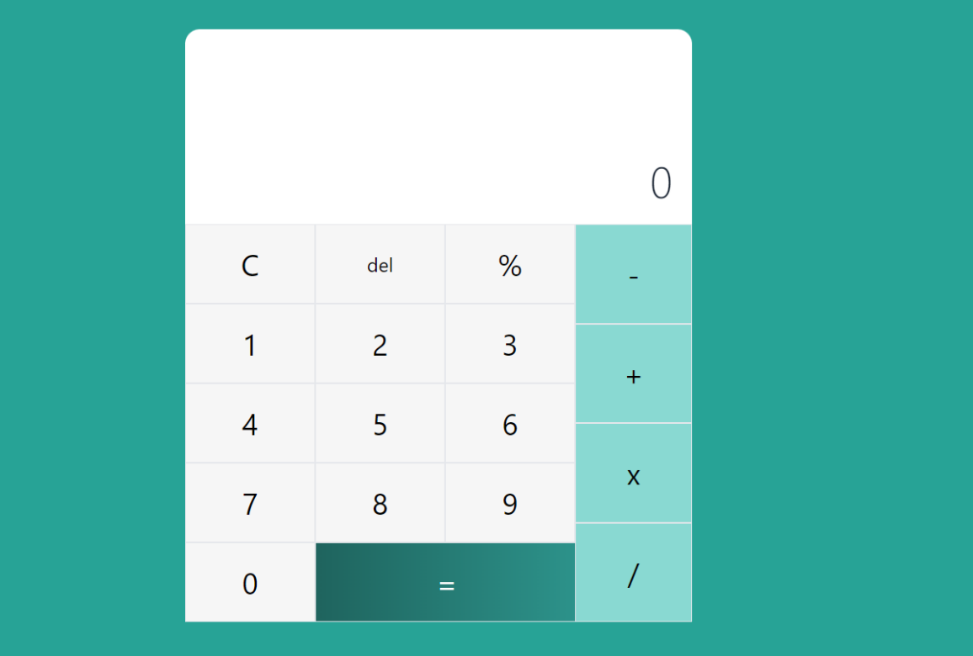

1. **Algorithm Used In Task**

* In this project, I developed a calculator component using **React** and **Tailwind CSS** to perform basic arithmetic operations.
* The key components and algorithms utilized are as follows:
* **Calculator Component**:

This is the main component that holds the state of the calculator (e.g., current input, result) and handles the logic for performing calculations. It renders the display and buttons.

* **Reusable Button Component**:

A custom button component was created to standardize the appearance and behavior of all buttons within the calculator. This component accepts props for:

**Label**: The text displayed on the button (e.g., numbers, operators).

**onClick**: A function to handle the button click event, allowing different behaviors depending on the button type (number, operator, etc.).