**Internship Report: Dynamic Table Generator**

1. **Task Description**

Create dynamic table based on array values it will automatic create table for that.

1. **Task Output Screenshot**

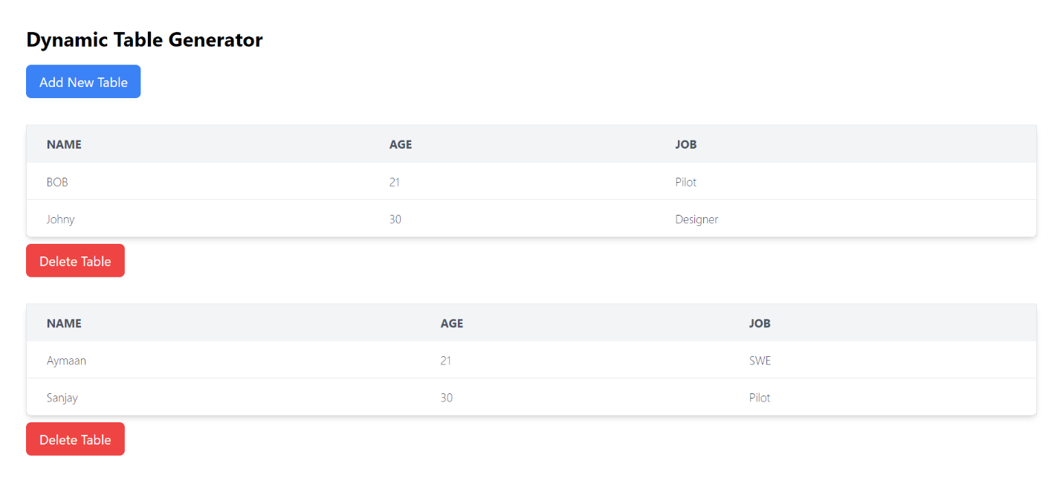

1. **Algorithm Used In Task**

Dynamic State Management (React's useState):

Algorithm: State Updating

Description: This algorithm uses the useState hook to manage a dynamic list of tables. Whenever a new table is added, the state is updated to include the new table. Similarly, when a table is deleted, the state is updated by filtering out the table at the corresponding index.