**Internship Report: Shared input component**

1. **Task Description**

Create common shared component that can handle common input like input textarea checkbox radio and use this component into one form

1. **Task Output Screenshot**

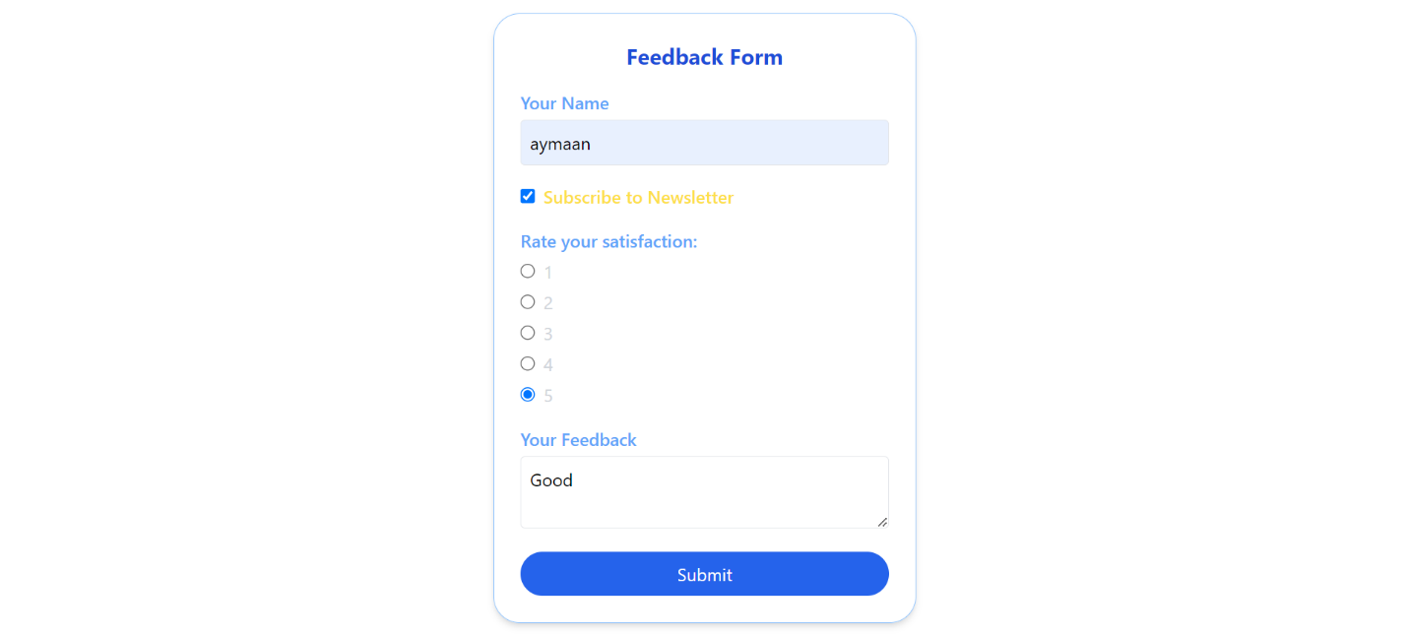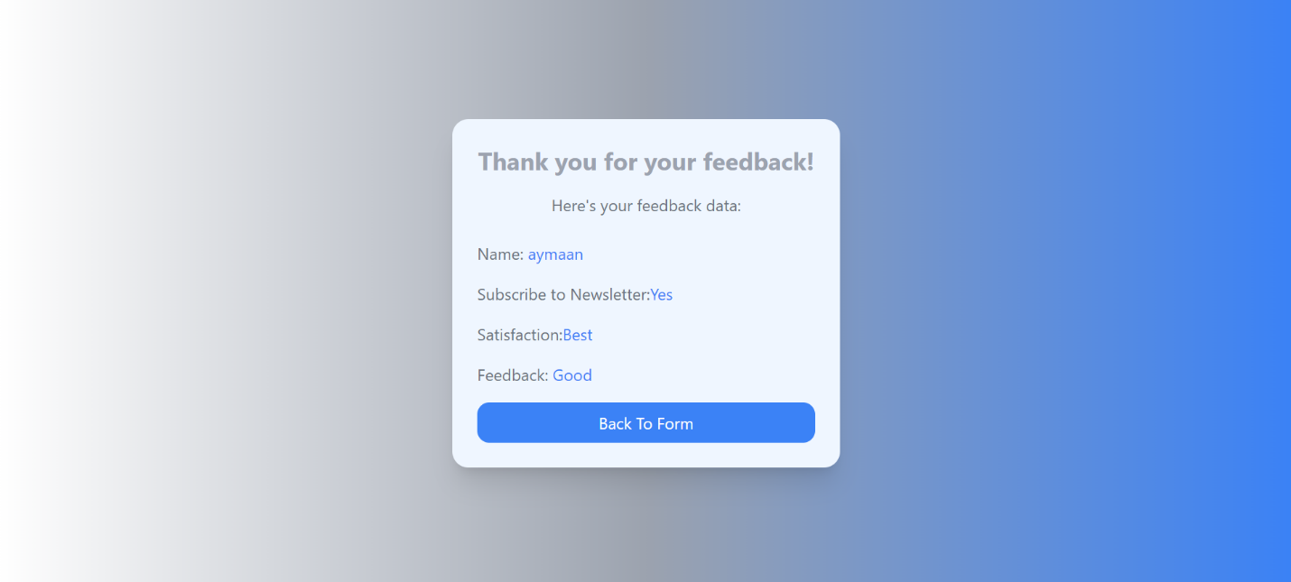

1. **Algorithm Used In Task**
2. **Create a Common Input Component**:
   1. This component should be able to accept props like type, name, value, onChange, Etc…
   2. Based on the type prop, render the appropriate input type (input, textarea, checkbox, radio).
3. **Use Tailwind for Styling**:
   1. Apply conditional classes for different input types.
   2. Ensure all form elements have a consistent look and feel.
4. **Integrate Common Component in a Form**:
   1. Create a form that uses the common input component multiple times with different configurations for each input type.
   2. Use React state to manage form data.
5. **Handle Form Submission**:
   1. On form submission, display a notification using react-hot-toast.