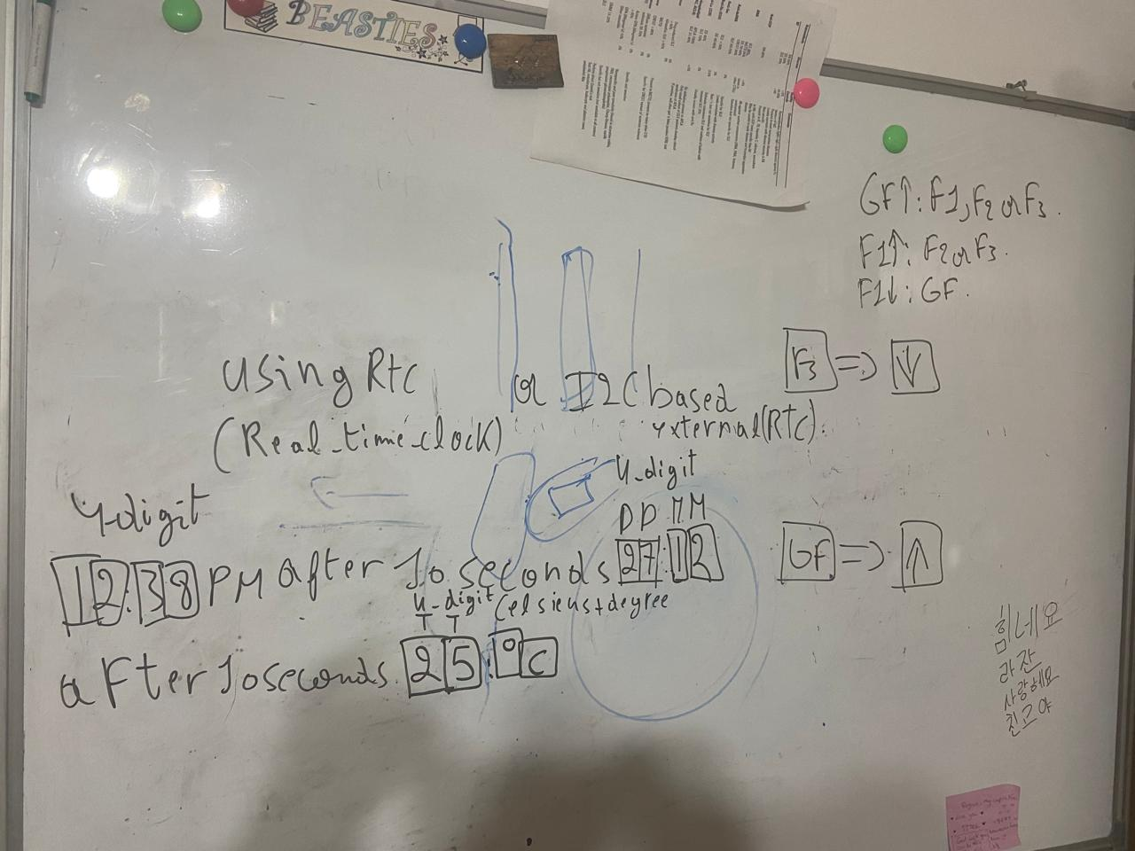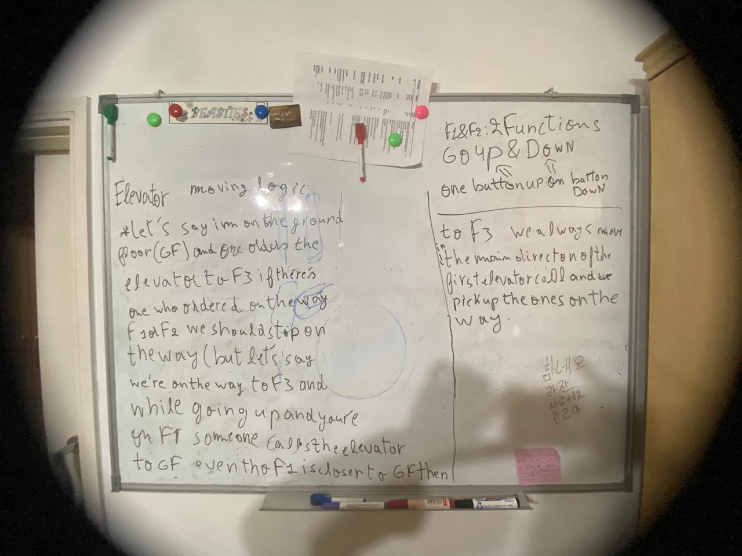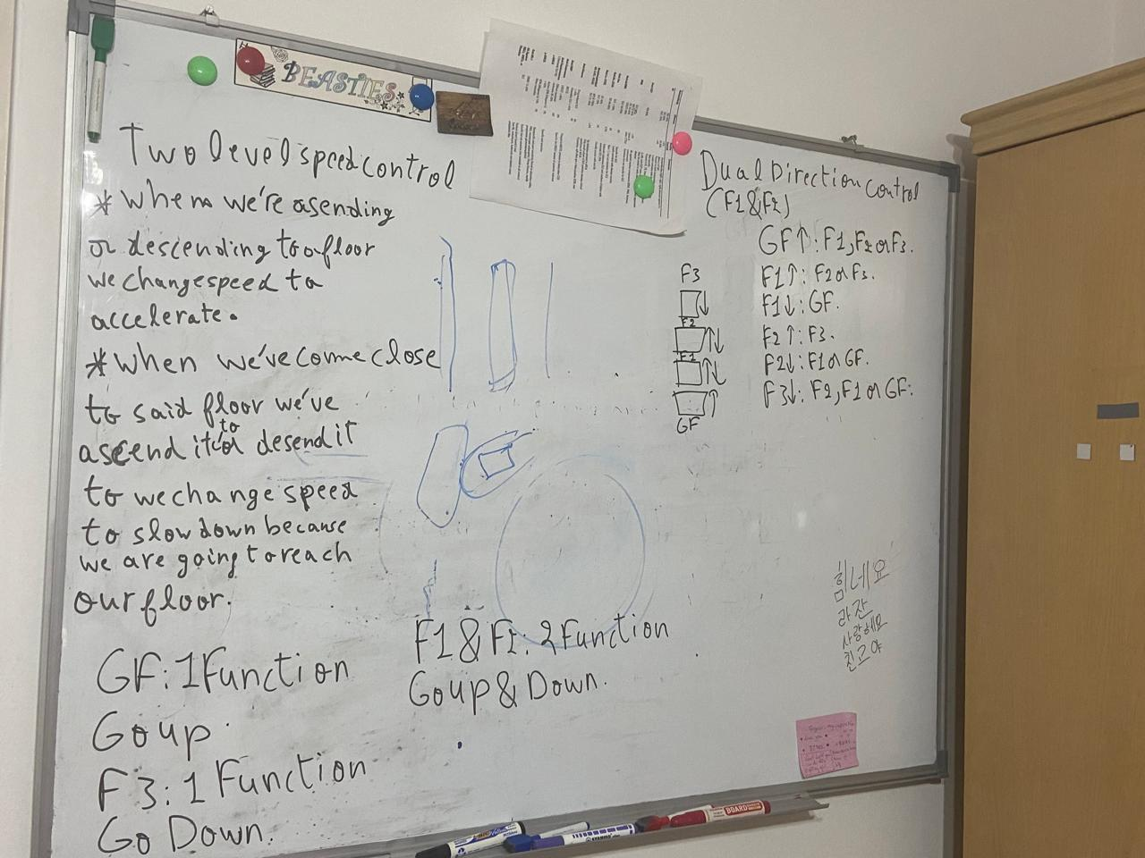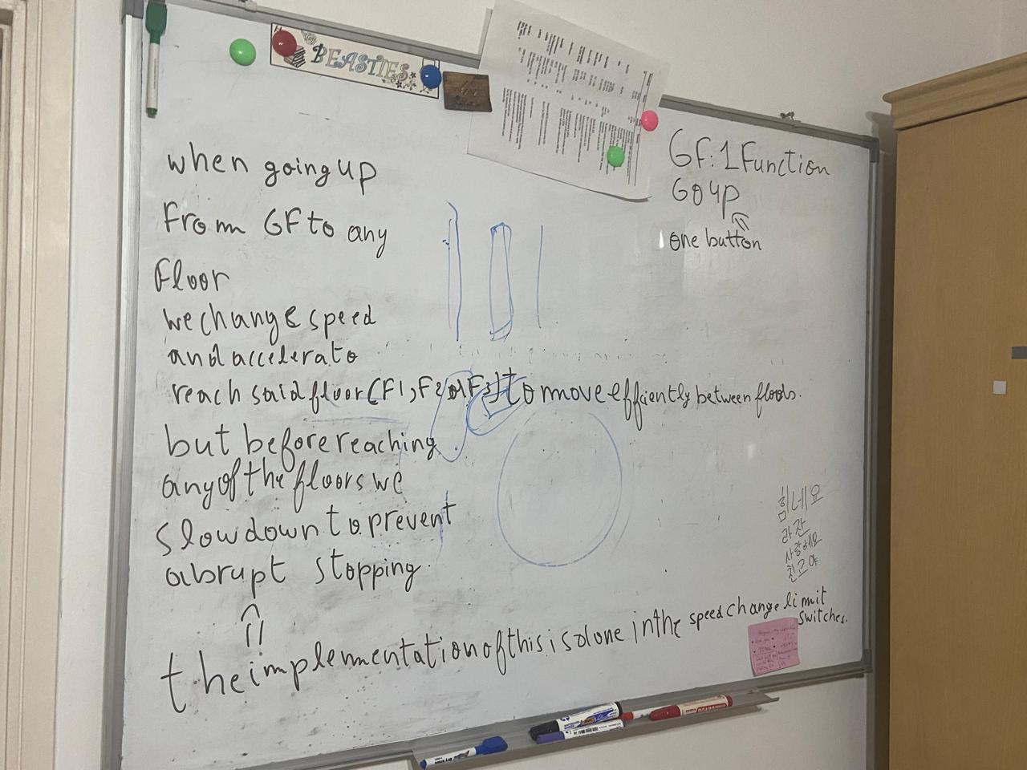

Summary of whiteboard brainstorming:

GF:1 FONCTION GO UP

F1 AND F2: 2 FONCTIONS GO UP & DOWN

F3:1 FONCTION GO DOWN

• Two-level speed control

WHEN FIRST TRYING TO REACH A CERTAIN FLOOR BY ASCEND OR DESCEND WE ACCELERATE(CHANGE SPEED FASTER FONCTION) TILL WE'RE CLOSE TO REACHING SAID FLOOR,

BY ASCEND OR DESCEND WE SLOW DOWN(CHANGE SPEED SLOWER FONCTION) THEN WE STOP(STOP FONCTION) AT SAID FLOOR (GF,F1,F2 AND F3).

• Dual direction control

GF^:F1,F2 OR F3.

F1^:F2 OR F3.

F1 DOWN:GF.

F2^:F3.

F2 DOWN:F1 OR GF.

F3 DOWN:F2,F1 OR GF.

Three limit switches for cabin feedback:

o One indicates the STOP position.

o One indicates SPEED CHANGE when going UP (except of F3).

o One indicates SPEED CHANGE when going DOWN (except on GF).

Keys: HH(hours):MM(minutes of said hour),MM(Month of the year):DD(day of the month)and TT(temprature):DT(degree celsius)

4-digit display become 5-digit including the 2 points in the middle

HH:MM MM:DD TT:DT

12:38 after 10 seconds 27:12 after 10 seconds 25:'C all this displays loop forever in sequence dislpaying each one 10 seconds apart

date and time can be displayed using a Real-Time Clock (RTC) Either you implement it by software, or

▪ Use an I2C-based external RTC (datasheet included).

The temperature is delivered by the famous LM35 analog sensor.

the logic of the elevator as a whole:

1st case:

firstly let's say the elevator is on the ground floor and im on the third floor and im the first one who called for it it should come to me

but in the case that there's someone after who ordered on the first or second floor and is on the way of the intial service to the third we shall stop

at their level and pick them up on our way to the third floor.

Elevator moving logic:

-Let's say im on the ground floor(gf)and one orders the elevator to f3 if there's one who ordered on the way(f1,f2) we should stop on the way(but let's say)

we're on the way to f3 and while going up and you're on f1 someone calls the elevator to gf even tho f1 is closer to gf then to f3 we always move in the main

direction of the first elevator call and we pick up the ones on the way.

this is a more detailed elevator logic breakdown:

Logic Breakdown

1. Initial Request

The elevator starts at the Ground Floor (GF).

The first request comes to go to Floor 3 (F3).

The elevator sets its main direction to up and begins moving upward.

2. New Requests on the Way (Same Direction)

As the elevator moves upward, it will stop at floors F1 and F2 only if someone presses the elevator call button on those floors

(i.e., they request the elevator).

If there are no requests from F1 or F2, the elevator will continue directly to F3 without stopping.

3. New Requests Against the Direction

While moving upward, if someone:

On F1 requests to go to GF, or

On GF requests the elevator to come down,

The elevator queues these requests in the opposite direction (in the downward queue) and does not stop for them during the upward journey.

Once the elevator completes its upward journey (e.g., reaches F3), it will switch its direction to down and serve the downward requests in order.

Summary of Behavior

Main Direction: The elevator prioritizes the direction of the first request.

Pickup Rules:

Same direction: Stops on a floor only if someone calls the elevator in the same direction.

Opposite direction: Queues the request for later and does not stop.

Direction Switch:

Once the elevator completes all requests in the current direction, it switches direction to serve queued requests in the opposite direction.

Example Scenario

Initial Request:

Elevator is at GF.

Someone on GF presses the button to go to F3.

Elevator sets its direction to up and starts moving.

New Request on F1:

While moving up to F3, someone on F1 presses the elevator button.

The elevator stops on F1 to pick them up.

Opposite Direction Request:

While still moving up, someone on F1 requests to go to GF, or someone on GF calls the elevator.

The elevator queues these requests for its downward journey and continues upward to F3 without stopping.

Completing the Journey:

The elevator serves all upward requests (e.g., stops at F1, F2, and F3 as needed).

After reaching F3 and finishing the upward journey, the elevator switches direction to down.

It then serves the downward requests in order (e.g., stops at F2, F1, and GF).