**----------------------------- Lecture # 02 -----------------------------**

**VCS-git**

* **Git clone**
  + **git clone** is a **Git** command line utility which is used to target an existing repository and create a **clone**, or copy of the target repository.
  + **Command:**

**git clone https://github.com/Ayman-Shafique/Mobile_Computing_Practice.git** 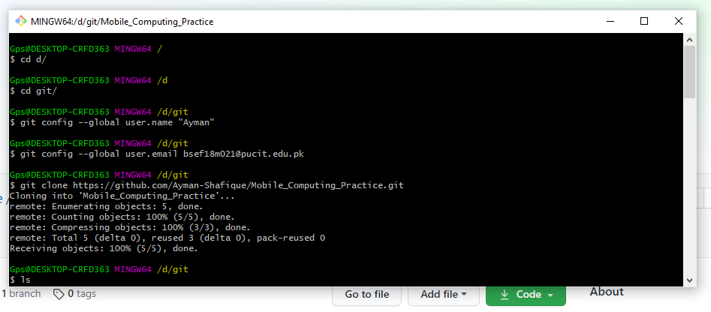

* **Git add**
  + The **git add** command adds a change in the working directory to the staging area.
  + **cd Mobile_Computing_Practice**
  + **Command:** git add text.txt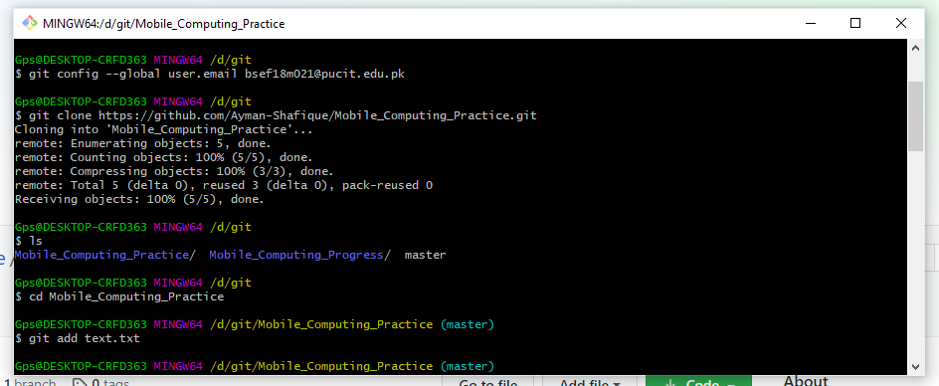
* **Git commit**
  + The **git commit** command captures a snapshot of the project's currently staged changes.
  + **Command:** git commit -m "First Commit"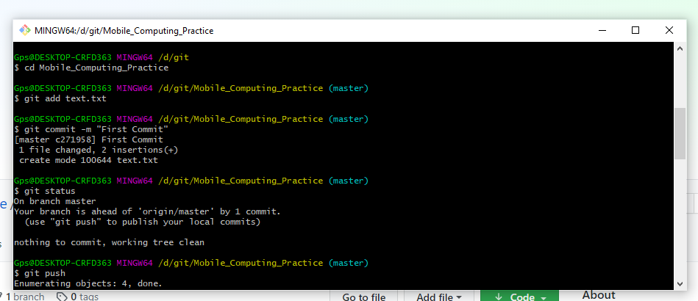
* **Git push**
  + The **git push** command is used to upload local repository content to a remote repository. **Pushing** is how you transfer commits from your local repository to a remote repository.
  + **Command:** git push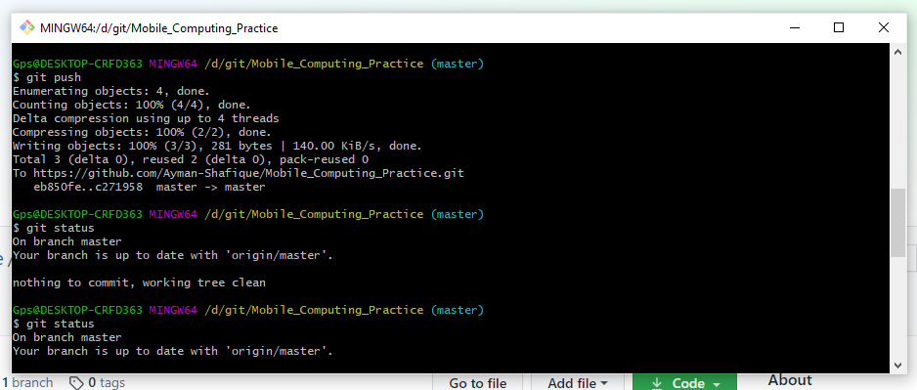
* **Git status**
  + The **git status** command displays the state of the working directory and the staging area. It lets you see which changes have been staged, which haven't, and which files aren't being tracked by **Git**.
  + **Command:** git status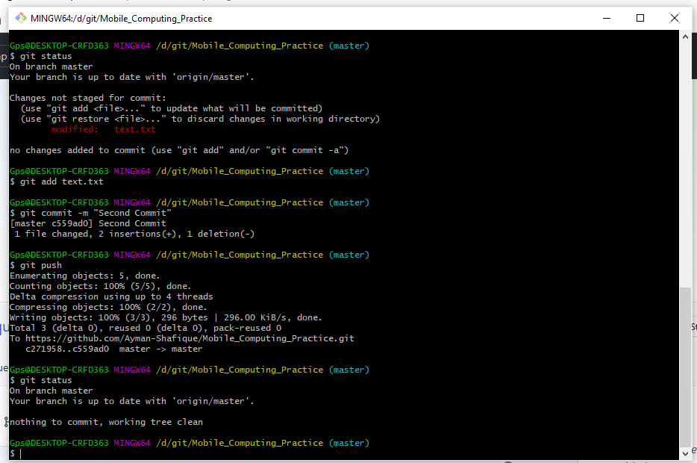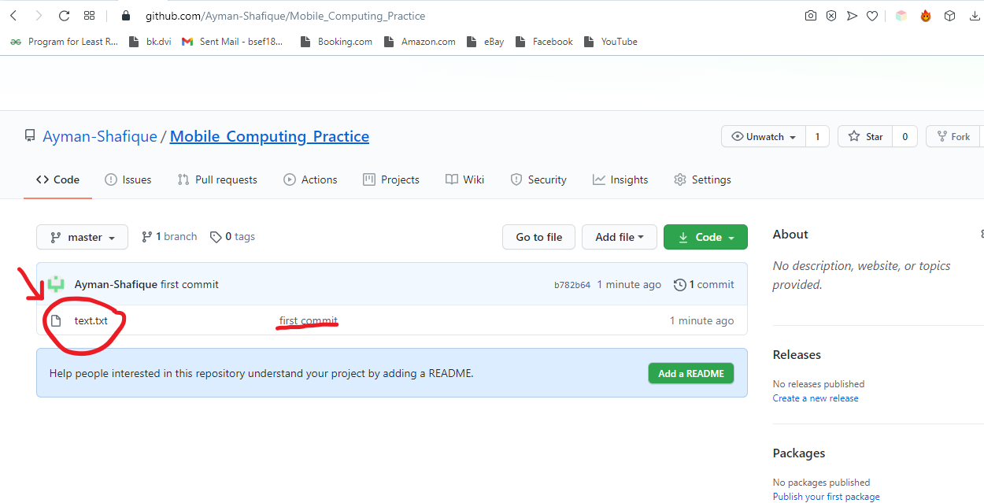

**----------------------------- Lecture # 03 -----------------------------**

**Merge Conflicts**

* **Text.txt file before editing:**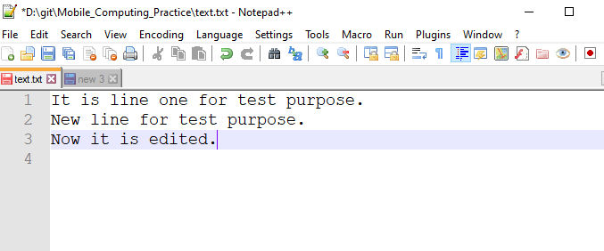
* **Editing in Web version of GitHub:**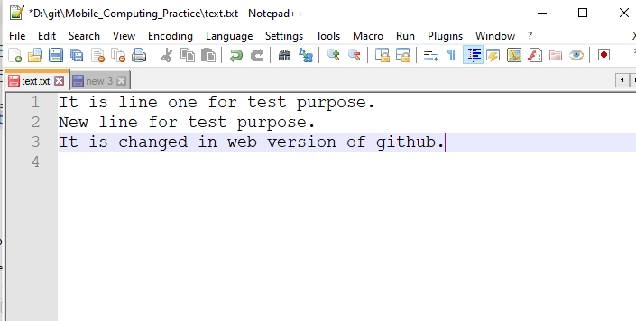
* **Online Editing:**

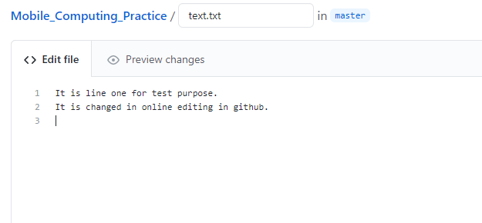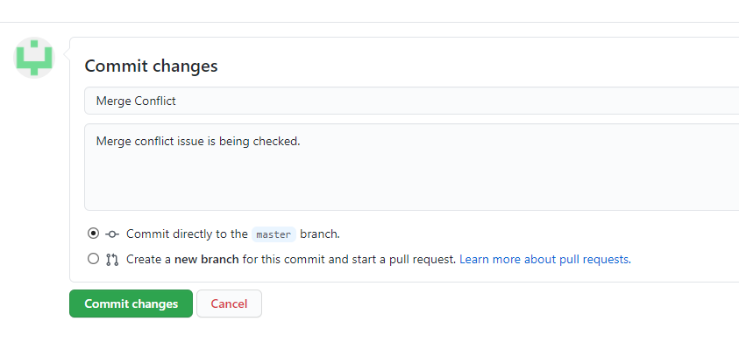

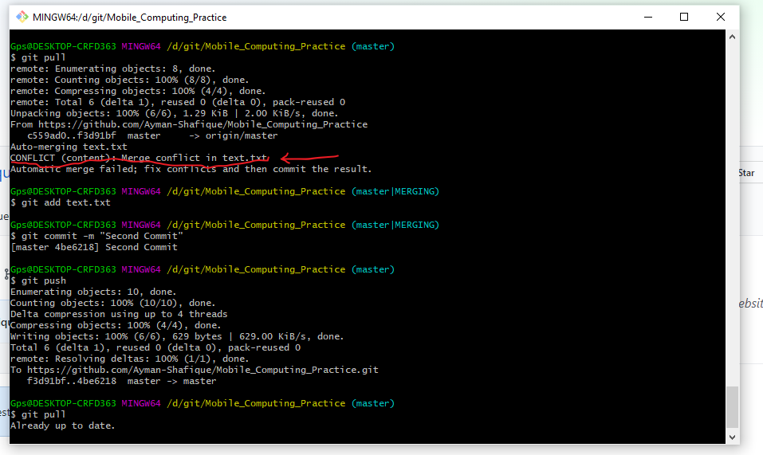

* **Merge issue resolved now text.txt is:**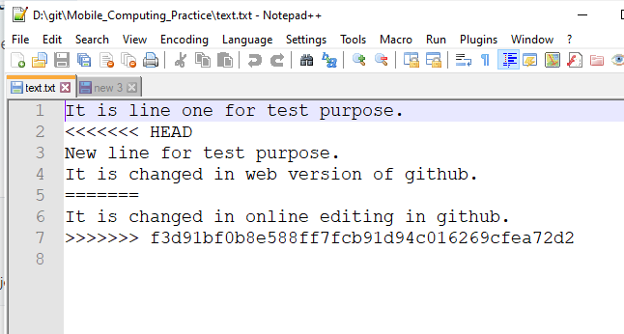
* **Git log:**
  + **git log:**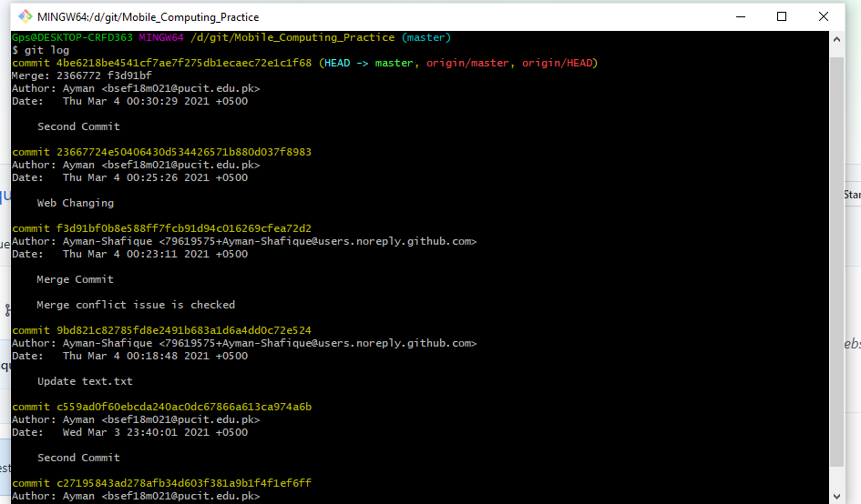
* **Git add:**
  + **Two new files are added:**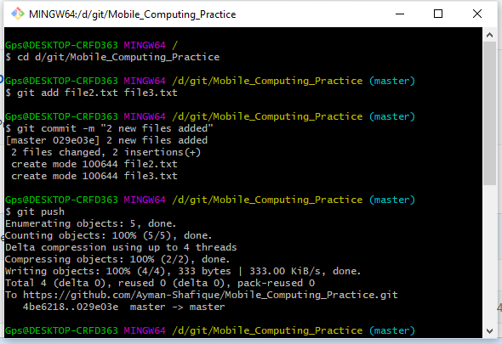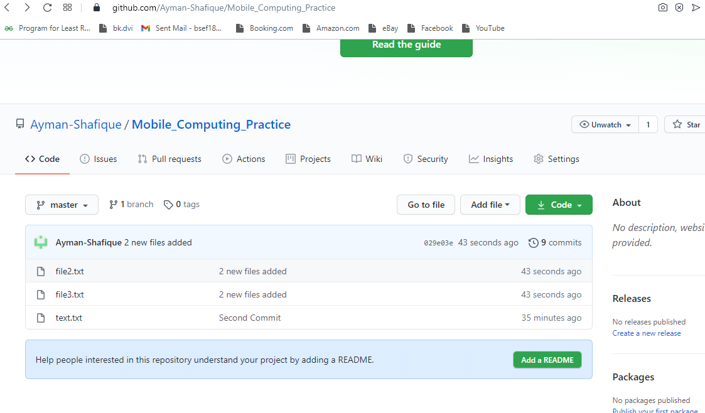
* **Git rm:**
  + **Git rm file3.txt:**

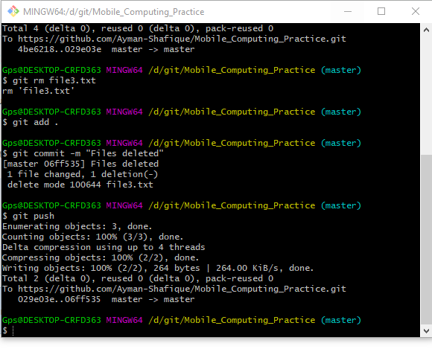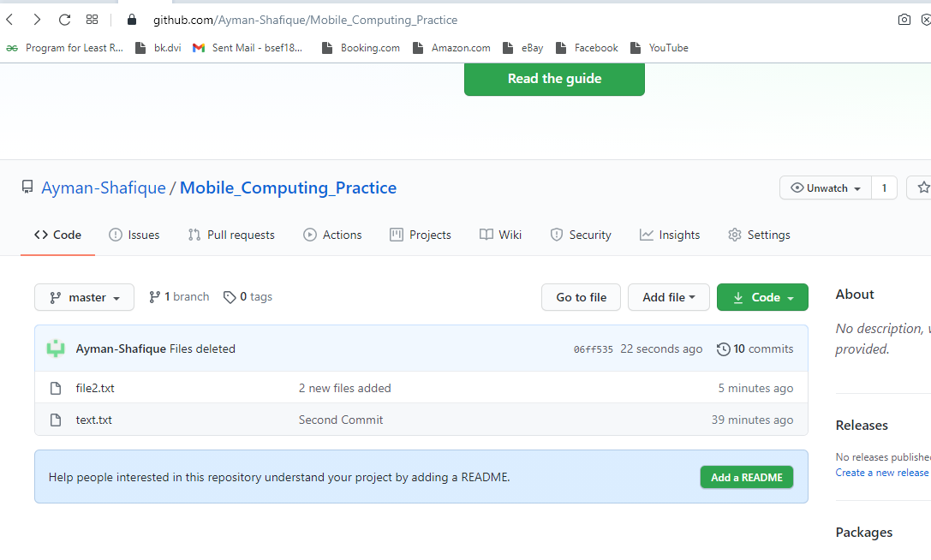

* **File3 deleted:**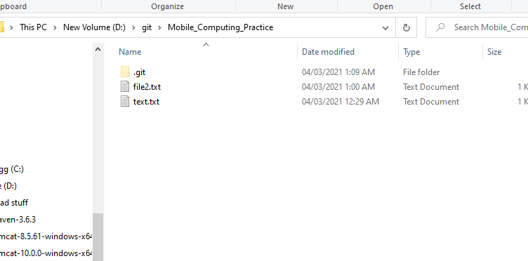
* **Merge Conflict:**

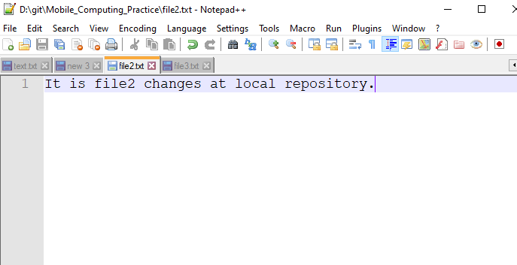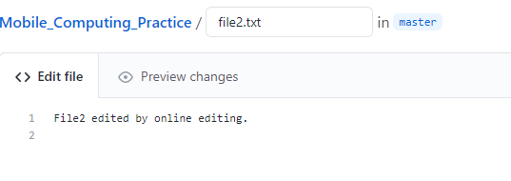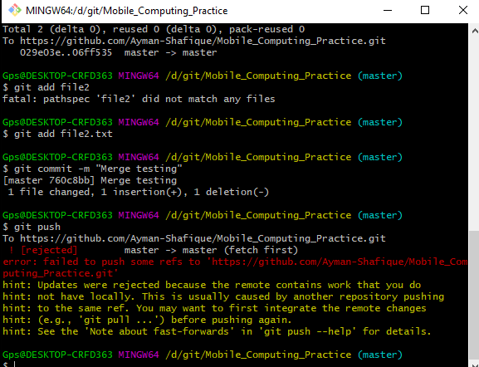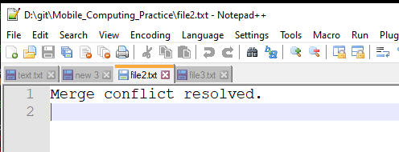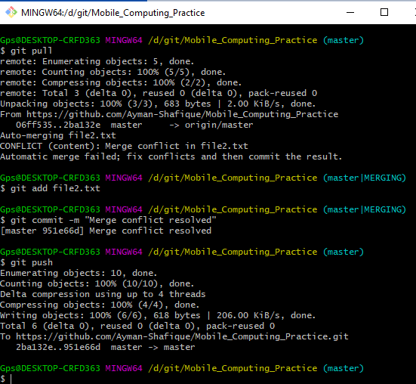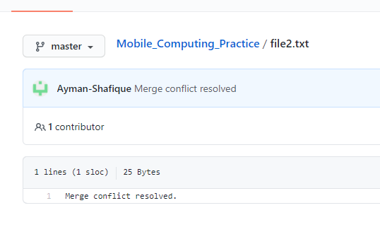

* **Git log:**
  + The **Git Log** tool allows you to view information about previous commits that have occurred in a project. The simplest version of the **log** command shows the commits that lead up to the state of the currently checked out branch. These commits are shown in reverse chronological order (the most recent commits first).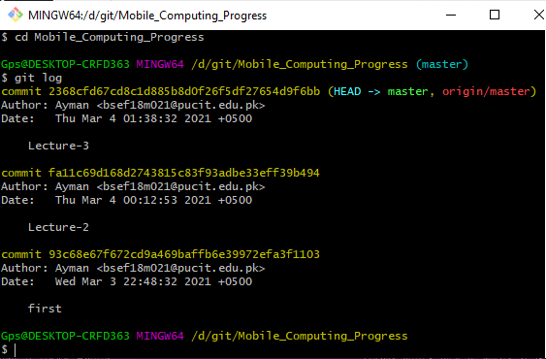
* **Branching:**
  + Lecture3.txt file: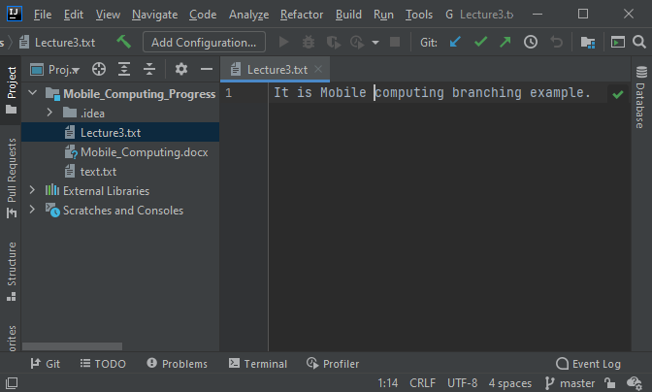
* **Git branch:**
  + List branches (the asterisk denotes the current **branch**).
  + **Command:** git branch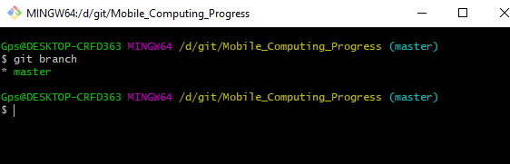
* **Git checkout:**
  + The git checkout command is used to switch between branches in a repository. Be careful with your staged files and commits when switching between branches. The git checkout command operates upon three different entities which are files, commits, and branches.
  + **Command:** git branch –b “new branch name”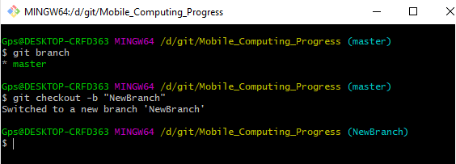
  + Check the branch in which we are right now: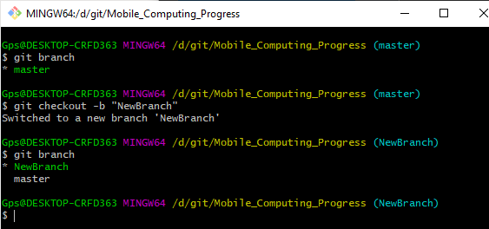
  + Now the Lecture3: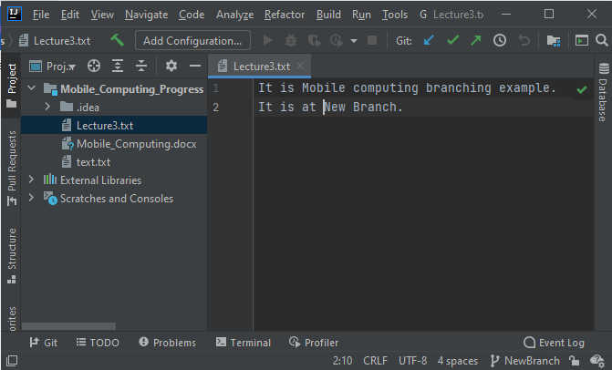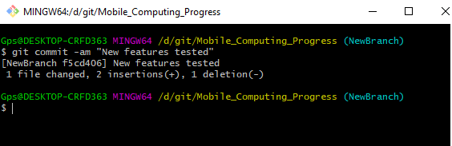
* **Git checkout:**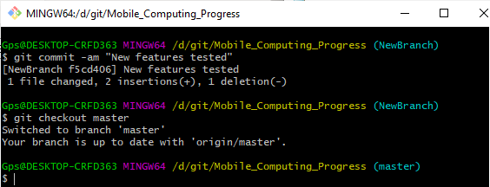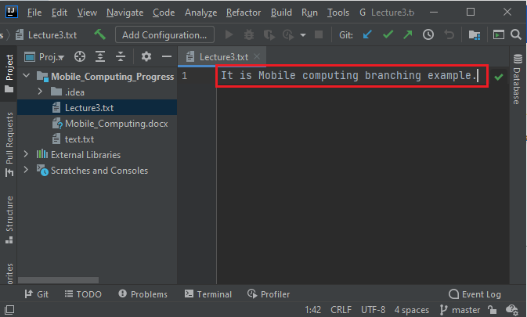
* **Git commit:**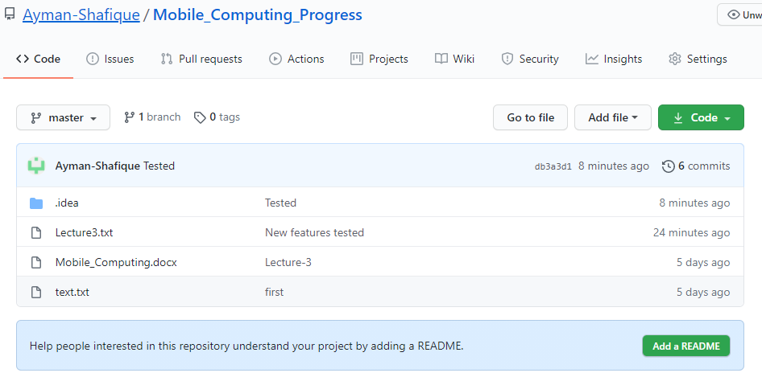
* **File: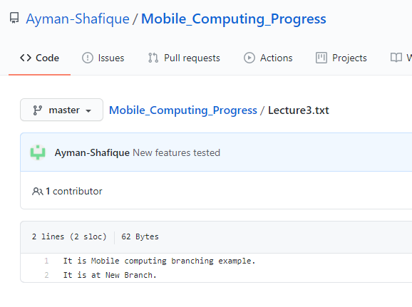----------------------------- Lecture # 04 -----------------------------**

**Android Studio**

* **Start a new project:**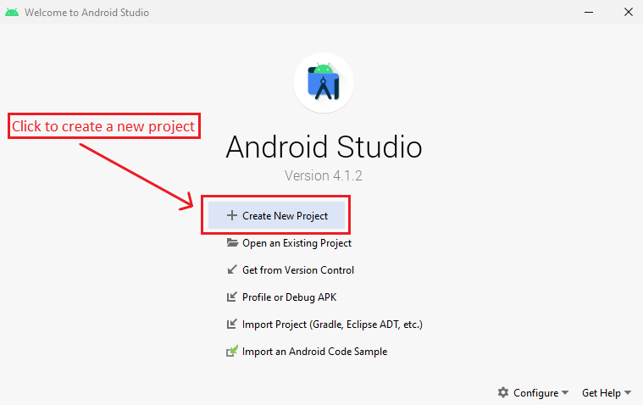
* **Select a template:**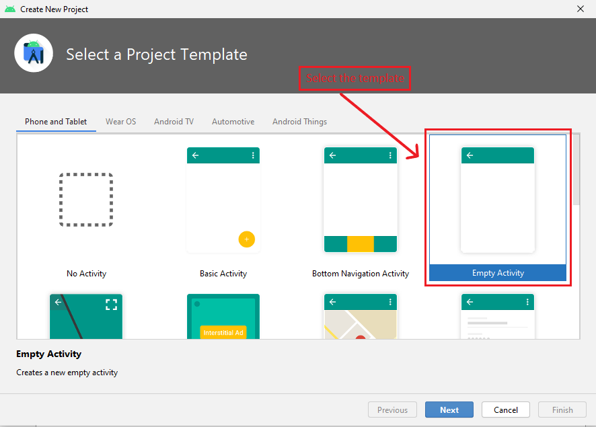

**Then enter next**  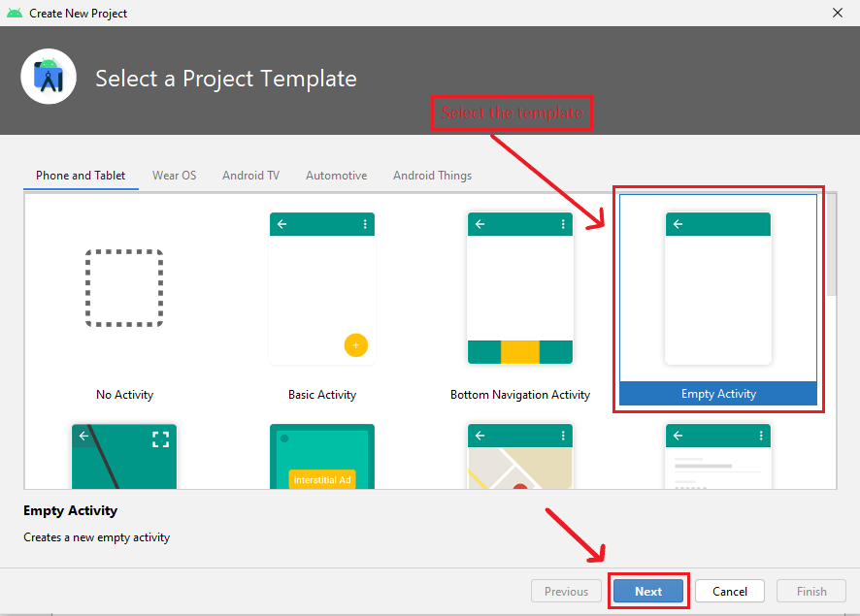

* **Project Specifications: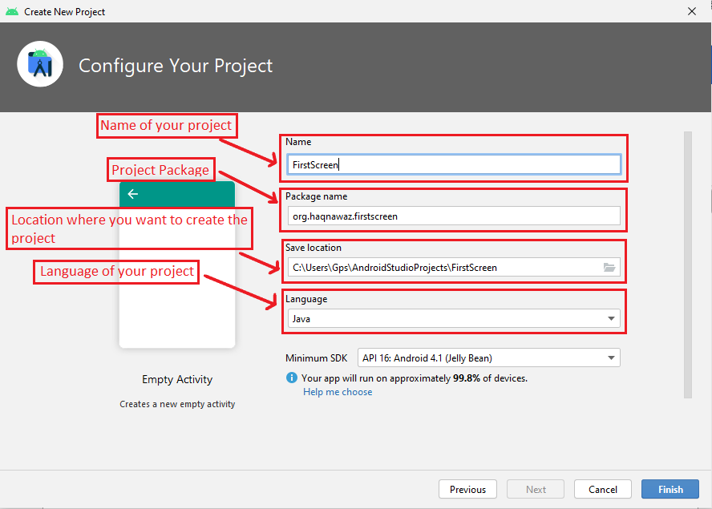 Then enter next** 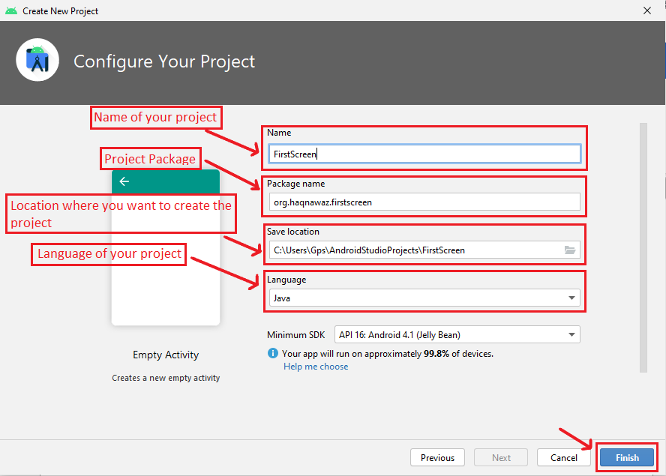
* **Project View:**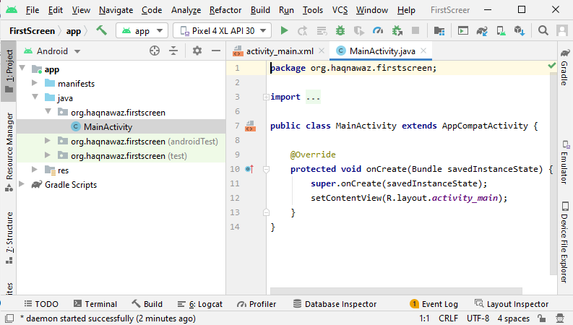
* **Go to activity_main_xml:**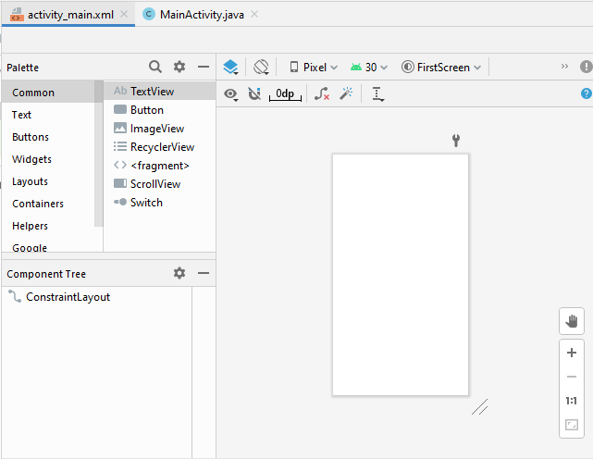

**Creating A Screen ON Android Studio**

* **Calendar View:**
  + Select the Widget.
  + Select the CalendarView.
  + Drag the CalendarView and drop on the screen.
  + Connect the top of CalendarView to the top of the screen.
  + Connect the right and left side of CalendarView to the right and left side of screen respectively.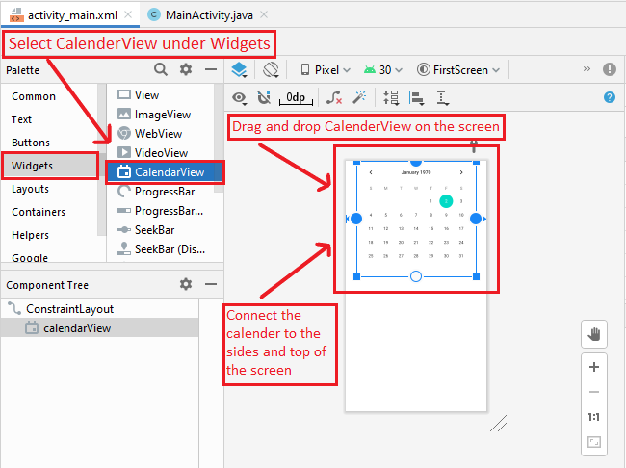
* **SearchView:**
  + Select the Wigets.
  + Select the SearchView.
  + Drag the SearchView and drop on the screen.
  + Adjust the size.
  + Connect the top of SearchView to the bottom of the Calendar.
  + Connect the right and left side of SearchView to the right and left side of screen respectively.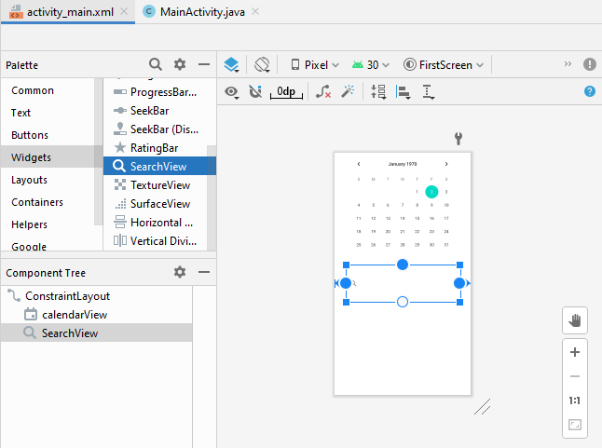
* **Plain Text:**
  + Select the Text.
  + Select the Plain Text.
  + Drag the Plain Text and drop on the screen.
  + Adjust the size.
  + Connect the top and bottom of PlainText box to the top and bottom of the SearchView box respectively.
  + Connect the right and left side of Plain Text to the right and left side of SearchView box respectively.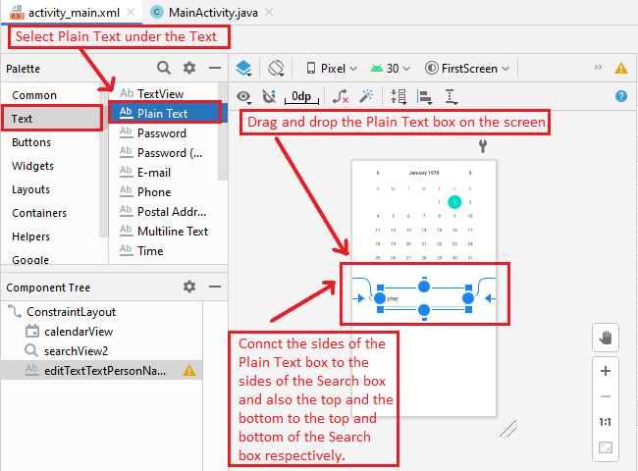
* **Change the Text in Plain Text Box:**
  + Click on the Plain Text Box.
  + Go to attributes.
  + Change the text in **text** column.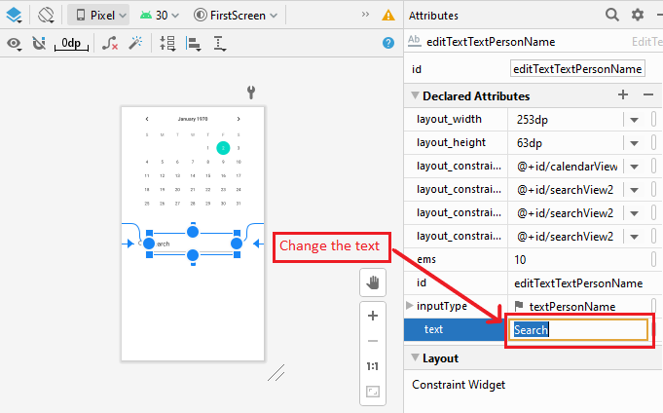
* **Image Buttons:**
  + Select the Buttons.
  + Select the ImageButton.
  + Drag the ImageButton and drop on the screen.
  + Select the ImageButton you want to use.
  + Adjust the size.
  + Connect the top ImageButton to the top and bottom of the SearchView box.
  + Connect the two ImageButtons togather.
  + Connect the right and left side of Plain Text to the right and left side of SearchView box respectively.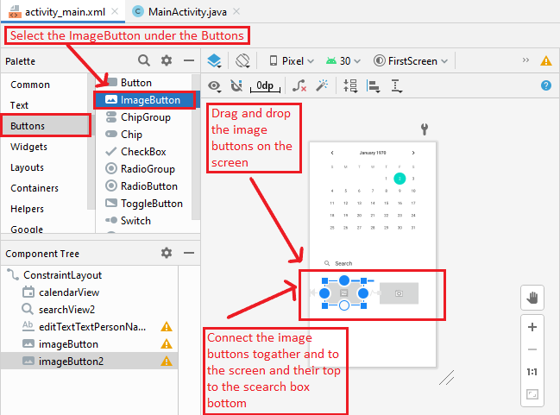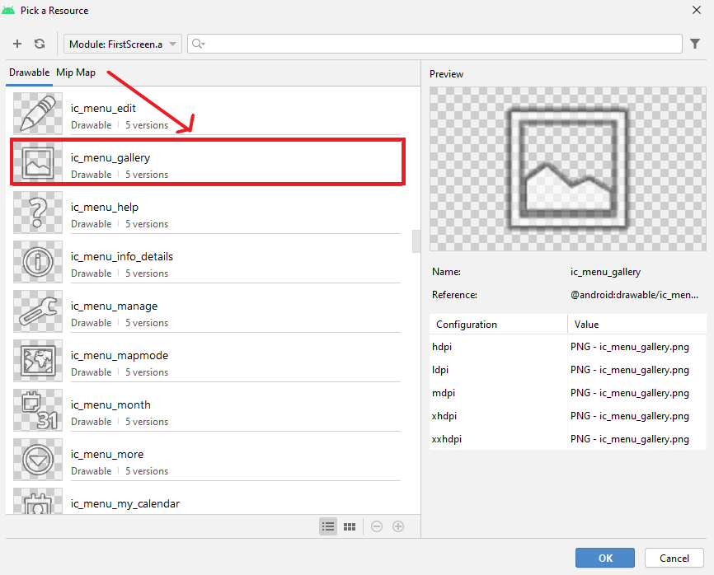
* **Run the Project:**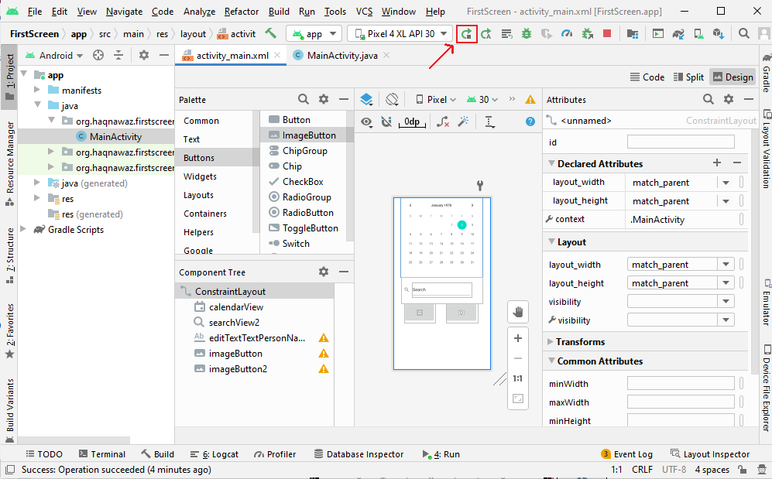
* **The Screen:**

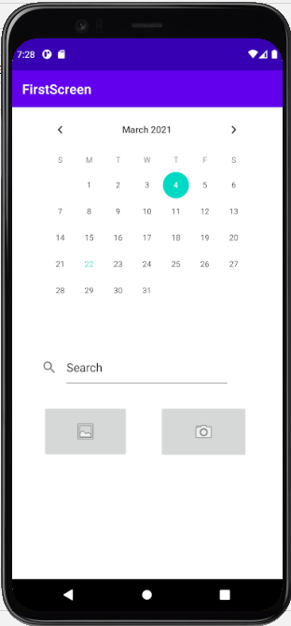

**Uploading the Project on GitHub**

* **Check the folder:** 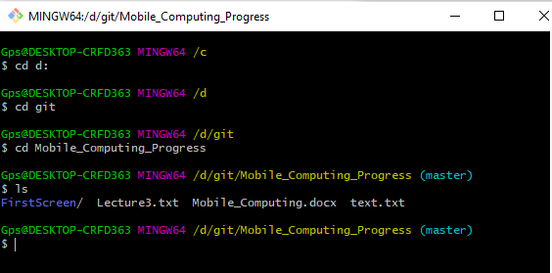
* **Git add:**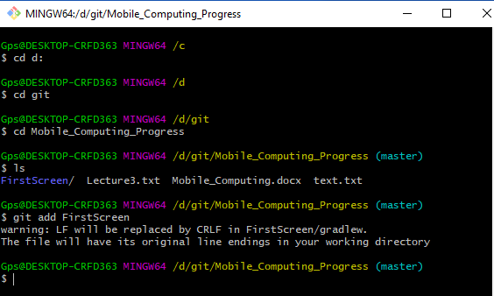
* **Git commit:**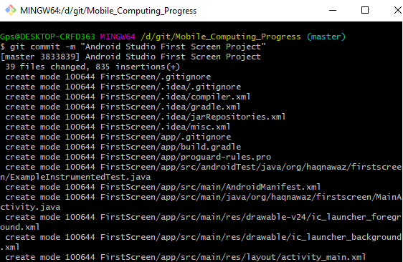
* **Git push:**