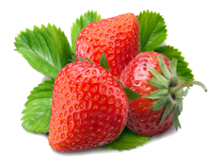

ADD AN ITEM TO DB

Item ID:

BACK

ADD

Name:

Description:

Price:

Image URL:

Quantity:

Category

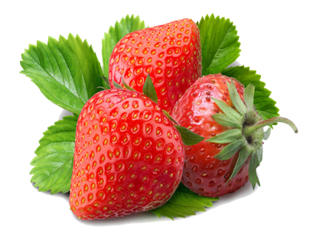

S

**3 wild trawberry’s store INVENTORY**

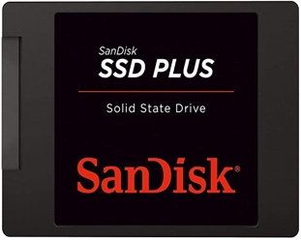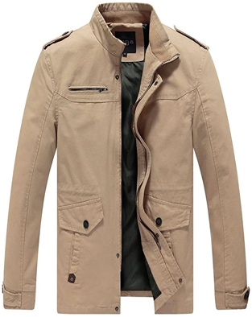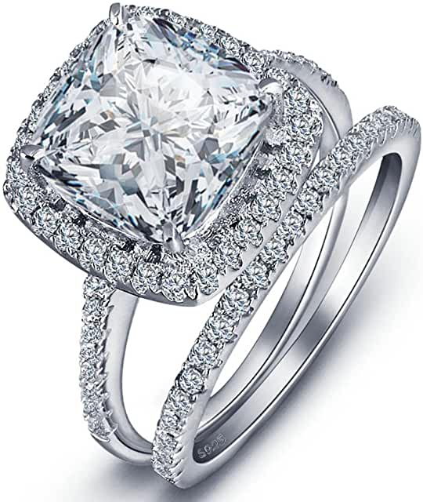

Jewelry

Men’s Clothing

Electronics

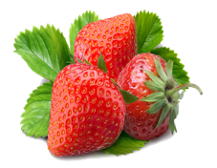

Men’s Clothing

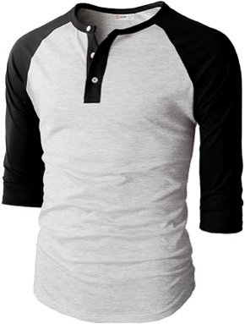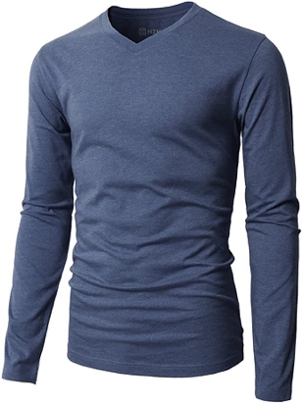

**Men’s casual premium 26.99**

**slim fit T-Shirt**

**Men’s** **casual slim fit. 24.99**

**Men cotton jacket 55.99**

Add

Details

**Delete**

Details

Add

**Delete**

**Delete**

Add

Details



Men cotton jacket



# great outerwear jackets for Spring/Autumn/Winter, suitable for many occasions, such as working, hiking, camping, mountain/rock climbing, cycling, traveling or other outdoors. Good gift choice for you or your family member. A warm-hearted love to Father, husband or son in this thanksgiving or Christmas Day.

**55.99**

**Inventory Details**

**Inventory Details**