**Idea 1: Motor Imagery based photo viewer**

* **Team Data:**

|  |  |
| --- | --- |
| Name | ID |
| محمد جمال ابراهيم علي | **20191700922** |
| ايمن سالم صالح ابراهيم | **20201700167** |
| فاطمه نميري عبدالله | **20201700574** |
| اسراء حربي سعد عبدالحميد | **20191700876** |

* **Introduction:**Is a simple UI should include just two buttons that represent the two directions previous(left movement) and next(right movement).
* **Data Preparation:**

**Loading Dataset:**

The EEG eye state classification dataset is loaded from a CSV file named "BCICIV_2a_all_patients.csv" using pandas . that contain 4 classes “ right , left , tongue , foot “ . We dropped “tongue and foot from data set and saved data in csv file Named “filtered_file.csv”

**Handling Missing Values:**

Rows and columns with missing values (NaN) are removed from the dataset using the **dropna** function. This ensures that the dataset contains only valid data.

* **perprocessing:**
* **A high-pass filter:** is applied to the EEG signals using a Butterworth filter with a cutoff frequency of 4.0 Hz. This helps remove low-frequency noise from the signals.
* **Normalization:** The data is normalized using Min-Max scaling to scale the features in the range [0, 1]
* **Train-Test Split:** the preprocessed data is split into training and testing sets using the **train_test_split** function from scikit-learn. The training set contains 80% of the data, while the testing set contains the remaining 20%.
* **PCA**: is a technique used for dimensionality reduction, particularly for reducing the number of features in a dataset while preserving most of the variability in the data.
* **ICA**: is a method for separating a multivariate signal into additive, independent components.

**Before PCA**:

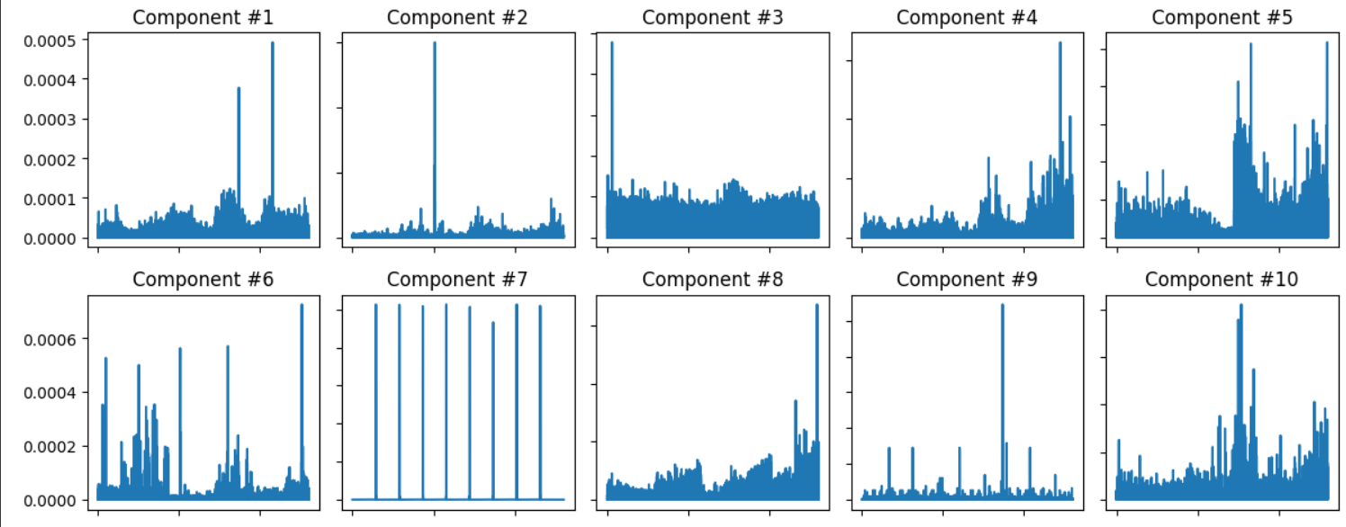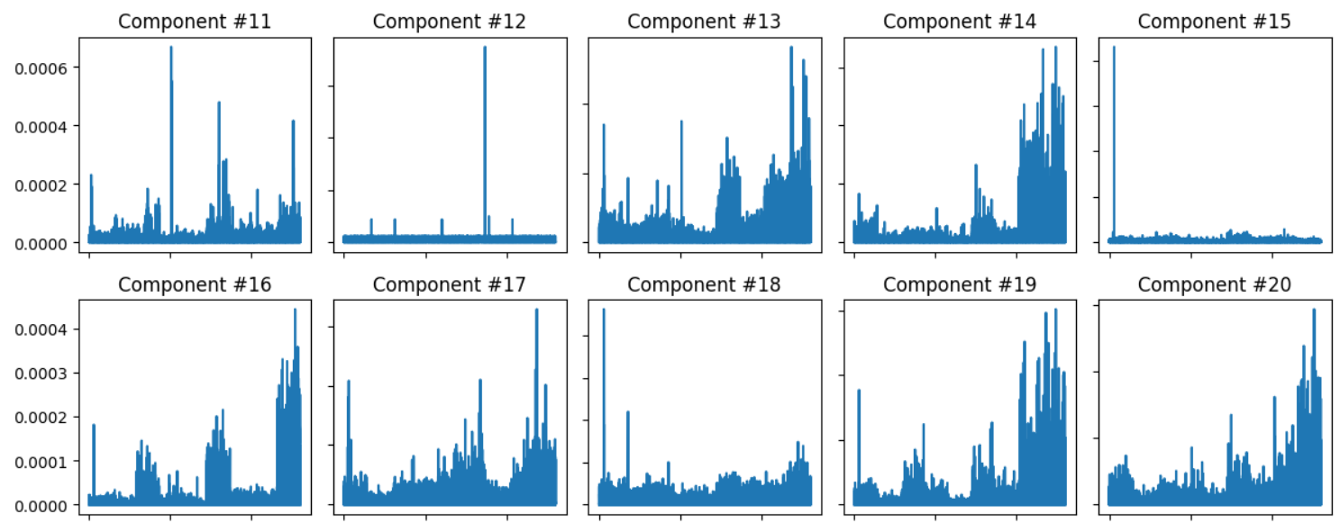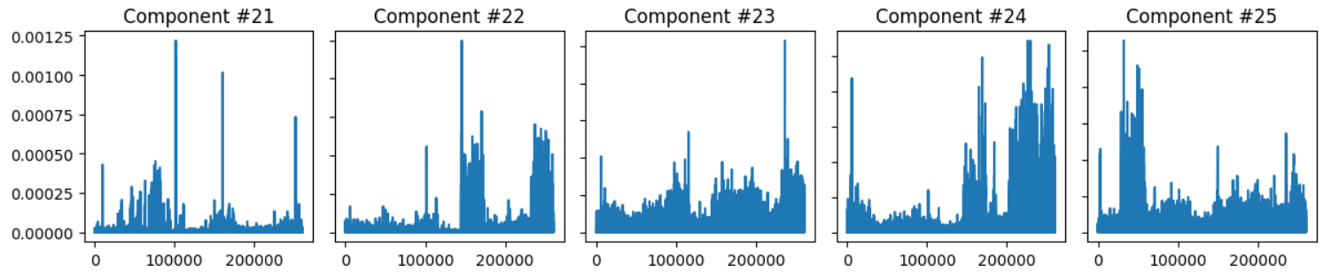

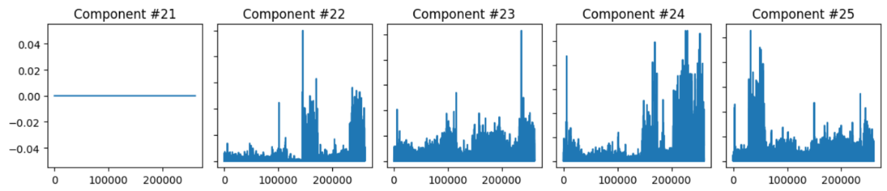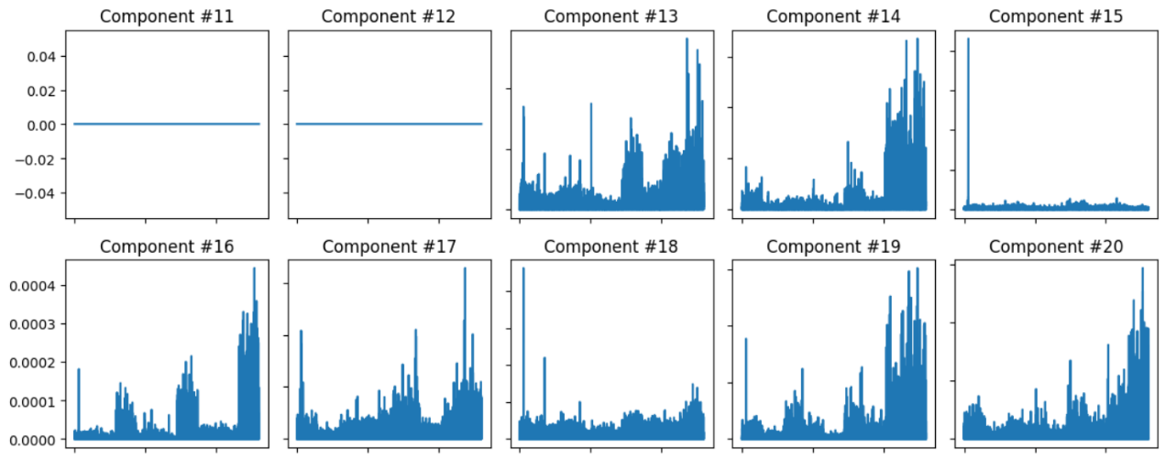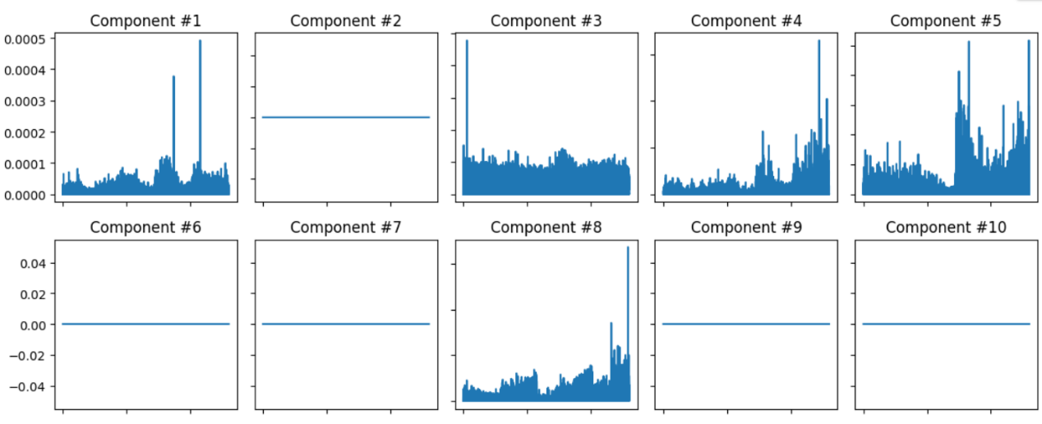**After PCA:**

* **Features extraction and Models evaluation:**
* **features extraction method:**

**CSP:** is applied to the preprocessed data to extract discriminative spatial filters that enhance the separation between different classes (e.g., 'left' and 'right' eye states). CSP aims to maximize the variance of EEG signals for one class while minimizing the variance for another class. The resulting CSP filters are used to transform the EEG data, effectively extracting features that are optimized for classification.

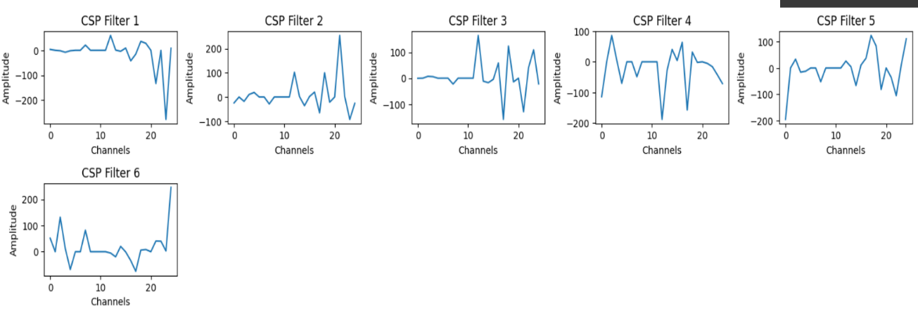**After CSP:**

* **Models (Classifiers):**
* **Support Vector Machine**
* **K Neighbors**
* **XGBoost**

|  |  |  |
| --- | --- | --- |
| Model Name | Parameters | Accuracy |
| KNN | **n_neighbors=5, metric="minkowski", p=2** | **51.1** |
| SVM | **kernel='poly', C=2, gamma='auto'** | **51.6** |
| SVM | **kernel='rbf', C=10, gamma='auto'** | **49.8** |
| XGBoost | **'max_depth': 3, 'eta': 0.1,  'objective': 'binary:logistic', 'eval_metric':** **'logloss'** | **52.07** |
| XGBoost | **'max_depth': 15, 'eta': 0.01,  'objective': 'binary:logistic', 'eval_metric': 'logloss'** | **51.9** |

* **User interface Based prediction of classifiers:**
* two buttons that represent the two directions previous (left movement) and next (right movement).

